Section 1: general information

Specifications

Description

The method determines if someone can get a concealed carry license based on several factors.

Javadoc

    /**

     * Determine whether someone gets a license to carry concealed based on several factors.

     * Age: Must be at least 21 years old (or at least 18 years old and a member of the military or honorably discharged veteran). Applicants over 80 years old do not qualify and are denied. Negative ages result in an error.

     * Criminal History: Must not have a felony conviction or be subject to an outstanding felony warrant. Even military do not get a license if they are f

     * Training: completed a firearms safety training course. If they have not, they can get a temporary license for 90 days to complete the course.

     *

     * @param age integer

     * @param military boolean

     * @param no_criminal boolean

     * @param trained boolean

     *

     * @return

     * GRANTED - all conditions are met. license is granted for five years

     * DENIED - at least one disqualifying condition. license is denied

     * TEMPORARY - licensed for up to 90 days after which the license is either granted or denied

     * ERROR - for incomplete information or incorrect data

     */

Note: do not delete anything from this document, only add to it. Do not re-order things in this document.

-------------------------------------------end of section 1 -----------------------------------------------------

Section 2: chapter-specific data

Natural ranges for Equivalence partitions

age

| Integer.MIN_VALUE --- Integer.MAX_VALUE |

military:

|True | false|

No_criminal:

|True | false|

trained:

|True | false|

decision

| GRANTED | DENIED | TEMPORARY | ERROR |

Specifications-based Ranges

|  |  |  |
| --- | --- | --- |
| **Parameter** | **Natural Range** | **Equivalence value** |
| age | Long.MIN_VALUE .. -1 | -10 |
|  | 0 .. 17 | 15 |
|  | 18 .. 20 | 19 |
|  | 21 .. 80 | 30 |
|  | 81 .. Long.MAX_VALUE | 90 |
| military | True | True |
|  | False | False |
| No_criminal | True | True |
|  | False | False |
| trained | True | True |
|  | False | False |
| Decision | GRANTED | GRANTED |
|  | DENIED | DENIED |
|  | TEMPORARY | TEMPORARY |
|  | ERROR | ERROR |

Rules for decision tables

* Age < 18
* Age < 21
* Age <= 80
* Military
* No_criminal
* trained

For the spreadsheet, double click in the area below.

These are all the tests with invalid combinations filtered out:

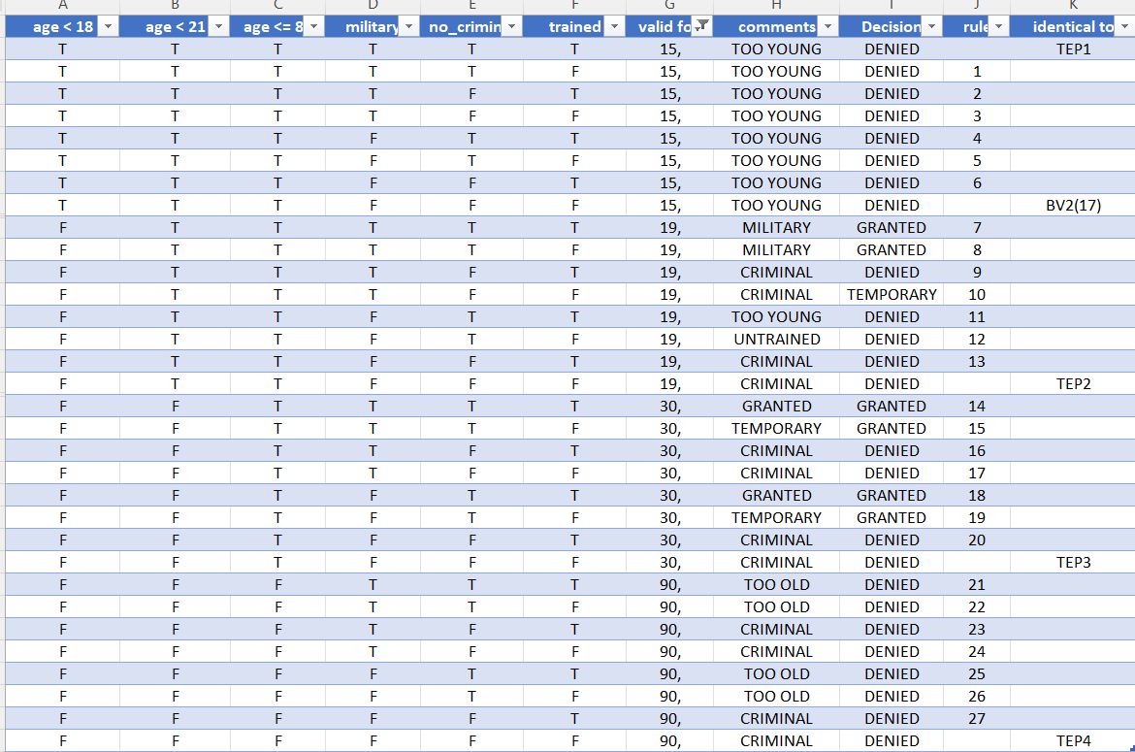

If you filter on age 15 also, you get all denied because the applicant is too young:

If you filter on no_criminal as false, you see that all criminals get denied

Military get approved unless they are too young or too old:

Untrained applicants who are not too young, not too old, and who are not criminals get a temporary license:

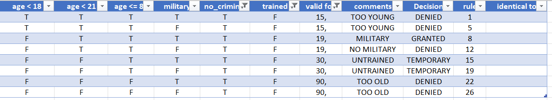

Screenshot of jacoco in browser for statement coverage (before any new tests)

Screenshot of highlighted code for statement coverage (before any new tests)

Interpretation of screenshots for statement coverage

The Missed Instructions for the Decide method show that there is only 91% coverage, and the code shows in red that statement 48 is not executed. We need to add test for age of 25, not military, no_criminal, and training true.

Screenshot of jacoco in browser for branch coverage (before any new tests)

Screenshot of highlighted code for branch coverage (before any new tests)

Interpretation of screenshots for branch coverage

All statements are now covered as evidenced by the Missed Instructions column now showing 100% coverage. However, branch coverage is only 95%. One of six branches on line 47 is not followed. This can be corrected by adding a test for age = 25, military, no_criminal, and training true. This resolves all coverage.

---------------------------------------------- end of section 2---------------------------------------------

Section 3: TCI table and Tests table

**Test Coverage Items table. Complete the Test Case column after you add the tests for each section.**

|  |  |  |  |
| --- | --- | --- | --- |
| **TCI** | **Parameter** | **Equivalence partition, boundary value, decision, etc** | **Test case** |
| EP1* | age | (*) Integer.MIN_VALUE .. -1 | TEP5 |
| EP2 |  | 0 .. 17 | TEP1 |
| EP3 |  | 18 .. 20 | TEP2 |
| EP4 |  | 21 .. 80 | TEP3 |
| EP5 |  | 81 .. Integer.MAX_VALUE | TEP4 |
| EP6 | military | True | TEP1 |
| EP7 |  | False | TEP2 |
| EP8 | No_criminal | True | TEP1 |
| EP9 |  | False | TEP2 |
| EP10 | trained | True | TEP1 |
| EP11 |  | False | TEP2 |
| EP12 | Decision | GRANTED |  |
| EP13 |  | DENIED | TEP1 |
| EP14 |  | TEMPORARY |  |
| EP15* |  | ERROR | TEP5 |
|  |  |  |  |
|  |  |  |  |
| BV1* | Points | Integer.MIN_VALUE | TBV9 |
| BV2* |  | -1 | TBV10 |
| BV3 |  | 0 | TBV1 |
| BV4 |  | 17 | TBV2 |
| BV5 |  | 18 | TBV3 |
| BV6 |  | 20 | Tbv4 |
| BV7 |  | 21 | TBV5 |
| BV8 |  | 80 | TBV6 |
| BV9 |  | 81 | TBV7 |
| BV10 |  | Integer.MAX_VALUE | TBV8 |
| BV11 | military | True | TBV1 |
| BV12 |  | False | TBV2 |
| BV13 | No_criminal | True | TBV1 |
| BV14 |  | False | TBV2 |
| BV15 | trained | True | TBV1 |
| BV16 |  | False | TBV2 |
| BV17 | Decision | GRANTED |  |
| BV18 |  | DENIED | TBV1 |
| BV19 |  | TEMPORARY |  |
| BV20 |  | ERROR | TBV10 |
|  |  |  |  |
| DT1 |  |  |  |
| DT2 |  |  |  |
| DT3 |  |  |  |
| DT4 |  |  |  |
| DT5 |  |  |  |
| DT6 |  |  |  |
| DT7 |  |  |  |
| DT8 |  |  |  |
| DT9 |  |  |  |
| DT10 |  |  |  |
|  |  |  |  |
|  |  |  |  |
|  |  |  |  |
| NOTE: tests in red are evaluated late to show that it is not necessary to have all outcomes covered during equivalence partition testing. | | | |

**Test Cases**

|  |  |  |  |  |  |  |  |  |  |  |
| --- | --- | --- | --- | --- | --- | --- | --- | --- | --- | --- |
| **ID** | **TCI covered** | | **Inputs** | | | | | | **Exp. results** | **comment** |
| age | | Military | No_criminal | trained |  | decision |  |
| TEP1 | EP2,EP7,EP9,EP11,EP13 | | 15 | | True | True | true |  | DENIED |  |
| TEP2 | EP3,EP7,EP9,EP11,EP13 | | 19 | | false | false | false |  | DENIED |  |
| TEP3 | EP4,EP7,EP9,EP11,EP13 | | 30 | | false | false | false |  | DENIED |  |
| TEP4 | EP5,EP7,EP9,EP11,EP13 | | 90 | | false | false | false |  | DENIED |  |
| TEP5 | EP1, ,EP6,EP8,EP10,EP15 | | -10 | | false | false | false |  | ERROR |  |
| TBV1 |  | | 0 | | true | true | true |  | DENIED |  |
| TBV2 |  | | 17 | | false | false | false |  | DENIED |  |
| TBV3 |  | | 18 | | false | false | false |  | DENIED |  |
| TBV4 |  | | 20 | | false | false | false |  | DENIED |  |
| TBV5 |  | | 21 | | false | false | false |  | DENIED |  |
| TBV6 |  | | 80 | | false | false | false |  | DENIED |  |
| TBV7 |  | | 81 | | false | false | false |  | DENIED |  |
| TBV8 |  | | Integer.MAX_VALUE | | false | false | false |  | DENIED |  |
| TBV9 |  | | Integer.MIN_VALUE | | false | false | false |  | ERROR |  |
| TBV10 |  | | -1 | | false | false | false |  | ERROR |  |
|  |  | |  | |  |  |  |  |  |  |
| TBV11 |  | |  | |  |  |  |  |  |  |
| TBV12 |  | |  | |  |  |  |  |  |  |
| TDT1 |  | |  | |  |  |  |  |  |  |
| TDT2 |  | |  | |  |  |  |  |  |  |
| TDT3 |  | |  | |  |  |  |  |  |  |
| TDT4 |  | |  | |  |  |  |  |  |  |
| TDT5 |  | |  | |  |  |  |  |  |  |
| TSC1 |  | |  | |  |  |  |  |  |  |
| TSC2 |  | |  | |  |  |  |  |  |  |
| TSC3 |  | |  | |  |  |  |  |  |  |
| TBC1 |  | |  | |  |  |  |  |  |  |
|  | |  | | Note: repetitive TCIs are noted in red rather than with square brackets as in the book. | | | | | | |