Section 1: general information

Specifications

Description

The method the student classification based on credit hours and graduation status.

Javadoc

    public static enum Classification {FRESHMAN, SOPHOMORE, JUNIOR, SENIOR, GRADUATE, ERROR};

    /**

     * Determine the classification based on credit hours and graduation status

     * Undergraduate credit hours are for NSU only. If a student has graduated from the undergraduate degree and has more than 128 hours, the student is a graduate student.

     * FRESHMAN: has completed 0-29 semester credit hours.

     * SOPHOMORE: has completed 30-59 semester credit hours.

     * JUNIOR: has completed 60-89 semester credit hours.

     * SENIOR: has completed 90 or more semester credit hours but has not graduated.

     * GRADUATE: has graduated with at least 124 credit hours.

     *

     * @param credits How many credit hours the student has passed

     * @param graduated Whether the student has graduated with a bachelor's degree

     *

     * @return

     * FRESHMAN

     * SOPHOMORE

     * JUNIOR

     * SENIOR

     * GRADUATE

     * ERROR - credits less than 0 or less than 124 credits but is listed as graduated

     */

Note: do not delete anything from this document, only add to it. Do not re-order things in this document.

-------------------------------------------end of section 1 -----------------------------------------------------

Section 2: chapter-specific data

Natural ranges for Equivalence partitions

credits

| Long.MIN_VALUE --- long.MAX_VALUE |

Graduated:

|True | false|

Classification

| FRESHMAN|SOPHOMORE|JUNIOR|SENIOR|GRADUATE| ERROR |

Specifications-based Ranges

|  |  |  |
| --- | --- | --- |
| **Parameter** | **Natural Range** | **E**quivalence value |
| credits | Long.MIN_VALUE .. -1 | -10 |
|  | 0 .. 29 | 20 |
|  | 30 .. 59 | 50 |
|  | 60 .. 89 | 70 |
|  | 90 .. Long.MAX_VALUE | 100 |
| Graduated | True | True |
|  | False | False |
| classification | FRESHMAN | FRESHMAN |
|  | SOPHOMORE | SOPHOMORE |
|  | JUNIOR | JUNIOR |
|  | SENIOR | SENIOR |
|  | GRADUATE | GRADUATE |
|  | ERROR | ERROR |

Rules for decision tables

* Credits < 30
* Credits < 60
* Credits < 90
* graduated

For the spreadsheet, double click in the area below. (in this solution, I simply pasted a picture of the spreadsheet to make it fit better)



Screenshot of jacoco in browser for statement coverage (before any new tests)

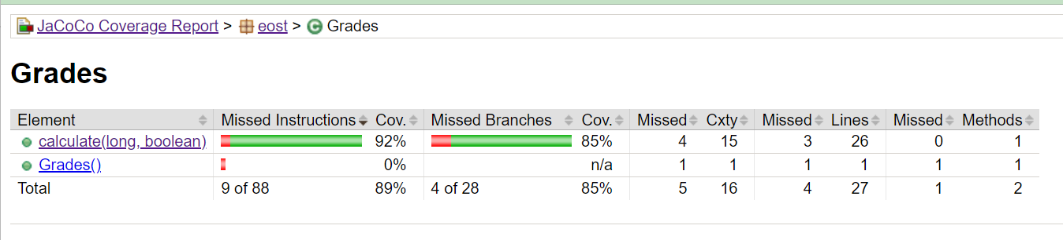

Screenshot of highlighted code for statement coverage (before any new tests)

Interpretation of screenshots for statement coverage

The Missed Instructions for the calculate method show that there is only 92% coverage, and the code shows in red that statement 35, 65, and 68 are not executed. We need to add tests for credits = 128 (graduated not important), credits = 77 (graduated not important) and credits = 666 (credits not important).

Note: this leads to additional errors in the results but that is because the faults introduced violate the specifications. What matters is that the statements are now all covered.

Screenshot of jacoco in browser for branch coverage (before any new tests)

Screenshot of highlighted code for branch coverage (before any new tests)

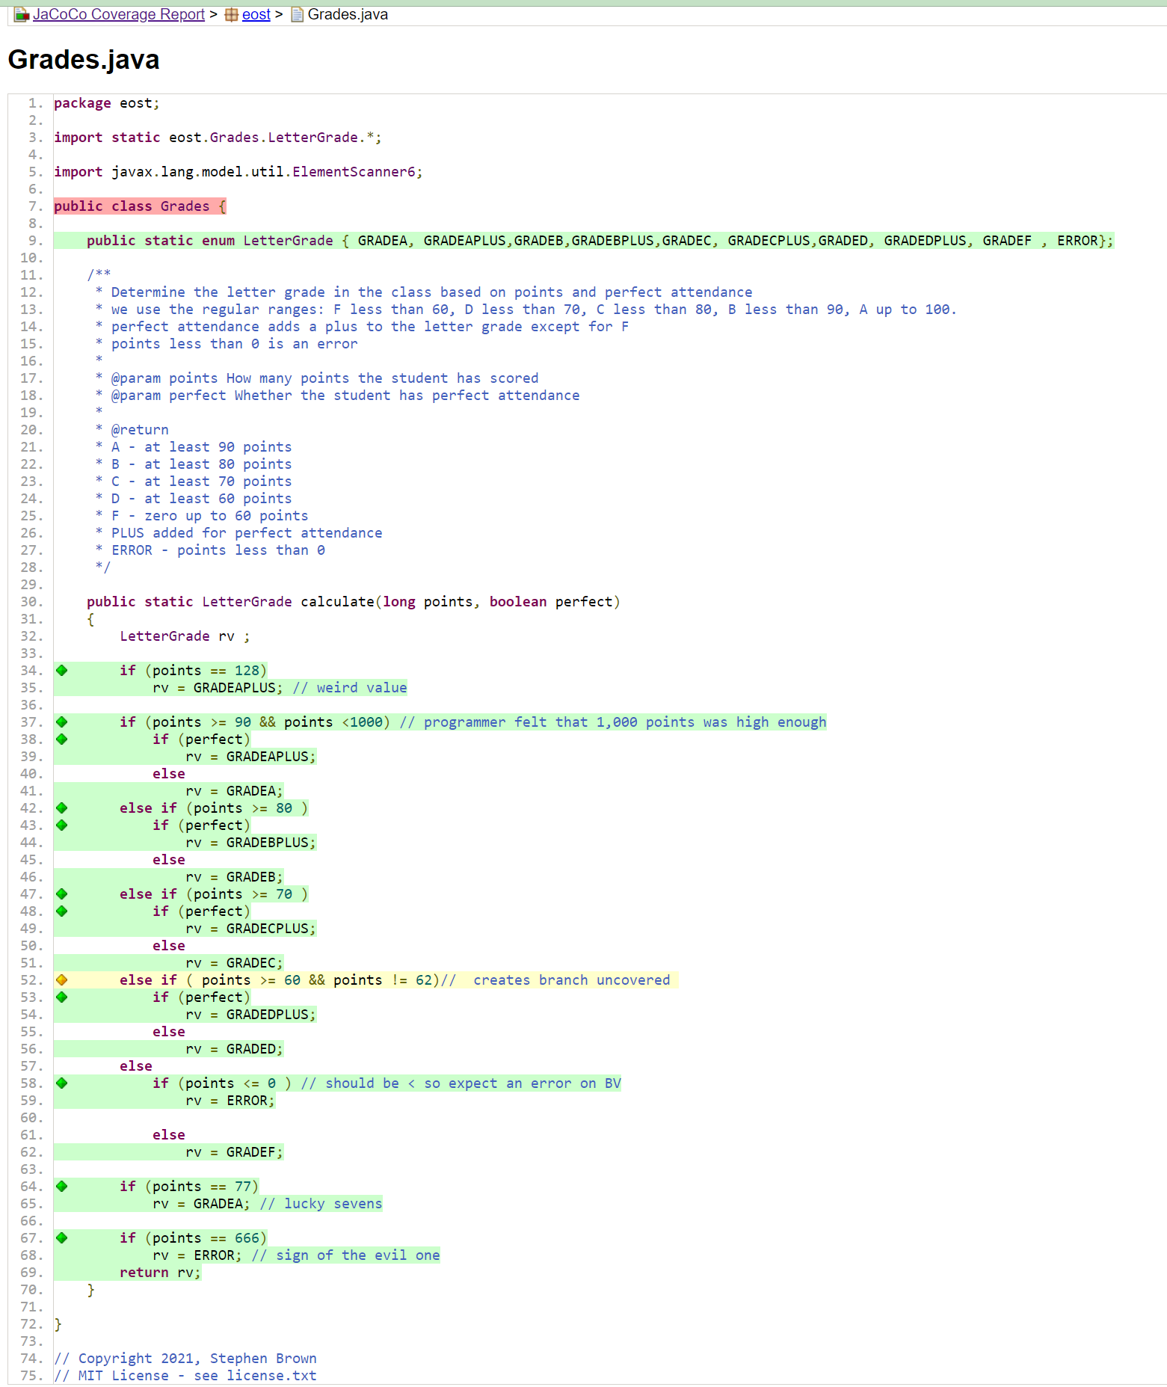

Interpretation of screenshots for branch coverage

All statements are now covered as evidenced by the Missed Instructions column now showing 100% coverage. However, branch coverage is only 96%. One of four branches on line 52 is not followed. This can be corrected by adding a test for credits = 62 (graduated not important). This resolves all coverage.

---------------------------------------------- end of section 2---------------------------------------------

Section 3: TCI table and Tests table

**Test Coverage Items table. Complete the Test Case column after you add the tests for each section.**

|  |  |  |  |
| --- | --- | --- | --- |
| **TCI** | **Parameter** | **Equivalence partition, boundary value, decision, etc** | **Test case** |
| EP1* | credits | (*) Long.MIN_VALUE .. -1 | TEP6 |
| EP2 |  | 0 .. 59 | TEP1 |
| EP3 |  | 60 .. 69 | TEP2 |
| EP4 |  | 70 .. 79 | TEP3 |
| EP5 |  | 80 .. 89 | TEP4 |
| EP6 |  | 90 .. Long.MAX_VALUE | TEP5 |
| EP7 | Graduated | True | TEP1 |
| EP8 |  | False | TEP2 |
| EP9 | classification | GRADEA | TEP5 |
| EP10 |  | GRADEAPLUS | TDT5 |
| EP11 |  | GRADEB | TEP4 |
| EP12 |  | GRADEBPLUS | TDT4 |
| EP13 |  | GRADEC | TEP3 |
| EP14 |  | GRADECPLUS | TDT3 |
| EP15 |  | GRADED | TEP2 |
| EP16 |  | GRADEDPLUS | TDT2 |
| EP17 |  | GRADEF | TEP1 |
| EP18* |  | (*) ERROR | TEP6 |
| BV1 | Credits | Long.MIN_VALUE | TBV11 |
| BV2 |  | -1 | TBV12 |
| BV3 |  | 0 | TBV1 |
| BV4 |  | 59 | TBV2 |
| BV5 |  | 60 | TBV3 |
| BV6 |  | 69 | TBV4 |
| BV7 |  | 70 | TBV5 |
| BV8 |  | 79 | TBV6 |
| BV9 |  | 80 | TBV7 |
| BV10 |  | 89 | TBV8 |
| BV11 |  | 90 | TBV9 |
| BV12 |  | Long.MAX_VALUE | TBV10 |
| BV13 | Graduated | True | TBV1 |
| BV14 |  | False | TBV2 |
| BV15 | classification | GRADEA | TBV9 |
| BV16 |  | GRADEAPLUS | TDT5 |
| BV17 |  | GRADEB | TBV7 |
| BV18 |  | GRADEBPLUS | TDT4 |
| BV19 |  | GRADEC | TBV5 |
| BV20 |  | GRADECPLUS | TDT3 |
| BV21 |  | GRADED | TBV3 |
| BV22 |  | GRADEDPLUS | TDT2 |
| BV23 |  | GRADEF | TBV1 |
| BV24 |  | ERROR | TBV11 |
| DT1 | Rule 1 | 55,true | TDT1 |
| DT2 | Rule 2 | 55,false | TEP1 |
| DT3 | Rule 3 | 65, true | TDT2 |
| DT4 | Rule 4 | 65, false | TEP2 |
| DT5 | Rule 5 | 75, true | TDT3 |
| DT6 | Rule 6 | 75, false | TEP3 |
| DT7 | Rule 7 | 85, true | TDT4 |
| DT8 | Rule 8 | 85, false | TEP4 |
| DT9 | Rule 9 | 95, true | TDT5 |
| DT10 | Rule 10 | 95, false | TEP5 |
| NOTE: tests in red are evaluated late to show that it is not necessary to have all outcomes covered during equivalence partition testing. | | | |

Equivalence Values

|  |  |  |
| --- | --- | --- |
| **Parameter** | **Equivalence partition, boundary value, decision, etc** | **Equivalence value** |
| credits | Long.MIN_VALUE .. -1 | -10 |
|  | 0 .. 59 | 55 |
|  | 60 .. 69 | 65 |
|  | 70 .. 79 | 75 |
|  | 80 .. 89 | 85 |
|  | 90 .. Long.MAX_VALUE | 95 |
| Graduated | True | True |
|  | False | False |
| classification | GRADEA | GRADEA |
|  | GRADEAPLUS | GRADEAPLUS |
|  | GRADEB | GRADEB |
|  | GRADEBPLUS | GRADEBPLUS |
|  | GRADEC | GRADEC |
|  | GRADECPLUS | GRADECPLUS |
|  | GRADED | GRADED |
|  | GRADEDPLUS | GRADEDPLUS |
|  | GRADEF | GRADEF |
|  | ERROR | ERROR |

**Test Cases**

|  |  |  |  |  |  |  |
| --- | --- | --- | --- | --- | --- | --- |
| **ID** | **TCI covered** | **Inputs** | | | **Exp. results** | **comment** |
| credits | graduated |  | return value |  |
| TEP1 | EP2,EP7,EP17 | 55 | true |  | GRADEF |  |
| TEP2 | EP3,EP8,EP15 | 65 | false |  | GRADED |  |
| TEP3 | EP4,EP8,EP13 | 75 | false |  | GRADEC |  |
| TEP4 | EP5,EP8,EP11 | 85 | false |  | GRADEB |  |
| TEP5 | EP6,EP8,EP9 | 95 | false |  | GRADEA |  |
| TEP6 | EP1,EP8,EP18 | -10 | false |  | ERROR |  |
| TBV1 | BV3,BV13,BV23 | 0 | true |  | GRADEF | Will find an error due to deliberate error in the code |
| TBV2 | BV4, BV14,BV23 | 59 | false |  | GRADEF |  |
| TBV3 | BV5, BV14,BV21 | 60 | false |  | GRADED |  |
| TBV4 | BV6, BV14,BV21 | 69 | false |  | GRADED |  |
| TBV5 | BV7, BV14,BV19 | 70 | false |  | GRADEC |  |
| TBV6 | BV8, BV14,BV19 | 79 | false |  | GRADEC |  |
| TBV7 | BV9, BV14,BV17 | 80 | false |  | GRADEB |  |
| TBV8 | BV10, BV14,BV17 | 89 | false |  | GRADEB |  |
| TBV9 | BV11, BV14,BV15 | 90 | false |  | GRADEA |  |
| TBV10 | BV12, BV14,BV15 | Long.MAX_VALUE | false |  | GRADEA | Will find an error due to deliberate error in the code |
| TBV11 | BV1, BV14,BV24 | Long.MIN_VALUE | false |  | ERROR |  |
| TBV12 | BV2, BV14,BV24 | -1 | false |  | ERROR |  |
| TDT1 | DT1 | 55 | true |  | GRADEF |  |
| TDT2 | DT3 | 65 | true |  | GRADEDPLUS |  |
| TDT3 | DT5 | 75 | true |  | GRADECPLUS |  |
| TDT4 | DT7 | 85 | true |  | GRADEBPLUS |  |
| TDT5 | DT9 | 95 | true |  | GRADEAPLUS |  |
| TSC1 | Line 35 | 128 | true |  | GRADEAPLUS |  |
| TSC2 | Line 65 | 77 | true |  | GRADECPLUS | Will find an error due to deliberate error in the code |
| TSC3 | Line 68 | 666 | true |  | GRADEAPLUS | Will find an error due to deliberate error in the code |
| TBC1 | Line 52 | 62 | true |  | GRADEF |  |
| Note: repetitive TCIs are noted in red rather than with square brackets as in the book. | | | | | | |