**Title of the Project:**

Recognizing human activity using multiple wearable accelerometer sensors placed on different body positions.

**Group Information:**

Group: COM 17

Name: Beknazar Bazarbek uulu

**Abstract:**

In this work, we implemented and evaluated classification algorithm to detect four crucial human physical activities (walking, cycling, sitting, and lying) using five triaxial accelerometers worn concurrently on different parts of the body (dominant hip, upper arm, ankle, thigh, and wrist). The accelerometer data were collected, cleaned, and preprocessed to extract features from 10 s window. These time and frequency domain features were used with Random Forest and k-Nearest Neighbour classifier to classify subject activities. The algorithms were evaluated based on Leave-One-Subject-Out (LOSO) and ten-fold cross-validation strategy using both accelerometer data as well as annotated activity labels from 33 participants in a lab. Random Forest showed the best performance recognizing the activities with overall accuracy of 89 % for LOSO strategy for hip data. Combining data from both hip and ankle improved the overall accuracy by 3.5 %, and by 10% for lying activity, which had the lowest classification accuracy (80%) for hip data. We conclude that our algorithm that uses 10 features shows good activity classification, and is computationally efficient to be implemented in real-time mobile systems.

Keywords: Activity recognition; Random Forest; k-NearestNeighbors; leave-one-subject-out;

**Introduction of the background:**

Automatic detection of human physical activities (PA) could have huge impacts not only in health interventions, social networking, lifestyle, but also in targeted advertisement and corporate management **[1]**. Accelerometers can be used as motion detectors**[2]** as well as for body-position and posture sensing**[3]**. Their low power consumption, small dimensions, and light weight make them great candidates to make long-term activity monitoring, balance assessment, fall detection more practical. These sensors can be worn on a single or multiple body sites. A multisite configuration is preferable to detect variety of activities with fine complexity by capturing upper and lower body motion independently **[8]**. Hip location has been studied extensively in activity recognition as it generally captures major body motion**[5]**. In this work, we implemented classification algorithms for previously collected lab-setting accelerometer data from 33 participants performing a set of activities. We aimed at classifying activities for four classes (walking, cycling, sitting, and lying), using a LOSO and ten-fold strategy to evaluate algorithm performance. From a 10 sec window, we extracted some of the most common features in activity classification based on accelerometer data.**[6]**

**Problem Definition and Formalization:**

Sensor-based Activity recognition (AR) is an emerging field of research that has made significant progress in recent, and has attracted multiple domains**[3]**. The AR systems that are commercially available consist of a

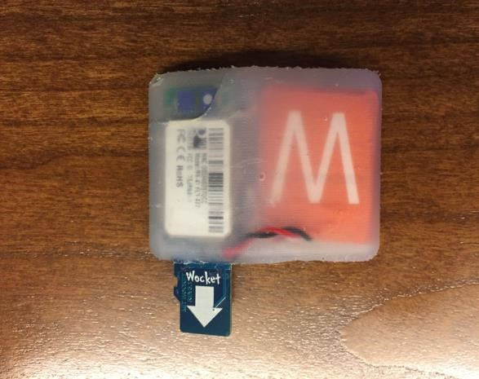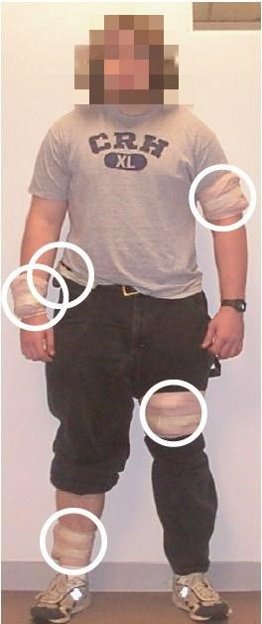

Figure 1. Wocket Accelerometer Figure 2. Wocket placement sites

wearable sensor (smart watch/band) placed on the user’s wrist. There is no published literature validating the efficacy and accuracy of these systems for AR. Therefore, it is imperative to work on validating data mining algorithms and determine the optimum sensor placement site or a combination of sites for robust recognition of everyday human activities.

The physical activities that we focused on were walking, cycling, lying on back, and sitting. The rationale for picking these activities was that two of them are stationary and the other two mobile. A real-time activity recognition system could reward the user after detecting mobile activities (walking and cycling), or give reinforcement feedback in case detecting long duration stationary activities (sitting and lying on back). Wocket accelerometer**[4]** was used to collect the data. The sampling rate was 90 Hz and the sampling range was +- 4 g (m/s2). Wockets were used because they are sufficiently small that they can be comfortably worn on all five body locations at the same time. We have wearable sensors at five different positions : dominant ankle, dominant thigh, dominant hip, dominant arm and dominant wrist as shown in Fig 1. These placement sites were selected because of their relevance in exercise monitoring research[**5**].

**Formalization:**

The dataset consists of acceleration(unit: g or m/s2) in x, y and z direction with timestamps. It is also annotated with physical activity labels that account for all time points. These are the ground truth labels for this classification problem. We started by visualizing the raw data from all five placement sites for all four activities to observe the quality of the data and remove any outliers if present. Figure 3. shows representative plots of raw data for sitting activity.

.

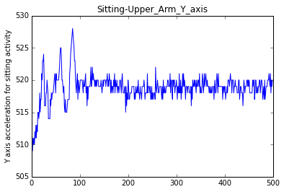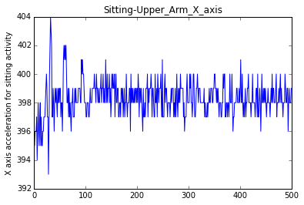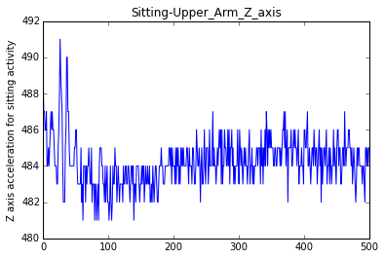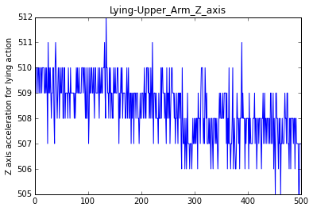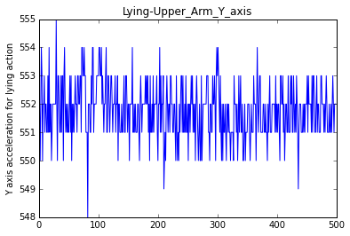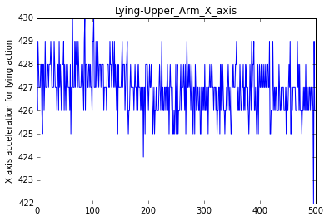

Figure 3. Plotting x,y,z acceleration values for sitting and lying activities for sensor position at upper-arm

● What data mining tasks are needed?

Our datasets consists of raw accelerometer data from 5 sensors placed in different body sites plus the annotated labels. The data mining techniques required for successful execution of the project involves: (i) checking the quality and integrity of data, i.e.: if there is accelerometer data and/or annotation data missing, (ii) checking if various data sources are in sync/accordance with each other, and if the activity labels make sense with respective sensor data, (iii) removing of any outliers in terms of sensor data, annotations, or participant, (iv) performing dimensional reduction of sensor data (given high sampling rate of sensors), (v) transforming data to relevant features for machine learning, (vi) determining best machine learning algorithm.

**Data Description and Preprocessing:**

The dataset (accelerometer data tagged with physical activity label) consists of 33 participants recruited from the

Stanford, California community for other research studies of Drs. William Haskell and Mary Rosenberg. Prof. Stephen Intille made the data available.**[6]**

Data Description:

The dataset consists of several files per participant, among these files, we are only interested in six files. 5 files are the different output files from each sensor placed at different locations and 6th file is the annotation interval file. Basically, for each participant we are interested in these files:

* AnnotationIntervals.csv
* Wocket_00_RawCorrectedData_Dominant-Ankle.csv
* Wocket_01_RawCorrectedData_Dominant-Thigh.csv
* Wocket_02_RawCorrectedData_Dominant-Hip.csv
* Wocket_03_RawCorrectedData_Dominant-Wrist.csv
* Wocket_04_RawCorrectedData_Dominant-Upper-Arm.csv

The AnnotationIntervals.csv files has the time intervals and the activity annotations and the wocket files has the x,y,z acceleration along with the timestamp.

Data Preprocessing:

For preprocessing, we extracted the above mentioned files for each participant and created a merged file. This merged file was created on per participant basis. For merging, we took each wocket file with the timestamp and merged it with the annotation file by placing each time stamp into correct time interval. In the annotation file we added 2 sec to start-time and subtracted 2 sec from endtime to avoid the transition phase between two activities.. The transition phase was discarded to make the resultant data as unambiguous as possible in terms of its activity label. The final merged file had X,Y,Z, Sensor Location, TimeStamp, Activity columns. This was performed for all 33 participants.

**Methods Description:**

Once the data was preprocessed, and the merged file had been obtained for each participant as explained above, the relevant features were extracted from the dataset for classification purpose.

Feature Extraction:

For feature extraction purpose, we considered 10 seconds window in each of the merged file, as 10 seconds is considered sufficient to detect any frequency features **[5]**. For each of these windows, *signal magnitude vector values*

(SM = 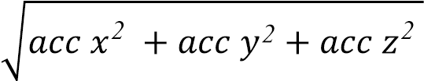) was calculated. This was done to remove the dependence of the resulting signal from the orientation of the sensor. Figure 3. shows SM for all four activities for data from wrist and hip. This resultant signal magnitude represents the motion. In addition to that, we performed the fast-fourier transform (FFT) of the SM to obtain frequency related features that would explain intensity (from power) and pattern (from frequency) of each activity. A butterworth band-pass filter was used to restrict frequencies within 0.3 - 15 Hz, the range relevant to normal human movement. Figure 4. shows the result of FFT before and after filtering. A smaller frequency(0.6 - 2.5 Hz) band was implemented based on [6]. Table 1. lists all the features we considered from both time and frequency domain features for a 10 sec window. This calculation was done for each of the participant. The usefulness of these features has been demonstrated in prior work **[7]**.

|  |  |  |
| --- | --- | --- |
| Feature in dataset | Feature Meaning | Description |
| 1) MeanSM | The mean of signal  magnitude data | It represents the mean acceleration value over that window, and could potentially remove some of the  outliers (if present) |
| 2) StDevSM - | The standard deviation of signal magnitude data | It is used to capture the fact that the range of possible acceleration values differ for different activities such as walking, cycling, etc. |
| 3) MdnSM | The median of signal  magnitude data | It helps eliminate unwanted transients or spikes. Median filtering is a natural way to eliminate them |
| 4) belowPer25SM | The squared sum of magnitude data below 25 [percentile.](http://www.mathworks.com/help/stats/prctile.html) | Most of the time, when we have the data with mean and standard deviation we consider data to have normal distribution (bell-shaped curve). The two features i.e. taking data below 25th percentile and taking the data below 75th percentile have been used to describe dataset that is not normally distributed. There may be the case, where the data is skew and it may have outliers. These percentiles are called interquartile range and covers the central half of the data. The central |
|  |  | half of the data is less likely to be affected by outliers, that mostly affects the tails. |
| 5) belowPer75SM | The squared sum of magnitude data below 75 percentile. | Same as for 25 percentile feature. |
| 6) TotPower_0.3_15 | The total power in the frequency between 0.3 and  15 Hz | It represents the total intensity of an activity within the specified range. |
| 7) FirsDomFre_0.3_15 | The first dominant frequency between 0.3 and 15 Hz: | It represents the dominant movement pattern of an activity within the specified range. |
| 8) PowFirsDomFre_0.3_15 | Power of first dominant frequency between 0.3 and 15 Hz | It represents the intensity of the dominant motion pattern. |
| 9)SecDomFre_0.3_15 | The second dominant frequency between 0.3 and 15 Hz | It represents the second dominant movement pattern of an activity within the specified range. |
| 10)PowSecDomFre_0.3_15 | Power of second dominant frequency between 0.3 and 15 Hz | It represents the intensity of the second dominant motion pattern within the specified range. |
| 11) FirsDomFre_0.6_2.5 | The first dominant frequency between 0.6 and 2.5 Hz | It represents the dominant movement pattern of an activity within the specified range. |
| 12) PowFirsDomFre_0.6_2.5 | Power of first dominant frequencies between 0.6 and  2.5 Hz | It represents the intensity of the dominant motion pattern within the specified range. |
| 13) FirsDomFre_per_TotPower_0.3_15 | The ratio between the first dominant frequency and the total power between 0.3 and 15 Hz | It represents the ratio between first dominant frequency and the total power between 0.3 and 15 Hz. |

Table 1. List of features for the physical activity classification.

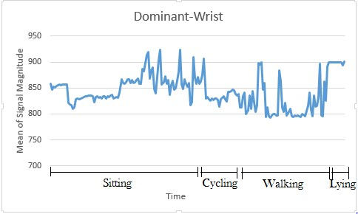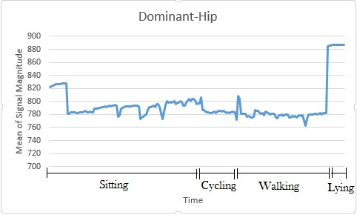

Figure 4. Mean Signal Magnitude for wrist (left) and hip (right) data

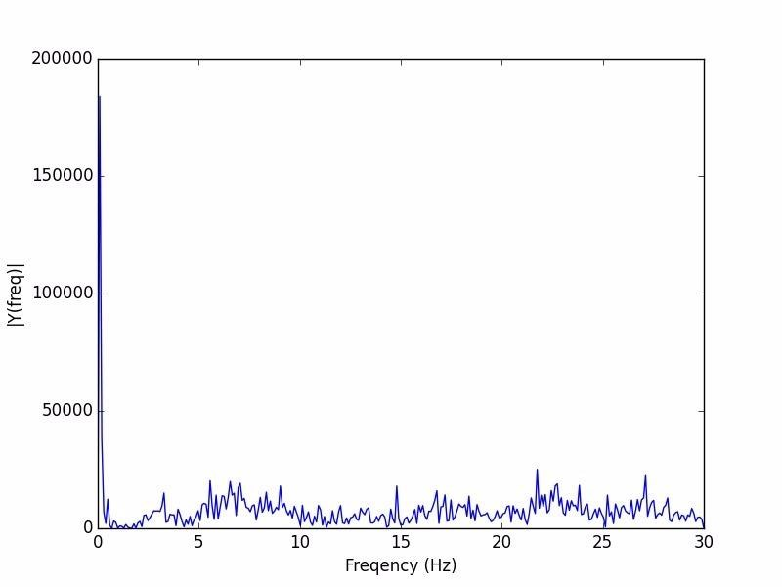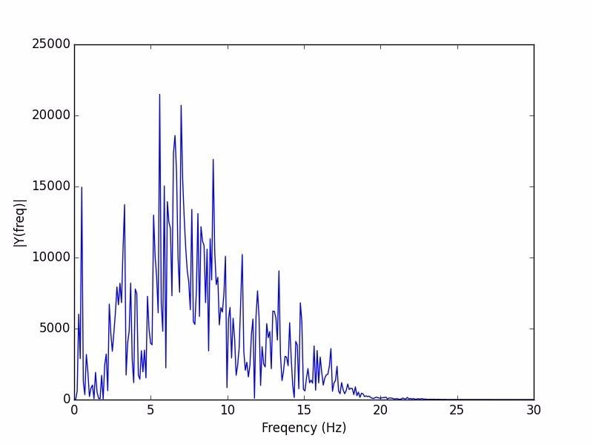

Figure 5.Frequency distribution before(left) and after(right) bandpass filtering

Further processing:

Univariate feature selection based on Analysis of Variance (ANOVA) was performed in training dataset during each cross-validation to select the most relevant features. This process ranks the features based on the difference in their means for each class/activity label. This process was able to discard three non-relevant features, namely: 25th and 75th percentile of SM and the ratio between the first dominant frequency and the total power between 0.3 and 15 Hz. The ten time-frequency domain feature set was further used to train and test the classification algorithm.

Classification approach and algorithm:

For classification purpose, k-Nearest Neighbors (kNN)**[8]** andRandom Forests**[9]** were employed. k-NN is a type of [instance-based learning,](https://en.wikipedia.org/wiki/Instance-based_learning) or [lazy learning,](https://en.wikipedia.org/wiki/Lazy_learning) where the function is only approximated locally and all computation is deferred until classification. The k-NN algorithm is among the simplest of all [machine learning](https://en.wikipedia.org/wiki/Machine_learning) algorithms**[10]**. KNearest Neighbor is a supervised learning algorithm where the result of new instance query is classified based on majority of K-Nearest Neighbor category. It is one of the most popular algorithms for pattern recognition. The best choice of k depends upon the data; generally, larger values of k reduce the effect of noise on the classification, but make boundaries between classes less distinct. A good k can be selected by various heuristic techniques, for example, cross-validation. The training phase of the algorithm consists only of storing the feature vectors and class labels of the training samples. In the classification phase, k is a user-defined constant, and an unlabeled vector (a query or test point) is classified by assigning the label which is most frequent among the k training samples nearest to that query point. Complexity of kNN: O(n) where n is the number of data points

Random Forests are ensemble learning algorithms for classification that operate by constructing a multitude of decision trees **[11]** at training time and outputting the class that is the mode of the classes. We choose Random Forests as they correct the overfitting common in individual decision trees. It achieves this by following a technique called bootstrap aggregating or bagging. Random Forests grows many classification trees. To classify a new object from an input vector, put the input vector down each of the trees in the forest. Each tree gives a classification, and we say the tree "votes" for that class. The forest chooses the classification having the most votes (over all the trees in the forest). Some benefits of RF are (i) It runs efficiently on large data bases (ii) Generated forests can be saved for future use on other data (iii) Random forests does not overfit (iv) It is fast. Complexity of Random Forest: If we have *n* instances and *m* attributes then computational cost of building tree is O(mn log n). If we grow M trees, then complexity is O(M(mn log n)).

We have used *GridSearch* technique to perform the exhaustive search over the parameters of Random Forest and kNN. GridSearch accepts a range of parameters that will be used by the algorithm to fit the data. The parameters of the estimator used to apply these methods are optimized by cross-validated grid-search over a parameter grid. Using this technique we got following parameters for RF and k-NN:

● Random Forest:

○ Number of Decision Tree created : 50-200

○ Algorithm used : InfoGain(entropy) ● k-NearestNeigbor:

○ Value of k varied from 9 - 11

○ Distance measure : euclidean

○ uniform weight for all the points

Python’s scikit-learn package **[12]** was usedfor performing all of the above mentioned tasks. This package provides standard machine learning libraries that we can modify as per our need and use it for our dataset. In addition to this, we will be using numpy, pandas for data processing and matplotlib for visualization purpose.

Additional algorithm we explored:

We also explored One-Vs-Rest algorithm for multiclass classification. This algorithm involves training a single classifier per class, with the samples of that class as positive samples and all other samples as negative samples. This strategy requires the base classifiers to produce a real-valued confidence score for its decision, rather than just a class label; discrete class labels alone can lead to ambiguities, where multiple classes are predicted for a single sample**[14].** One-Vs-Rest algorithm takes a binary classifier as a parameter. We tried SVM, Logistic Regression, and LDA as the binary classifiers. Out of which LDA gave the best accuracy but not as good as Random Forest and kNN algorithm. So, we focused on RF and kNN to build a robust classifier.

**Experiments design and Evaluation:**

The Experiments for this project are designed in several stages.

* We started by visualizing the raw data i.e. the acceleration in x,y,z axes. This visualization helped us to see and analyze the acceleration patterns for different activities. Using this, we saw that how activity such as walking and climbing stairs have similar acceleration patterns and lying and sitting have similar acceleration patterns. This relation was expected.
* We preprocessed the dataset in several stages to achieve the required dataset. The preprocessing stages are shown in Figure 6 below.

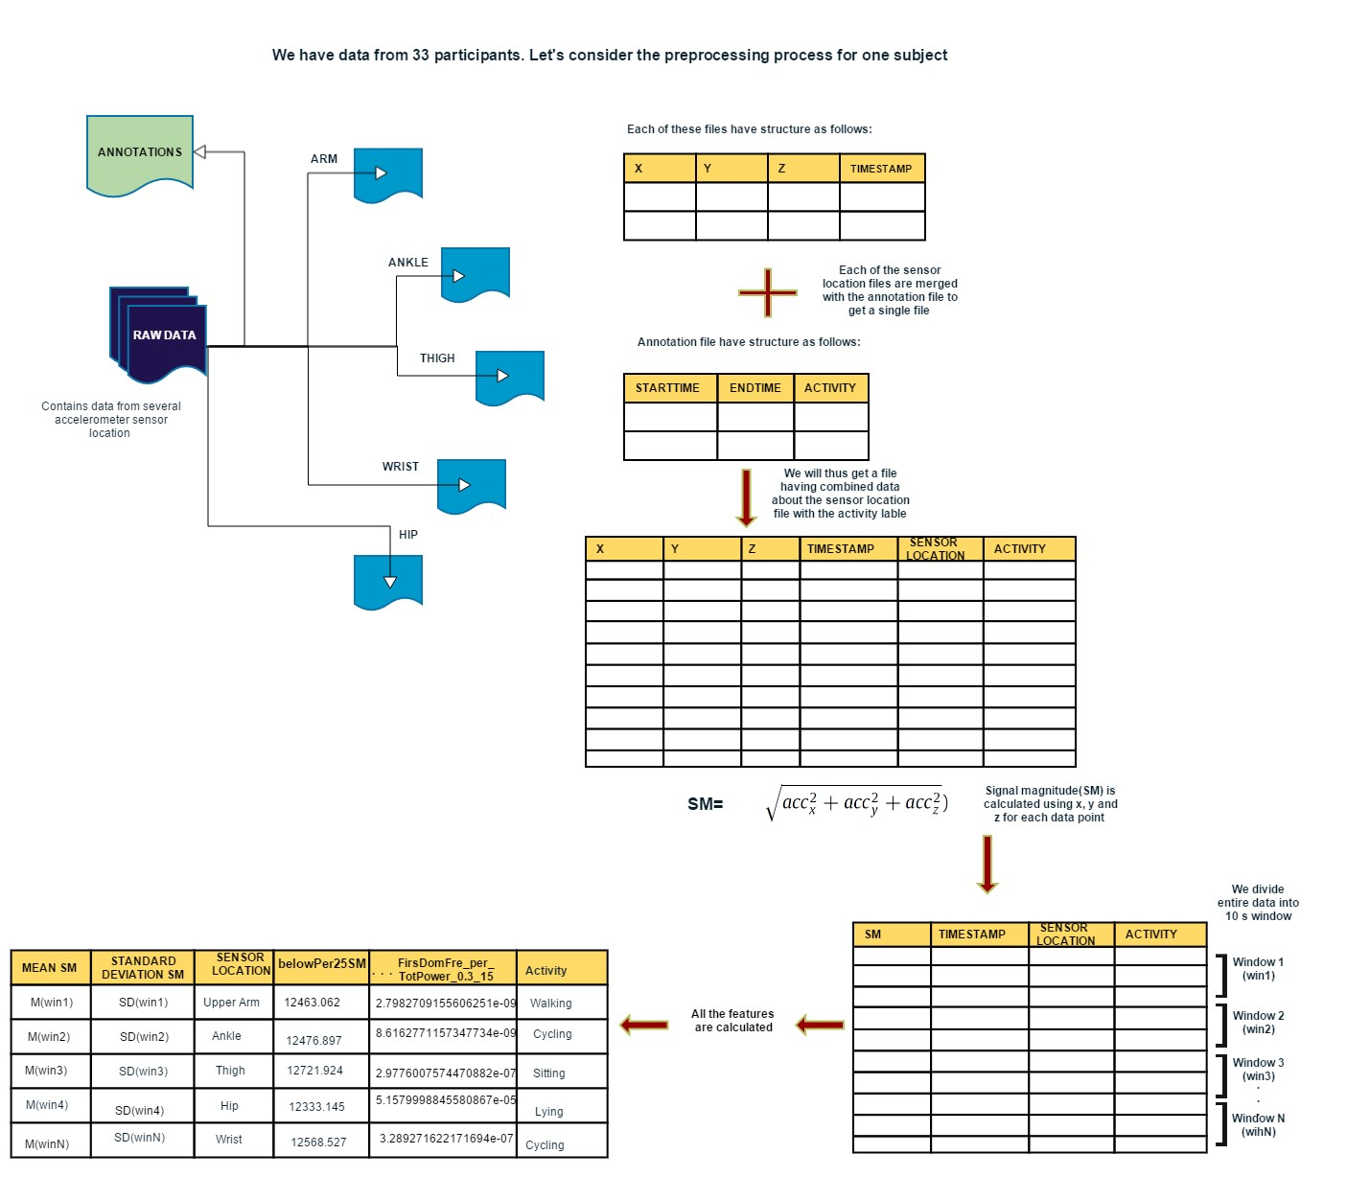

Figure 6. Raw data and initial pre-processing schema

* Figure 7. below shows the pre-processing resulting in final time-frequency domain features.

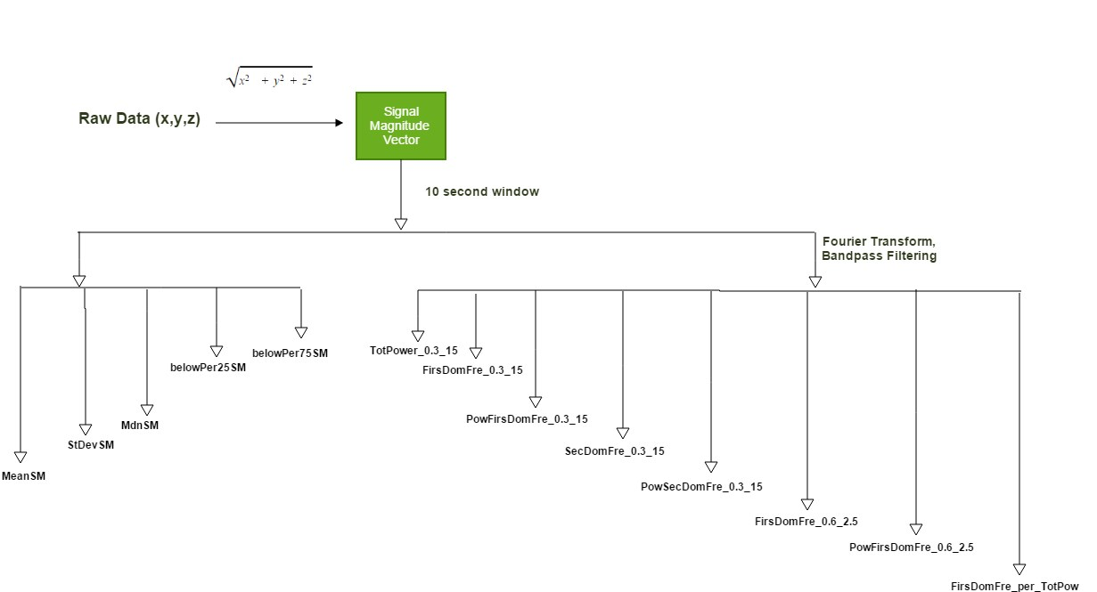

Figure 7. Pre-processing for extracting feature vector from raw data.

**Evaluation:**

For evaluating our model, we use two validation technique. The first approach is 10-fold cross validation technique. In this approach data (consisting of the windowed sections of data-label pairs) are randomized and divided into 10 different subsets (folds). The algorithm is trained on n-1 subsets and tested on the remaining one. The second approach was leave-one-subject-out cross validation (LOSO validation). Recognition models were trained on data from all subjects except one that is used for the test phase. In both case the procedure was repeated to test all data. The advantage of LOSO is that it simulates real-life situation when the model is trained in some number of subjects, but after deployed would be tested by individual user. At the end of the procedure, results are shown using confusion matrices. Cross validation is a well known established technique used for validating the model. The 10-fold cross validation technique may sometime overfit the data. The LOSO validation approach is more likely to avoid this problem and generalize to new data, it is therefore preferable method. Results will also be evaluated in terms of overall accuracy and F1-score for each class.

*F1-score = 2 *(Precision*Recall/Precision+Recall) | where Precision = TP/TP+FP and Recall = TP/TP+FN*.

True Positives (TP) are data correctly classified within the selected class. False Positives (FP) are those data that are incorrectly classified as belonging to the selected class. False Negatives (FN) are data belonging to the selected class that are incorrectly classified in another one. True Negative (TN) are data belonging to some class and predicted to some another class. The F1-score merges precision and recall into single number, it ranges from 0 to 1, where 1 is perfect classification.

Table 2. summarizes the final results of the project that shows data from dominant hip and dominant ankle give best overall performance when used in RF classifier. The kNN underperforms and has slightly lower overall accuracy, while poorly classifying lying (just above chance). We repeated LOSO by combining data from two sites (10 possible combinations from 5 sites), and not surprisingly, the combination of the top two sites (hip and ankle) that had given best overall performance individually, improved the overall accuracy by 3 %. The noteworthy thing about this was that the classification accuracy of lying(that has the lowest accuracy 80% for single site data classification) increased to 90%.

|  |  |  |  |  |  |  |
| --- | --- | --- | --- | --- | --- | --- |
| Classifier | CV | Sensor Position | Walking | Cycling | Sitting | Lying |
| Random  Forest | LOSO | Dominant-  Wrist | A-0.89  P-0.93  R-0.88  F1-0.9 | A-0.8  P-0.93  R-0.8  F1-0.84 | A-0.92  P-0.83  R-0.91  F1-0.87 | A-0.51  P-0.58  R-0.46  F1-0.48 |
| Dominant-Hip | A-0.94  P-0.96  R-0.94  F1-0.94 | A-0.88  P-0.9  R-0.89  F1-0.89 | A-0.95  P-0.93  R-0.95  F1-0.93 | A-0.8  P-0.73  R-0.78  F1-0.74 |
| DominantThigh | A-0.96  P-0.98  R-0.95  F1-0.96 | A-0.96  P-0.98  R-0.97  F1-0.97 | A-0.93  P-0.86  R-0.93  F1-0.89 | A-0.24  P-0.34  R-0.22  F1-0.25 |
| DominantAnkle | A-0.93  P-0.95  R-0.93  F1-0.93 | A-0.89  P-0.89  R-0.87  F1-0.88 | A-0.97  P-0.94  R-0.97  F1-0.95 | A-0.76  P-0.79  R-0.73  F1-0.72 |
| Dominant-  Upper-Arm | A-0.93  P-0.94  R-0.9  F1-0.92 | A-0.91  P-0.95  R-0.89  F1-0.9 | A-0.94  P-0.91  R-0.94  F1-0.92 | A-0.65  P-0.58  R-0.54  F1-0.55 |
| kNN | Dominant-  Wrist | A-0.86  P-0.82  R-0.86  F1-0.83 | A-0.57  P-0.8  R-0.57  F1-0.63 | A-0.85  P-0.76  R-0.85  F1-0.8 | A-0.41  P-0.55  R-0.37  F1-0.42 |
| Dominant-Hip | A-0.94  P-0.97  R-0.94  F1-0.95 | A-0.89  P-0.83  R-0.89  F1-0.85 | A-0.96  P-0.87  R-0.96  F1-0.91 | A-0.4  P-0.74  R-0.39  F1-0.46 |
| DominantThigh | A-0.95  P-0.94  R-0.95 | A-0.91  P-0.95  R-0.91 | A-0.95  P-0.83  R-0.95 | A-0.12  P-0.34  R-0.12 |
|  |  |  | F1-0.94 | F1-0.92 | F1-0.89 | F1-0.16 |
| DominantAnkle | A-0.93  P-0.97  R-0.93 | A-0.91  P-0.89  R-0.91 | A-0.98  P-0.88  R-0.98 | A-0.51  P-0.79  R-0.5 |
|  |  |  | F1-0.95 | F1-0.9 | F1-0.93 | F1-0.56 |
| Dominant-  Upper-Arm | A-0.91  P-0.89  R-0.89 | A-0.78  P-0.82  R-0.75 | A-0.94  P-0.86  R-0.94 | A-0.39  P-0.54  R-0.32 |
|  |  |  | F1-0.88 | F1-0.77 | F1-0.9 | F1-0.38 |

Table 2. LOSO cross validation for kNN and Random Forest

|  |  |  |  |  |  |  |
| --- | --- | --- | --- | --- | --- | --- |
| Classifier | CV | Sensor Position | Walking | Cycling | Sitting | Lying |
| Random  Forest | 10-  Fold | Dominant-  Wrist | A-0.88  P-0.91  R-0.88  F1-0.9 | A-0.78  P-0.91  R-0.78  F1-0.83 | A-0.91  P-0.82  R-0.91  F1-0.86 | A-0.48  P-0.64  R-0.46  F1-0.52 |
| DominantHip | A-0.95  P-0.94  R-0.94  F1-0.94 | A-0.91  P-0.95  R-0.92  F1-0.93 | A-0.95  P-0.93  R-0.95  F1-0.94 | A-0.8  P-0.85  R-0.81  F1-0.79 |
| DominantThigh | A-0.96  P-0.96  R-0.96  F1-0.96 | A-0.98  P-0.98  R-0.98  F1-0.98 | A-0.91  P-0.86  R-0.91  F1-0.87 | A-0.26  P-0.49  R-0.25  F1-0.28 |
| DominantAnkle | A-0.95  P-0.94  R-0.95  F1-0.94 | A-0.86  P-0.98  R-0.87  F1-0.91 | A-0.98  P-0.93  R-0.98  F1-0.95 | A-0.75  P-0.91  R-0.76  F1-0.79 |
| Dominant-  Upper-Arm | A-0.94  P-0.98  R-0.94  F1-0.96 | A-0.95  P-0.98  R-0.95  F1-0.96 | A-0.95  P-0.9  R-0.94  F1-0.92 | A-0.61  P-0.81  R-0.6  F1-0.63 |
| kNN | Dominant-  Wrist | A-0.83  P-0.83  R-0.83  F1-0.83 | A-0.6  P-0.78  R-0.6  F1-0.68 | A-0.84  P-0.75  R-0.84  F1-0.79 | A-0.37  P-0.49  R-0.37  F1-0.41 |
| DominantHip | A-0.94  P-0.95  R-0.94  F1-0.94 | A-0.9  P-0.85  R-0.9  F1-0.87 | A-0.96  P-0.88  R-0.96  F1-0.91 | A-0.46  P-0.84  R-0.46  F1-0.55 |
| DominantThigh | A-0.96  P-0.95  R-0.96 | A-0.92  P-0.98  R-0.92 | A-0.93  P-0.84  R-0.93 | A-0.16  P-0.31  R-0.16 |
|  |  |  | F1-0.95 | F1-0.95 | F1-0.88 | F1-0.2 |
| DominantAnkle | A-0.94  P-0.95  R-0.94 | A-0.91  P-0.93  R-0.91 | A-0.97  P-0.89  R-0.97 | A-0.54  P-0.81  R-0.54 |
|  |  |  | F1-0.94 | F1-0.92 | F1-0.93 | F1-0.63 |
| Dominant-  Upper-Arm | A-0.91  P-0.91  R-0.91 | A-0.8  P-0.88 R-0.8 | A-0.93  P-0.86  R-0.93 | A-0.4  P-0.58 R-0.4 |
|  |  |  | F1-0.91 | F1-0.82 | F1-0.89 | F1-0.46 |

Table 3. 10-Fold cross validation for kNN and Random Forest

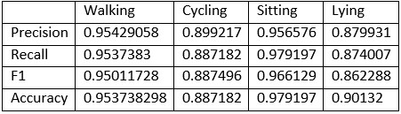

Table 4: Outcome result for combination of Hip and Ankle data

**Conclusion:**

We have identified the most suitable features required for classification of above mentioned activities:- Mean, St. deviation, Median, along with Frequency domain features extracted from signal magnitude vector. Past experiments have proved that triaxial accelerometer data can be used to classify these type of human activities. We performed LOSO and 10-fold cross validation techniques to validate our model using Random Forest and kNN, and for both, RF works better than k-NN. We also found that sensor located at dominant hip position was most discriminative in classification, followed by sensor at dominant-ankle. Another task that was performed was to combine data from two sensors located at two different position and perform the LOSO and 10-fold CV. This resulted in improved classification accuracy for some of the activities that were not classified as robustly using single site data. Future work could include including more finer human activities in the classification, and implement the algorithm in real-time system like smart phone. Window size could also be decreased from 10 sec to reduce the latency of such real-time system. The automatic detection of sensor placement sites could reduce the risk of people using wearable sensors inappropriately and inefficiently.

Task Distribution Form:

|  |  |
| --- | --- |
| Task | People |
| 1. Collecting and preprocessing data | Lijo, Binod |
| 2. Implementing Algorithm 1 | Sanjiv, Lijo |
| 3. Implementing Algorithm 2 | Binod, Meera |
| 4. Evaluating and Comparing Algorithm | Binod, Sanjiv |
| 5. Writing Report | Meera, Binod, Lijo, Sanjiv |

**References:**

1. Lockhart, J.W.; Pulickal, T.; Weiss, G.M. Applications of mobile activity recognition. Proceedings of the 14th ACM International Conference on Ubiquitous Computing, Pittsburgh, PA, USA, 5–8 September 2012; pp. 1054–1058
2. DeVaul, R.W., Dunn, S. *Real-Time Motion Classification for Wearable Computing Applications*. Technical report, MIT Media Laboratory (2001)
3. Foerster F. and Fahrenberg J. *Motion pattern and posture: correctly assessed by calibrated accelerometers*. In Behavior Research Methods, Instruments, & Computers, 32(3), 450-7. (2000)
4. Chen, L., Hoey, J., Nugent, C. D., Cook, D. J., and Yu, Z. *Sensor-based activity recognition*. IEEE Transaction on Systems, Man, and Cybernetics, Part C: Applications and Reviews PP, 99 (2012), 1 -19.
5. S.S. Intille, F. Albinali, S. Mota, B. Kuris, P. Botana, W.L. Haskell. *Design of a wearable physical activity monitoring system using mobile phones and accelerometers*, in: Proc. of the IEEE Engineering in Medicine and Biology Society Meeting, EMBS, Boston, Massachusetts USA, 2011.
6. Mannini A, Intille S S, Rosenberger M, Sabatini A M and Haskell W. *Activity recognition using a single accelerometer placed at the wrist or ankle* *Med. Sci. Sports Exerc.* 2013 45 2193–203
7. Tulen, J. H. M., Bussmann, J. B. J., van Steenis, H. G., Pepplinkhuizen, L., & Man in’t Veld, A. J. (1997). A novel tool to quantify physical activities: Ambulatory accelerometry in psychopharmacology. *Journal of Clinical Psychopharmacology*,17, 202–207.
8. Bao, L., Intille, S. *Activity Recognition from User-Annotated Acceleration Data*. In 2nd International Conference, PERVASIVE '04, Vienna, Austria, April 21-23, 2004.
9. Keller,J.M, Gray,M.R, Givens,J.A k-NearestNeighbor. [IEEE Transactions on Systems Man and Cybernetics](https://www.researchgate.net/journal/0018-9472_IEEE_Transactions_on_Systems_Man_and_Cybernetics) 07/1985; SMC-15(4). DOI: 10.1109/TSMC.1985.6313426
10. Ho, T.K. [*Random Decision Forests*.](http://ect.bell-labs.com/who/tkh/publications/papers/odt.pdf) Proceedings of the 3rd International Conference on Document Analysis and Recognition, Montreal, QC, 14–16 August 1995. pp. 278–282.
11. Baum, L. E., Petrie, T. [*Statistical Inference for Probabilistic Functions of Finite State Markov Chains*.](http://projecteuclid.org/DPubS/Repository/1.0/Disseminate?handle=euclid.aoms/1177699147&view=body&content-type=pdf_1) The Annals of Mathematical Statistics 37 (6): 1996. 1554–1563.
12. L. Breiman, J. Friedman, R. Olshen, and C. Stone. *Classification and Regression Trees*. Wadsworth International Group, 1984
13. L. Buitinck, G. Louppe, M. Blondel, F. Pedregosa, A. Müller, O. Grisel, V. Niculae, P. Prettenhofer, A. Gramfort, J. Grobler, R. Layton, J. Vanderplas, A. Joly, B. Holt, and G. Varoquaux. *API design for machine learning software: experiences from the scikit-learn project*. In ECML PKDD Workshop on Languages for Machine Learning, 2013.
14. Novel one-vs-rest classifier based on SVM and multi-spheres;[Xu, L.](https://getinfo.de/en/search/?tx_tibsearch_search%5Bquery%5D=person%3A%28Xu%2C%20L.%29) / [Zhao, G.-z.](https://getinfo.de/en/search/?tx_tibsearch_search%5Bquery%5D=person%3A%28Zhao%2C%20G.-z.%29) / [Gu, H.](https://getinfo.de/en/search/?tx_tibsearch_search%5Bquery%5D=person%3A%28Gu%2C%20H.%29) in [JOURNAL- ZHEJIANG UNIVERSITY ENGINEERING SCIENCE;](https://getinfo.de/en/search/?tx_tibsearch_search%5Bquery%5D=journal%3A%28JOURNAL-%20ZHEJIANG%20UNIVERSITY%20ENGINEERING%20SCIENCE%29) 43, 2; 303-308; JOURNAL- ZHEJIANG UNIVERSITY ENGINEERING

SCIENCE by [ZHEJIANG UNIVERSITY PRESS;](https://getinfo.de/en/search/?tx_tibsearch_search%5Bquery%5D=publisher%3A%28ZHEJIANG%20UNIVERSITY%20PRESS%29) 2009