

Max Point: 40

Time Allowed: 90 Min

Obtained Marks:

Department of Computer Science | School of Arts & Sciences

**Course: Theory of Automata**

**Final Term Exam, Spring 2020**

**Note:**

* **Submit Answers Papers Through Email**
* **In case of late submission I will deduct marks**

|  |  |
| --- | --- |
| **Student Name: Beknazar Jumabaev** | **ID: 520352** |

**Question 1.**

**a. Convert the Following Regular Expression to Context Free Grammars**

**(i). (a+b)*b*b*ab\***

**S-> ABBaB**

**A-> aA/bA/** λ

**B-> bB/** λ

**(ii). (a+b)*(a+b)*a**

**S-> AAa**

**A->aA/bA/** λ

**(iii) a*bb(a+b)*ba\***

**S-> AbbCba**

**A-> aA/** λ

**C-> aC/bC/** λ

**b. Convert the Following Expressions to Context Free Grammars**

**(i). an+2b3n** { n ≥1}

**(aaabbb, aaaabbbbbb,…)**

**S-> AaaabbbB**

**A->aA/** λ

**B-> bbbB/** λ

**(ii). an  b2n-2 {** n ≥1}

**(a,aa,bb,aaa,bbbb,…)**

**S-> aXY**

**X-> aX/** λ

**Y->bbY/** λ

**(iii). an+2bn+3 {** n ≥1**}**

**(aaabbbb,aaaabbbbb,…)**

**S-> aaaAbbbbB**

**A-> aA/** λ

**B-> bB/** λ

**Question 2. Convert the Following Context Free Grammars to Chomsky’s Normal Forms**

1. **Given CFG**

**S🡪aXYb**

**X🡪 aXb**

**X🡪 bb**

**Y🡪 a**

1. **Given CFG**

**S🡪 XbXbY**

**X🡪aXa/bXb/^**

**Y🡪 aY/^**

**1st we need to remove null**

**S-> XbXbY/bbY/XbXb/bb/XbbY/bXbY/xbb/bxb**

**X-> aXa/bXb/aa/bb**

**Y->bYa/ba**

**2nd wee need to remove useless productions:**

**A-> a B->b**

**S->XBXBY/BBY/XBXB/BB/XBBY/BXBY?XBB/BXB**

**X-> AXA/BXB/AA/BB**

**Y-> BYA/BA**

**B->b; A-a**

**Question 3.**

**Construct Push Down Automates for the Following Expressions.**

**(i). an+2b3n** { n ≥1}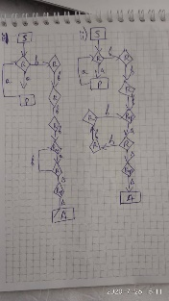

**(aaabbb,aaaabbbbbb…)**

**(ii). an  b2n+2 {** n ≥1}

**(abbb,aabbbbbb,…)**

**(iii). anbn+3 {** n ≥1**}**

**(abbbb,aabbbbb,…)**

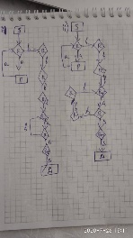

**BONUS**

**Construct a Turing Machine for the Following Regular Expressions**

**anb2n+1**