⌊.⌋ : R −→ Z — floor of x, the greatest integer ≤ x

⌈.⌉ : R −→ Z — ceiling of x, the least integer ≥ x /Users/hilda/Library/Containers/com.tencent.xinWeChat/Data/Library/Application Support/com.tencent.xinWeChat/2.0b4.0.9/ad67de56aff4431a51fb148e37233796/Message/MessageTemp/798e358b1f67550b44f5e190afee16ab/Image/23441523282404_.pic.jpg

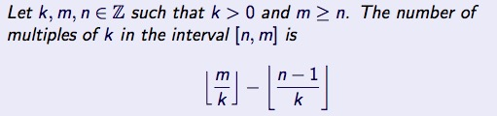gcd（0，n）＝｜n｜/Users/hilda/Library/Containers/com.tencent.xinWeChat/Data/Library/Application Support/com.tencent.xinWeChat/2.0b4.0.9/ad67de56aff4431a51fb148e37233796/Message/MessageTemp/798e358b1f67550b44f5e190afee16ab/Image/23451523282497_.pic.jpg

Power set Pow(X ) = { A : A ⊆ X } |Pow(X )| = 2|X |

|∅| = 0 Pow(∅) = {∅} |Pow(∅)| = 1 Pow(Pow(∅)) = {∅, {∅}} |Pow(Pow(∅))| = 2

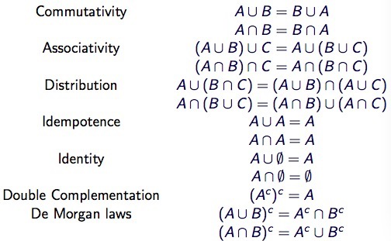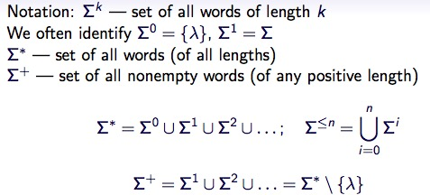|{a}|=1 Pow({a})={∅,{a}} |Pow({a})|=2 A ⊕ B = (A \ B) ∪ (B \ A)

../../Library/Containers/com.tencent.xinWeChat/Data/Library/Application%20Support/com.tencent.xinWeChat/2.0b4.0.9/ad67de56aff4431a51fb148e37233796/Message/MessageTemp/798e358b1f67550b44f5e190afee16ab/Image/24761523495305_.pic.jpgevery function maps its domain into its codomain, but only onto its image.

Σk — set of all words of length k

A unless B ➡ ¬B ⇒ A

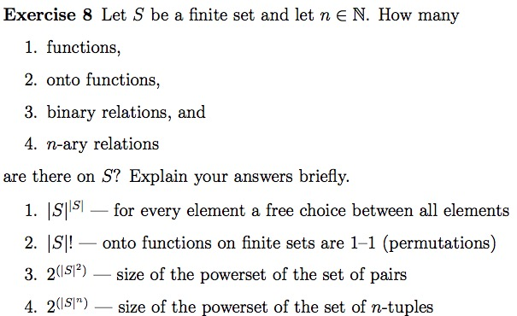S × T = { (s, t) : s ∈ S, t ∈ T } where (s, t) is an ordered pair

S — domain of f , symbol: Dom(f )

T — codomain of f , symbol: Codom(f )

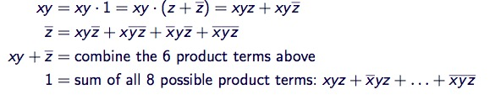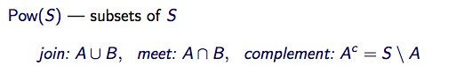{f(x):x∈Dom(f)}—image of f : Im(f ) ⊆ Codom(f )

1–1 (one-to-one) or injective : f(x)=f(y)⇒x =y

onto (or surjective): if every element of the codomain is mapped to by at least on x in the domain, i.e. Im(f) = T

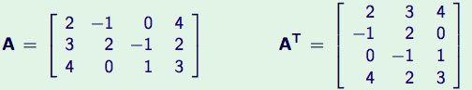A matrix M is called symmetric if MT = M

../../Library/Containers/com.tencent.xinWeChat/Data/Library/Application%20Support/com.tencent.xinWeChat/2.0b4.0.9/ad67de56aff4431a51fb148e37233796/Message/MessageTemp/798e358b1f67550b44f5e190afee16ab/Image/26901523524360_.pic.jpg../../Library/Containers/com.tencent.xinWeChat/Data/Library/Application%20Support/com.tencent.xinWeChat/2.0b4.0.9/ad67de56aff4431a51fb148e37233796/Message/MessageTemp/798e358b1f67550b44f5e190afee16ab/Image/26891523524344_.pic.jpg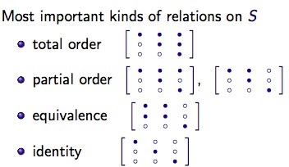Row : hang Column : lie rotating :xuanzhuan

