Iff==iff if and only if

A proposition is a statement (communication) that is either true or false

A=》B equal to not B=>not A

|  |  |
| --- | --- |
| If A then not B | If B then not A |
| Not A or not B | Not(A and B) |

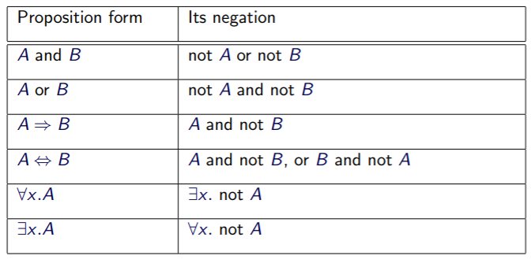

Root:根，满足方程解为0的所有x的取值

Contrapositive:假设不成立反推

dealing with ∀：寻找arbitrary值，使其覆盖所有可能

1.2 a) (-1)^-0.5 don’t exists

b) 1=-1 0.5=-0.5 add1.5 in both sides

c)

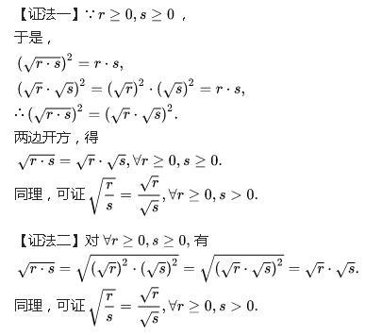

1.5 Solution. The basic problem is that “surprise” is not a mathematical concept, nor is there any generally accepted way to give it a mathematical definition. The “proof” above assumes some plausible axioms about surprise, without defining it. The paradox is that these axioms are inconsistent. But that’s no surprise :­), since—mathematically speaking—we don’t know what we’re talking about. Mathematicians and philosophers have had a lot more to say about what might be wrong with the students’ reasoning, (see Chow, Timothy Y. The surprise examination or unexpected hanging paradox, American Math. Monthly (January 1998), pp.41–51.)

1.6 Suppose log7n=pqlog7⁡n=pq is rational, then 7p/q=n7p/q=n, raising both sides to the qthqth power, we see that 7p=nq7p=nq. Now we have by unique prime factorization that n=7kn=7k for some integer kk, since it divides 7p7p. But then 7p=7kq7p=7kq, or p=kqp=kq, but then pq=kpq=k is an integer as desired.

1.7

1)assume it is irrational 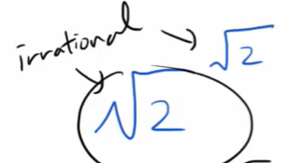 number then power anther 2^0.5

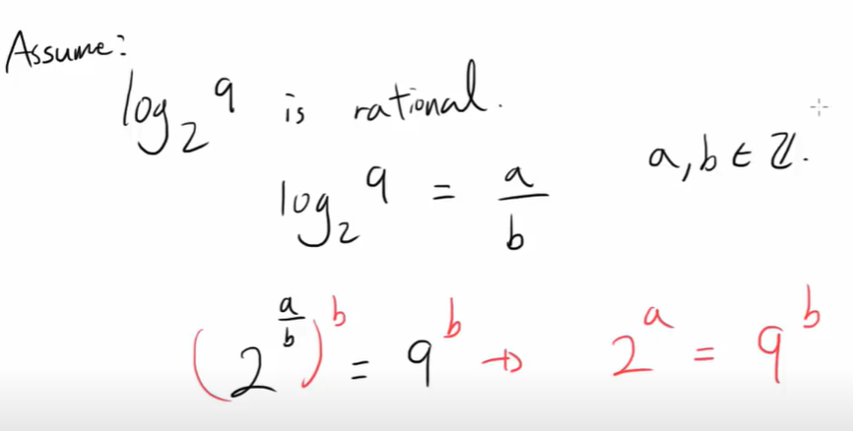

1.8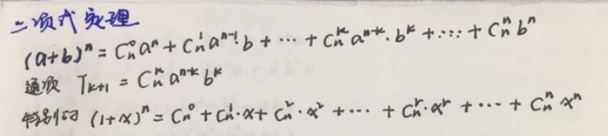

Z：整数0，1，2，3，N自然数-1，-2，-3，0…. Q 分数

0.999999…=1

0.111111…=1 in binary





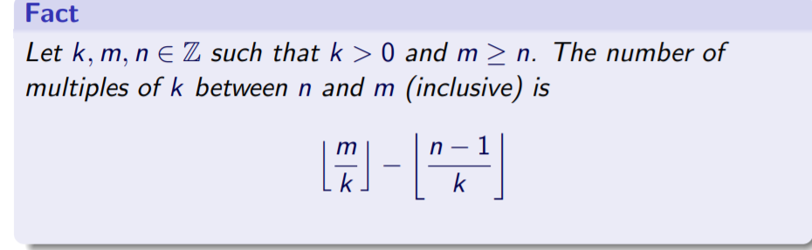

The floor of m/k 等于 k的倍数 （在[0,m]之间） 的数量

The floor of (m-1)/k 等于 k 的倍数[0，m )之间 的数量

Lcm(m,n)gcd(m,n)=mn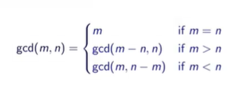

M div n= The floor of m/n

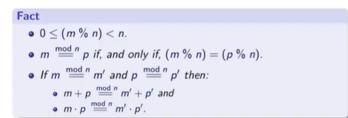



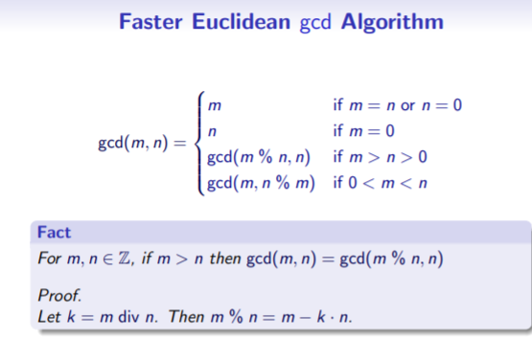

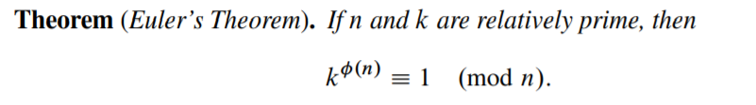

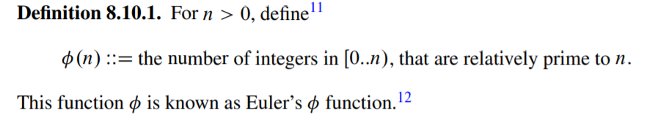

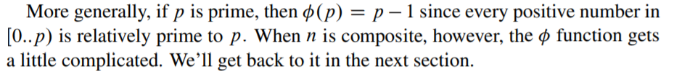

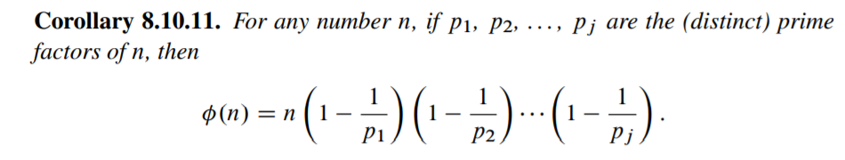

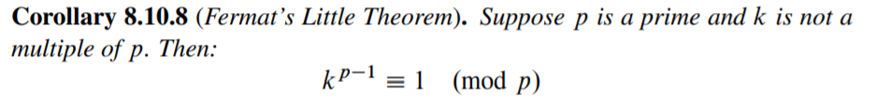

8.24