# Driverless AI Experiment: gipokoho

Generated by: admin

Generated on: Tue Oct 20 19:24:03 2020

Driverless AI Experiment: gipokoho 1

Experiment Overview 3

Data Overview 3

Methodology 3

Data Sampling 3

Validation Strategy 3

Model Tuning 3

Feature Evolution 3

Feature Transformations 3

Final Model 3

Alternative Models 3

Deployment 3

Partial Dependence Plots 3

Appendix 4

## Experiment Overview

Driverless AI built 1 LightGBMModel to predict *Target(Brent)* given 10 original features from the input dataset *brent_train_daily_scaled.csv*. This regression experiment completed in 3 minutes and 53 seconds (0:03:53), using 9 of the 10 original features, and 96 of the 0 engineered features.

### Performance

|  |  |
| --- | --- |
| **Dataset** | **RMSE** |
| Internal Validation | 3.277 |
| Test Data | 4.283 |

### Driverless Settings

|  |  |  |  |
| --- | --- | --- | --- |
| **Dial Settings** | **Description** | **Setting Value** | **Range of Possible Values** |
| **Accuracy** | Controls accuracy needs of the model | 9 | 1-10 |
| **Time** | Controls duration of the experiment | 9 | 1-10 |
| **Interpretability** | Controls complexity of the model | 1 | 1-10 |

### System Specifications

|  |  |  |  |  |
| --- | --- | --- | --- | --- |
| **Address** | **System** | **System Memory** | **CPUs** | **GPUs** |
| http://127.0.0.1:12345 | Docker/Linux | 60 GB | 4 | 1 |

### Versions

|  |  |
| --- | --- |
| **Driverless AI version** | 1.9.0 |
| **h2o4gpu version** | 0.4.1 |
| **h2o_mli version** | 1.9.117 |
| **mojo2_runtime version** | 2.4.8 |
| **procsy version** | 0.6.0 |
| **pydatatable version** | 0.11.0a1735 |
| **vis_data_server version** | 2.0.5 |

## Data Overview

This section provides information on the datasets used for the experiment.

|  |  |  |  |  |
| --- | --- | --- | --- | --- |
| **data** | **file path** | **file size** | **number of rows** | **number of columns** |
| training | ./tmp/admin/d407ac10-1308-11eb-bb85-0242ac110002/brent_train_daily_scaled.csv.1603221420.5206876.bin | 23.4 KiB | 243 | 11 |
| validation | Not provided | None | None | None |
| testing | ./tmp/admin/cdb4d356-1308-11eb-bb85-0242ac110002/brent_test_daily_scaled.csv.1603221409.9215763.bin | 3.9 KiB | 30 | 11 |

### Training Data

The training data consists of only numeric columns.

The summary of the columns is shown below :

#### Numeric Columns

|  |  |  |  |  |  |  |  |
| --- | --- | --- | --- | --- | --- | --- | --- |
| **name** | **data_type** | **min** | **mean** | **max** | **std** | **unique** | **freq of mode** |
| Date | time [%Y-%m-%d] | 2018-10-01 |  | 2019-05-31 |  | 243 | 1 |
| Germany Price [€/MWh] | real | 0.000 | 0.586 | 1.000 | 0.149 | 243 | 1 |
| Czech Republic Price [€/MWh] | real | 0.000 | 0.552 | 1.000 | 0.163 | 243 | 1 |
| Germany - Czech Power Flow [MWh] | real | 0.000 | 0.506 | 1.000 | 0.174 | 229 | 15 |
| Germany Wind Generation [MWh] | real | 0.000 | 0.355 | 1.000 | 0.244 | 243 | 1 |
| Germany Solar Generation [MWh] | real | 0.000 | 0.335 | 1.000 | 0.278 | 243 | 1 |
| Germany Lignite Generation [MWh] | real | 0.000 | 0.668 | 1.000 | 0.260 | 243 | 1 |
| Czech Wind Generation [MWh] | real | 0.000 | 0.374 | 1.000 | 0.251 | 243 | 1 |
| Czech Solar Generation [MWh] | real | 0.000 | 0.353 | 1.000 | 0.282 | 243 | 1 |
| Czech Lignite Generation [MWh] | real | 0.000 | 0.612 | 1.000 | 0.199 | 243 | 1 |
| Target(Brent) | real | 50.570 | 66.742 | 86.070 | 7.935 | 186 | 5 |

### Shifts Detected

Driverless AI can perform shift detection between the training, validation, and testing datasets. It does this by training a binomial model to predict which dataset a record belongs to. For example, it may find that it is able to separate the training and testing data with an AUC of 0.8 using only the column: C1 as the predictor. This indicates that there is some sort of drift in the distribution of C1 between the training and testing data.

For this experiment, Driverless AI checked the train and test data for any shift in distribution and found the following significant differences:

Significant difference detected between training and test data distribution for feature <<<Czech Lignite Generation _MWh_>>> (AUC: 0.836).

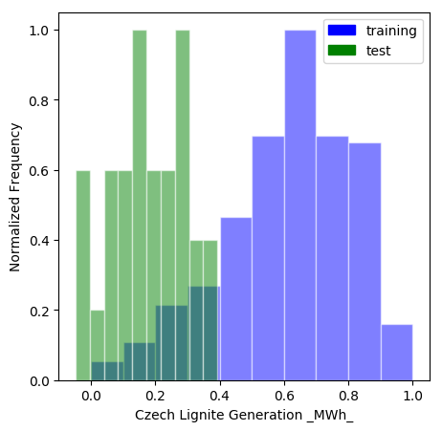

Significant difference detected between training and test data distribution for feature <<<Czech Republic Price _€/MWh_>>> (AUC: 0.761).

None

Significant difference detected between training and test data distribution for feature <<<Czech Solar Generation _MWh_>>> (AUC: 0.925).

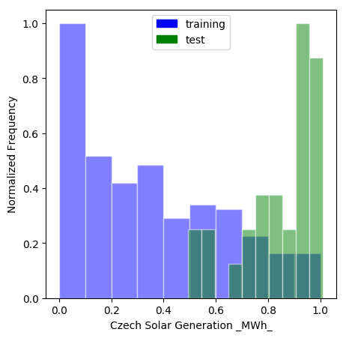

Significant difference detected between training and test data distribution for feature <<<Czech Wind Generation _MWh_>>> (AUC: 0.695).

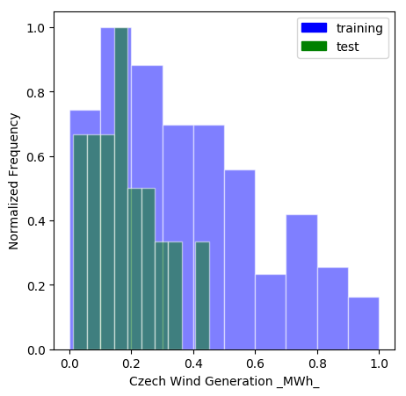

Significant difference detected between training and test data distribution for feature <<<Germany Lignite Generation _MWh_>>> (AUC: 0.828).

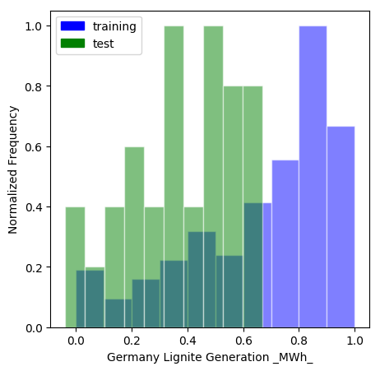

Significant difference detected between training and test data distribution for feature <<<Germany Price _€/MWh_>>> (AUC: 0.79).

None

Significant difference detected between training and test data distribution for feature <<<Germany Solar Generation _MWh_>>> (AUC: 0.915).

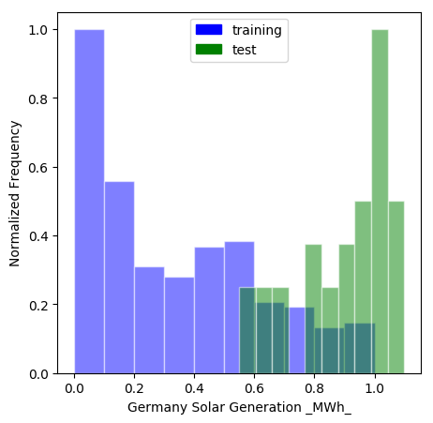

Significant difference detected between training and test data distribution for feature <<<Germany Wind Generation _MWh_>>> (AUC: 0.723).

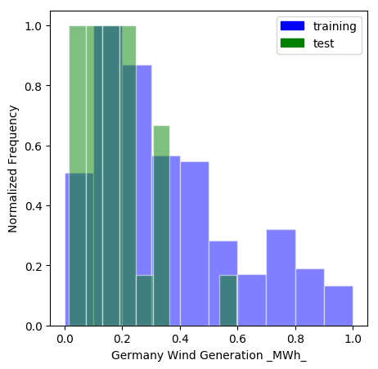

## Methodology

This section describes the experiment methodology.

### Assumptions and Limitations

Driverless AI trains all models based on the training data provided (in this case: *brent_train_daily_scaled.csv*). It is the assumption of Driverless AI that this dataset is representative of the data that will be seen when scoring.

Driverless AI may perform shift detection between the train and test data. If a shift in distribution is detected, this may indicate that the data that will be used for scoring may have distributions not represented in the training data.

For this experiment, Driverless AI performed shift detection and found significant differences described below:

|  |  |  |
| --- | --- | --- |
| **shift_col** | **shift_data_first** | **shift_data_second** |
| Czech Lignite Generation [MWh] | training | test |
| Czech Republic Price [€/MWh] | training | test |
| Czech Solar Generation [MWh] | training | test |
| Czech Wind Generation [MWh] | training | test |
| Germany Lignite Generation [MWh] | training | test |
| Germany Price [€/MWh] | training | test |
| Germany Solar Generation [MWh] | training | test |
| Germany Wind Generation [MWh] | training | test |

### Experiment Pipeline

For this experiment, Driverless AI performed the following steps to find the optimal final model:



The steps in this pipeline are described in more detail below:

* **Ingest Data**
* detected column types
* **Feature Preprocessing**
* turned raw features into numeric
* **Model and Feature Tuning**

This stage combines random hyperparameter tuning with feature selection and generation. Features in each iteration are updated using variable importance from the previous iteration as a probabilistic prior to decide what new features to create. The best performing model and features are then passed to the feature evolution stage. This experiment did not perform the Model and Feature Tuning stage due to the experiment's configurations.

* **Feature Evolution**

This stage uses a genetic algorithm to find the best set of model parameters and feature transformations to be used in the final model. This experiment did not perform the Feature Evolution stage due to the experiment's configurations.

* **Final Model**
* created the best model from the feature engineering iterations
* no stacked ensemble is done because a time column was provided
* **Create Scoring Pipeline**
* created and exported the Python scoring pipeline (no MOJO Scoring Pipeline automatically created)
* Python Scoring Pipeline: None

Driverless AI trained models throughout the experiment in an effort to determine the best parameters, model dataset, and optimal final model. The stages are described below:

|  |  |  |
| --- | --- | --- |
| **Driverless AI Stage** | **Timing (seconds)** | **Number of Models** |
| **Data Preparation** | 9.45 | 0 |
| **Model and Feature Tuning** | 0.48 | 0 |
| **Feature Evolution** | 7.29 | 0 |
| **Final Pipeline Training** | 189.40 | 1 |

### Experiment Settings

Below are the settings selected for the experiment by admin. The Defined Parameters represent the high-level parameters.

**Defined Parameters**

|  |  |
| --- | --- |
| **Parameter** | **Value** |
| is_classification | False |
| enable_gpus | True |
| seed | False |
| accuracy | 9 |
| time | 9 |
| interpretability | 1 |
| num_prediction_periods | 30 |
| num_gap_periods | 0 |
| is_timeseries | True |
| is_image | False |

These Accuracy, Time, and Interpretability settings map to the following internal configuration of the Driverless AI experiment:

|  |  |
| --- | --- |
| **Internal Parameter** | **Value** |
| data filtered | False |
| tune target transform | True |
| number of feature engineering iterations | 0 |
| number of models trained per iteration | 8 |
| early stopping rounds | 30 |
| monotonicity constraint | False |
| number of model tuning model combinations | 1 |
| number of base learners in ensemble | 0 |
| time column | Date |
| time group columns | ['Date'] |
| time period | day |
| number of prediction periods | 30 |
| number of gap periods | 0 |

#### Details

* **data filtered:** Driverless AI may filter the training data depending on the number of rows and the Accuracy setting.
* for this experiment, the training data was not filtered.
* **tune target transform:** whether Driverless AI evaluated the model performance if the target was transformed.
* ex: the model performance may be better by predicting the log of the target column instead of the raw target column
* **number of feature engineering iterations**: the number of iterations performed of feature engineering.
* **number of models evaluated per iteration:** for each feature engineering iteration, Driverless AI trains multiple models. Each model is trained with a different set of predictors or features. The goal of this step is to determine which types of features lead to the least RMSE.
* **early stopping rounds:** if Driverless AI does not see any improvement after 30 iterations of feature engineering, the feature engineering step is automatically stopped.
* **monotonicity constraint:** if enabled, the models will only have monotone relationships between the predictors and target variable.
* **number of model tuning combinations:** the number of model tuning combinations evaluated to determine the optimal model settings for the models.
* **number of base learners in ensemble:** the number of base models used to create the final ensemble.
* **time column:** the column that provides the time column. If a time column is provided, feature engineering and model validation will respect the causality of time. If the time column is turned off, no time order is used for modeling and data may be shuffled randomly (any potential temporal causality will be ignored).
* **time group columns:** the columns that make up the time series groups.
* **time period**: the periodicity found in the dataset.
* **number of prediction periods:** the number of periods you want to predict in advance.
* **number of gap periods:** the gap between the data available and the forecast period desired.

## Data Sampling

Driverless AI did not perform any down sampling of the data.

## Validation Strategy

Driverless AI did not perform any internal validation, because this experiment's pipeline did not include the model parameter tuning and feature engineering stages.

## Model Tuning

The table below shows a portion of the different parameter configurations evaluated by Driverless AI for the No Tuning models and their score and training time. The table is ordered based on a combination of least score and lowest training time.

|  |  |
| --- | --- |
| **booster** | **scores** |
| No Tuning | 0 |

## Feature Evolution

The goal of the Feature Evolution stage is to determine the best features to use for the final model. This experiment did not perform the Feature Evolution stage due to the experiment's configurations.

## Feature Transformations

The result of the Feature Evolution Stage is a set of features to use for the final model. Some of these features were automatically created by Driverless AI. The top features used in the final model are shown below, ordered by importance. The features in the table are limited to the top 50, restricted to those with relative importance greater than or equal to 0.003. If no transformer was applied, the feature is an original column.

|  |  |  |  |  |
| --- | --- | --- | --- | --- |
|  | **Feature** | **Description** | **Transformer** | **Relative Importance** |
| 1 | 22_EWMA(0.05)(1)TargetLags: Date.35: 42: 49: 56: 63: 70: 77: 84: 91: 98: 105: 112 | EWMA (α = 0.05) of differentiated target lags [35, 42, 49, 56, 63, 70, 77, 84, 91, 98, 105, 112] grouped by [] | Exponential Weighted Moving Average | 1.0 |
| 2 | 16_TargetLag: Date.31 | Lag of target for groups [] by 31 time periods | Lags | 0.1521 |
| 3 | 16_TargetLag: Date.30 | Lag of target for groups [] by 30 time periods | Lags | 0.1095 |
| 4 | 21_TargetLagsKurtosis: Date.30: 31: 32: 33: 34: 35: 36: 37: 38: 39: 40: 41: 42: 43: 44: 74: 75: 76: 77: 78: 79: 80: 81: 82: 83: 84: 85: 86: 87: 88 | Kurtosis of target lags [30, 31, 32, 33, 34, 35, 36, 37, 38, 39, 40, 41, 42, 43, 44, 74, 75, 76, 77, 78, 79, 80, 81, 82, 83, 84, 85, 86, 87, 88] grouped by [] | Lags | 0.0557 |
| 5 | 24_Lag: Date.Germany Wind Generation _MWh_.31 | Lag of feature Germany Wind Generation _MWh_ for groups [] by 31 time periods | Lags | 0.0448 |
| 6 | 18_EWMA(0.05)(1)TargetLags: Date.30: 31: 32: 33: 34: 35: 36: 37: 38: 39: 40: 41: 42: 43: 44: 74: 75: 76: 77: 78: 79: 80: 81: 82: 83: 84: 85: 86: 87: 88 | EWMA (α = 0.05) of differentiated target lags [30, 31, 32, 33, 34, 35, 36, 37, 38, 39, 40, 41, 42, 43, 44, 74, 75, 76, 77, 78, 79, 80, 81, 82, 83, 84, 85, 86, 87, 88] grouped by [] | Exponential Weighted Moving Average | 0.0427 |
| 7 | 16_TargetLag: Date.78 | Lag of target for groups [] by 78 time periods | Lags | 0.0383 |
| 8 | 21_TargetLagsMean: Date.30: 31: 32: 33: 34: 35: 36: 37: 38: 39: 40: 41: 42: 43: 44: 74: 75: 76: 77: 78: 79: 80: 81: 82: 83: 84: 85: 86: 87: 88 | Mean of target lags [30, 31, 32, 33, 34, 35, 36, 37, 38, 39, 40, 41, 42, 43, 44, 74, 75, 76, 77, 78, 79, 80, 81, 82, 83, 84, 85, 86, 87, 88] grouped by [] | Lags | 0.038 |
| 9 | 12_Date~get_dayofyear | Dayofyear extracted from 'Date' | Date Expansion | 0.0353 |
| 10 | 12_Date~get_month | Month extracted from 'Date' | Date Expansion | 0.0304 |
| 11 | 12_Date~get_week | Week extracted from 'Date' | Date Expansion | 0.0273 |
| 12 | 16_TargetLag: Date.77 | Lag of target for groups [] by 77 time periods | Lags | 0.0237 |
| 13 | 16_TargetLag: Date.32 | Lag of target for groups [] by 32 time periods | Lags | 0.022 |
| 14 | 16_TargetLag: Date.80 | Lag of target for groups [] by 80 time periods | Lags | 0.0207 |
| 15 | 20_EWMA(0.05)(1)TargetLags: Date.35: 42: 49: 56 | EWMA (α = 0.05) of differentiated target lags [35, 42, 49, 56] grouped by [] | Exponential Weighted Moving Average | 0.0171 |
| 16 | 24_Lag: Date.Germany Wind Generation _MWh_.32 | Lag of feature Germany Wind Generation _MWh_ for groups [] by 32 time periods | Lags | 0.0169 |
| 17 | 7_Germany Solar Generation _MWh_ | Germany Solar Generation _MWh_ (Original) | None | 0.011 |
| 18 | 17_EWMA(0.05)(0)TargetLags: Date.30: 31: 32 | EWMA (α = 0.05) of target lags [30, 31, 32] grouped by [] | Exponential Weighted Moving Average | 0.0098 |
| 19 | 16_TargetLag: Date.76 | Lag of target for groups [] by 76 time periods | Lags | 0.0094 |
| 20 | 12_Date~get_day | Day extracted from 'Date' | Date Expansion | 0.0068 |
| 21 | 21_TargetLagsMax: Date.30: 31: 32: 33: 34: 35: 36: 37: 38: 39: 40: 41: 42: 43: 44: 74: 75: 76: 77: 78: 79: 80: 81: 82: 83: 84: 85: 86: 87: 88 | Max of target lags [30, 31, 32, 33, 34, 35, 36, 37, 38, 39, 40, 41, 42, 43, 44, 74, 75, 76, 77, 78, 79, 80, 81, 82, 83, 84, 85, 86, 87, 88] grouped by [] | Lags | 0.0067 |
| 22 | 12_Date~get_quarter | Quarter extracted from 'Date' | Date Expansion | 0.0065 |
| 23 | 16_TargetLag: Date.79 | Lag of target for groups [] by 79 time periods | Lags | 0.0065 |
| 24 | 16_TargetLag: Date.84 | Lag of target for groups [] by 84 time periods | Lags | 0.0045 |
| 25 | 21_TargetLagsStd: Date.30: 31: 32: 33: 34: 35: 36: 37: 38: 39: 40: 41: 42: 43: 44: 74: 75: 76: 77: 78: 79: 80: 81: 82: 83: 84: 85: 86: 87: 88 | Std of target lags [30, 31, 32, 33, 34, 35, 36, 37, 38, 39, 40, 41, 42, 43, 44, 74, 75, 76, 77, 78, 79, 80, 81, 82, 83, 84, 85, 86, 87, 88] grouped by [] | Lags | 0.004 |
| 26 | 16_TargetLag: Date.34 | Lag of target for groups [] by 34 time periods | Lags | 0.0038 |
| 27 | 16_TargetLag: Date.43 | Lag of target for groups [] by 43 time periods | Lags | 0.0033 |

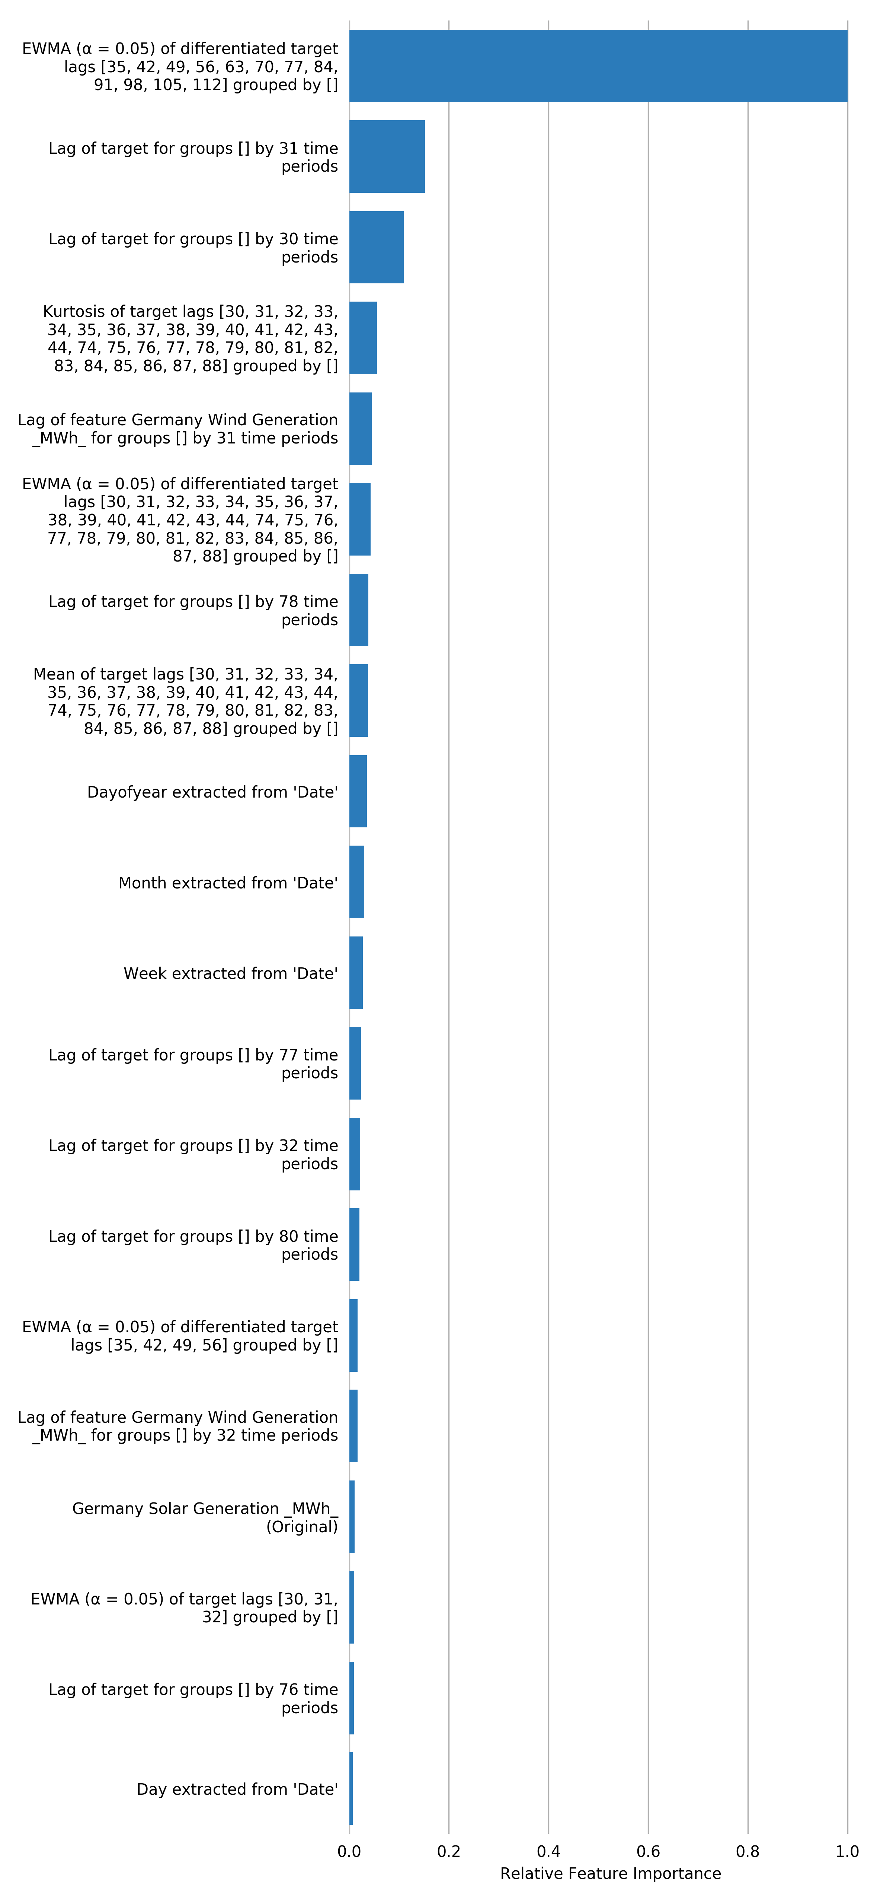

## Final Model

**Pipeline**

Final LightGBMModel pipeline with ensemble_level=0 transforming 10 original features -> 0 features in each of 1 models each fit on time-based hold-out.:

**Details**

* The fitted features of the final model are the best features found during the feature engineering iterations.
* The target transformer indicates the type of transformation applied to the target column.

|  |  |  |  |  |
| --- | --- | --- | --- | --- |
| **Model Index** | **Type** | **Model Weight** | **Fitted features** | **Target Transformer** |
| 0 | LightGBMModel | 1 | 105 | unit_box |

* Model Index: 0 has a weight of 1 in the final ensemble

|  |  |  |  |  |  |  |  |  |  |  |
| --- | --- | --- | --- | --- | --- | --- | --- | --- | --- | --- |
| **Type** | **learning rate** | **model class name** | **subsample** | **colsample bytree** | **Split Type** | **max leaves** | **tree method** | **max depth** | **index** | **grow policy** |
| LightGBMModel | 0.02 | LightGBMModel | 0.7 | 0.8 | None | 64 | gpu_hist | 6 | 0 | depthwise |

For a complete list of the parameters of the final model, see the Appendix.

**Performance of Final Model**

|  |  |  |  |  |  |  |
| --- | --- | --- | --- | --- | --- | --- |
| **Scorer** | **Optimized** | **Better score is** | **Final ensemble scores on validation (internal or external holdout(s)) data** | **Final ensemble standard deviation on validation (internal or external holdout(s)) data** | **Final test scores** | **Final test standard deviation** |
| GINI |  | higher | 0.7691187 | 0.02446561 | -0.2928866 | 0.2003626 |
| MAE |  | lower | 2.535967 | 0.1152333 | 4.049177 | 0.2113882 |
| MAPE |  | lower | 3.775323 | 0.1645524 | 6.314918 | 0.3481196 |
| MER |  | lower | 3.209126 | 0.1624102 | 6.502281 | 0.4930749 |
| MSE |  | lower | 10.74018 | 0.8751869 | 18.34519 | 1.593163 |
| R2 |  | higher | 0.6041991 | 0.03110864 | 0 | 0.01175886 |
| R2COD |  | higher | 0.5452423 | 0.04252724 | -4.826299 | 1.100681 |
| RMSE | * | lower | 3.277221 | 0.1342397 | 4.283129 | 0.1863187 |
| RMSLE |  | lower | 0.04846695 | 0.001895103 | 0.06412847 | 0.002841438 |
| RMSPE |  | lower | 4.802577 | 0.1815142 | 6.717939 | 0.3113167 |
| SMAPE |  | lower | 3.836994 | 0.1701733 | 6.140175 | 0.3275379 |

*Actual vs Predicted*

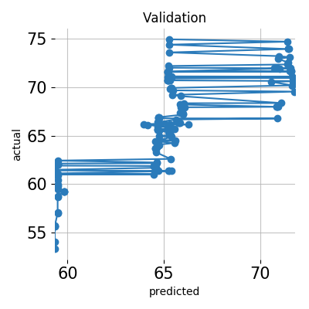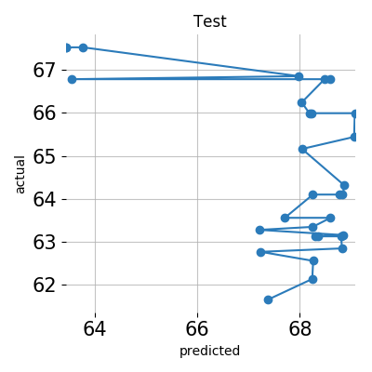

## Alternative Models

During the experiment, Driverless AI trained 0 alternative models. The following algorithms were evaluated during the Driverless AI experiment:

|  |  |  |  |
| --- | --- | --- | --- |
| **algorithm** | **package** | **version** | **documentation** |
| No Tuning | custom package | unavailable | unavailable |

Driverless AI can evaluate an array of algorithms, including but not limited to XGBoost GBM, XGBoost Dart, XGBoost GLM, LightGBM, RuleFit, Tensorflow, and FTRL models. The table below explains why certain algorithms were not selected for the final model, if any.

|  |  |
| --- | --- |
| **algorithm** | **selection** |
| gbtree | algorithm not evaluated due to experiment configuration |
| gblinear | algorithm not evaluated due to experiment configuration |
| lightgbm | algorithm not evaluated due to experiment configuration |
| decision tree | algorithm not evaluated due to experiment configuration |
| rulefit | algorithm not evaluated due to experiment configuration |
| tensorflow | algorithm not evaluated due to experiment configuration |
| ftrl | algorithm not evaluated due to experiment configuration |
| dart | algorithm not evaluated due to experiment configuration |

## Deployment

For this experiment, the MOJO Scoring Pipeline is available for productionizing the final model pipeline for a given row of data or table of data. The Python Scoring Pipeline is not available.

## Partial Dependence Plots

Partial dependence plots show the partial dependence as a function of specific values for a feature subset. The plots show how machine-learned response functions change based on the values of an input feature of interest, while taking nonlinearity into consideration and averaging out the effects of all other input features. Partial dependence plots enable increased transparency in a model and enable the ability to validate and debug a model by comparing a feature's average predictions across its domain to known standards and reasonable expectations.

The partial dependence plots are shown for the top 3 original variables. The top 3 original variables are chosen based on their Component Based Variable Importance. Partial Dependence computation reached maximum allowed time 20 seconds.

**Plot Details**

In the Driverless AI PDP, the y-axis represents the mean response, and a shaded region (for numeric features) or shaded bar (for categorical features) represents 1 standard deviation. Out-of-range PDP (diamond markers) represent values outside feature intervals seen in the data, unseen categorical values, or missing values.

For continuous features, numeric values up to 3 standard deviations lower than the minimum training value and higher than the maximum training value are feed into the model. For categorical features, an unseen categorical value is feed into the model denoted by UNSEEN (if the categorical value "UNSEEN" already exists in the training data, the out-of-range is done on a value called "UNSEEN_[x]," where x is some integer).

Feature **Date**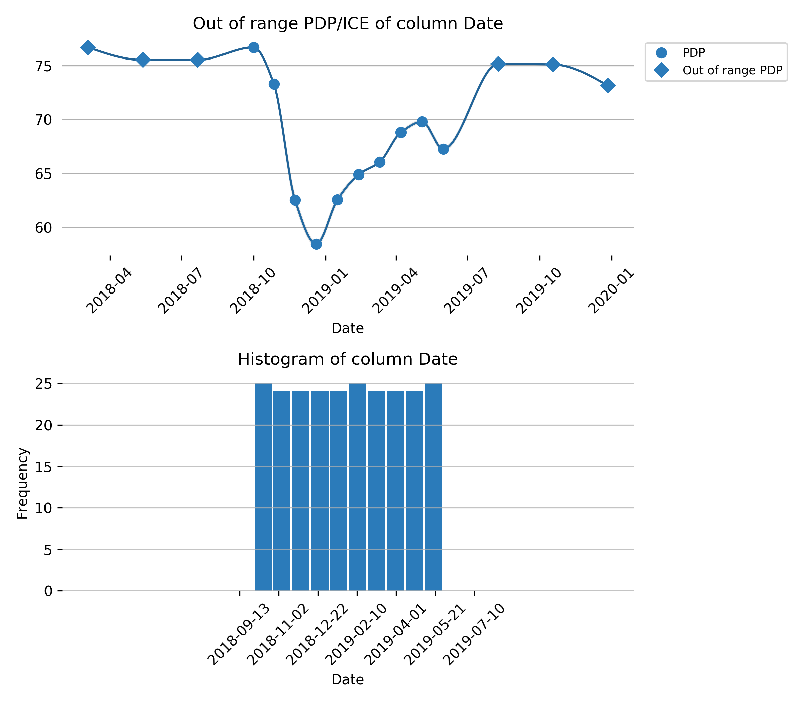

Feature **Germany Wind Generation _MWh_**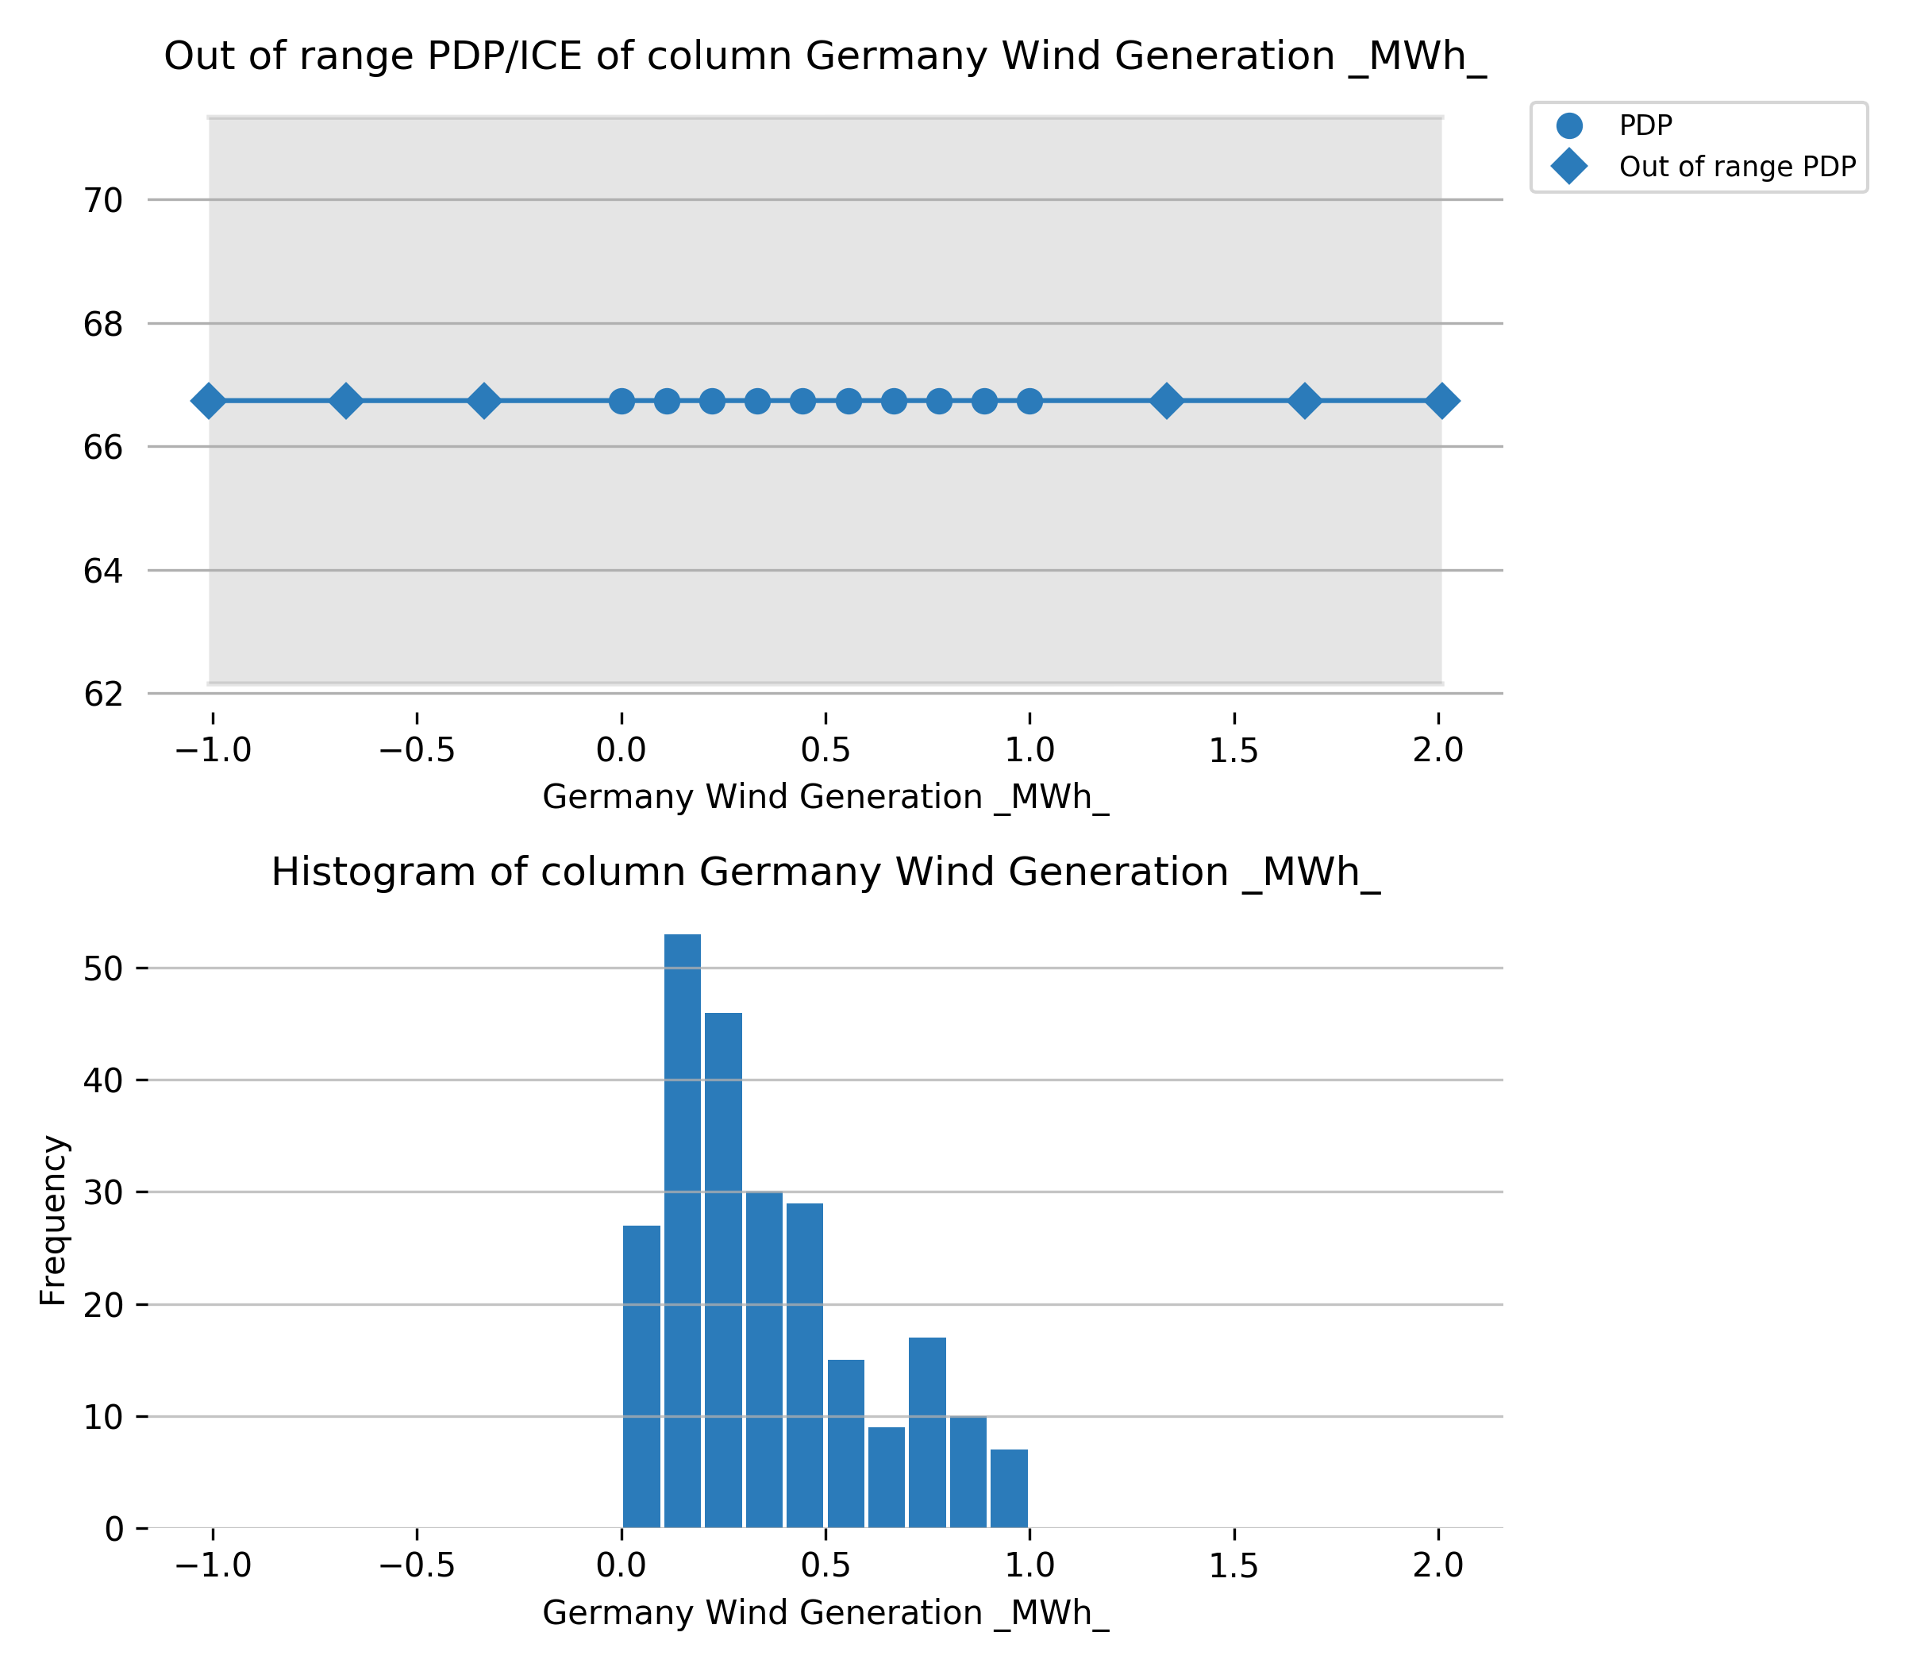

Feature **Germany Solar Generation _MWh_**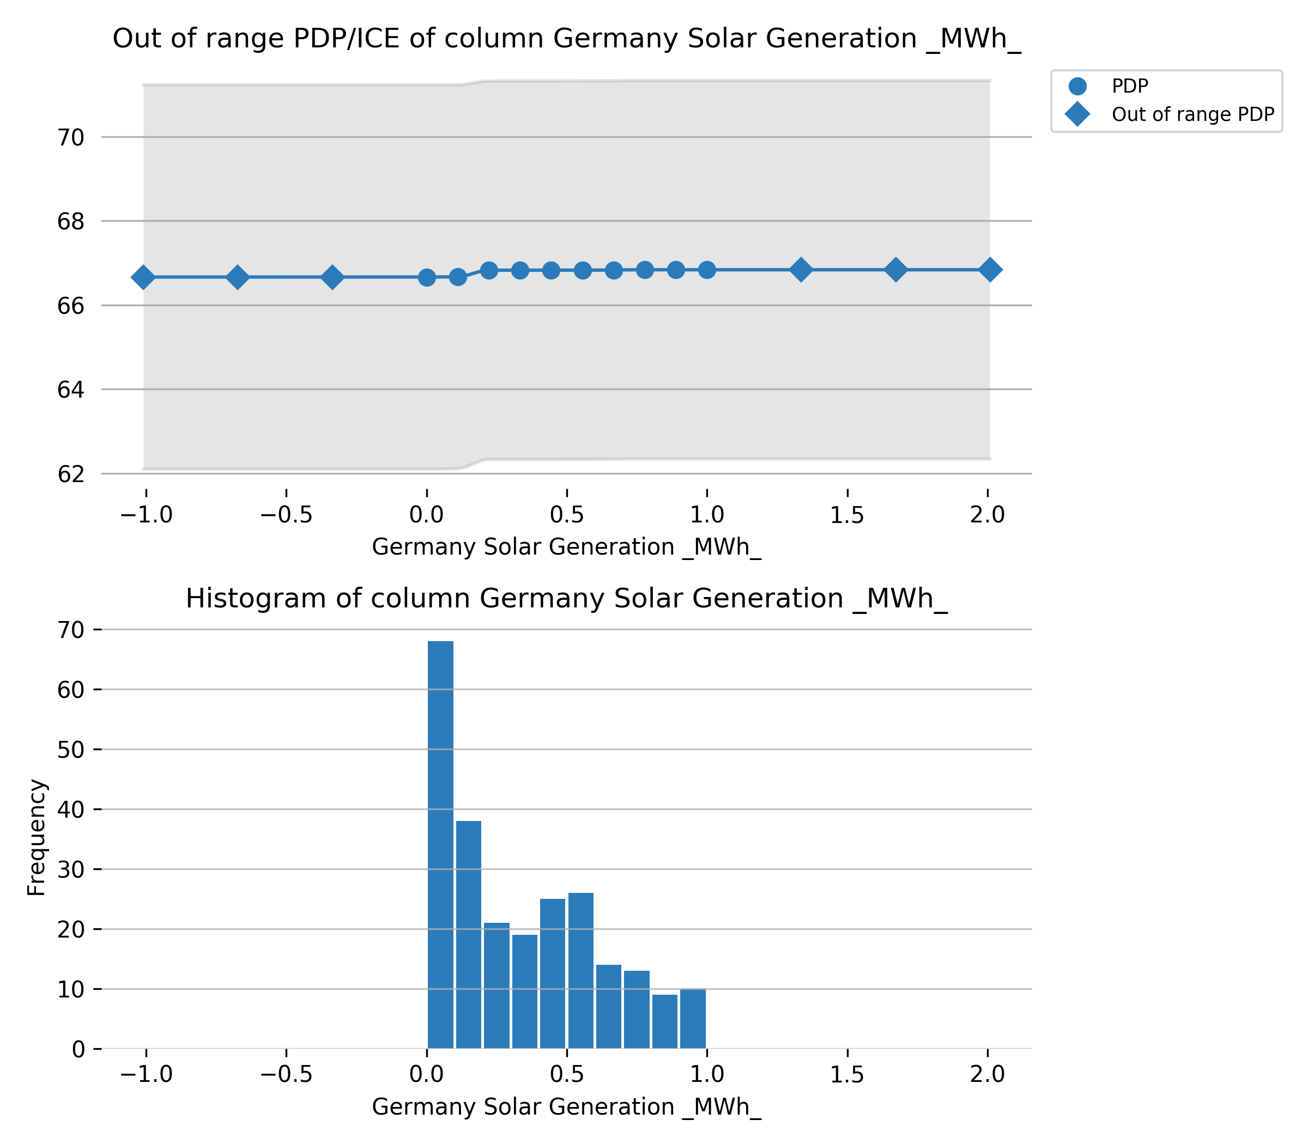

## Appendix

### Final Model Details

|  |  |  |  |  |
| --- | --- | --- | --- | --- |
| **Model Index** | **Type** | **Model Weight** | **Fitted features** | **Target Transformer** |
| 0 | LightGBMModel | 1 | 105 | unit_box |

**Model Index: Final Model - Single Model**

|  |  |
| --- | --- |
| **parameter** | **value** |
| accuracy | 9 |
| booster | lightgbm |
| boosting_type | gbdt |
| colsample_bytree | 0.8 |
| disable_gpus | False |
| encoder | {'bad_fit': False, 'copy': True, 'display_name': 'DATETIMELABELENCODER', 'dummy_tr': None, 'feature_desc': None, 'fit_exception': None, 'fitted_output_feature_names': None, 'full_feature_desc': None, 'input_feature_names': ['Date'], 'is_custom': False, 'is_orig': True, 'is_raw': False, 'lag_feature': None, 'monthly': False, 'outer_cv': None, 'output_feature_extra_descriptions': None, 'output_feature_names_backup': None, 'period': 86400000000000.0, 'random_state': 42, 'target': None, 'time_bins': [1.5383088e+18, 1.5383952e+18, 1.5384816e+18, 1.538568e+18, 1.5386544e+18, 1.5387408e+18, 1.5388272e+18, 1.5389136e+18, 1.539e+18, 1.5390864e+18, 1.5391728e+18, 1.5392592e+18, 1.5393456e+18, 1.539432e+18, 1.5395184e+18, 1.5396048e+18, 1.5396912e+18, 1.5397776e+18, 1.539864e+18, 1.5399504e+18, 1.5400368e+18, 1.5401232e+18, 1.5402096e+18, 1.540296e+18, 1.5403824e+18, 1.5404688e+18, 1.5405552e+18, 1.5406416e+18, 1.540728e+18, 1.5408144e+18, 1.5409008e+18, 1.5409872e+18, 1.5410736e+18, 1.54116e+18, 1.5412464e+18, 1.5413328e+18, 1.5414192e+18, 1.5415056e+18, 1.541592e+18, 1.5416784e+18, 1.5417648e+18, 1.5418512e+18, 1.5419376e+18, 1.542024e+18, 1.5421104e+18, 1.5421968e+18, 1.5422832e+18, 1.5423696e+18, 1.542456e+18, 1.5425424e+18, 1.5426288e+18, 1.5427152e+18, 1.5428016e+18, 1.542888e+18, 1.5429744e+18, 1.5430608e+18, 1.5431472e+18, 1.5432336e+18, 1.54332e+18, 1.5434064e+18, 1.5434928e+18, 1.5435792e+18, 1.5436656e+18, 1.543752e+18, 1.5438384e+18, 1.5439248e+18, 1.5440112e+18, 1.5440976e+18, 1.544184e+18, 1.5442704e+18, 1.5443568e+18, 1.5444432e+18, 1.5445296e+18, 1.544616e+18, 1.5447024e+18, 1.5447888e+18, 1.5448752e+18, 1.5449616e+18, 1.545048e+18, 1.5451344e+18, 1.5452208e+18, 1.5453072e+18, 1.5453936e+18, 1.54548e+18, 1.5455664e+18, 1.5456528e+18, 1.5457392e+18, 1.5458256e+18, 1.545912e+18, 1.5459984e+18, 1.5460848e+18, 1.5461712e+18, 1.5462576e+18, 1.546344e+18, 1.5464304e+18, 1.5465168e+18, 1.5466032e+18, 1.5466896e+18, 1.546776e+18, 1.5468624e+18, 1.5469488e+18, 1.5470352e+18, 1.5471216e+18, 1.547208e+18, 1.5472944e+18, 1.5473808e+18, 1.5474672e+18, 1.5475536e+18, 1.54764e+18, 1.5477264e+18, 1.5478128e+18, 1.5478992e+18, 1.5479856e+18, 1.548072e+18, 1.5481584e+18, 1.5482448e+18, 1.5483312e+18, 1.5484176e+18, 1.548504e+18, 1.5485904e+18, 1.5486768e+18, 1.5487632e+18, 1.5488496e+18, 1.548936e+18, 1.5490224e+18, 1.5491088e+18, 1.5491952e+18, 1.5492816e+18, 1.549368e+18, 1.5494544e+18, 1.5495408e+18, 1.5496272e+18, 1.5497136e+18, 1.5498e+18, 1.5498864e+18, 1.5499728e+18, 1.5500592e+18, 1.5501456e+18, 1.550232e+18, 1.5503184e+18, 1.5504048e+18, 1.5504912e+18, 1.5505776e+18, 1.550664e+18, 1.5507504e+18, 1.5508368e+18, 1.5509232e+18, 1.5510096e+18, 1.551096e+18, 1.5511824e+18, 1.5512688e+18, 1.5513552e+18, 1.5514416e+18, 1.551528e+18, 1.5516144e+18, 1.5517008e+18, 1.5517872e+18, 1.5518736e+18, 1.55196e+18, 1.5520464e+18, 1.5521328e+18, 1.5522192e+18, 1.5523056e+18, 1.552392e+18, 1.5524784e+18, 1.5525648e+18, 1.5526512e+18, 1.5527376e+18, 1.552824e+18, 1.5529104e+18, 1.5529968e+18, 1.5530832e+18, 1.5531696e+18, 1.553256e+18, 1.5533424e+18, 1.5534288e+18, 1.5535152e+18, 1.5536016e+18, 1.553688e+18, 1.5537744e+18, 1.5538608e+18, 1.5539472e+18, 1.5540336e+18, 1.55412e+18, 1.5542064e+18, 1.5542928e+18, 1.5543792e+18, 1.5544656e+18, 1.554552e+18, 1.5546384e+18, 1.5547248e+18, 1.5548112e+18, 1.5548976e+18, 1.554984e+18, 1.5550704e+18, 1.5551568e+18, 1.5552432e+18, 1.5553296e+18, 1.555416e+18, 1.5555024e+18, 1.5555888e+18, 1.5556752e+18, 1.5557616e+18, 1.555848e+18, 1.5559344e+18, 1.5560208e+18, 1.5561072e+18, 1.5561936e+18, 1.55628e+18, 1.5563664e+18, 1.5564528e+18, 1.5565392e+18, 1.5566256e+18, 1.556712e+18, 1.5567984e+18, 1.5568848e+18, 1.5569712e+18, 1.5570576e+18, 1.557144e+18, 1.5572304e+18, 1.5573168e+18, 1.5574032e+18, 1.5574896e+18, 1.557576e+18, 1.5576624e+18, 1.5577488e+18, 1.5578352e+18, 1.5579216e+18, 1.558008e+18, 1.5580944e+18, 1.5581808e+18, 1.5582672e+18, 1.5583536e+18, 1.55844e+18, 1.5585264e+18, 1.5586128e+18, 1.5586992e+18, 1.5587856e+18, 1.558872e+18, 1.5589584e+18, 1.5590448e+18, 1.5591312e+18, 1.5592176e+18, 1.559304e+18, 1.5593904e+18, 1.5594768e+18, 1.5595632e+18, 1.5596496e+18, 1.559736e+18, 1.5598224e+18, 1.5599088e+18, 1.5599952e+18, 1.5600816e+18, 1.560168e+18, 1.5602544e+18, 1.5603408e+18, 1.5604272e+18, 1.5605136e+18, 1.5606e+18, 1.5606864e+18, 1.5607728e+18, 1.5608592e+18, 1.5609456e+18, 1.561032e+18, 1.5611184e+18, 1.5612048e+18, 1.5612912e+18, 1.5613776e+18, 1.561464e+18, 1.5615504e+18, 1.5616368e+18, 1.5617232e+18, 1.5618096e+18, 1.5618528e+18, 1.5619824e+18, 1.5620688e+18, 1.5621552e+18, 1.5622416e+18, 1.562328e+18, 1.5624144e+18, 1.5625008e+18, 1.5625872e+18, 1.5626736e+18, 1.56276e+18, 1.5628464e+18, 1.5629328e+18, 1.5630192e+18, 1.5631056e+18, 1.563192e+18, 1.5632784e+18, 1.5633648e+18, 1.5634512e+18, 1.5635376e+18, 1.563624e+18, 1.5637104e+18, 1.5637968e+18, 1.5638832e+18, 1.5639696e+18, 1.564056e+18, 1.5641424e+18, 1.5642288e+18, 1.5643152e+18, 1.5644016e+18, 1.564488e+18, 1.5645744e+18, 1.5646608e+18, 1.5647472e+18, 1.5648336e+18, 1.56492e+18, 1.5650064e+18, 1.5650928e+18, 1.5651792e+18, 1.5652656e+18, 1.565352e+18, 1.5654384e+18, 1.5655248e+18, 1.5656112e+18, 1.5656976e+18, 1.565784e+18, 1.5658704e+18, 1.5659568e+18, 1.5660432e+18, 1.5661296e+18, 1.566216e+18, 1.5663024e+18, 1.5663888e+18, 1.5664752e+18, 1.5665616e+18, 1.566648e+18, 1.5667344e+18, 1.5668208e+18, 1.5669072e+18, 1.5669936e+18, 1.56708e+18, 1.5671664e+18, 1.5672528e+18, 1.5673392e+18, 1.5674256e+18, 1.567512e+18, 1.5675984e+18, 1.5676848e+18, 1.5677712e+18, 1.5678576e+18, 1.567944e+18, 1.5680304e+18, 1.5681168e+18, 1.5682032e+18, 1.5682896e+18, 1.568376e+18, 1.5684624e+18, 1.5685488e+18, 1.5686352e+18, 1.5687216e+18, 1.568808e+18, 1.5688944e+18, 1.5689808e+18, 1.5690672e+18, 1.5691536e+18, 1.56924e+18, 1.5693264e+18, 1.5694128e+18, 1.5694992e+18, 1.5695856e+18, 1.569672e+18, 1.5697584e+18, 1.5698448e+18, 1.5699312e+18, 1.5700176e+18, 1.570104e+18, 1.5701904e+18, 1.5702768e+18, 1.5703632e+18, 1.5704496e+18, 1.570536e+18, 1.5706224e+18, 1.5707088e+18, 1.5707952e+18, 1.5708816e+18, 1.570968e+18, 1.5710544e+18, 1.5711408e+18, 1.5712272e+18, 1.5713136e+18, 1.5714e+18, 1.5714864e+18, 1.5715728e+18, 1.5716592e+18, 1.5717456e+18, 1.571832e+18, 1.5719184e+18, 1.5720048e+18, 1.5720912e+18, 1.5721776e+18, 1.572264e+18, 1.5723504e+18, 1.5724368e+18, 1.5725232e+18, 1.5726096e+18, 1.572696e+18, 1.5727824e+18, 1.5728688e+18, 1.5729552e+18, 1.5730416e+18, 1.573128e+18, 1.5732144e+18, 1.5733008e+18, 1.5733872e+18, 1.5734736e+18, 1.57356e+18, 1.5736464e+18, 1.5737328e+18, 1.5738192e+18, 1.5739056e+18, 1.573992e+18, 1.5740784e+18, 1.5741648e+18, 1.5742512e+18, 1.5743376e+18, 1.574424e+18, 1.5745104e+18, 1.5745968e+18, 1.5746832e+18, 1.5747696e+18, 1.574856e+18, 1.5749424e+18, 1.5750288e+18, 1.5751152e+18, 1.5752016e+18, 1.575288e+18, 1.5753744e+18, 1.5754608e+18, 1.5755472e+18, 1.5756336e+18, 1.57572e+18, 1.5758064e+18, 1.5758928e+18, 1.5759792e+18, 1.5760656e+18, 1.576152e+18, 1.5762384e+18, 1.5763248e+18, 1.5764112e+18, 1.5764976e+18, 1.576584e+18, 1.5766704e+18, 1.5767568e+18, 1.5768432e+18, 1.5769296e+18, 1.577016e+18, 1.5771024e+18, 1.5771888e+18, 1.5772752e+18, 1.5773616e+18, 1.577448e+18, 1.5775344e+18, 1.5776208e+18, 1.5777072e+18, 1.5777936e+18, 1.57788e+18, 1.5779664e+18, 1.5780528e+18, 1.5781392e+18, 1.5782256e+18, 1.578312e+18, 1.5783984e+18, 1.5784848e+18, 1.5785712e+18, 1.5786576e+18, 1.578744e+18, 1.5788304e+18, 1.5789168e+18, 1.5790032e+18, 1.5790896e+18, 1.579176e+18, 1.5792624e+18, 1.5793488e+18, 1.5794352e+18, 1.5795216e+18, 1.579608e+18, 1.5796944e+18, 1.5797808e+18, 1.5798672e+18, 1.5799536e+18, 1.58004e+18, 1.5801264e+18, 1.5802128e+18, 1.5802992e+18, 1.5803856e+18, 1.580472e+18, 1.5805584e+18, 1.5806448e+18, 1.5807312e+18, 1.5808176e+18, 1.580904e+18, 1.5809904e+18, 1.5810768e+18, 1.5811632e+18, 1.5812496e+18, 1.581336e+18, 1.5814224e+18, 1.5815088e+18, 1.5815952e+18, 1.5816816e+18, 1.581768e+18, 1.5818544e+18, 1.5819408e+18, 1.5820272e+18, 1.5821136e+18, 1.5822e+18, 1.5822864e+18, 1.5823728e+18, 1.5824592e+18, 1.5825456e+18, 1.582632e+18, 1.5827184e+18, 1.5828048e+18, 1.5828912e+18, 1.5829776e+18, 1.583064e+18, 1.5831504e+18, 1.5832368e+18, 1.5833232e+18, 1.5834096e+18, 1.583496e+18, 1.5835824e+18, 1.5836688e+18, 1.5837552e+18, 1.5838416e+18, 1.583928e+18, 1.5840144e+18, 1.5841008e+18, 1.5841872e+18, 1.5842736e+18, 1.58436e+18, 1.5844464e+18, 1.5845328e+18, 1.5846192e+18, 1.5847056e+18, 1.584792e+18, 1.5848784e+18, 1.5849648e+18, 1.5850512e+18, 1.5851376e+18, 1.585224e+18, 1.5853104e+18], 'ts': 1538352000000000000, 'weekdays_only': False} |
| ensemble_level | 0 |
| eval_metric | rmse |
| gamma | 0 |
| gpu_id | 0 |
| grow_policy | depthwise |
| interpretability | 5 |
| labels | None |
| learning_rate | 0.02 |
| lossguide | False |
| max_bin | 256 |
| max_delta_step | 0 |
| max_depth | 6 |
| max_leaves | 64 |
| min_child_samples | 1 |
| min_child_weight | 1 |
| min_data | 1 |
| min_data_in_bin | 1 |
| model_class_name | LightGBMModel |
| model_id | Final Model - Single Model |
| model_origin | EXTRA_DEFAULT |
| monotonicity_constraints | False |
| n_estimators | 47 |
| n_gpus | 1 |
| n_jobs | 2 |
| num_class | 1 |
| num_classes | 1 |
| objective | reg:squarederror |
| pred_gap | 0 |
| pred_periods | 30 |
| random_state | 945372307 |
| reg_alpha | 0.0 |
| reg_lambda | 1.0 |
| scale_pos_weight | 1 |
| score_f_name | RMSE |
| seed | 945372307 |
| silent | True |
| subsample | 0.7 |
| subsample_freq | 1 |
| target | Target(Brent) |
| tgc | ['Date'] |
| time_column | Date |
| time_tolerance | 9 |
| train_shape | [243, 11] |
| tree_method | gpu_hist |
| tsp | {'datetime_format': '%Y-%m-%d', 'dtlabel_encoder': {'bad_fit': False, 'copy': True, 'display_name': 'DATETIMELABELENCODER', 'dummy_tr': None, 'feature_desc': None, 'fit_exception': None, 'fitted_output_feature_names': None, 'full_feature_desc': None, 'input_feature_names': ['Date'], 'is_custom': False, 'is_orig': True, 'is_raw': False, 'lag_feature': None, 'monthly': False, 'outer_cv': None, 'output_feature_extra_descriptions': None, 'output_feature_names_backup': None, 'period': 86400000000000.0, 'random_state': 42, 'target': None, 'time_bins': [1.5383088e+18, 1.5383952e+18, 1.5384816e+18, 1.538568e+18, 1.5386544e+18, 1.5387408e+18, 1.5388272e+18, 1.5389136e+18, 1.539e+18, 1.5390864e+18, 1.5391728e+18, 1.5392592e+18, 1.5393456e+18, 1.539432e+18, 1.5395184e+18, 1.5396048e+18, 1.5396912e+18, 1.5397776e+18, 1.539864e+18, 1.5399504e+18, 1.5400368e+18, 1.5401232e+18, 1.5402096e+18, 1.540296e+18, 1.5403824e+18, 1.5404688e+18, 1.5405552e+18, 1.5406416e+18, 1.540728e+18, 1.5408144e+18, 1.5409008e+18, 1.5409872e+18, 1.5410736e+18, 1.54116e+18, 1.5412464e+18, 1.5413328e+18, 1.5414192e+18, 1.5415056e+18, 1.541592e+18, 1.5416784e+18, 1.5417648e+18, 1.5418512e+18, 1.5419376e+18, 1.542024e+18, 1.5421104e+18, 1.5421968e+18, 1.5422832e+18, 1.5423696e+18, 1.542456e+18, 1.5425424e+18, 1.5426288e+18, 1.5427152e+18, 1.5428016e+18, 1.542888e+18, 1.5429744e+18, 1.5430608e+18, 1.5431472e+18, 1.5432336e+18, 1.54332e+18, 1.5434064e+18, 1.5434928e+18, 1.5435792e+18, 1.5436656e+18, 1.543752e+18, 1.5438384e+18, 1.5439248e+18, 1.5440112e+18, 1.5440976e+18, 1.544184e+18, 1.5442704e+18, 1.5443568e+18, 1.5444432e+18, 1.5445296e+18, 1.544616e+18, 1.5447024e+18, 1.5447888e+18, 1.5448752e+18, 1.5449616e+18, 1.545048e+18, 1.5451344e+18, 1.5452208e+18, 1.5453072e+18, 1.5453936e+18, 1.54548e+18, 1.5455664e+18, 1.5456528e+18, 1.5457392e+18, 1.5458256e+18, 1.545912e+18, 1.5459984e+18, 1.5460848e+18, 1.5461712e+18, 1.5462576e+18, 1.546344e+18, 1.5464304e+18, 1.5465168e+18, 1.5466032e+18, 1.5466896e+18, 1.546776e+18, 1.5468624e+18, 1.5469488e+18, 1.5470352e+18, 1.5471216e+18, 1.547208e+18, 1.5472944e+18, 1.5473808e+18, 1.5474672e+18, 1.5475536e+18, 1.54764e+18, 1.5477264e+18, 1.5478128e+18, 1.5478992e+18, 1.5479856e+18, 1.548072e+18, 1.5481584e+18, 1.5482448e+18, 1.5483312e+18, 1.5484176e+18, 1.548504e+18, 1.5485904e+18, 1.5486768e+18, 1.5487632e+18, 1.5488496e+18, 1.548936e+18, 1.5490224e+18, 1.5491088e+18, 1.5491952e+18, 1.5492816e+18, 1.549368e+18, 1.5494544e+18, 1.5495408e+18, 1.5496272e+18, 1.5497136e+18, 1.5498e+18, 1.5498864e+18, 1.5499728e+18, 1.5500592e+18, 1.5501456e+18, 1.550232e+18, 1.5503184e+18, 1.5504048e+18, 1.5504912e+18, 1.5505776e+18, 1.550664e+18, 1.5507504e+18, 1.5508368e+18, 1.5509232e+18, 1.5510096e+18, 1.551096e+18, 1.5511824e+18, 1.5512688e+18, 1.5513552e+18, 1.5514416e+18, 1.551528e+18, 1.5516144e+18, 1.5517008e+18, 1.5517872e+18, 1.5518736e+18, 1.55196e+18, 1.5520464e+18, 1.5521328e+18, 1.5522192e+18, 1.5523056e+18, 1.552392e+18, 1.5524784e+18, 1.5525648e+18, 1.5526512e+18, 1.5527376e+18, 1.552824e+18, 1.5529104e+18, 1.5529968e+18, 1.5530832e+18, 1.5531696e+18, 1.553256e+18, 1.5533424e+18, 1.5534288e+18, 1.5535152e+18, 1.5536016e+18, 1.553688e+18, 1.5537744e+18, 1.5538608e+18, 1.5539472e+18, 1.5540336e+18, 1.55412e+18, 1.5542064e+18, 1.5542928e+18, 1.5543792e+18, 1.5544656e+18, 1.554552e+18, 1.5546384e+18, 1.5547248e+18, 1.5548112e+18, 1.5548976e+18, 1.554984e+18, 1.5550704e+18, 1.5551568e+18, 1.5552432e+18, 1.5553296e+18, 1.555416e+18, 1.5555024e+18, 1.5555888e+18, 1.5556752e+18, 1.5557616e+18, 1.555848e+18, 1.5559344e+18, 1.5560208e+18, 1.5561072e+18, 1.5561936e+18, 1.55628e+18, 1.5563664e+18, 1.5564528e+18, 1.5565392e+18, 1.5566256e+18, 1.556712e+18, 1.5567984e+18, 1.5568848e+18, 1.5569712e+18, 1.5570576e+18, 1.557144e+18, 1.5572304e+18, 1.5573168e+18, 1.5574032e+18, 1.5574896e+18, 1.557576e+18, 1.5576624e+18, 1.5577488e+18, 1.5578352e+18, 1.5579216e+18, 1.558008e+18, 1.5580944e+18, 1.5581808e+18, 1.5582672e+18, 1.5583536e+18, 1.55844e+18, 1.5585264e+18, 1.5586128e+18, 1.5586992e+18, 1.5587856e+18, 1.558872e+18, 1.5589584e+18, 1.5590448e+18, 1.5591312e+18, 1.5592176e+18, 1.559304e+18, 1.5593904e+18, 1.5594768e+18, 1.5595632e+18, 1.5596496e+18, 1.559736e+18, 1.5598224e+18, 1.5599088e+18, 1.5599952e+18, 1.5600816e+18, 1.560168e+18, 1.5602544e+18, 1.5603408e+18, 1.5604272e+18, 1.5605136e+18, 1.5606e+18, 1.5606864e+18, 1.5607728e+18, 1.5608592e+18, 1.5609456e+18, 1.561032e+18, 1.5611184e+18, 1.5612048e+18, 1.5612912e+18, 1.5613776e+18, 1.561464e+18, 1.5615504e+18, 1.5616368e+18, 1.5617232e+18, 1.5618096e+18, 1.5618528e+18, 1.5619824e+18, 1.5620688e+18, 1.5621552e+18, 1.5622416e+18, 1.562328e+18, 1.5624144e+18, 1.5625008e+18, 1.5625872e+18, 1.5626736e+18, 1.56276e+18, 1.5628464e+18, 1.5629328e+18, 1.5630192e+18, 1.5631056e+18, 1.563192e+18, 1.5632784e+18, 1.5633648e+18, 1.5634512e+18, 1.5635376e+18, 1.563624e+18, 1.5637104e+18, 1.5637968e+18, 1.5638832e+18, 1.5639696e+18, 1.564056e+18, 1.5641424e+18, 1.5642288e+18, 1.5643152e+18, 1.5644016e+18, 1.564488e+18, 1.5645744e+18, 1.5646608e+18, 1.5647472e+18, 1.5648336e+18, 1.56492e+18, 1.5650064e+18, 1.5650928e+18, 1.5651792e+18, 1.5652656e+18, 1.565352e+18, 1.5654384e+18, 1.5655248e+18, 1.5656112e+18, 1.5656976e+18, 1.565784e+18, 1.5658704e+18, 1.5659568e+18, 1.5660432e+18, 1.5661296e+18, 1.566216e+18, 1.5663024e+18, 1.5663888e+18, 1.5664752e+18, 1.5665616e+18, 1.566648e+18, 1.5667344e+18, 1.5668208e+18, 1.5669072e+18, 1.5669936e+18, 1.56708e+18, 1.5671664e+18, 1.5672528e+18, 1.5673392e+18, 1.5674256e+18, 1.567512e+18, 1.5675984e+18, 1.5676848e+18, 1.5677712e+18, 1.5678576e+18, 1.567944e+18, 1.5680304e+18, 1.5681168e+18, 1.5682032e+18, 1.5682896e+18, 1.568376e+18, 1.5684624e+18, 1.5685488e+18, 1.5686352e+18, 1.5687216e+18, 1.568808e+18, 1.5688944e+18, 1.5689808e+18, 1.5690672e+18, 1.5691536e+18, 1.56924e+18, 1.5693264e+18, 1.5694128e+18, 1.5694992e+18, 1.5695856e+18, 1.569672e+18, 1.5697584e+18, 1.5698448e+18, 1.5699312e+18, 1.5700176e+18, 1.570104e+18, 1.5701904e+18, 1.5702768e+18, 1.5703632e+18, 1.5704496e+18, 1.570536e+18, 1.5706224e+18, 1.5707088e+18, 1.5707952e+18, 1.5708816e+18, 1.570968e+18, 1.5710544e+18, 1.5711408e+18, 1.5712272e+18, 1.5713136e+18, 1.5714e+18, 1.5714864e+18, 1.5715728e+18, 1.5716592e+18, 1.5717456e+18, 1.571832e+18, 1.5719184e+18, 1.5720048e+18, 1.5720912e+18, 1.5721776e+18, 1.572264e+18, 1.5723504e+18, 1.5724368e+18, 1.5725232e+18, 1.5726096e+18, 1.572696e+18, 1.5727824e+18, 1.5728688e+18, 1.5729552e+18, 1.5730416e+18, 1.573128e+18, 1.5732144e+18, 1.5733008e+18, 1.5733872e+18, 1.5734736e+18, 1.57356e+18, 1.5736464e+18, 1.5737328e+18, 1.5738192e+18, 1.5739056e+18, 1.573992e+18, 1.5740784e+18, 1.5741648e+18, 1.5742512e+18, 1.5743376e+18, 1.574424e+18, 1.5745104e+18, 1.5745968e+18, 1.5746832e+18, 1.5747696e+18, 1.574856e+18, 1.5749424e+18, 1.5750288e+18, 1.5751152e+18, 1.5752016e+18, 1.575288e+18, 1.5753744e+18, 1.5754608e+18, 1.5755472e+18, 1.5756336e+18, 1.57572e+18, 1.5758064e+18, 1.5758928e+18, 1.5759792e+18, 1.5760656e+18, 1.576152e+18, 1.5762384e+18, 1.5763248e+18, 1.5764112e+18, 1.5764976e+18, 1.576584e+18, 1.5766704e+18, 1.5767568e+18, 1.5768432e+18, 1.5769296e+18, 1.577016e+18, 1.5771024e+18, 1.5771888e+18, 1.5772752e+18, 1.5773616e+18, 1.577448e+18, 1.5775344e+18, 1.5776208e+18, 1.5777072e+18, 1.5777936e+18, 1.57788e+18, 1.5779664e+18, 1.5780528e+18, 1.5781392e+18, 1.5782256e+18, 1.578312e+18, 1.5783984e+18, 1.5784848e+18, 1.5785712e+18, 1.5786576e+18, 1.578744e+18, 1.5788304e+18, 1.5789168e+18, 1.5790032e+18, 1.5790896e+18, 1.579176e+18, 1.5792624e+18, 1.5793488e+18, 1.5794352e+18, 1.5795216e+18, 1.579608e+18, 1.5796944e+18, 1.5797808e+18, 1.5798672e+18, 1.5799536e+18, 1.58004e+18, 1.5801264e+18, 1.5802128e+18, 1.5802992e+18, 1.5803856e+18, 1.580472e+18, 1.5805584e+18, 1.5806448e+18, 1.5807312e+18, 1.5808176e+18, 1.580904e+18, 1.5809904e+18, 1.5810768e+18, 1.5811632e+18, 1.5812496e+18, 1.581336e+18, 1.5814224e+18, 1.5815088e+18, 1.5815952e+18, 1.5816816e+18, 1.581768e+18, 1.5818544e+18, 1.5819408e+18, 1.5820272e+18, 1.5821136e+18, 1.5822e+18, 1.5822864e+18, 1.5823728e+18, 1.5824592e+18, 1.5825456e+18, 1.582632e+18, 1.5827184e+18, 1.5828048e+18, 1.5828912e+18, 1.5829776e+18, 1.583064e+18, 1.5831504e+18, 1.5832368e+18, 1.5833232e+18, 1.5834096e+18, 1.583496e+18, 1.5835824e+18, 1.5836688e+18, 1.5837552e+18, 1.5838416e+18, 1.583928e+18, 1.5840144e+18, 1.5841008e+18, 1.5841872e+18, 1.5842736e+18, 1.58436e+18, 1.5844464e+18, 1.5845328e+18, 1.5846192e+18, 1.5847056e+18, 1.584792e+18, 1.5848784e+18, 1.5849648e+18, 1.5850512e+18, 1.5851376e+18, 1.585224e+18, 1.5853104e+18], 'ts': 1538352000000000000, 'weekdays_only': False}, 'frequency_in_si': 11.57, 'period': 86400000000000.0, 'period_in_si': 1.0, 'test_periods': 30, 'time_column': 'Date', 'time_resolution_si': 'd', 'train_periods': 243} |
| valid_shape |  |
| nfolds | 1 |

### Config Overrides

The Config Overrides represent the fine-control parameters.

|  |  |
| --- | --- |
| **Parameter** | **Value** |
| vis_server_port | 12346 |
| procsy_port | 12347 |
| h2o_port | 12348 |
| h2o_recipes_kwargs | {} |
| redis_port | 6379 |
| authentication_method | none |
| supported_file_types | ['csv', 'tsv', 'txt', 'dat', 'tgz', 'gz', 'bz2', 'zip', 'xz', 'xls', 'xlsx', 'jay', 'feather', 'bin', 'arff', 'parquet', 'pkl', 'orc'] |
| recipe_supported_file_types | ['py', 'pyc'] |
| enabled_file_systems | ['upload', 'file', 'hdfs', 's3', 'recipe_file', 'recipe_url'] |
| missing_values | ['', '?', 'None', 'nan', 'NA', 'N/A', 'unknown', 'inf', '-inf', '1.7976931348623157e+308', '-1.7976931348623157e+308'] |
| monotonicity_constraints_dict | {} |
| params_lightgbm | {} |
| params_xgboost | {} |
| params_dart | {} |
| params_tensorflow | {} |
| params_gblinear | {} |
| params_decision_tree | {} |
| params_rulefit | {} |
| params_ftrl | {} |
| params_tune_lightgbm | {} |
| params_tune_xgboost | {} |
| params_tune_dart | {} |
| params_tune_tensorflow | {} |
| params_tune_gblinear | {} |
| params_tune_rulefit | {} |
| params_tune_ftrl | {} |
| ts_target_trafo_epidemic_params_dict | {} |
| mli_cloud_name | H2O-MLI-DAI-12266 |
| recipe_dict | {} |
| cuda_visible_devices | None |
| last_recipe | auto |
| enable_genetic_algorithm | off |
| feature_engineering_effort | 8 |
| make_python_scoring_pipeline | off |
| make_mojo_scoring_pipeline | off |
| make_pipeline_visualization | off |
| benchmark_mojo_latency | off |
| included_transformers | ['BERTTransformer', 'CVCatNumEncodeTransformer', 'CVTargetEncodeTransformer', 'CatOriginalTransformer', 'CatTransformer', 'ClusterDistTransformer', 'ClusterTETransformer', 'DateOriginalTransformer', 'DateTimeOriginalTransformer', 'DatesTransformer', 'EwmaLagsTransformer', 'FrequentTransformer', 'ImageOriginalTransformer', 'ImageVectorizerTransformer', 'InteractionsTransformer', 'IsHolidayTransformer', 'IsolationForestAnomalyNumCatAllColsTransformer', 'IsolationForestAnomalyNumCatTransformer', 'IsolationForestAnomalyNumericTransformer', 'LagsAggregatesTransformer', 'LagsInteractionTransformer', 'LagsTransformer', 'LexiLabelEncoderTransformer', 'NumCatTETransformer', 'NumToCatTETransformer', 'NumToCatWoEMonotonicTransformer', 'NumToCatWoETransformer', 'OneHotEncodingTransformer', 'OriginalTransformer', 'TextBiGRUTransformer', 'TextCNNTransformer', 'TextCharCNNTransformer', 'TextLinModelTransformer', 'TextOriginalTransformer', 'TextTransformer', 'TruncSVDNumTransformer', 'WeightOfEvidenceTransformer'] |
| included_models | ['CONSTANT', 'DECISIONTREE', 'FTRL', 'GLM', 'IMAGEAUTO', 'IMBALANCEDLIGHTGBM', 'IMBALANCEDXGBOOSTGBM', 'LIGHTGBM', 'RULEFIT', 'TENSORFLOW', 'TEXTALBERT', 'TEXTBERT', 'TEXTCAMEMBERT', 'TEXTDISTILBERT', 'TEXTROBERTA', 'TEXTXLM', 'TEXTXLMROBERTA', 'TEXTXLNET', 'XGBOOSTDART', 'XGBOOSTGBM', 'ZEROINFLATEDLIGHTGBM', 'ZEROINFLATEDXGBOOST'] |
| included_scorers | ['ACCURACY', 'AUC', 'AUCPR', 'F05', 'F1', 'F2', 'FDR', 'FNR', 'FOR', 'FPR', 'GINI', 'LOGLOSS', 'MACROAUC', 'MAE', 'MAPE', 'MCC', 'MER', 'MSE', 'NPV', 'PRECISION', 'R2', 'R2COD', 'RECALL', 'RMSE', 'RMSLE', 'RMSPE', 'SMAPE', 'TNR'] |
| max_nestimators_feature_evolution_factor | 0.5 |
| prob_lag_non_targets | 0.1 |
| prob_default_lags | 0.2 |
| prob_lagsinteraction | 0.2 |
| prob_lagsaggregates | 0.2 |
| varimp_threshold_at_interpretability_10 | 1e-30 |
| included_transformers_user | ['BERTTransformer', 'CVCatNumEncodeTransformer', 'CVTargetEncodeTransformer', 'CatOriginalTransformer', 'CatTransformer', 'ClusterDistTransformer', 'ClusterTETransformer', 'DateOriginalTransformer', 'DateTimeOriginalTransformer', 'DatesTransformer', 'EwmaLagsTransformer', 'FrequentTransformer', 'ImageOriginalTransformer', 'ImageVectorizerTransformer', 'InteractionsTransformer', 'IsHolidayTransformer', 'IsolationForestAnomalyNumCatAllColsTransformer', 'IsolationForestAnomalyNumCatTransformer', 'IsolationForestAnomalyNumericTransformer', 'LagsAggregatesTransformer', 'LagsInteractionTransformer', 'LagsTransformer', 'LexiLabelEncoderTransformer', 'NumCatTETransformer', 'NumToCatTETransformer', 'NumToCatWoEMonotonicTransformer', 'NumToCatWoETransformer', 'OneHotEncodingTransformer', 'OriginalTransformer', 'TextBiGRUTransformer', 'TextCNNTransformer', 'TextCharCNNTransformer', 'TextLinModelTransformer', 'TextOriginalTransformer', 'TextTransformer', 'TruncSVDNumTransformer', 'WeightOfEvidenceTransformer'] |