Lab 1

1. Superkeys:

[EmpID]

[SSN]

[Email]

[EmpID, phone]

[SSN, email]

[name, department, phone]

1. Candidate keys:

[empID]

[SSN]

[Email]

1. [empID] because it can be primary key. It is especially created to be unique, and 2 things can’t be the same basically like SSN email Salary etc.
2. Yes, the phone number can be match between 2 workers in real life so it сan not be chosen as primary key.

Relation B: Course Registration

Registration(StudentID, CourseCode, Section, Semester, Year, Grade, Credits)

Business Rules:

- A student can take the same course in different semesters

- A student cannot register for the same course section in the same semester

- Each course section in a semester has a fixed credit value

Your Tasks: 1. Determine the minimum attributes needed for the primary key 2. Explain why each

attribute in your primary key is necessary 3. Identify any additional candidate keys (if they exist)

1. Minimum atributes: [StudentID, CourseCode, Section, Semester, Year]
2. So the StudentID for identification, CourseCode is for identification of the course, Section is for the distinguishing different section on the same course, Semester and Year is just for specifying.
3. You actually can add any surrogate keys for the candidate key or it can be if you combine Year and semester.

Task 1.2: Foreign Key Design

Design the foreign key relationships for this university system:Given Tables:

Student(StudentID, Name, Email, Major, AdvisorID)

Professor(ProfID, Name, Department, Salary)

Course(CourseID, Title, Credits, DepartmentCode)

Department(DeptCode, DeptName, Budget, ChairID)

Enrollment(StudentID, CourseID, Semester, Grade)

Your Tasks: 1. Identify all foreign key relationships

Student.AdvID – Professsor.ProfID

Course.DepartmentCode – Department.DeptCode

Department.ChairID – Professor.ProfID

Enrollment.StudentID – Student.StudentID

Enrollment.CourseID – Course.CourseID

Part 2: ER Diagram Construction

Task 2.1: Hospital Management System

Scenario: Design a database for a hospital management system.

Requirements:

• Patients have unique patient IDs, names, birthdates, addresses (street, city, state, zip), phone

numbers (multiple allowed), and insurance information

• Doctors have unique doctor IDs, names, specializations (can have multiple), phone numbers, and

office locations

• Departments have department codes, names, and locations

• Appointments track which patient sees which doctor at what date/time, the purpose of visit, and

any notes

• Prescriptions track medications prescribed by doctors to patients, including dosage and

instructions

• Hospital Rooms are numbered within departments (room 101 in Cardiology is different from

room 101 in Neurology)

Your Tasks: 1. Identify all entities (specify which are strong and which are weak) 2. Identify all attributes

for each entity (classify as simple, composite, multi-valued, or derived) 3. Identify all relationships with

their cardinalities (1:1, 1:N, M:N) 4. Draw the complete ER diagram using proper notation 5. Mark

primary keys

1. **Entities (strong):** Patient, Doctor, Department, HospitalRoom, Appointment, Prescription, Medication, PrescriptionItem.

**Weak / multi-valued handlers:** PatientPhone, DoctorPhone, DoctorSpecialization.

**Patient:**

* PatientID (PK)
* Name
* Birthdate
* Address (композитный: street, city, state, zip)
* Phone (мультизначный)
* InsuranceInfo

**Doctor:**

* DoctorID (PK)
* Name
* Specialization (мультизначный)
* Phone (мультизначный)
* OfficeLocation

**Department:**

* DeptCode (PK)
* DeptName
* Location

**Appointment:**

* AppointmentID (PK)
* DateTime
* Purpose
* Notes

**Prescription:**

* PrescriptionID (PK)
* MedicationName
* Dosage
* Instructions

**Room (weak entity):**

* RoomNumber (partial key)
* DeptCode (FK, часть составного PK)

• **Patient — Appointment — Doctor**:

* Patient (1) - (N) Appointment
* Doctor (1) - (N) Appointment

• **Doctor — Prescription — Patient**:

* Doctor (1) - (N) Prescription
* Patient (1) - (N) Prescription

• **Department — Doctor**:

* Department (1) - (N) Doctor

• **Department — Room**:

* Department (1) - (N) Room (Room — слабая сущность, PK = (DeptCode, RoomNumber))

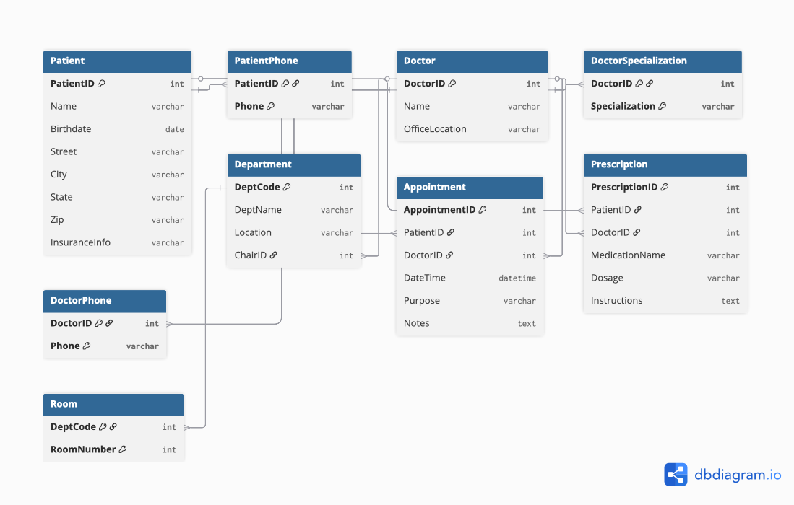

Task 2.2: E-commerce Platform

Scenario: Design a simplified e-commerce database.

Requirements:

• Customers place Orders for Products

• Products belong to Categories and are supplied by Vendors

• Orders contain multiple Order Items (quantity and price at time of order)

• Products have reviews and ratings from customers

• Track Inventory levels for each product

• Shipping addresses can be different from customer billing addresses

1 task

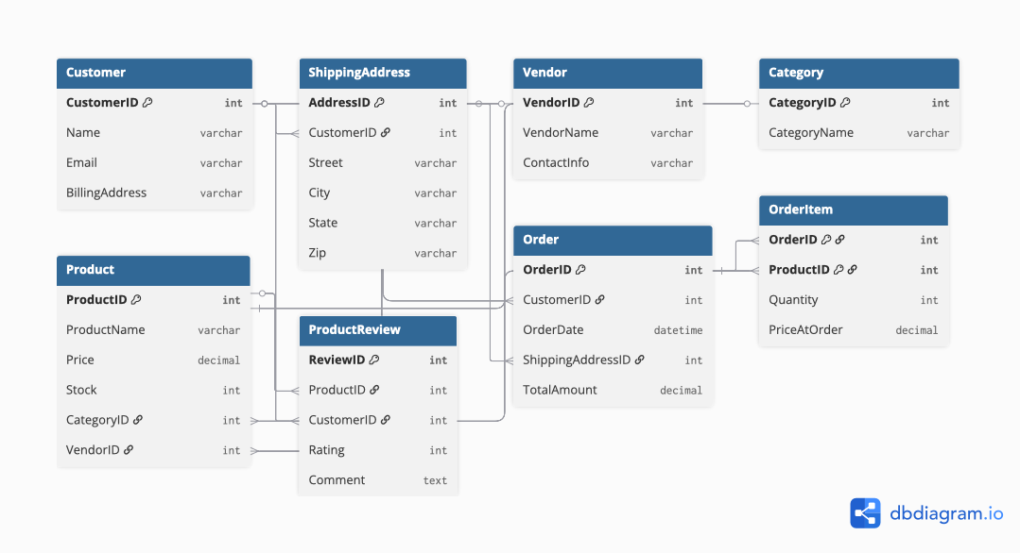

Task 2

OrderItem is weak because it depends on will there be OrderID and ProductID

Task 3

Order – Product many to many bc there can be one product that ordered 1000 times

Product – Customer

Part 4: Normalization Workshop

Task 4.1: Denormalized Table Analysis

Given Table:

StudentProject(StudentID, StudentName, StudentMajor, ProjectID, ProjectTitle,

ProjectType, SupervisorID, SupervisorName, SupervisorDept,

Role, HoursWorked, StartDate, EndDate)

Your Tasks: 1. Identify functional dependencies: List all FDs in the format A → B 2. Identify

problems: - What redundancy exists in this table? - Give specific examples of update, insert, and delete

anomalies 3. Apply 1NF: Are there any 1NF violations? How would you fix them? 4. Apply 2NF: - What is

the primary key of this table? - Identify any partial dependencies - Show the 2NF decomposition 5. Apply

3NF: - Identify any transitive dependencies - Show the final 3NF decomposition with all table schemas

1 task

StudentID → StudentName, StudentMajor

ProjectID → ProjectTitle, ProjectType

SupervisorID → SupervisorName, SupervisorDept

(StudentID, ProjectID) → Role, HoursWorked, StartDate, EndDate

2 task

Update**:** if a student changes their major, all rows must be updated.

Insert**:** it is not possible to add a new student without a project, or a new project without a student.

Delete**:** if the last student participating in a project is deleted, the data about the project and the supervisor is also lost.

3 task

Table doesnt have 1NF violations there is no matching groups

4 task

Student(StudentID [PK], StudentName, StudentMajor)  
Project(ProjectID [PK], ProjectTitle, ProjectType, SupervisorID [FK])  
Supervisor(SupervisorID [PK], SupervisorName, SupervisorDept)  
StudentProject(StudentID [PK, FK], ProjectID [PK, FK], Role, HoursWorked, StartDate, EndDate)

5 task

Student(StudentID [PK], StudentName, StudentMajor)  
Supervisor(SupervisorID [PK], SupervisorName, SupervisorDept)  
Project(ProjectID [PK], ProjectTitle, ProjectType, SupervisorID [FK])  
StudentProject(StudentID [PK, FK], ProjectID [PK, FK], Role, HoursWorked, StartDate, EndDate)

Task 4.2: Advanced Normalization

Given Table:

CourseSchedule(StudentID, StudentMajor, CourseID, CourseName,

InstructorID, InstructorName, TimeSlot, Room, Building)

Business Rules:

• Each student has exactly one major

• Each course has a fixed name

• Each instructor has exactly one name

• Each time slot in a room determines the building (rooms are unique across campus)

• Each course section is taught by one instructor at one time in one room

• A student can be enrolled in multiple course sections

Your Tasks: 1. Determine the primary key of this table (hint: this is tricky!) 2. List all functional

dependencies 3. Check if the table is in BCNF 4. If not in BCNF, decompose it to BCNF showing your work

5. Explain any potential loss of information in your decomposition

1 task

Primary key is StudentID

2 task

StudentID → StudentMajor

CourseID → CourseName, InstructorID, TimeSlot, Room

InstructorID → InstructorName

Room → Building

(StudentID, CourseID) → (StudentMajor, CourseName, InstructorID, InstructorName, TimeSlot, Room, Building)

3 task

No BCNF keys depend to each other

4 task

Student(StudentID [PK], StudentMajor)

Instructor(InstructorID [PK], InstructorName)

Room(Room [PK], Building)

Course(CourseID [PK], CourseName, InstructorID [FK], TimeSlot, Room [FK])

Enrollment(StudentID [PK, FK], CourseID [PK, FK])

5 task

Actually no risks because we just splitted and created multiple tables BCNF but all thing are the same

This recomposition of table imporves inserting deleting and updating table protects from actual data loss

Part 5: Design Challenge

Task 5.1: Real-World Application

Scenario: Your university wants to track student clubs and organizations with the following

requirements:

System Requirements:

• Student clubs and organizations information

• Club membership (students can join multiple clubs, clubs have multiple members)

• Club events and student attendance tracking

• Club officer positions (president, treasurer, secretary, etc.)

• Faculty advisors for clubs (each club has one advisor, faculty can advise multiple clubs)

• Room reservations for club events

• Club budget and expense trackingYour Tasks: 1. Create a complete ER diagram for this system 2. Convert your ER diagram to a normalized

relational schema 3. Identify at least one design decision where you had multiple valid options and

explain your choice 4. Write 3 example queries that your database should support (in English, not SQL)

Example Query Format: - “Find all students who are officers in the Computer Science Club” - “List all

events scheduled for next week with their room reservations”

1 task

Student(StudentID, Name, Email, Major, Year)

Club(ClubID, ClubName, Description, Budget, AdvisorID [FK])

FacultyAdvisor(AdvisorID, Name, Department, Email)

Membership(StudentID [FK], ClubID [FK], JoinDate, Role) ← связь Student–Club

Event(EventID, ClubID [FK], Title, Date, RoomID [FK])

Attendance(EventID [FK], StudentID [FK]) ← кто был на мероприятии

OfficerPosition(ClubID [FK], StudentID [FK], PositionTitle, StartDate, EndDate)

Room(RoomID, Location, Capacity)

Expense(ExpenseID, ClubID [FK], Amount, Category, Date, Description)

2 task

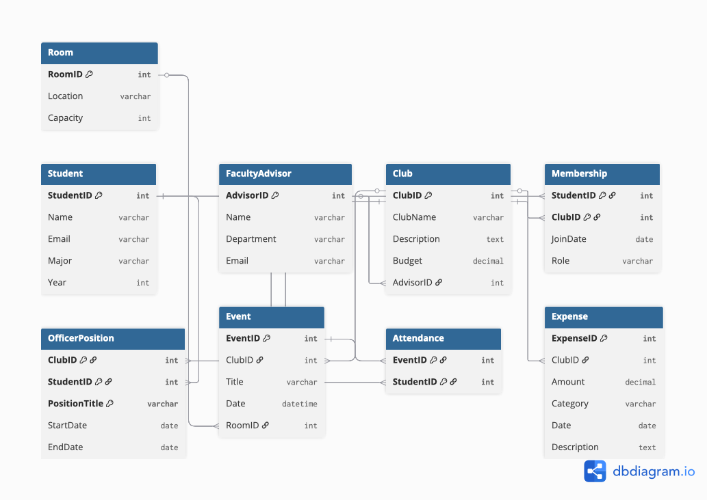

Normalized schema

Student(StudentID **PK**, Name, Email, Major, Year)  
FacultyAdvisor(AdvisorID **PK**, Name, Department, Email)  
Club(ClubID **PK**, ClubName, Description, Budget, AdvisorID **FK**)  
Membership(StudentID **PK, FK**, ClubID **PK, FK**, JoinDate, Role)  
OfficerPosition(ClubID **PK, FK**, StudentID **PK, FK**, PositionTitle **PK**, StartDate, EndDate)  
Room(RoomID **PK**, Location, Capacity)  
Event(EventID **PK**, ClubID **FK**, Title, Date, RoomID **FK**)  
Attendance(EventID **PK, FK**, StudentID **PK, FK**)  
Expense(ExpenseID **PK**, ClubID **FK**, Amount, Category, Date, Description)

Task 3

### **3) Design decision (multiple valid options)**

**Officer positions: store in Membership vs separate table**

* **Option A (simpler):** add the *Role* attribute directly to the Membership table. This keeps membership and officer roles together, but makes it difficult to handle multiple roles for the same student and to track role histories over time.
* **Option B (chosen):** create a separate OfficerPosition table linked to Membership. This allows a student to hold multiple officer roles at different times and makes it easier to record the start and end dates of each role.

I chose **Option B** because it provides more flexibility and scalability for managing officer positions.

Task 4

**1 ‘**Find all students who are officers in the Computer Science Club’.

**2’** List all events scheduled for next week with their room reservations’.

**3 ‘**Show the total expenses for each club in the current semester’.