Compiling and Running C++ Programs with TextPad and G++

- Start TextPad
  - Open the Start menu.
  - Select All Programs.
  - Under the TextPad folder, click on TextPad.
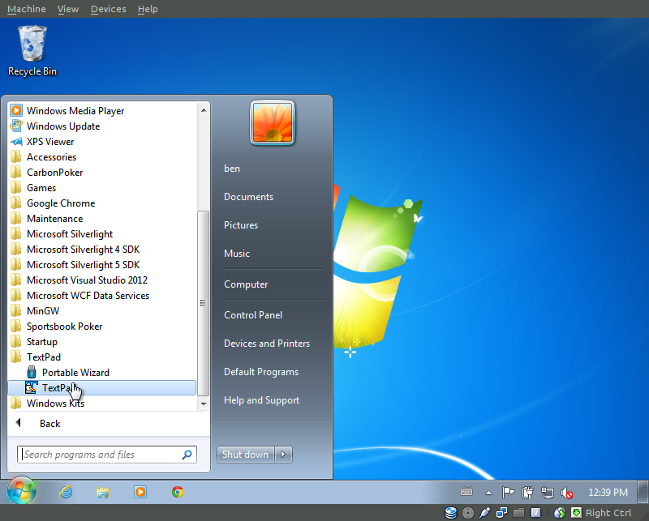
- Create a C++ source file with the TextPad editor.
  - Click the File menu.
  - Select New.
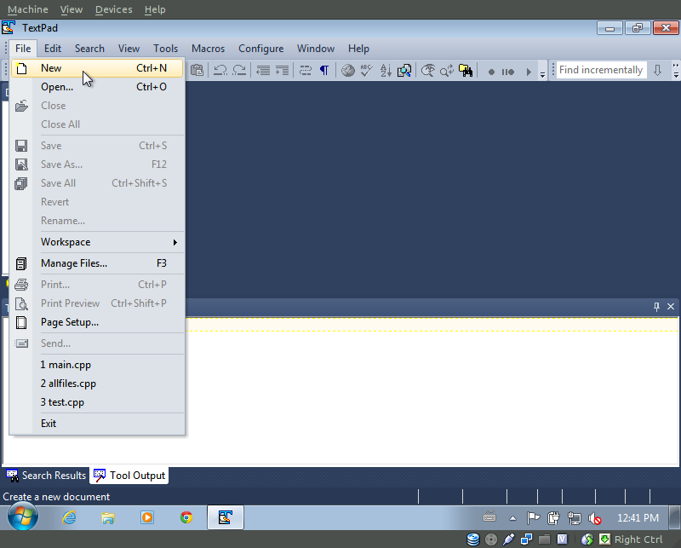
- Type your program in the text editor tab.

- Save your file.
  - Click the File menu.
  - Select Save As...
  - Enter an appropriate name for your file. (e.g. main.cpp – .cpp is the standard file extension for C++ source code. This lets the operating system and compiler know what kind of file it is).
  - Using the Save as type drop-down box, select C/C++.
Note: On some versions, this may cause the .cpp extension you just typed to become hidden. If this happens, do not worry, it is still being saved as a .cpp file.
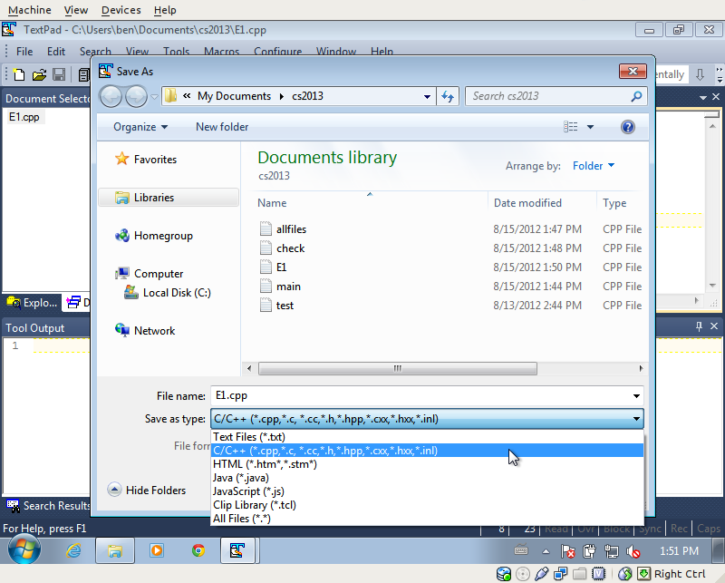

- Compile the program.
  - Ensure that cursor is in the text editor window pane (as opposed to one of the other panes, such as Tool Output).
Note: If your cursor is in the wrong window pane when you attempt to compile, you will get an error.
  - Click the Tools menu.
  - Select External Tools.
  - Choose Compile G++.
  - If the compilation stage worked properly, you will receive a message in the Tool Output tab that says, “Tool Completed Successfully.” Otherwise, see Troubleshooting (Step 7) below.
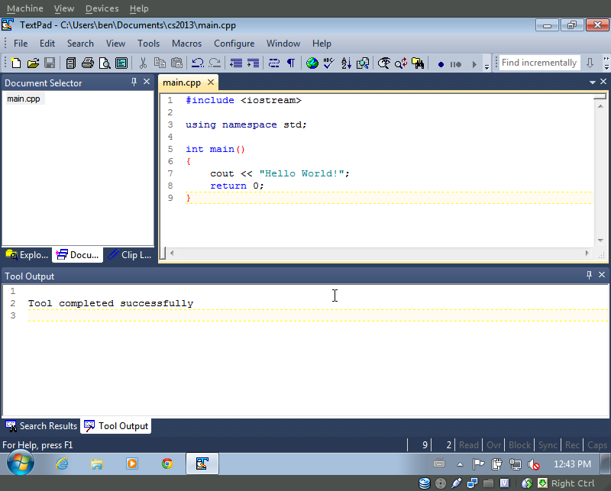

- Run the program.
  - Ensure that cursor is in the text editor tab (as opposed to one of the other tabs, such as Tool Output).
  - Click the Tools menu.
  - Select External Tools.
  - Choose Run C++
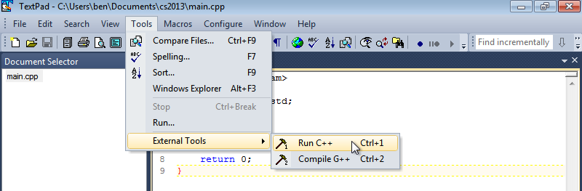

- Troubleshooting
  - If the Tool Output window says “g++.exe: fatal error: no input files” and “Tool completed with exit code 1”, this means no source code file was passed to the compiler. The most common reason for this error is that you have clicked in a window pane other than the text editor pane. Try clicking once anywhere inside your code and running the compile tool again.
If the problem persists, verify that you have TextPad properly configured.
If after re-configuring TexPad, the error still remains, please meet with one of the tutors or with Professor Matzen during office hours.
  - If you received a list of errors with their respective line numbers followed by descriptions, you must debug your program (Step 8).

- Debugging your program
  - Look at the list of errors presented in the Tool Output panel. Each error is listed by the path and file name of the source code followed by a line number and description. You should always work from the top down (smallest line number first) because solving one error will often correct some or all of the other errors as well.
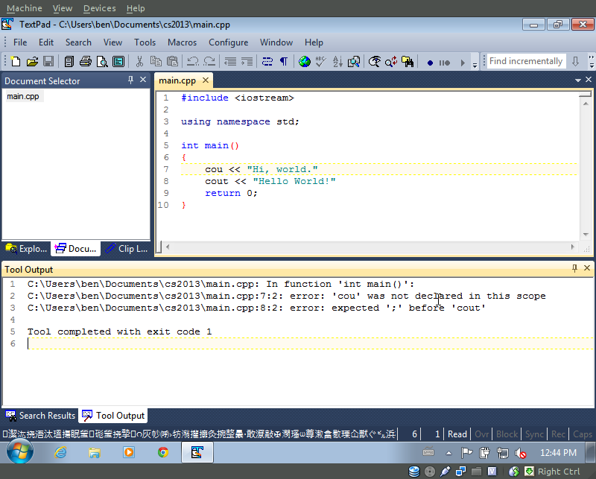
  - If TextPad/G++ are properly configured, clicking on the error message should take your cursor to the relevant line in your program.
Note: The line number given in an error is merely the compiler's best guess as to the location of the error. Because the program has syntax errors, the compiler can't know for sure what your intent is. Often times you will have to check lines in the vicinity of the suggested line number.
  - Once you believe you've corrected an error, it's helpful to try to compile again to see if your change did indeed solve the problem and to see how the list of remaining errors has changed now that the previous error was solved. (Remember to click in the source code editor panel before attempting to compile.)
  - Once you've cleared every error and compiling is completed successfully, it is time to run your program (Step 6).

Tip: It helps to have line numbers turned on when debugging. To do this: Open the Configure menu and choose Preferences. On the left side of the Preferences window, select View. Then, on the right side, click the checkbox next to Line Numbers to make them visible. Once you hit OK, you should see line numbers listed down the left side of your document.
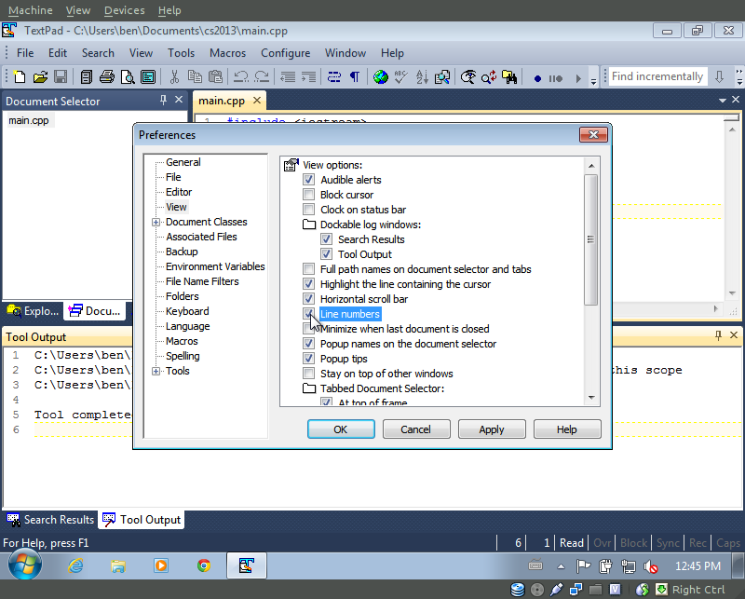
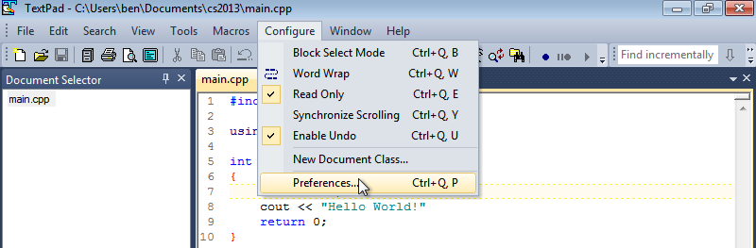

Compiling and Running C++ Programs with TextPad and G++ by Benjamin J. Kruger is licensed under a Creative Commons Attribution-ShareAlike 3.0 Unported License.
This document derived from the work of Dr. Richard Matzen

