PrEP-to-Need Ratio and Municipal HIV Trends in Brazil: Evidence for a 3:1 Coverage Benchmark

Tiago Benoliel¹, Isabela O. Pereira¹, Beatriz B. Kamiensky¹, Artur O. Kalichman¹, Draurio Barreira¹, Ana Roberta P. Pascom^{1§}

1 Department of HIV/AIDS, Tuberculosis, Viral Hepatitis and STIs, Ministry of Health, Brasilia, Brazil.

§ Corresponding author: Ana Roberta P. Pascom
SRTVN 701, PO700,
Brasília, 70.719-040, Brazil
Phone number: 55 61 3315 7641
Email: ana.roberta@aids.gov.br

E-mail addresses of authors:
TB: tiago.rocha@aids.gov.br
IOP: isabela.pereira@aids.gov.br
BBK: beatriz.brittes@aids.gov.br
AOK: artur.kalichman@aids.gov.br
DB: draurio.barreira@aids.gov.br
ARPP: ana.roberta@aids.gov.br

Keywords: Pre-exposure prophylaxis; PrEP-to-Need Ratio; HIV incidence; public health surveillance; PrEP coverage; HIV elimination goals
Word count:
Abstract: 344/350
Main text: 2075/3500
Abstract
Introduction: Brazil has rapidly expanded Pre-exposure prophylaxis (PrEP) access through public health system since 2017. However, coverage remains uneven across regions and populations, limiting its potential impact on HIV transmission. The PrEP-to-need ratio (PNR)—the ratio between PrEP users and newly detected HIV cases—has emerged as a useful metric to assess whether PrEP availability aligns with local prevention needs. This study aimed to identify the level of PNR that is associated with reductions in HIV detection across Brazilian municipalities.

Methods: Municipality-level data from national HIV and PrEP databases covering 2018–2024 were used to compute PNR and HIV detection rate for all Brazilian municipalities. The monthly growth rate of HIV detection (MGRHIV) for 2023–2024 was estimated using autocorrelation-adjusted linear regression. And HIV detection rates in the pre-pandemic period (2018–2019) and post-pandemic period (2023–2024) were compared using t-tests or Mann–Whitney tests.

Results: 258 municipalities met inclusion criteria for analyses, representing 75% of new HIV detections in Brazil in 2023-2024. Municipalities were grouped by their maximum PNR in 2022 and evaluated for HIV detection in 2023-2024. Groups that reached 3:1 or higher PNR showed the strongest declines in HIV rates, with a −1.0% MGRHIV and a 16% reduction between pre- (2018–2019) and post-pandemic (2023–2024) periods. At the individual-municipality level, 48% of those reaching the 3:1 threshold experienced decreased HIV detection, compared with 23% among those below it. These findings indicate that achieving a PNR of 3:1 is associated with greater reductions in HIV detection rates at the municipal level.

Conclusions: Municipalities that reached a PNR of 3:1 showed greater reductions in HIV detection rates, suggesting that this threshold may serve as a meaningful benchmark for PrEP expansion in Brazil. Although causality cannot be established, the findings indicate that higher PrEP coverage may reflect a stronger HIV prevention and care network and, in turn, better epidemic control. As a pragmatic indicator derived from routine health data, the PNR provides a simple tool to track PrEP scale-up, align prevention efforts with local needs, and support national progress toward ending HIV as a public health threat.

Introduction

Pre-exposure prophylaxis (PrEP) is a medication-based prevention strategy that can prevent up to 99% of HIV infections by sexual exposure [1,2]. Brazil introduced PrEP into its public healthcare system in December 2017, becoming one of the first middle-income countries to provide it free of charge. Since then, national efforts to expand access and promote PrEP as part of a combined prevention strategy have led to increased uptake, with over 160,000 individuals having received PrEP at least once in 2024 [3].
Despite this progress, PrEP coverage remains uneven across Brazilian populations, regions, states, and municipalities, limiting efforts to achieve consistent reductions in HIV transmission at the national level [3,4]. Such heterogeneity poses challenges to accurately evaluate the impact of PrEP on HIV epidemic dynamics, especially in local settings. To address this, the PrEP-to-need ratio (PNR) has been proposed as an indicator that relates the number of PrEP users to the number of new HIV diagnoses in a population, reflecting the adequacy of PrEP availability relative to potential need [5].
In Brazil, this indicator can be calculated as the ratio between the number of individuals on regular PrEP use and the number of new HIV detections registered on national health databases. This metric allows for consistent comparisons across geographic levels and time periods, providing a useful tool for monitoring PrEP coverage and its potential impact on HIV incidence.
The aim of this study was to identify the level of PrEP coverage associated with reductions in HIV incidence across Brazilian municipalities, using the PNR indicator as a measure of exposure.

Methods

Data sources and data processing
The study used anonymized, municipality-level secondary data from national health information systems of the Brazilian Ministry of Health, covering January 2018 to December 2024. It included all confirmed HIV cases, identified by the earliest available record across notification systems, CD4 and viral-load tests, antiretroviral dispensing, and mortality data [6,7]. For each month from 2018 to 2024, the number of newly detected HIV cases was calculated for all 5,570 Brazilian municipalities, along with a 3-month moving average and the cumulative number of new detections over the previous six months. The monthly HIV detection rate was then calculated by dividing the number of newly detected cases by the estimated population of the corresponding municipality.
The national PrEP dispensation database was used to estimate the number of individuals in regular PrEP use for each municipality from January to December 2022. Individuals were considered to be in PrEP use if, on the reference date, they had a valid medication dispensation (defined as being within 40% of the dispensation duration beyond its nominal end date) [6].
The ratio between the number of people using PrEP and the cumulative number of new HIV detections in the preceding six months was calculated to generate the PNR indicator for each municipality and month in 2022.
No identifiable personal information was accessed. The study was conducted in accordance with national data protection regulations and ethical standards for research using public health surveillance data. All databases used in this study are publicly available [3,7].
All analyses were performed using the Python programming language [8] within the JupyterLab [9] and Visual Studio Code [10] environments. The pandas [11] and NumPy [12] libraries were used for data organization, while Statsmodels [13] and Scikit-learn [14] were employed for statistical analyses and modeling. Data visualization and graphical analyses were conducted using Matplotlib [15] and Seaborn [16].

Monthly Growth Rate of HIV Detection (MGRHIV)
The monthly growth rate of HIV detection (MGRHIV) was estimated for HIV detection rates between January 2023 and December 2024 using the coefficient of a linear regression model adjusted for autocorrelation. The optimal order of the model was selected within the range [0–5] using the Yule–Walker method [17,18] and residuals were assessed for normality using the Shapiro–Francia test [19]. All analyses were conducted with a 95% confidence level.

Comparison between pre- and post-pandemic periods
The monthly HIV detection rate was compared between the pre-pandemic period (January 2018 to December 2019) and the post-pandemic period (January 2023 to December 2024) using Student’s t-test [20], with variance equality assessed by Levene’s test [21]. The percentage change between periods was calculated as the ratio of post-pandemic to pre-pandemic means, and 95% confidence intervals were estimated using 10,000 bootstrap resamples.
For municipalities in which the monthly HIV detection rate did not follow a normal distribution according to the Shapiro–Francia test [19], comparisons were performed using the Mann–Whitney U test [22] based on the median values. The variation between periods and corresponding 95% confidence intervals were estimated using the same bootstrap procedures described above.

Results
The indicator PNR was calculated for every month of 2022 for all 5,570 Brazilian municipalities. Only municipalities with a three-month moving average of HIV diagnoses equal to or greater than one between January 2023 and December 2024 were included in the analyses, totaling 258 municipalities nationwide. These municipalities accounted for 75% of all new HIV cases in Brazil during the period.
To explore the association between the PNR and the temporal variation in HIV detection, the maximum value of the indicator in each municipality in 2022 was used as the exposure measure. Based on this value, municipalities were classified into two groups: those with an indicator below the reference value and those with an indicator equal to or above it. For each PNR reference point, the monthly growth rate of HIV detection (MGRHIV) was estimated in both groups for the period from January 2023 to December 2024. This procedure was repeated incrementally for reference values ranging from 0.5 to 4.0, in steps of 0.1 units (Figure 1).

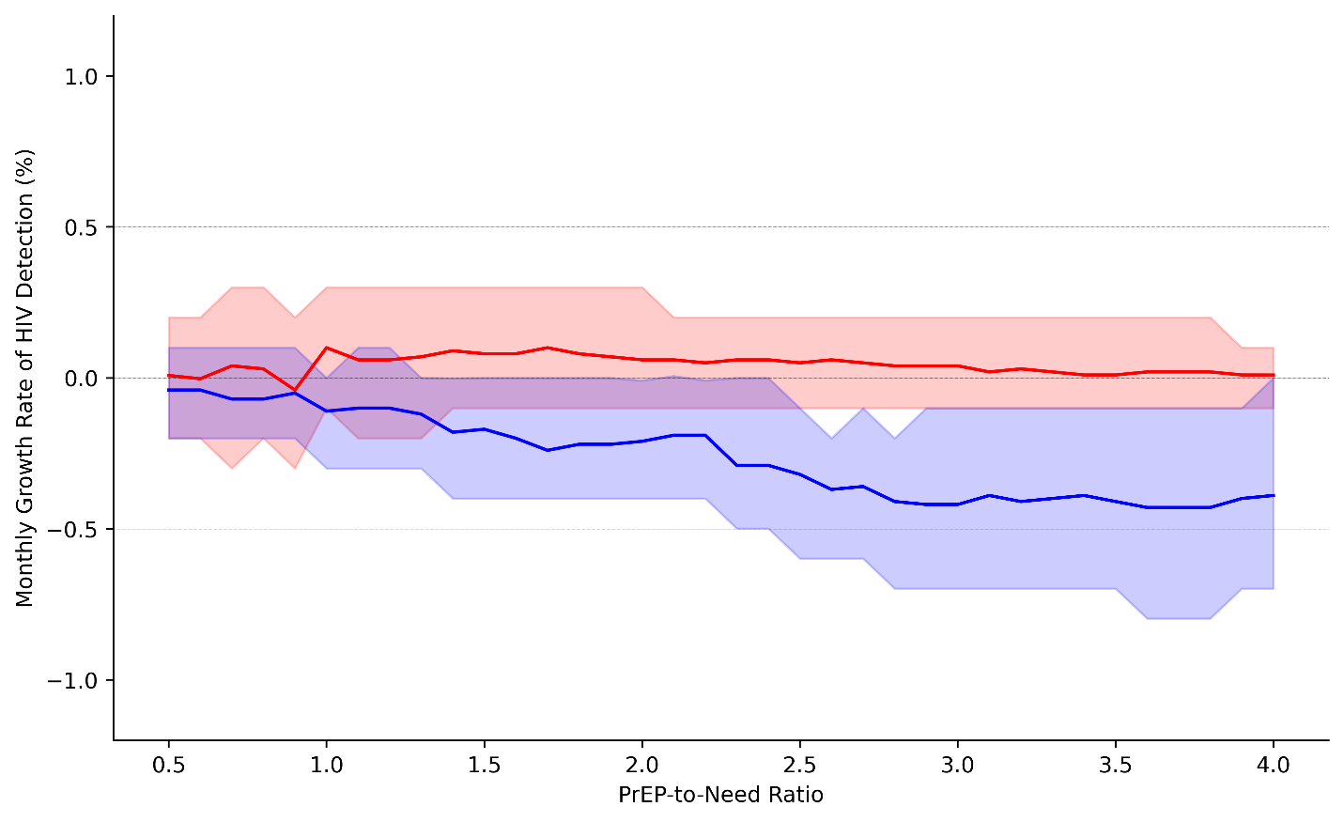
Figure 1. Monthly growth rate of HIV detection as a function of the PNR indicator. Municipalities that reached (blue) and did not reach (red) each threshold of the indicator in 2022 were compared, considering the estimated growth rate of HIV detection rate for the 2023–2024 period. Filled areas represent 95% confidence intervals.

The difference in MGRHIV between municipal groups increased with the level of the indicator, becoming significantly negative for a ratio above 2.5. This finding suggests a correlation between the indicator and MGRHIV (Figure 1). To investigate at which PNR a reduction in HIV detection rate occurs, municipalities were stratified into five groups based on the maximum indicator value reached in 2022 (Table 1). The time series of HIV detection rates in these groups, from 2018 to 2024, is shown in Figure 2.

Table 1. Municipal groups according to the PNR indicator in 2022
Group | PNR range* | Number of municipalities | Number of cases in 2022 (thousands)
Group 0 | [0.0-1.0[ | 134 | 16.4
Group 1 | [1.0-2.0[ | 60 | 11.5
Group 2 | [2.0-3.0[ | 37 | 11.6
Group 3 | [3.0-4.0[ | 17 | 2.5
Group 4 | [4.0-5.0] | 10 | 5.8
*Range containing the municipality's maximum monthly indicator value in 2022.

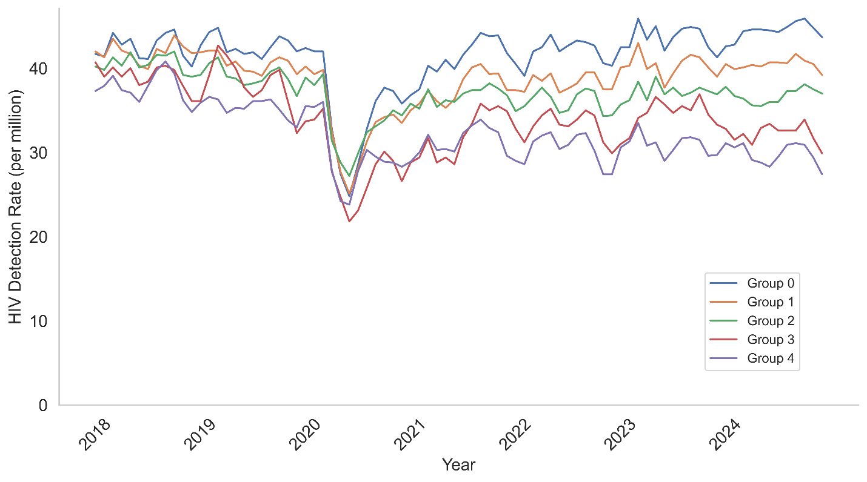
Figure 2. Time series of HIV detection rates across municipal groups. Groups were defined according to the maximum PNR achieved by each municipality in 2022.

The analysis of the HIV detection time series across the five groups suggests that differences among them became more pronounced after the COVID-19 pandemic, leading to a stratification of detection rate values that appears to correlate with the PNR indicator. To further explore this relationship, two complementary approaches were adopted. The first involved calculating MGRHIV for the five groups during the period from 2023 to 2024 (Figure 3). The second assessed the change in HIV detection rate between the pre-pandemic (2018–2019) and post-pandemic (2023–2024) periods, examining whether statistically significant differences existed among the groups (Figure 4).

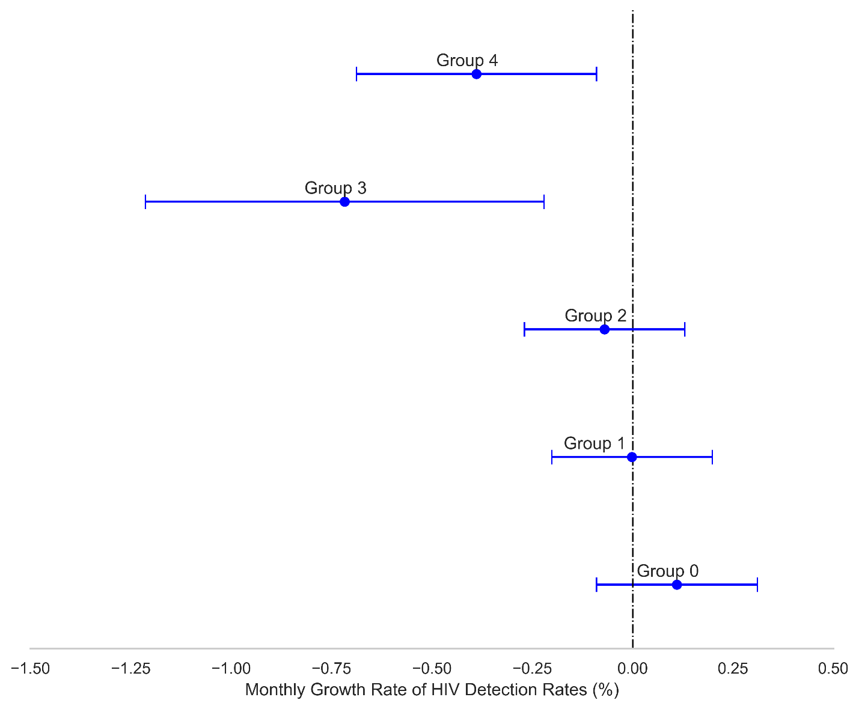
Figure 3. Monthly growth rate of HIV detection across municipal groups. Groups were defined according to the maximum PNR achieved by each municipality in 2022. The HIV detection growth rate was estimated for the 2023–2024 period, with blue bars indicating 95% confidence intervals.

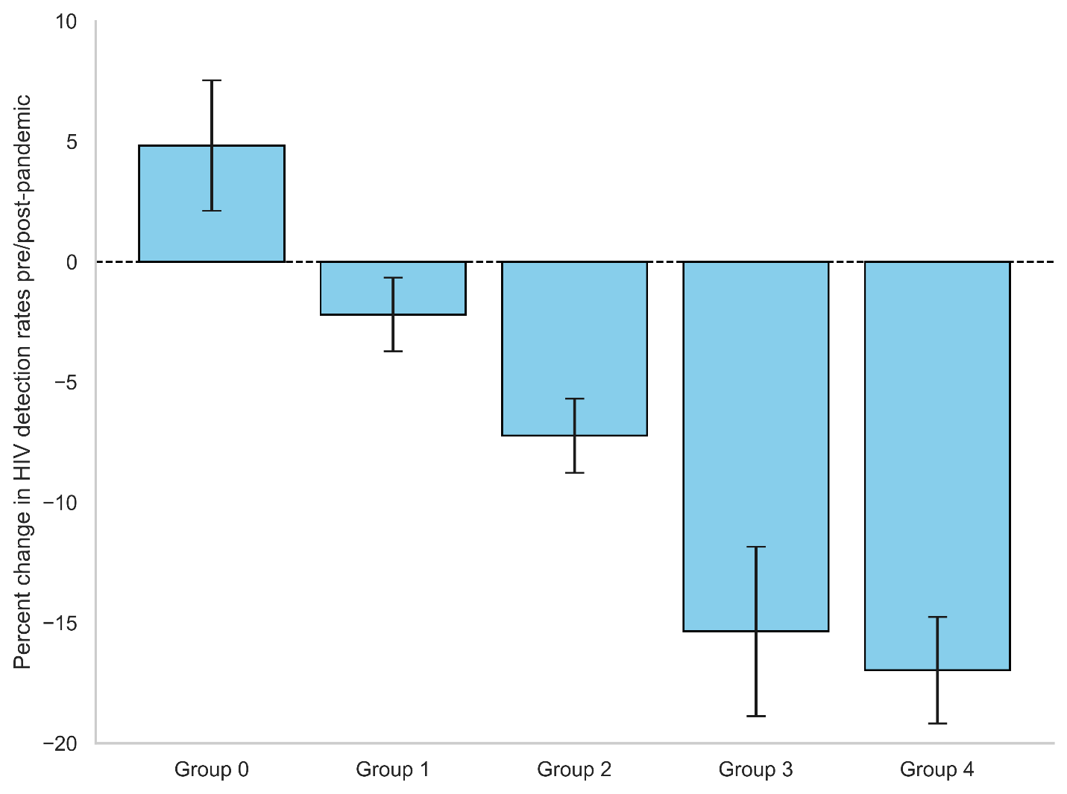
Figure 4. Percentage change in mean HIV detection rate between the pre- (Jan 2018–Dec 2019) and post-pandemic periods (Jan 2023–Dec 2024) across municipal groups. Groups were defined according to the maximum PNR achieved by each municipality in 2022. All groups showed mean values significantly different from zero (t-test with 10,000 bootstrap resamples, α = 0.05), except for Groups 3 and 4, which did not differ significantly from each other.

Only Group 0 showed a significant increase in HIV detection rate between the pre- and post-pandemic periods, whereas Groups 3 and 4 exhibited the largest reductions, approximately 15% and 17%, respectively (Figure 4). Additionally, these were the only groups to present a significantly negative MGRHIV. This suggests that a 3:1 ratio may represent a threshold at which the indicator correlates with reductions in HIV detection. To test this hypothesis, municipalities were reclassified into two groups: those that reached the indicator of three in 2022 (Group ≥3), comprising 27 municipalities, and those that did not (Group <3), comprising 231 municipalities.
The binary classification of municipalities highlights the differences between groups, with HIV detection consistently lower in Group ≥3 throughout the period from 2018 to 2024 (Figure 5). Analysis of the indicators also confirms a significantly greater reduction in HIV detection for Group ≥3, which showed an MGRHIV of −1.0% (95% CI: [−1.4%, −0.6%]) and a pre-/post-pandemic change of −16% (95% CI: [−18%, −14%]), whereas Group <3 had an MGRHIV of −0.1% (95% CI: [−0.6%, 0.3%]) and a pre-/post-pandemic change of −1.6% (95% CI: [−2.9%, −0.2%]).

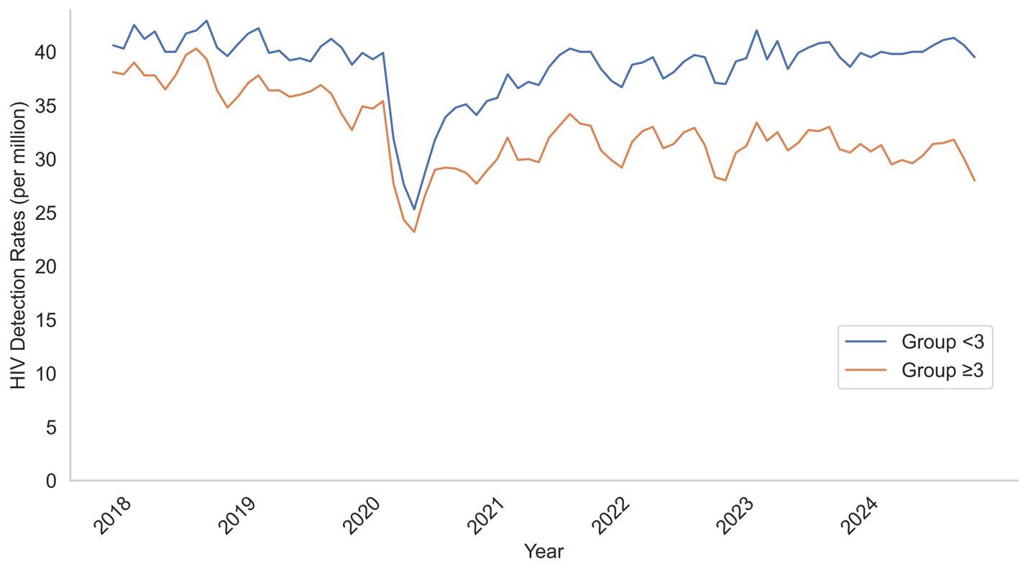
Figure 5. Time series of HIV detection rate for municipalities that reached the 3:1 PNR in 2022 and those that did not. Groups were defined according to the maximum PNR achieved by each municipality in 2022.

To further investigate the relationship between municipalities that reached the 3:1 PNR and reductions in HIV detection rates, the change in HIV detection was calculated individually for each municipality between the pre-/post-pandemic period. The proportion of municipalities exhibiting an increase, decrease, or stable detection rate was then assessed within each group (Figure 6). In Group ≥3, only 7% of municipalities showed an increase in detection, whereas 48% exhibited a decrease. In contrast, in Group <3, 28% of municipalities experienced an increase and only 23% showed a decrease, highlighting an association between achieving the 3:1 PNR and greater reductions in HIV detection rates at the municipal level.

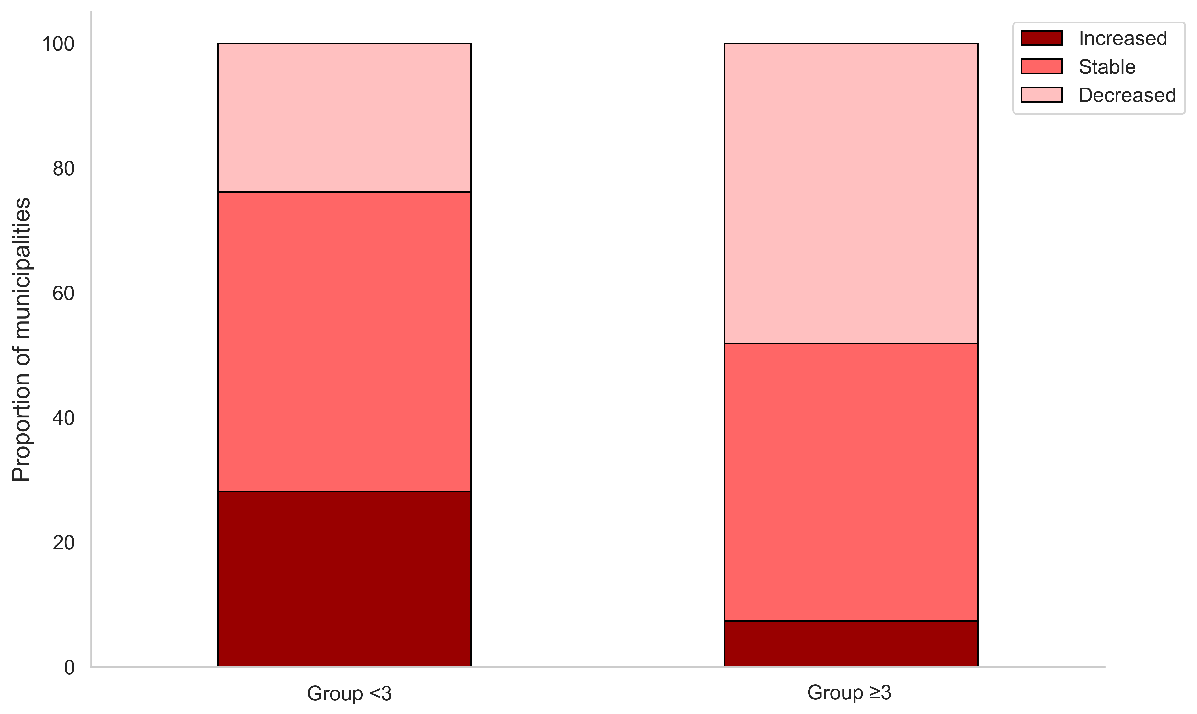
Figure 6. Distribution of municipalities that reached or did not reach the 3:1 PNR in 2022, according to changes in HIV detection rates between the pre- (Jan 2018–Dec 2019) and post-pandemic periods (Jan 2023–Dec 2024). Municipalities with mean values significantly above zero were classified as “Increased,” those significantly below zero as “Decreased,” and those not significantly different from zero as “Stable.” Statistical significance was assessed using parametric or non-parametric tests, as appropriate, with 10,000 bootstrap resamples (α = 0.05).

Discussion
The PrEP-to-Need Ratio (PNR) has been widely used worldwide to assess PrEP coverage in various contexts. In the United States and the United Kingdom, the PNR has been applied to evaluate the relationship between social determinants and unequal access to PrEP [23–27]. In Canada, this indicator is used to monitor the distribution and availability of PrEP across different regions of the country [28]. Global studies of countries supported by the U.S. President’s Emergency Plan for AIDS Relief (PEPFAR) have shown that the PNR increased by 214% across 21 countries during the COVID-19 pandemic [29]. However, when assessing the unmet need for PrEP in 48 countries in 2023, it was found that 40% had a PNR below 1.0 [30].
In Brazil, the results of this study show that achieving a 3:1 ratio in the PNR indicator is associated with a reduction in HIV detection rates at the municipal level. However, this do not configurates as evidence of a direct causal relationship. It is likely that municipalities with higher PNR values also have more structured HIV care networks, which, together with the expansion of PrEP, contributed to a stronger response during the COVID-19 pandemic and, consequently, a higher likelihood of reduced HIV detection rates in the 2023–2024 period.
The 3:1 PNR benchmark was adopted in Brazil as a programmatic target at both the national and subnational levels since 2023. Guided by the PNR, Brazil subsequently stimulated the expansion of differentiated service delivery (DSD), promoted the integration of PrEP into primary healthcare services, established telehealth (TelePrEP), and encouraged extramural activities, which consist of PrEP actions delivered outside conventional healthcare settings. This expansion considered regional specificities to ensure that PrEP delivery models could be adapted to the diverse contexts across the country.
By 2024, following this expansion, 45% of the municipalities had achieved the 3:1 ratio. However, progress remains uneven across Brazilian regions [3,7] and may also be influenced by diagnostic capacity and information-system completeness, which can affect HIV detection rates and thus the PNR independently of PrEP coverage.
With the currently available data, it is not yet possible to determine whether this expansion has had a significant impact on HIV detection rates at the municipal or national levels, but studies in the coming years may help clarify this relationship.
Despite the recognition of this indicator as an effective tool for assessing PrEP distribution across different locations and populations, defining a specific reference value that could serve as a global target for PrEP expansion and have a measurable impact on the HIV epidemic remains challenging. The structure and availability of HIV-related data vary substantially across countries [31,32], directly affecting how the indicator can be calculated. These differences make direct comparisons of indicator values between studies and countries difficult.
Nevertheless, because the PNR is a pragmatic indicator based on the most reliable data available on PrEP use and HIV detection, each country can develop its own version using routine national health information. Furthermore, this approach offers a straightforward method for calculating the PNR at different administrative levels. It does not require complex population estimates or new primary data, making the indicator practical and easy to implement widely.

Conclusions
This study demonstrates that the 3:1 level of the PNR indicator is associated with a more favorable response to the HIV epidemic, showing a higher likelihood of reduction in HIV detection rates across Brazilian municipalities. These findings suggest that the 3:1 threshold may serve as a minimum strategic target for equitable PrEP expansion in Brazil. Adopting this benchmark, alongside strengthened HIV care networks and combination prevention strategies, could play a key role in advancing HIV control and reducing incidence nationwide.
Beyond its biomedical role, PrEP also serves as an indicator of how well combined prevention strategies are implemented in a region. The PNR captures the relationship between PrEP use and the underlying need for prevention, providing a straightforward measure of the effectiveness of these collective efforts. This makes the PNR a useful metric for monitoring progress toward the goal of eliminating HIV as a public health threat by 2030.

Competing interests
All authors declare no competing interests, financial or otherwise, related to the work submitted for publication.

Authors’ contributions [Mandatory]
TB conceived the study, organized the databases, performed the analyses, drafted the manuscript, and finalized it for submission. IOP and ARPP contributed to the study design and interpretation, reviewed the manuscript, and approved the final version. AOK, BBK, and DB contributed to the discussion, reviewed the manuscript, and approved the final version.

Acknowledgements
The authors would like to acknowledge Tatianna Alencar for her valuable support during the early stages of this work.

Data Availability Statement
All databases are publicly available for download.
HIV database can be download at https://www.gov.br/aids/pt-br/indicadores-epidemiologicos/painel-de-monitoramento/painel-integrado-de-monitoramento-do-cuidado-do-hiv
PrEP database can be download at https://www.gov.br/aids/pt-br/indicadores-epidemiologicos/painel-de-monitoramento/painel-prep

List of abbreviations
Brazilian Ministry of Health (MoH)

Monthly Growth Rate of HIV Detection (MGRHIV)

Pre-exposure prophylaxis (PrEP)

PrEP-to-need ratio (PNR)

U.S. President’s Emergency Plan for AIDS Relief (PEPFAR)

References
[1] Baeten JM, Donnell D, Ndase P, Mugo NR, Campbell JD, Wangisi J, et al. Antiretroviral prophylaxis for HIV prevention in heterosexual men and women. N Engl J Med 2012;367:399–410. https://doi.org/10.1056/NEJMOA1108524.
[2] Grant RM, Lama JR, Anderson PL, McMahan V, Liu AY, Vargas L, et al. Preexposure chemoprophylaxis for HIV prevention in men who have sex with men. N Engl J Med 2010;363:2587–99. https://doi.org/10.1056/NEJMOA1011205.
[3] Ministério da Saúde. Painel PrEP — Departamento de HIV, Aids, Tuberculose, Hepatites Virais e Infecções Sexualmente Transmissíveis n.d. https://www.gov.br/aids/pt-br/indicadores-epidemiologicos/painel-de-monitoramento/painel-prep (accessed November 5, 2025).
[4] Souza JO de, Boas LPV, Cavalcante MC e, Pereira A de A, Rosa ENDP, Valdevino AV, et al. Análise do panorama da PrEP no Brasil de 2019 a 2024: indicadores, desigualdades e estratégias de prevenção. OBSERVATÓRIO DE LA ECONOMÍA LATINOAMERICANA 2024;22:e7927–e7927. https://doi.org/10.55905/OELV22N11-204.
[5] Siegler AJ, Mouhanna F, Giler RM, Weiss K, Pembleton E, Guest J, et al. The prevalence of PrEP use and the PrEP-to-need ratio in the fourth quarter of 2017, United States. Ann Epidemiol 2018;28:841. https://doi.org/10.1016/J.ANNEPIDEM.2018.06.005.
[6] Brasil. Relatório de Profilaxias PrEP e PEP 2023. Brasília: 2024.
[7] Ministério da Saúde. Painel Integrado de Monitoramento do Cuidado do HIV e da Aids 2025. https://www.gov.br/aids/pt-br/indicadores-epidemiologicos/painel-de-monitoramento/painel-integrado-de-monitoramento-do-cuidado-do-hiv (accessed March 24, 2025).
[8] Python Software Foundation. The Python Language Reference — Python 3.13.2 documentation 2025. https://docs.python.org/3/reference/index.html (accessed March 25, 2025).
[9] Jupyter Team. JupyterLab 2025. https://jupyter.org/ (accessed March 25, 2025).
[10] Microsoft Corporation. Visual Studio Code 2025.
[11] McKinney W. Data Structures for Statistical Computing in Python. Scipy 2010:56–61. https://doi.org/10.25080/MAJORA-92BF1922-00A.
[12] Harris CR, Millman KJ, van der Walt SJ, Gommers R, Virtanen P, Cournapeau D, et al. Array programming with NumPy. Nature 2020 585:7825 2020;585:357–62. https://doi.org/10.1038/s41586-020-2649-2.
[13] Seabold S, Perktold J. Statsmodels: Econometric and Statistical Modeling with Python. Scipy 2010:92–6. https://doi.org/10.25080/MAJORA-92BF1922-011.
[14] Pedregosa F, Varoquaux G, Gramfort A, Michel V, Thirion B, Grisel O, et al. Scikit-learn: Machine Learning in Python. Journal of Machine Learning Research 2011;12:2825–30.
[15] Hunter JD. Matplotlib: A 2D Graphics Environment. CSE 2007;9:90–5. https://doi.org/10.1109/MCSE.2007.55.
[16] Waskom ML. seaborn: statistical data visualization. J Open Source Softw 2021;6:3021. https://doi.org/10.21105/JOSS.03021.
[17] Walker G. On Periodicity in Series of Related Terms. Proceedings of the Royal Society of London 1931;131:518–32.
[18] Yule GU. On a Method of Investigating Periodicities in Disturbed Series, with Special Reference to Wolfer’s Sunspot Numbers. Philosophical Transactions of the Royal Society of London 1927;226:267–98.
[19] Shapiro SS, Francia RS. An Approximate Analysis of Variance Test for Normality. J Am Stat Assoc 1972;67:215. https://doi.org/10.2307/2284728.
[20] Student. The probable error of a mean. Biometrika 1908;6:1–25.
[21] Levene H. Robust testes for equality of variances. In Contributions to Probability and Statistics. Palo Alto, CA: Stanford Univ. Press; 1960.
[22] Mann HB, Whitney DR. On a test of whether one of two random variables is stochastically larger than the other. Annals of Mathematical Statistics 1947;18:50–60.
[23] Doherty R, Walsh J, Quinn K, John SA. Association of Race and Other Social Determinants of Health With HIV Pre-Exposure Prophylaxis Use: A County-Level Analysis Using the PrEP-to-Need Ratio. AIDS Educ Prev 2022;34:183–94. https://doi.org/10.1521/AEAP.2022.34.3.183.
[24] Sullivan PS, DuBose SN, Castel AD, Hoover KW, Juhasz M, Guest JL, et al. Equity of PrEP uptake by race, ethnicity, sex and region in the United States in the first decade of PrEP: a population-based analysis. The Lancet Regional Health - Americas 2024;33:100738. https://doi.org/10.1016/J.LANA.2024.100738/ATTACHMENT/A916C594-FA27-4E48-AD4D-87578C7472E5/MMC1.DOCX.
[25] Coukan F, Sullivan A, Mitchell H, Jaffer S, Williams A, Saunders J, et al. Impact of national commissioning of pre-exposure prophylaxis (PrEP) on equity of access in England: a PrEP-to-need ratio investigation. Sex Transm Infect 2024;100:166–72. https://doi.org/10.1136/SEXTRANS-2023-055989.
[26] Bunting SR, Hunt B, Boshara A, Jacobs J, Johnson AK, Hazra A, et al. Examining the Correlation Between PrEP Use and Black:White Disparities in HIV Incidence in the Ending the HIV Epidemic Priority Jurisdictions. J Gen Intern Med 2023;38:382–9. https://doi.org/10.1007/S11606-022-07687-Y.
[27] Miller SJ, Yang X, Qiao S. Longitudinal Impacts of Medicaid Expansion and Social Determinants of Health on PrEP Prevalence and PrEP-to-Need Ratio (PNR). AIDS Educ Prev 2024;36:324–40. https://doi.org/10.1521/AEAP.2024.36.5.324.
[28] Popovic N, Yang Q, Campeau L, Elliott J, Williams A, Lima VD, et al. The prevalence of HIV pre-exposure prophylaxis (HIV-PrEP) use and HIV-PrEP-to-need ratio in nine Canadian provinces, 2018–2021. Canada Communicable Disease Report 2025;51:35–42. https://doi.org/10.14745/CCDR.V51I01A05.
[29] Kerzner M, De AK, Yee R, Keating R, Djomand G, Stash S, et al. Pre-exposure prophylaxis (PrEP) uptake and service delivery adaptations during the first wave of the COVID-19 pandemic in 21 PEPFAR-funded countries. PLoS One 2022;17. https://doi.org/10.1371/JOURNAL.PONE.0266280.
[30] Mukherjee TI, Yep M, Koluch M, Abayneh SA, Eyassu G, Manfredini E, et al. Disparities in PrEP use and unmet need across PEPFAR-supported programs: doubling down on prevention to put people first and end AIDS as a public health threat by 2030. Frontiers in Reproductive Health 2024;6:1488970. https://doi.org/10.3389/FRPH.2024.1488970/BIBTEX.
[31] Garcia SA, Chen J, Calleja JG, Sabin K, Ogbuanu C, Lowrance D, et al. Availability and Quality of Surveillance and Survey Data on HIV Prevalence Among Sex Workers, Men Who Have Sex With Men, People Who Inject Drugs, and Transgender Women in Low- and Middle-Income Countries: Review of Available Data (2001-2017). JMIR Public Health Surveill 2020;6. https://doi.org/10.2196/21688.
[32] Bozicevic I, Sharifi H, Haghdoost AA, Sabry A, Hermez J. Availability of HIV surveillance data in key populations in the countries of the World Health Organization Eastern Mediterranean Region. Int J Infect Dis 2022;121:211–6. https://doi.org/10.1016/J.IJID.2022.05.003.

