

# Dharmsinh Desai University, Nadiad

### Faculty of Technology, Department of Computer Engineering B.Tech. CE Semester – VI

Subject: System Design Practice

Project Title:

**Go-On**

Submitted By:

|  |  |  |
| --- | --- | --- |
| AkbariRajkumar | CE005 | 17CEUOG126 |
| BeladiyaDarshan | CE013 | 17CEUBG057 |
| KoratVivek | CE063 | 17CEUOG128 |

Guided By:

Prof. Hari Om Pandya Assi. Professor, CE Dept.

Dharamsinh Desai University, Nadiad



# Dharmsinh Desai University, Nadiad

### Faculty of Technology, Department of Computer Engineering

#### CERTIFICATE

This is to certify that System Design Practice entitled “Go-On” is the bonafied report of work carried out by

|  |  |  |
| --- | --- | --- |
| **1) AkbariRajkumar** | **CE005** | **17CEUOG126** |
| **2) BeladiyaDarshan** | **CE013** | **17CEUBG057** |
| **3) KoratVivek** | **CE063** | **17CEUOG128** |

Of Department of Computer Engineering, Semester VI, academic year 2019-2020, under our supervision and guidance.

|  |  |
| --- | --- |
| Guide | HOD |
| **Prof.Hari Om Pandya** | **Dr. C. K. Bhensdadia** |
| Assistant Professor of | Head of the Department of |
| Department of Computer | Department of Computer |
| Engineering, Dharmsinh Desai  University, Nadiad. | Engineering, Dharmsinh Desai  University, Nadiad. |

**Content**

1. Abstract ………………………………………………………………………………………….4
2. Introduction ……………………………………………………………………………………...5
3. software requirementspecification……… ……………………………………………………...6
4. Design…………………………………………………………………….……………………...7
   1. Usecase diagram ………………………………………………………………………7
   2. Classdiagram ………………………………………………………………………….8
5. Implementation Details…………………………………………………………….……………9
6. Screen Shots…………………………………………………………………….……………...10
7. Conclusion……………………………………………………………………………………..13
8. Limitation & futureImplementationDetails 14
   1. Limitations…………………………………………………………………………..14
   2. Future implementations 14
9. Bibliography 15

1. Abstract

A Solution for tracking the live things.

-what’s going on in nearest places?

-current affairs as well as current videos of places.

-in shorts anyone can share their moments and anyone can see everyone’s moments.

-this can be useful in current days also (corona-effect).

2. Introduction

###### -Go-On is one intermediatory between users for sharing their moments as well as searching for moments .It is just storing live videos and searching in them with an efficient algorithms.

###### -searching is based on live coordinates.

Tools/Technologies

-Node-js

* RTCMultiConnection

-Ajax/jQuery/css/bootstrap

-socket.io

-HTML5 GeoLocation

3. Software Requirement Specifications

1)User

* 1. GoLive

Input : description about place, Location Output : Live video running on server

* 1. ShowLiveVideo

Input : select live video to show Output : Live video streaming

* 1. Fetch_Location

Input:it fetches location of users using HTML5Geolocation

* 1. Search
     1. nearest_search

Output: based on location coordinates it fetches data from folder andshows inwell definedformat

* + 1. recent_search

Output:based on recentness of videos (timestamp) sorts and shows on screen

* 1. Thumbnails

Output:shows All videos from folder with best algorithm R.5.1.Search (inherited R.4)

* 1. show_views

Output: Dynamic views on live videos

4. Design

###### Usecase_Diagram:

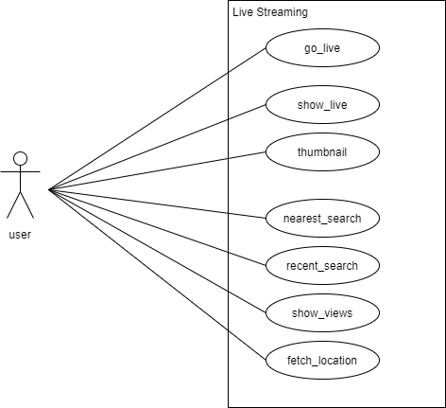

4.2 Class Diagram

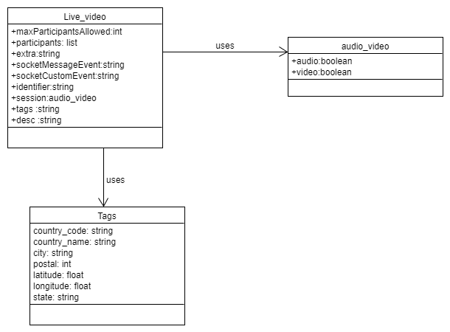

5. Implementation Details

* Live Streaming:

-Live Streaming videos using RTCMulticonnnection library and socket .io

-storing all videos in our folder with their descriptions and live coordinates

* Live Location:

-live coordinates are fetched using HTML5 geolocation API

* Search:

-75% efficient searching algorithm

-matches using frequencies of characters

-nearest search: shows nearest videos using HTML5 Geolocation APIandfetches location coordinates

* LiveViews:

-It shows live views on live videos for references as well as searching purpose

6. screen shots

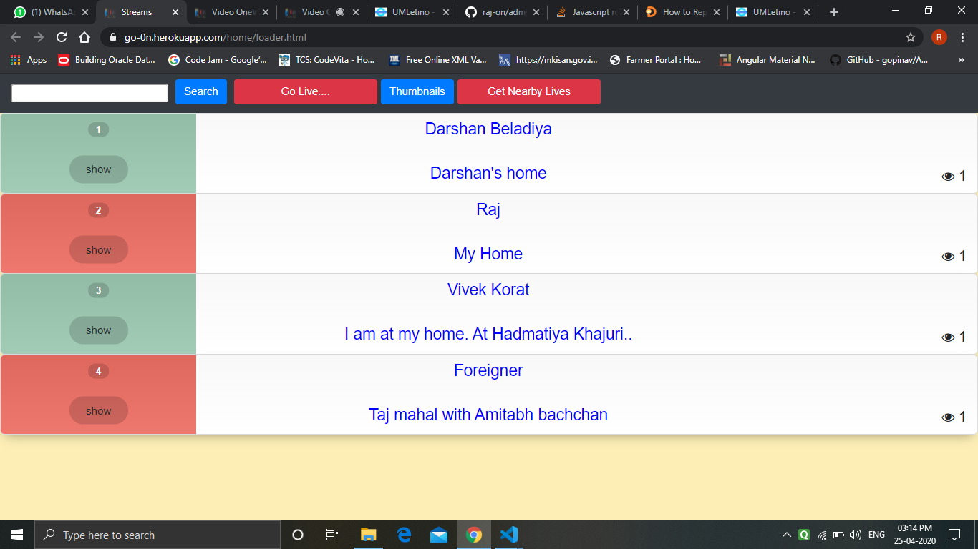

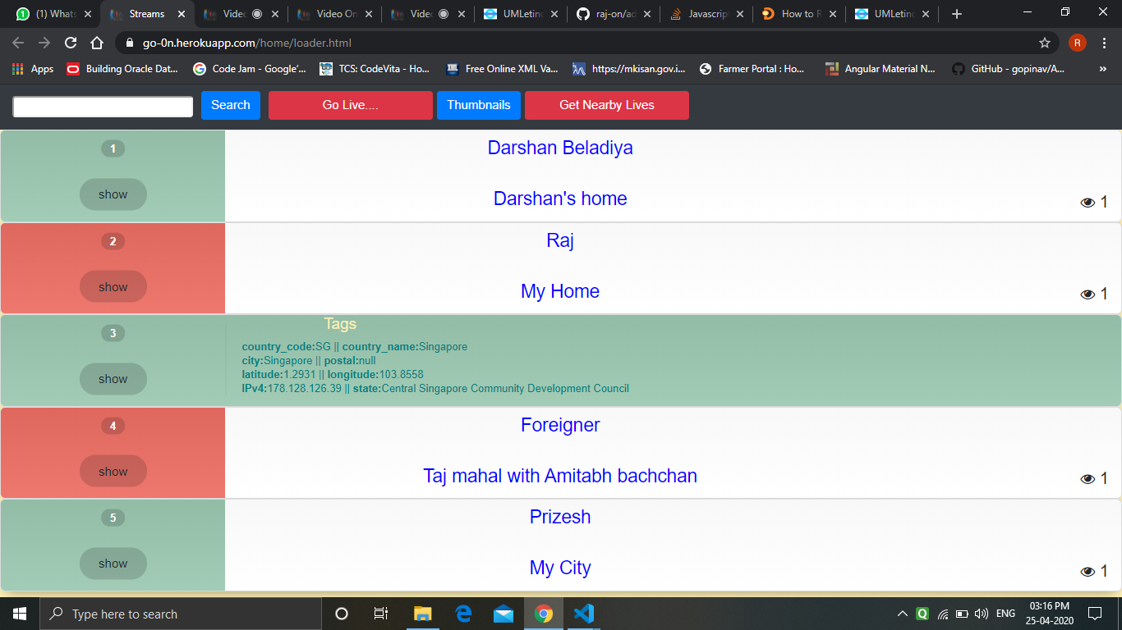

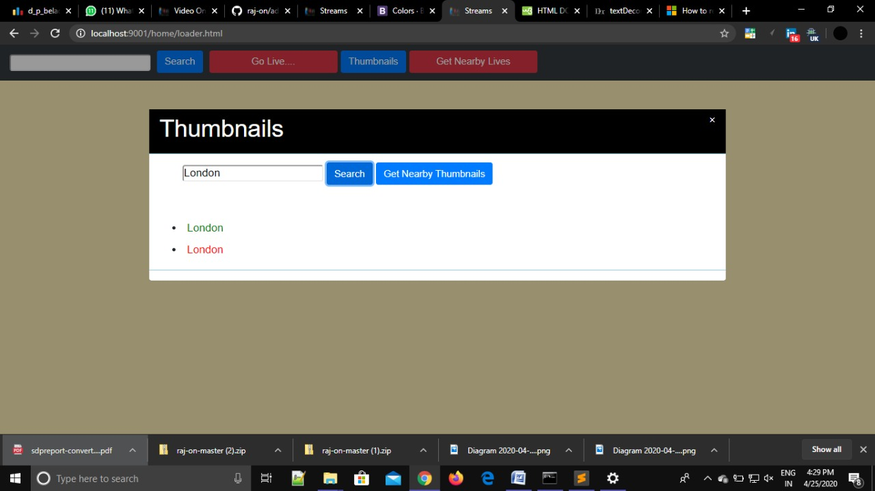

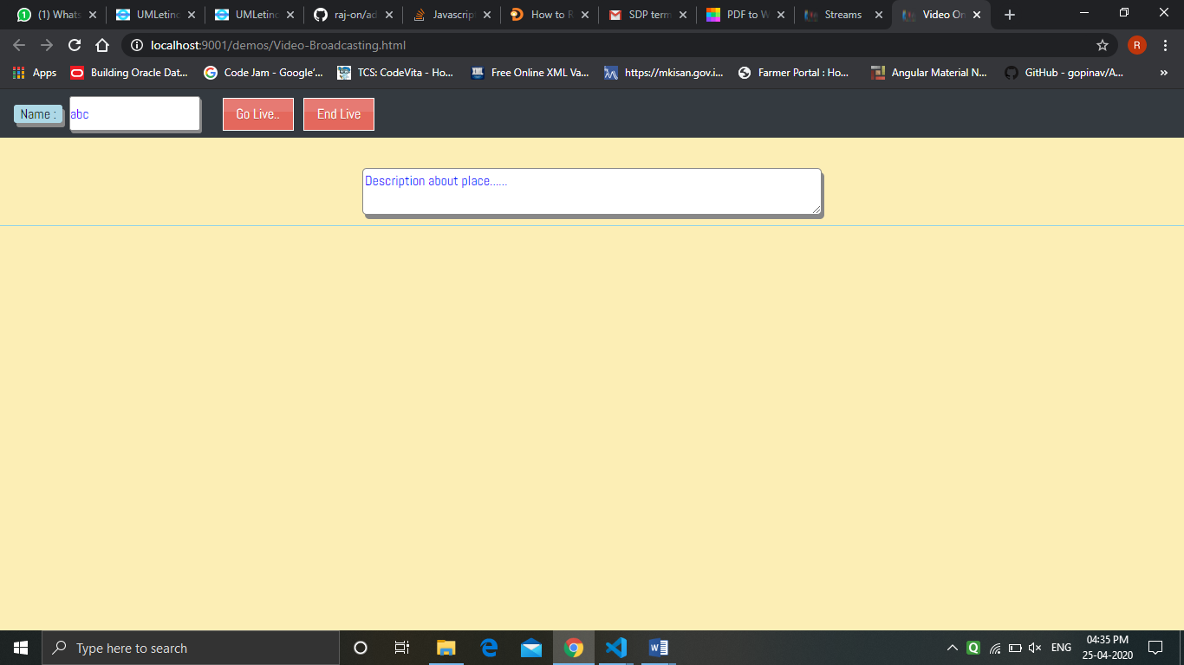

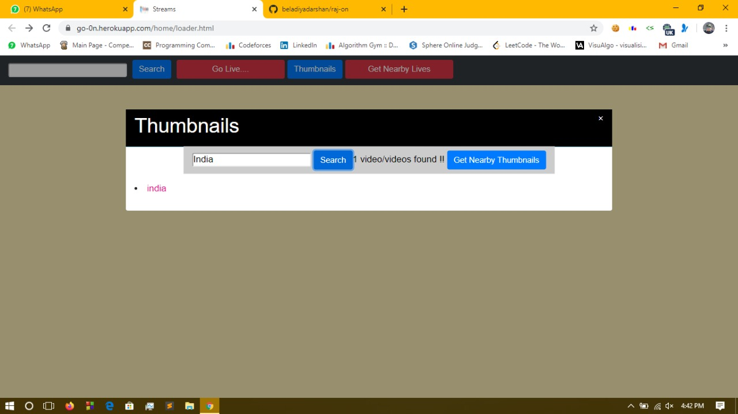

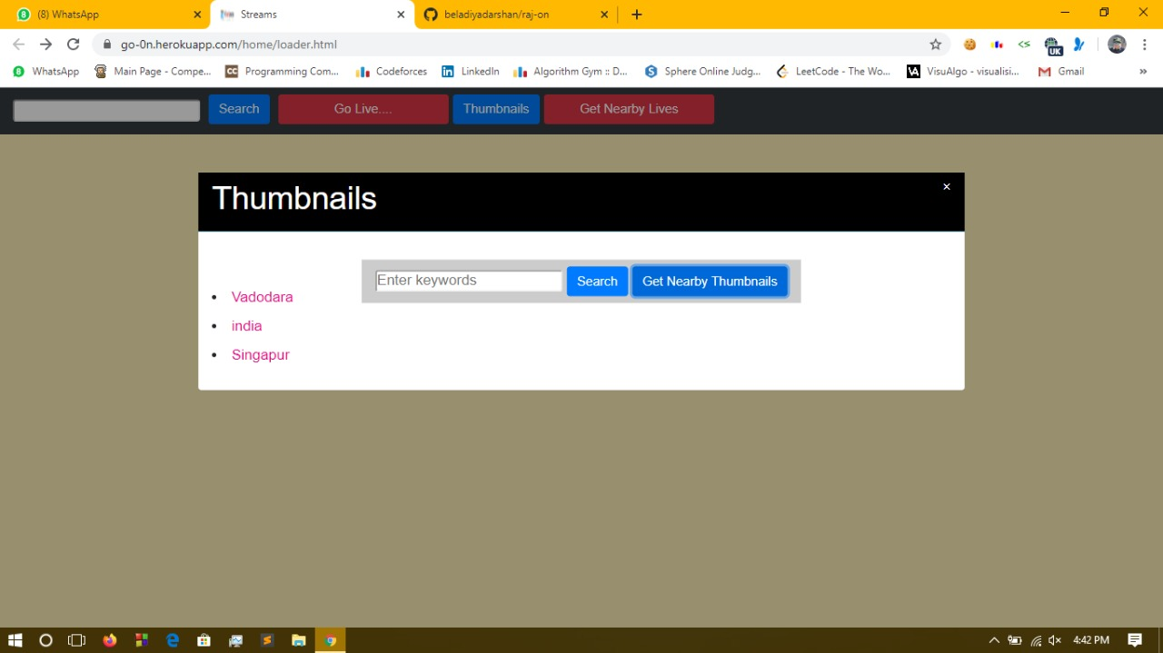

7. conclusion

-**I**t is useful in critical situations as well as happy moments of day 2 day life.

**-E**veryone will have news of every moments of every places

8. Limitations and Future Enhancements

* 1. Limitations

-Space limitations on server as well as limited live videos with server limit as well as storage limit.

* 1. FutureEnhancements

-ML detections for videosfacial

-recognition

* effects like tiktoketc…

9. Reference / Bibliography

* Standard Documentation

<https://doc-kurento.readthedocs.io/en/6.13.0/tutorials/node/tutorial-magicmirror.html>

* Exmples

<https://github.com/muaz-khan/RTCMultiConnection>