CITI BANK PAYMENT SERVER

PAYMENT RECEIPT

Citibank N.A. P.C. Box No. 4830, Anna Salai Post Oﬃce, Chennai - 600 002.

Regd No: **81347039399040**

**Receipt No:** 0056352758 **Date:** 2023-09-13

Received with thanks from Belal Moustafa Ahemad Elhemaly the sum of GBP one thousand four hundred seventy point zero by Bank with payment reference no IBAN:

EG2100590007000010000454861(Faisal Islamic Bank Of Egypt) for the Freelancer job.

**1,470**

**£**

Note: Receipt Clearance

Received By,

For, **CITI BANK PAYMENT SERVER**

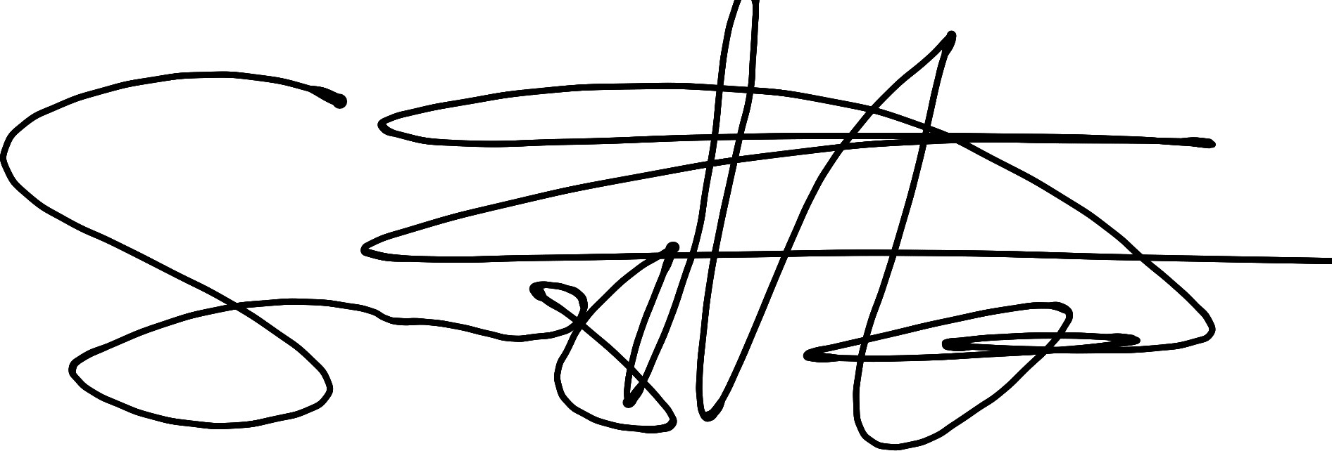

**Belal Moustafa Ahemad Elhemaly**

Status: PENDING