BDA400 | DATA SCIENCE TOOLS AND TECHNIQUES

Assignment 2
Technical Analysis Using R
Preliminary Stage
Student
Belal Al-bahrazawi
Course
BDA400 - Data Science Tools and Techniques
Repository
TechnicalAnalysis
GitHub repository link
https://github.com/belalalbahrazawi111-boop/TechnicalAnalysis

Project Overview
This report documents a preliminary R workflow for Belal Al-bahrazawi. The project reads a personal example portfolio, retrieves daily historical prices for each ticker from Yahoo Finance through quantmod, computes a moving average and descriptive statistics, then saves the data and charts under Assignment_2/outputs. The sample symbols below are for coursework practice and are not investment recommendations.

Repository and Project Files
The assignment materials belong in an Assignment_2 subdirectory within the TechnicalAnalysis repository, as required by the course instructions.
Path | Purpose
Assignment_2/portfolio.txt | One stock symbol per line.
Assignment_2/scripts/technical_analysis.R | Functions to import stock data, calculate statistics, and write tables and charts.
Assignment_2/reports/ | This report document.
Assignment_2/screenshots/ | Student-captured setup and execution evidence.
Assignment_2/outputs/ | Created by the script: daily CSV files, a summary CSV, and one chart per ticker.

Portfolio
The portfolio is illustrative. The script reads the text file instead of hard-coding symbols, so the list can be edited without changing the R functions.
Ticker | Market identifier
AAPL | Yahoo Finance symbol
MSFT | Yahoo Finance symbol
NVDA | Yahoo Finance symbol

Environment Setup
Install R, then install RStudio Desktop. Start RStudio after R is available. The exact installer and version shown in the screenshots should match the student’s computer.
- R download: https://cran.r-project.org/
- RStudio Desktop download: https://posit.co/downloads/

Evidence 1 - RStudio and R version
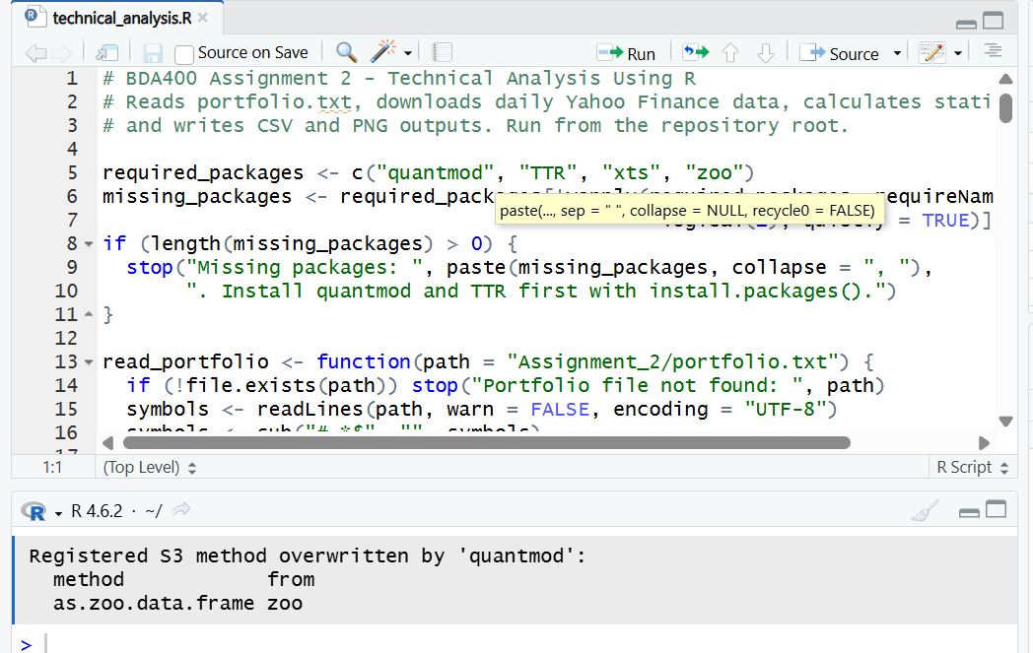
R 4.6.2 is visible in the RStudio session.

Package Installation and Project Configuration
The project uses quantmod to retrieve daily stock history and TTR to calculate the simple moving average. xts and zoo are installed as quantmod dependencies.
install.packages(c("quantmod", "TTR"), repos = "https://cloud.r-project.org")
packageVersion("quantmod")
packageVersion("TTR")
Evidence 2 - Installed package versions
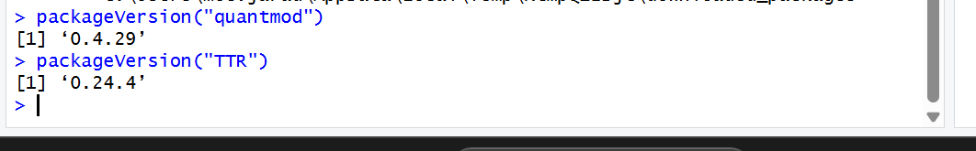
The Console confirms quantmod 0.4.29 and TTR 0.24.4.

Portfolio File
The portfolio.txt file contains one ticker per line. Blank lines and text after a # character are ignored by the reader.
AAPL
MSFT
NVDA
Evidence 3 - Portfolio file in GitHub
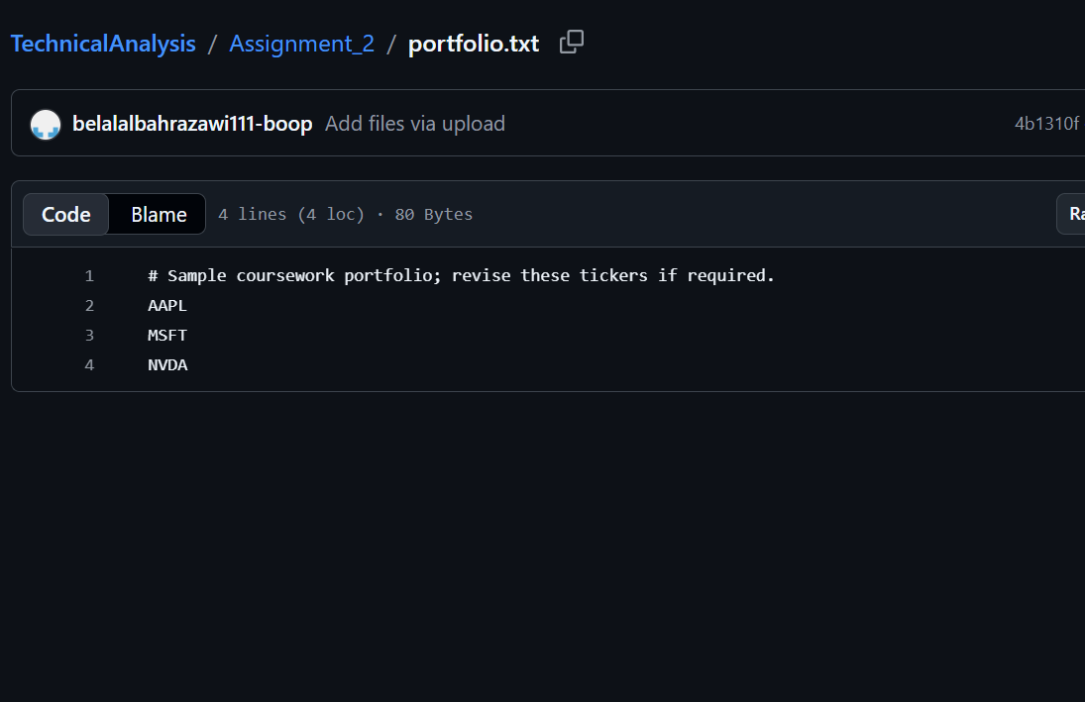
GitHub shows the portfolio file with AAPL, MSFT, and NVDA.

Import Function
read_portfolio() validates the text file and returns unique uppercase tickers. load_stock_data() requests a one-year daily history for each ticker through quantmod::getSymbols(..., src = "yahoo", auto.assign = FALSE). Each successful series is stored as its own data frame in a named list. A failed ticker produces a warning; the script stops if no series can be downloaded.

Statistics and Display
calculate_statistics() uses the adjusted closing price where available and falls back to Close if needed. The 20-day simple moving average is calculated with TTR::SMA. The mean, median, and standard deviation cover the available price observations in the selected date range. For mode, prices are rounded to two decimal places; when no rounded price repeats, the output says “No repeated value.”
Measure | Definition used
20-day moving average | Latest available simple moving average of adjusted close.
Mean and median | Descriptive summaries of adjusted close over the downloaded period.
Mode | Most frequent adjusted close rounded to two decimal places; reports no repeated value if all are unique.
Standard deviation | Sample standard deviation of adjusted close over the downloaded period.

Run the Analysis
- Install packages once using the command above.
- Set the working directory to the repository root.
- Run: Rscript Assignment_2/scripts/technical_analysis.R
- Alternatively, source the script and call run_technical_analysis().
- Review the console output and generated files in Assignment_2/outputs/
The script writes statistics_summary.csv, one daily-data CSV per ticker, and one PNG plot per ticker showing adjusted close and the 20-day moving average. The exact output depends on the selected symbols, date range, and data returned by Yahoo Finance.
Evidence 4 - Analysis output in R
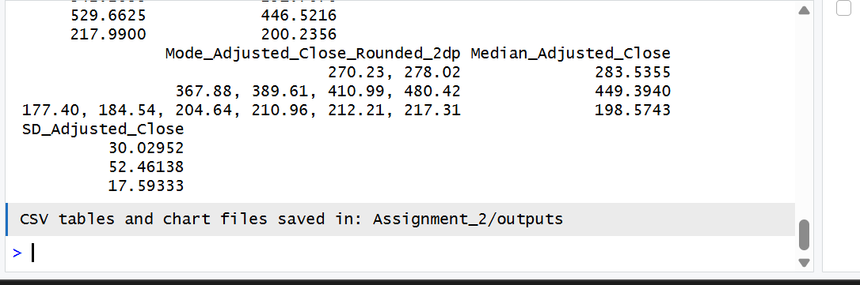
The R Console displays summary output and confirms that CSV tables and chart files were saved.

Evidence 5 - Generated AAPL chart
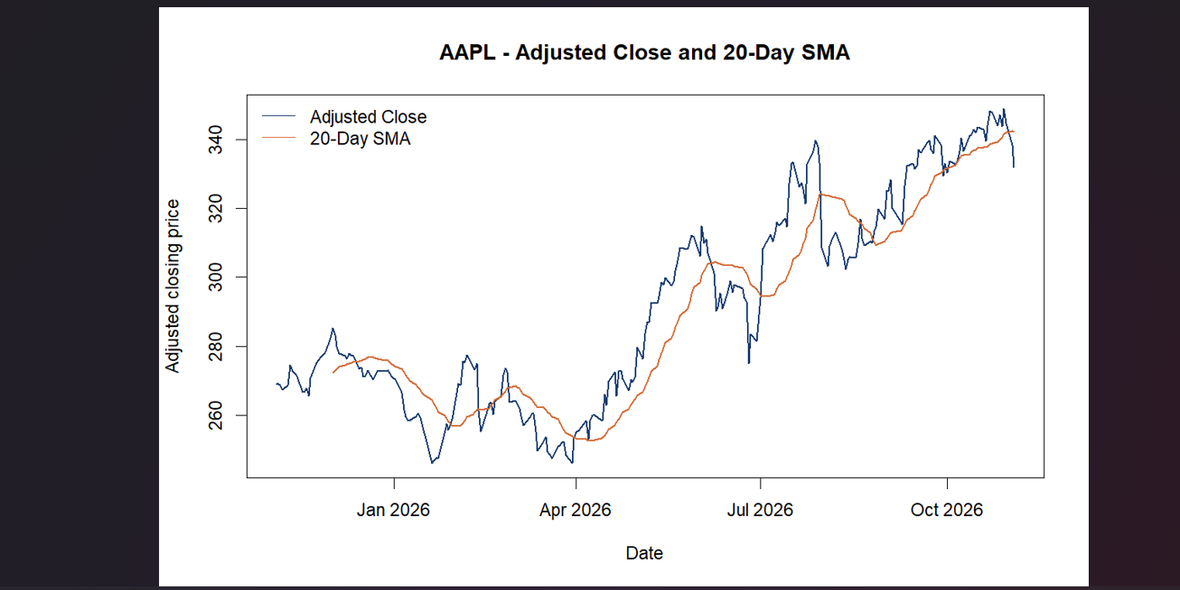
Generated chart of adjusted close and the 20-day simple moving average for AAPL.

Documentation Evidence
The screenshots below document the R environment, package versions, portfolio configuration, analysis output, chart, and GitHub project files.
Evidence 6 - GitHub project structure
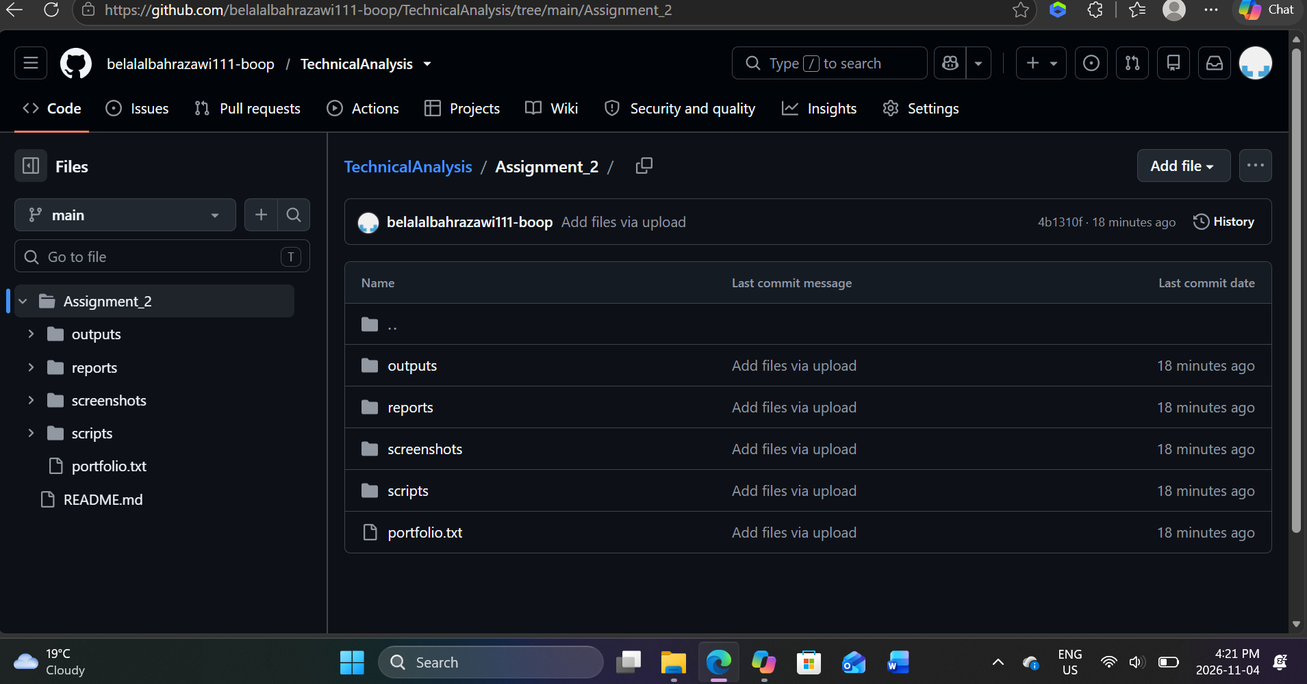
GitHub shows the Assignment_2 project folders and portfolio file.

Evidence 7 - R script in GitHub
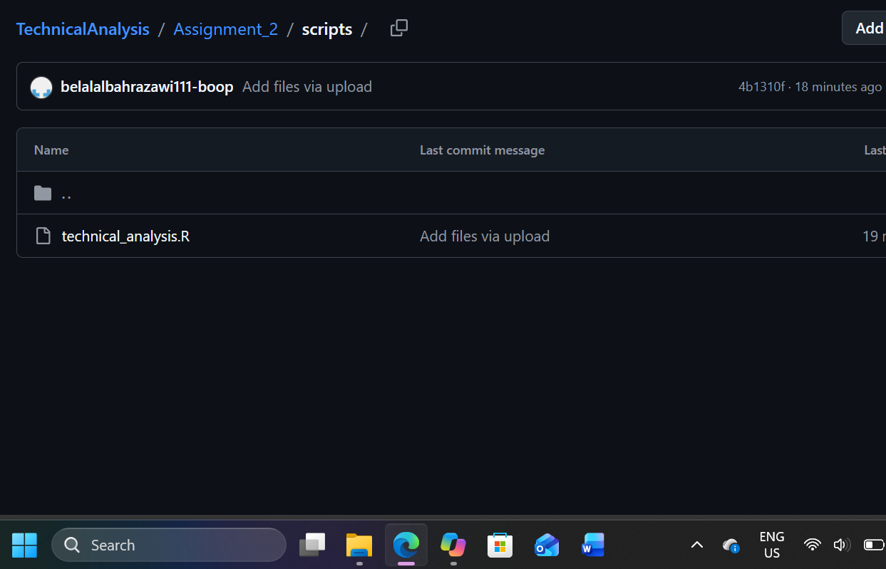
GitHub shows technical_analysis.R in the scripts folder.

Evidence 8 - Generated outputs in GitHub
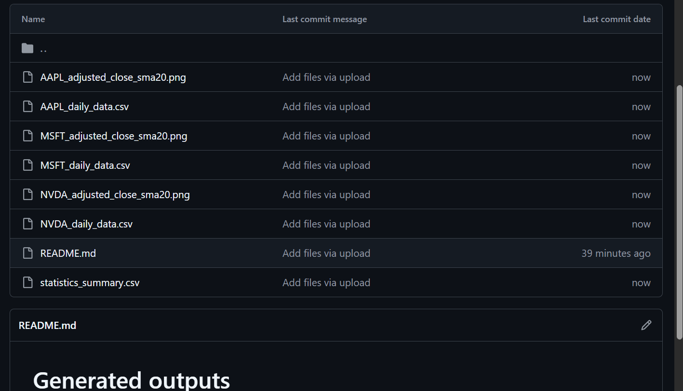
GitHub shows the generated CSV and PNG output files.

Review Checklist
- Repository is named TechnicalAnalysis and contains Assignment_2/.
- portfolio.txt contains the student’s intended symbols, one per line.
- quantmod and TTR are installed and the data retrieval completed for every ticker.
- Summary, per-ticker CSV files, and charts were generated and reviewed.
- The report includes genuine screenshots from the project setup, analysis, and GitHub repository.
- The repository URL on the cover opens the correct student-owned repository.

References
Course materials: BDA400 Assignment 2 - Technical Analysis Using R, Preliminary Stage, supplied in the LMS.
quantmod documentation: https://search.r-project.org/CRAN/refmans/quantmod/html/getSymbols.html
TTR simple moving average documentation: https://search.r-project.org/CRAN/refmans/TTR/html/SMA.html
R download: https://cran.r-project.org/ | RStudio Desktop: https://posit.co/downloads/

