T3N Agent Build Challenge

Confidential Invoice
Approval Agent
A T3N TEE agent for privacy preserving enterprise invoice decisions
Project | Confidential Invoice Approval Agent
Network | T3N testnet
Contract | invoice-approval, version 0.1.2, active
Repository | github.com/belalangeth/T3N-TASK

1. Project summary
Invoice approval is a practical confidential workflow. A host agent needs a decision, but it should not receive the tenant approval policy, duplicate invoice history, or internal notes. This project keeps those values inside a T3N TEE contract and returns only the information needed by the caller.
The agent supports three outcomes: approve, review, and reject. It validates input before dispatch, uses a private tenant KV map for policy and duplicate markers, and exposes a narrow delegated function to a separate funded agent identity.

2. Public repository and evidence
Public GitHub repository: https://github.com/belalangeth/T3N-TASK
Submission draft in the repository: https://github.com/belalangeth/T3N-TASK/blob/main/docs/submission.md
Bug report in the repository: https://github.com/belalangeth/T3N-TASK/blob/main/docs/bug-report.md

3. Architecture
The application boundary is deliberately small:
- Agent client authenticates with T3N and submits an allowlisted invoice payload.
- Rust WASM component runs as a TEE contract compiled for wasm32-wasip2.
- Private tenant KV stores the approval policy and seen invoice identifiers.
- The contract returns a redacted summary, decision, and reasons.
- The browser demo receives no tenant key or agent key. T3N calls remain server side.
Agent client -> T3N authenticated session -> invoice-approval TEE
|
+-- private tenant KV: policy
+-- private tenant KV: seen:<invoice_id>

4. Policy and privacy boundary
- USD is the seeded demo currency.
- Invoices at or below the 5,000 USD auto approval limit are approved.
- Invoices above the limit are routed to review.
- Malformed invoices, unsupported currencies, and duplicate identifiers are rejected.
- Purchase order values, tenant policy values, and duplicate map contents never leave the contract.

5. Live verification results
Scenario | Result | Evidence
Valid USD invoice | approve | Live tenant invocation
Duplicate invoice identifier | reject | Private KV duplicate marker
Invoice above limit | review | Policy boundary
Unsupported currency | reject | Currency validation
The verification scripts are available in the repository:
- scripts/invoke-demo.mjs
- scripts/verify-failure-paths.mjs

6. Delegated authorization proof
The tenant identity and application agent use separate T3N identities. The tenant granted only evaluate-invoice to the funded agent DID. set-policy was not included in the grant.
- Separate agent DID authentication: verified.
- Delegation grant readback: verified.
- evaluate-invoice authorization: authorised true.
- set-policy authorization: authorised false.
- Delegated evaluate-invoice invocation: approved.
- Delegated set-policy invocation: rejected with function_not_delegated.
- Agent balance decreased after the delegated invocation, proving agent-side metering.

7. Screenshots
The following screenshots show the contract verification output and the live delegated dapp result.
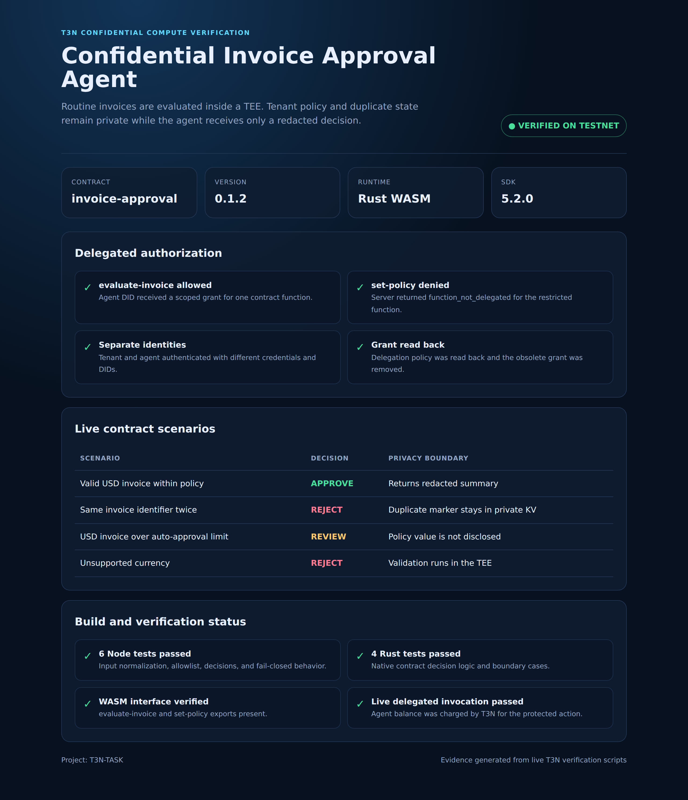
Figure 1. T3N contract deployment, descriptor, and verification evidence.
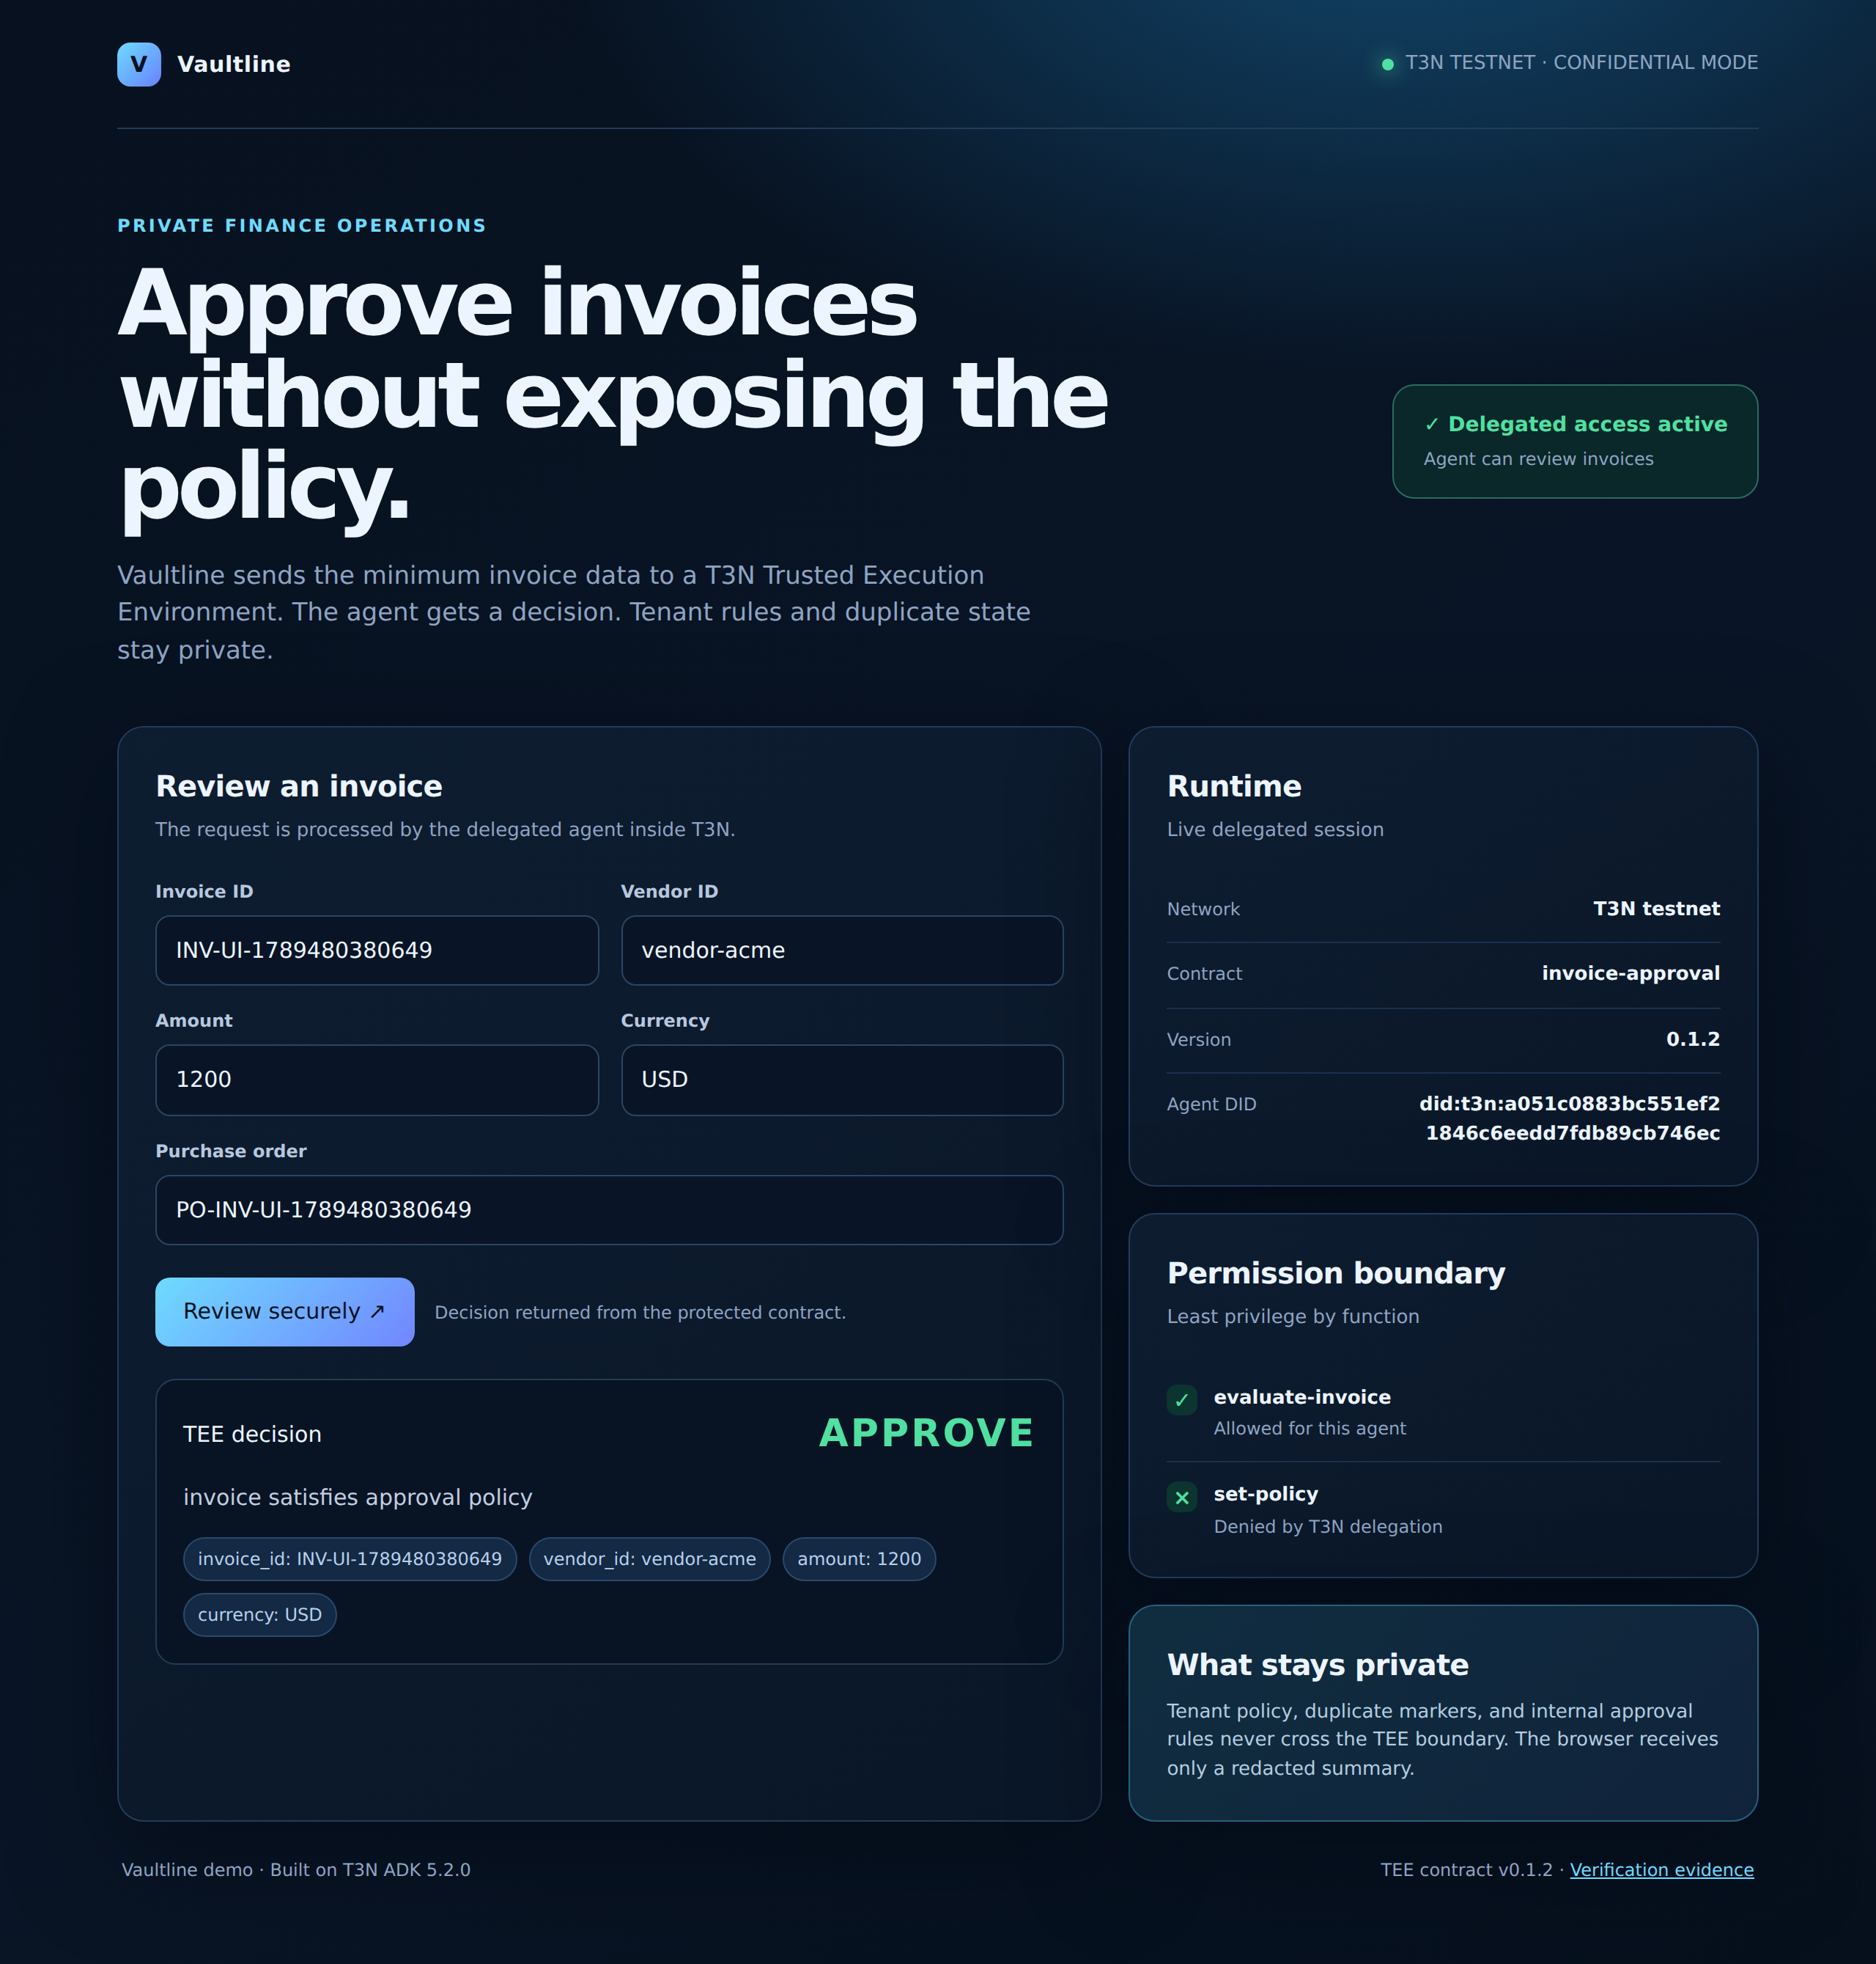
Figure 2. Thin Vaultline dapp showing a live delegated approval result.

8. SDK and documentation findings
The following integration findings were recorded during implementation with @terminal3/t3n-sdk@5.2.0:
- Current descriptor validation uses returns for a function return schema. The older returns_schema spelling failed validation.
- The SDK invocation surface uses functionName, while contract payload fields use snake_case such as invoice_id and vendor_id.
- Delegated authorization is separate from agent credit. A separate agent DID needs its own funded balance for metered execution.
Detailed reproduction notes are in docs/bug-report.md in the public repository.

9. Reviewer runbook
Requirements: Node 20 or newer, Rust, the wasm32-wasip2 target, wasm-tools, and a T3N testnet API key supplied through the environment only.
npm install
npm test
cargo test --manifest-path contract/Cargo.toml
cargo build --manifest-path contract/Cargo.toml --target wasm32-wasip2 --release
node scripts/invoke-demo.mjs
node scripts/verify-failure-paths.mjs
npm run dev
Never commit an environment file or place an API key in the browser, source code, screenshots, or documentation.

10. Maintenance and handover
- Keep the contract policy and KV naming scoped to the tenant context.
- Run Node tests, Rust tests, formatting, WASM build, and live failure path checks before release.
- Review the descriptor after every contract version change and read it back from T3N.
- Keep delegated grants limited to the exact functions required by each application agent.
- For handover, provide the public repository, deployment identifiers, runbook, testnet configuration instructions, and grant management procedure. Never transfer credentials through the repository.

11. Submission checklist
- Public GitHub repository: complete.
- Screenshots embedded in this document: complete.
- Bug findings documented: complete.
- Public Google Doc: upload this .docx to Google Docs, then set General access to Anyone with the link and Viewer.
- Superteam Earn submission: paste the public Google Doc URL and repository URL into the submission form.
All examples use synthetic invoice data. No private customer or financial records are included.

