Gravity Books DWH Documentation

Team Members:

* Belal Mohammad Eltaiby
* Haidy Hossam
* Mohammad Ghareeb
* Medhat Sobhy

DHW Schema Diagram:

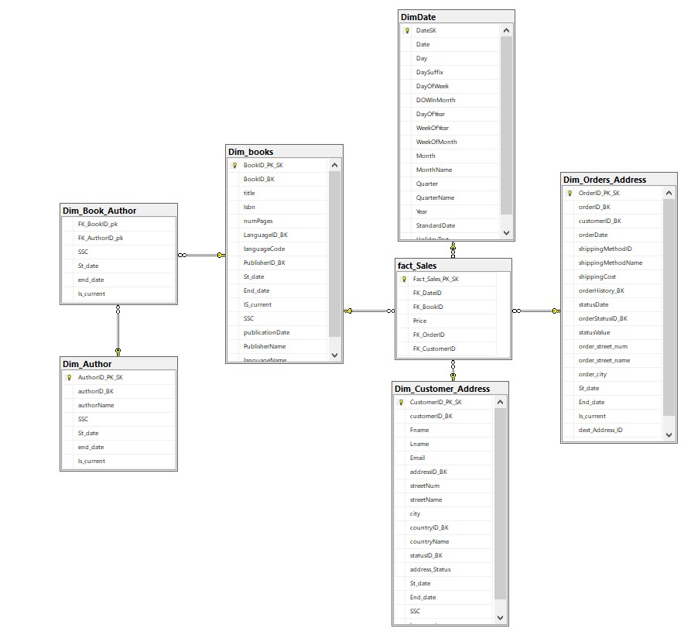

**DWH DDL Statement & Mapping:**

* **Link to the schema mapping Excel sheet:**

[**https://docs.google.com/spreadsheets/d/1k30Djd6lgteSnprG79aXEDHXA1-8ZTdH/edit?usp=sharing&ouid=102121981167089002487&rtpof=true&sd=true**](https://docs.google.com/spreadsheets/d/1k30Djd6lgteSnprG79aXEDHXA1-8ZTdH/edit?usp=sharing&ouid=102121981167089002487&rtpof=true&sd=true)

* **Link to the DDL SQL file:**

https://drive.google.com/file/d/1ngxah20lyObCiIy2gvn0Y0nQVKmDIRY_/view?usp=sharing

**DWH Schema Approach:**

* **Snowflake Schema:**

Due to the Many-Many relationship between Books and Authors Tables, We decided to normalize this part of the schema.

Schema Components:

1. Dim_Customer_Address
2. Dim_Order_Address
3. Dim_books
4. Dim_Authors
5. Dim_Book_Author (Bridge)
6. Fact_sales (fact table)

**Methods for integrity:**

* Adding attributes: Start_date, End_date, Is_current and SSc will maintain the integrity and the ability for Slowly Changing dimensions in addition to adding data sources without fear of Duplicates (Surrogate key also helps in this).
* Incremental loading of data into Fact table.
* Adding Date dimension to track historical changes.

SSIS Packages:

1. **Dim_books:**

*Source Data:*

select B.book_id, B.title, B.isbn13,B.num_pages,B.publication_date,

BL.language_id,BL.language_name,BL.language_code,

PB.publisher_id,PB.publisher_name

from dbo.book B

left join book_language BL

on B.language_id = BL.language_id

left join publisher PB

on B.publisher_id = PB.publisher_id

*Types of changes:*

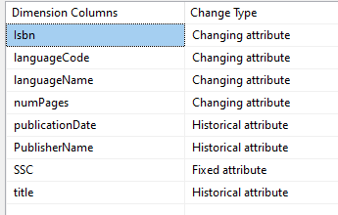

1. **Dim_Authors:**

*Source Data:*

select author_id, author_name

from author

*Types of changes:*

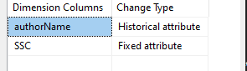

1. **Dim_book_Author:**

*Source Data:*

SELECT

DB.BookID_PK_SK,

DA.AuthorID_PK_SK

FROM

[DESKTOP-PKR2U6N].[gravity_books].[dbo].[book_author] GB_Src

JOIN Dim_books DB ON GB_Src.book_id = DB.BookID_BK

JOIN Dim_Author DA ON GB_Src.author_id = DA.authorID_BK;

*Types of Changes:*

**

1. **Dim_Customer_Address:**

*Source Data:*

select C.customer_id,C.first_name,C.last_name,C.email,

ADDR.address_id,ADDR.street_number,ADDR.street_name,ADDR.city,

Cntry.country_id,Cntry.country_name,

ADDS.status_id,ADDS.address_status

from customer C

left join customer_address CAdd

on C.customer_id = CAdd.customer_id

left join address_status ADDS

on CAdd.status_id = ADDS.status_id

left join address ADDR

on CAdd.address_id = ADDR.address_id

left join country Cntry

on ADDR.country_id = Cntry.country_id

order by C.customer_id asc

*Types of Changes:*

1. **Dim_Order_Address:**

*Source Data:*

select Cord.order_id,cord.order_date,

ShipM.method_id,ShipM.method_name,ShipM.cost,

OrdHis.history_id,OrdHis.status_date,

OrdSt.status_id,OrdSt.status_value,

Cus.customer_id,

addr.street_number,addr.street_name,addr.city,Addr.address_id

from cust_order Cord

left join shipping_method ShipM

on Cord.shipping_method_id = ShipM.method_id

left join order_history OrdHis

on Cord.order_id = OrdHis.order_id

left join order_status OrdSt

on OrdHis.status_id = OrdSt.status_id

left join customer Cus

on Cord.customer_id = Cus.customer_id

left join address Addr

on Cord.dest_address_id = Addr.address_id

left join country Cntry

on Addr.country_id = Cntry.country_id

order by order_id asc

*Types of changing:*

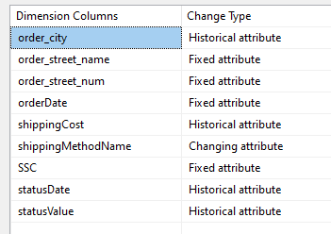

1. Fact_sales Package:

*Source data:*

select Cord.order_id,cord.order_date,

Cus.customer_id,

B.book_id,

ordlin.price

from cust_order Cord

left join shipping_method ShipM

on Cord.shipping_method_id = ShipM.method_id

left join customer Cus

on Cord.customer_id = Cus.customer_id

left join order_line ordlin

on Cord.order_id = ordlin.order_id

left join book B

on ordlin.book_id = B.book_id