Backend Case Study Task
Task Description Document

- Technologies and Tools
- Spring MVC
- Spring Security
- Hibernate
- MySQL
- Maven
- Github URL
- https://github.com/belalgalal/case-study
- Running on a local server
- Download the “BackEndTask.war” WAR file that is located on the Github repository.
- Make sure that the connection URL is “localhost” with port number “3306”. Also the username/password must be “root/admin”.
- Create a local MySQL schema through running the CaseStudy-Schema.sql file that is located on the Github repository under the “script” directory.
- Deploy the application WAR file to your local Tomcat server.
- Assuming that your local Tomcat server port is 8080, you can navigate to the application from your browser through the URL: http://localhost:8080/BackEndTask/.
- Applied Functionality
  - Create new user, user login & log out.
  - Create, edit and remove collections of monuments (multiple collections per user; attributes: name of collection).
  - Add, edit and remove monuments (multiple per collection; fields: name of monument, description, category).
  - Create, edit and remove categories for monuments (user defined categories; i.e.: church, palace, castle, etc.).
  - Add, edit and remove pictures (multiple pictures per monument; attributes: name, description, date).
  - Allow text field search for monuments by monument name or category and display results.

  - ERD Diagram
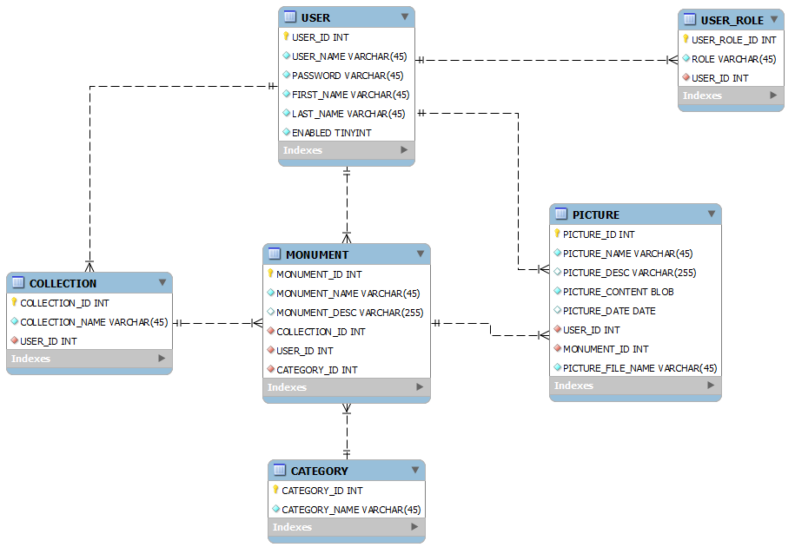
  - Features beside the functionalities mentioned before
- Global Exception handling.
- Role management for logged users.
- Password stored in DB are encrypted.

  - Navigation screens
    - Home page before login.
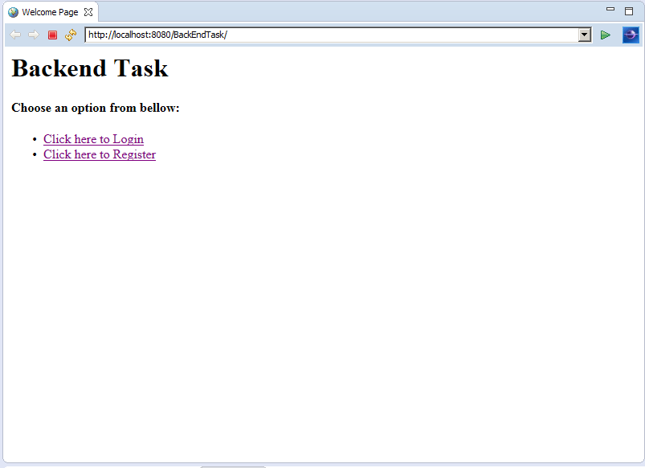
    - Register page, displaying validation error.
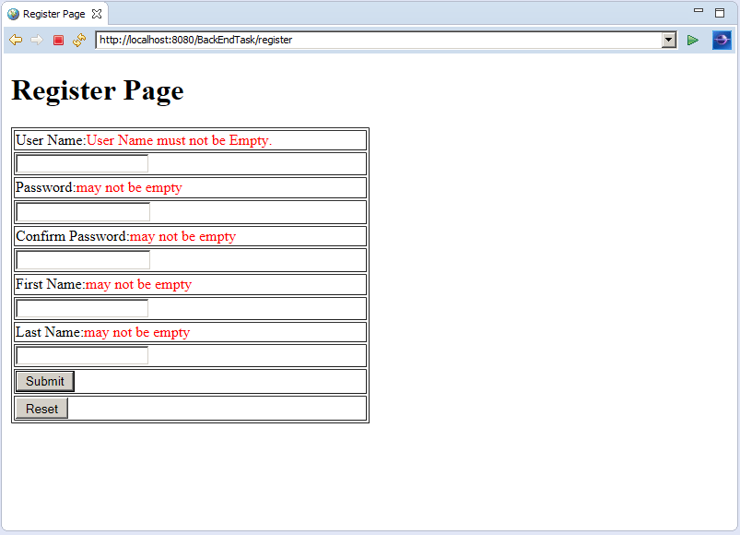
    - Success register page.
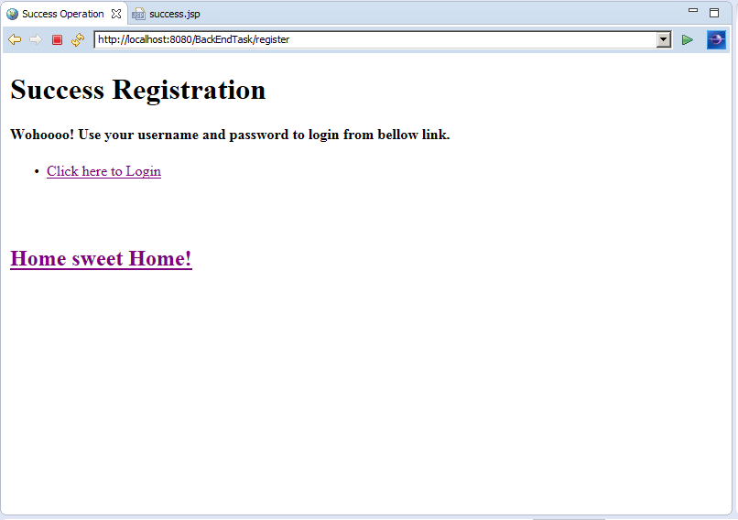
    - Login page.
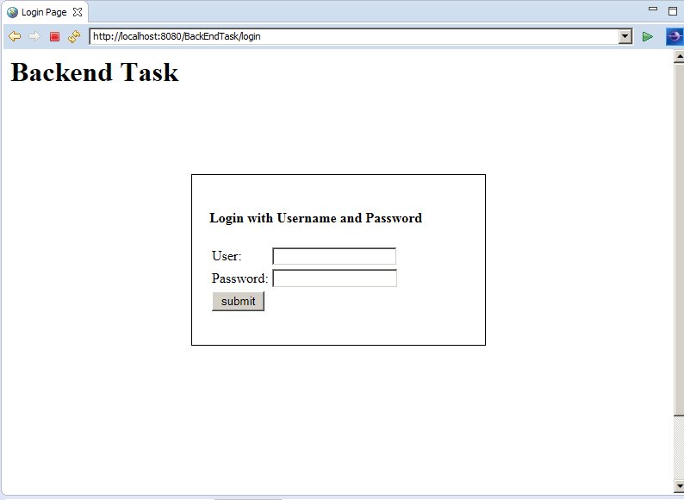
    - Home page after login.
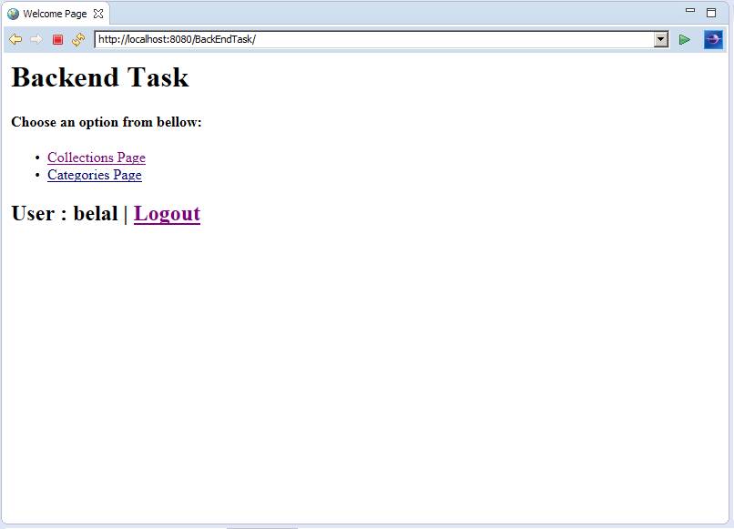
    - Collections page
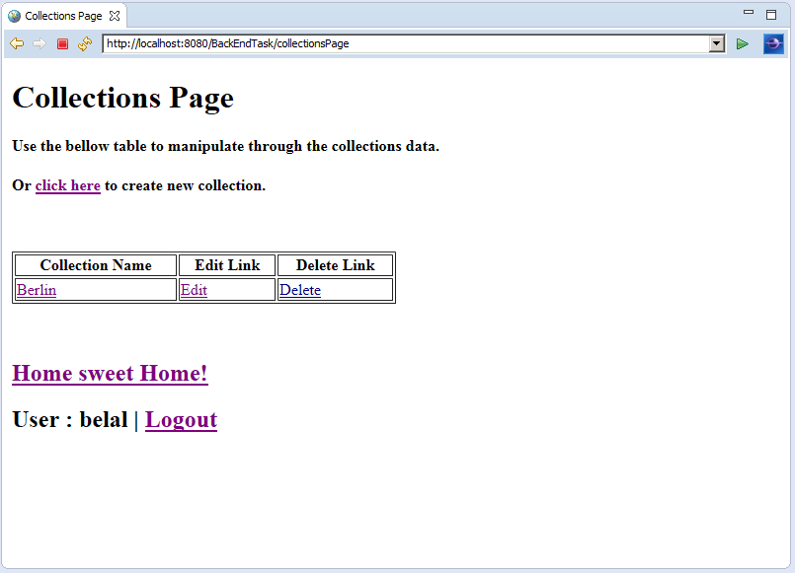

    - Add/Edit Collection page.
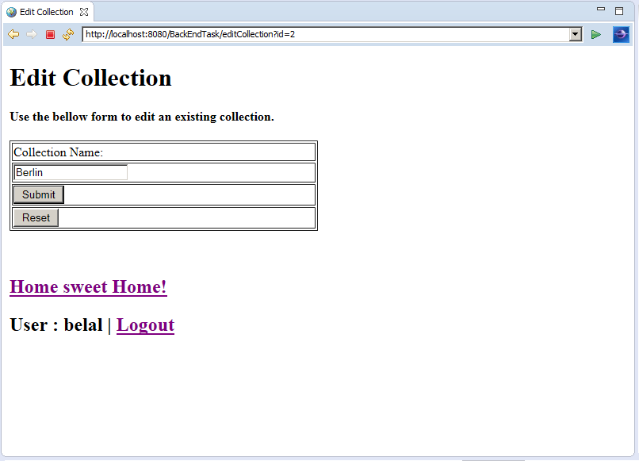
    - Categories page
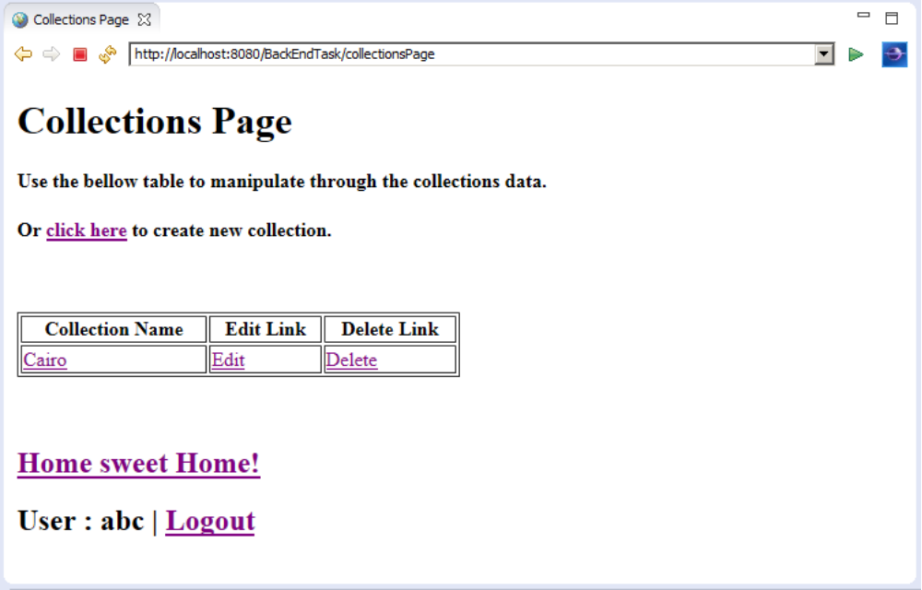

    - Add/edit Category page
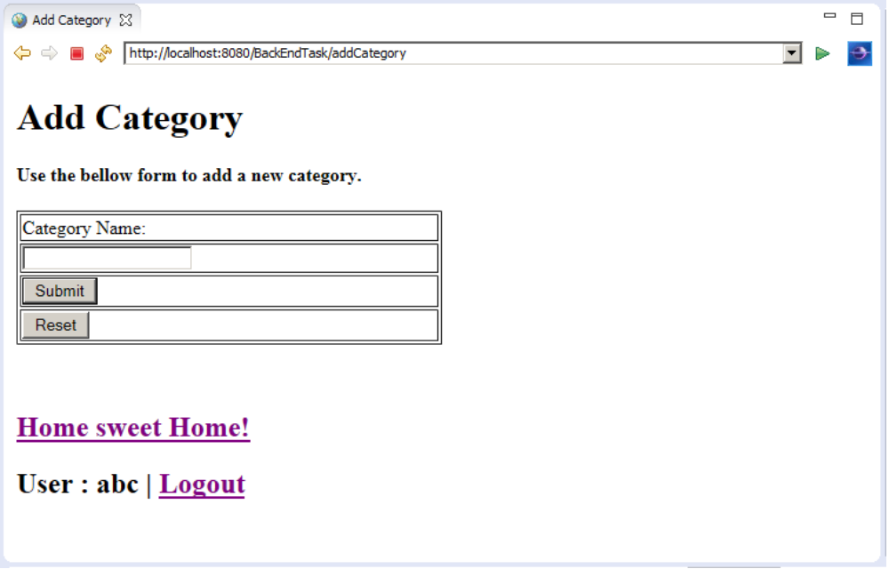
    - Monuments page
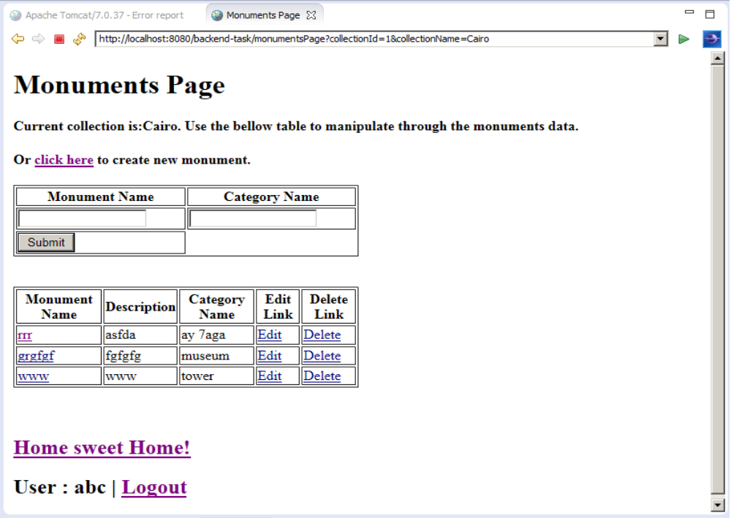

    - Add/Edit Monument page
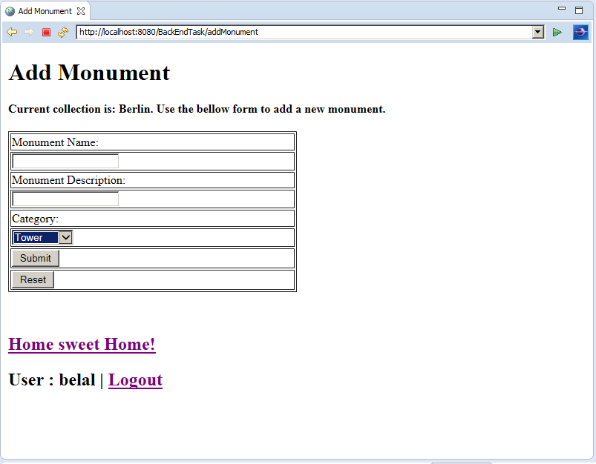
    - Pictures page
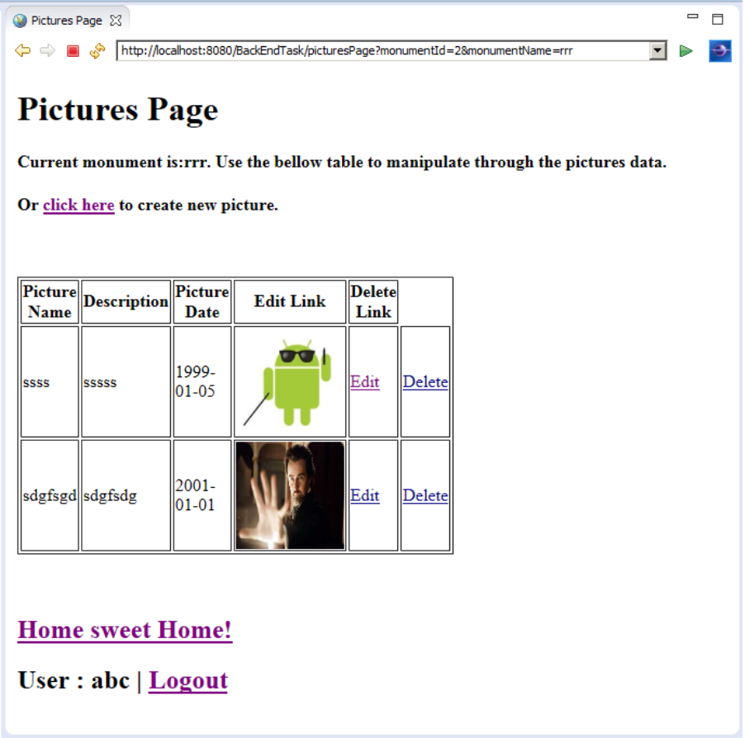
    - Add/edit picture page
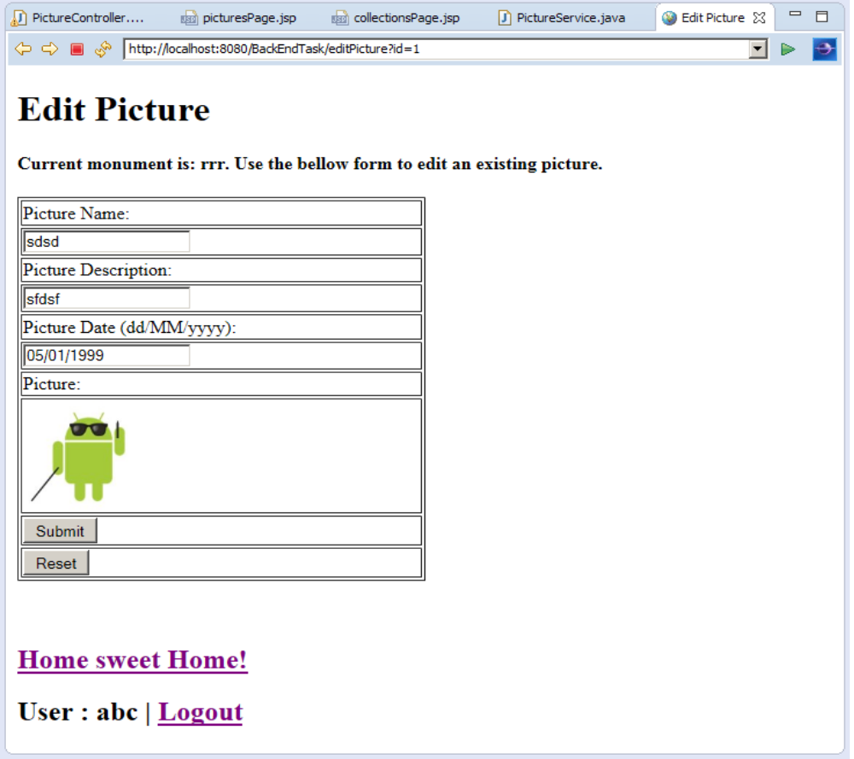
    - System error page (in case any exception is thrown)
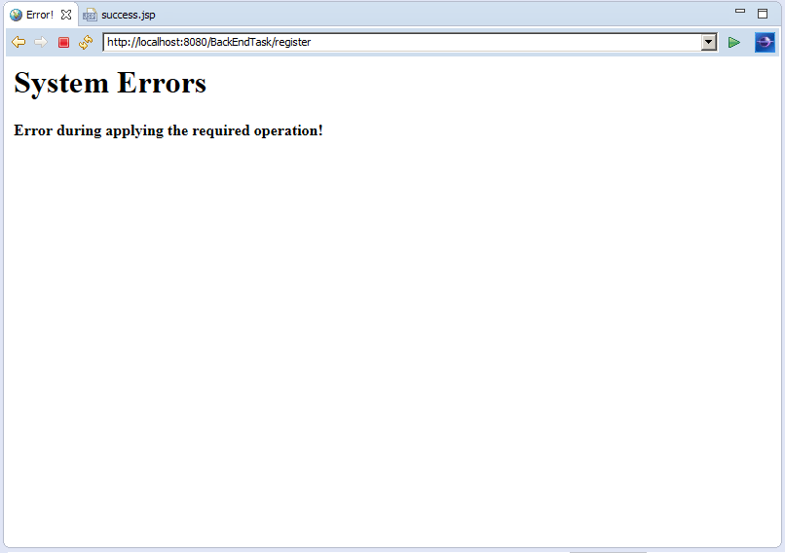

    - Success operation page, in case added, edited or deleted any element.
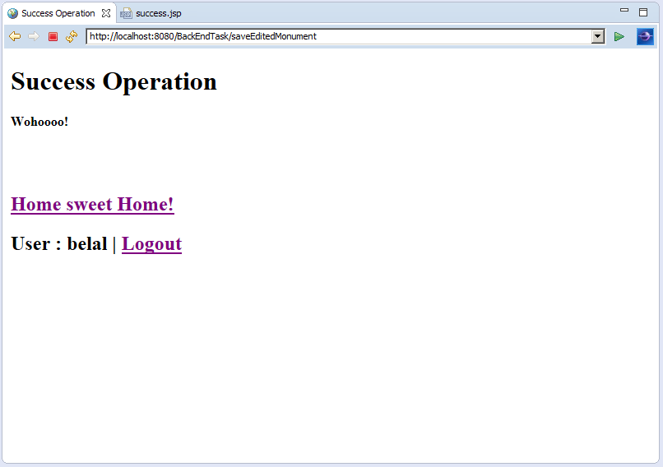

    - Admin page, Only displayed in case user with ROLE_ADMIN is logged in.
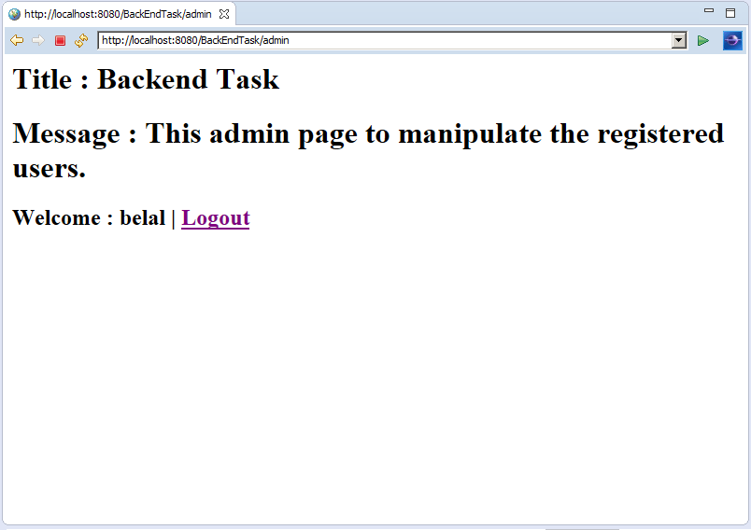

    - Access denied in case the user is not logged in.
