# DEDICATION

**TO MY FAMILY**

# 

# ACKNOWLEDGEMENT

Drafting this document would have not been possible without the contribution of some people who took upon themselves to see this work being accomplished. Our gratitude goes to the following people:

* The Resident Representative of AICS Cameroon, **Mr. ARMAND CLAUDE ABANDA**, for his support, words of encouragement and the different advices on how to approach situations.
* **Mr. TIOMELA JOU,** our professional supervisor for a cheerful welcome and a good working experience in the enterprise.
* **Mrs. ONGUENE VANESSA**, our academic supervisor, for a great follow up and advices during the realization of this document.
* To our academic teachers **Mrs. MOHAMMADOU, Mrs. TCHOUTOUO ISABELLE**, **Mr. AGBOR ANDERSON and Mr. MESSIO ULRICH** for their advice and assistance in realizing this document.
* To all my teachers of **AICS CAMEROON** for the knowledge they impacted me with for me to be where I am today.
* To **Mrs. KESSY**, Analyst in the enterprise, for her guides and intense working practices, **Mr.** **BOM GABRIEL** intern at Welldone, for his guide and advices on presentation and **Mr ESSONO JORDAN** for his tutoring, help and support**.**
* To my parents, **Mr. BELANGUE-NKENG DANIEL** and most especially my mother late **Mrs. MANEKEU CAROLINE** for her unconditional love and support even from the sky.
* To all the personnel of Welldone for their encouragement and advices during the internship period.
* Documentation.
* To all my friends and classmates of the 2023-2024 batch, in particular **NGO NGAN JULIENNE** and **KAMSONG ANDERSON**.
* To all those people near or far not cited above who contributed to the realization of this work or project.

# SUMMARY

# ABBREVATIONS

* **2TUP Two Track Unified Process;**
* **AICS: African Institute of Computer Sciences;**
* **DBMS: Database Management System;**
* **IDE: Integrated Development Kit;**
* **JSON: JavaScript Object Notation;**
* **MVC: Model View Controller;**
* **MERISE : Méthode d'Etude et de Réalisation Informatique pour des Systèmes d’Entreprise ;**
* **UML : Unified Modeling Langage**
* **OOSE: Object Oriented Software Engineering;**
* **OMT: Object Modeling Technic;**

# LIST OF FIGURES

# LIST OF TABLES

# ABSTRACT

The theme hair salon booking system offers an immersive and comprehensive virtual experience for customers to explore, plan, and book services. Key features include a cohesive visual theme and branding, AI-powered hairstyle visualization that allows customers to virtually try on different cuts and colours, convenient appointment booking integrated with the salon's calendar, a detailed service catalogue, personalized customer profiles, direct chat with hairdressers, and the ability to view detailed profiles of the salon's stylists, including their specialties, portfolios, and customer reviews. This advanced system provides a convenient and engaging way for customers to plan their desired salon look before even visiting the physical location, with the use of AI technology enhancing the experience through realistic hairstyle visualization. The theme hair salon booking system offers a comprehensive and immersive virtual experience that streamlines the customer journey and empowers them to personalize their salon experience. By combining intuitive interfaces, advanced visualization techniques, and a comprehensive database, this application revolutionizes the way individuals engage with their hair, helping them make informed choices. Additionally, the application will provide information on the various hair salons in Cameroon where these themed hairstyles can be implemented, allowing users to seamlessly transition from virtual visualization to physical transformation

**Keywords:**

* Hair visualization
* Hair salon
* Hairstyle
* Hairdresser
* AI technology
* Booking appointment

# RESUME

Le système de réservation de salon de coiffure à thème offre une expérience virtuelle immersive et complète aux clients pour explorer, planifier et réserver des services. Parmi les principales fonctionnalités, on trouve une thématique visuelle cohérente et une identité de marque, une visualisation de coiffures assistée par l'IA qui permet aux clients d'essayer virtuellement différentes coupes et couleurs, une réservation de rendez-vous pratique intégrée au calendrier du salon, un catalogue détaillé des services, des profils clients personnalisés, une discussion directe avec les coiffeurs, ainsi que la possibilité de consulter les profils détaillés des stylistes du salon, incluant leurs spécialités, leurs portfolios et les avis des clients. Ce système avancé offre un moyen pratique et attrayant pour les clients de planifier leur look de salon souhaité avant même de se rendre sur place, l'utilisation de la technologie IA améliorant l'expérience grâce à une visualisation réaliste des coiffures. Dans l'ensemble, le système de réservation de salon de coiffure à thème propose une expérience virtuelle complète et immersive qui simplifie le parcours client et les aide à personnaliser leur expérience de salon. En combinant des interfaces intuitives, des techniques de visualisation avancées et une base de données exhaustive, cette application révolutionne la façon dont les individus s'engagent avec leurs cheveux, les aidant à faire des choix éclairés. De plus, l'application fournira des informations sur les différents salons de coiffure au Cameroun où ces coiffures thématiques peuvent être réalisées, permettant ainsi aux utilisateurs de passer facilement de la visualisation virtuelle à la transformation physique.

**Mots-clés :**

* Visualization de coiffure
* Salon de coiffure
* Coiffure
* Coiffeuse
* Technologie IA
* Prendre rendez-vous

# GENERAL INTRODUCTION

The information technology (IT) domain is rapidly evolving in this century. IT devices such as mobile phones, laptops, and desktops, among others, have become integral to our daily lives. The African Institute of Computer Sciences, renowned for its leadership in the IT domain, aims to promote information communication and technology (ICT) tools and to provide Cameroon and Africa with numerous IT engineers. Each year, AICS-Cameroon organizes a three-month academic internship for second-year students to help them familiarize themselves with the professional environment. We completed our internship at "WELLDONE," a young company dedicated to providing application software for both individuals and companies. During our internship at WELLDONE, we were tasked with the theme "CONCEPTION AND REALIZATION OF A HAIR SALON BOOKING SYSTEM WITH HAIRSTYLE VISUALIZATION: NeXTLuk" using Yaoundé as our case study. NeXT Luk aims to provide guaranteed service and ending up satisfied with your look. To achieve these objectives, we followed six main phases:

**The Insertion Phase:** This phase introduces the company where we completed our internship and the integration of interns into the company.

**The Specification Book**: This document identifies the needs of future system users and outlines the various constraints of the project.

**The Analysis Phase**: Here, we selected our analysis method and presented all the diagrams used for the project analysis.

**The Conception Phase**: This phase details the generic and specific design of the project to highlight the real-world components.

**The Realization Phase:** This phase covers the choice of technologies and techniques necessary for implementing our solution.

**The User Guide:** This guide provides a user-friendly and graphical description of each functionality of the application.

PART I

# INSERTION PHASE

**Preamble**

This phase presents the details of how we were integrated in the host company, the company presentation and organization

**Overview**

INTRODUCTION

1. WELCOME AND INTEGRATION
2. GENERAL PRESENTATION OF THE COMPANY
3. HARDWARE AND SOFTWARE RESOURCES OF THE COMPANY
4. ORGANISATION OF THE COMPANY
5. BRIEF PRESENTATION OF THE PROJECT THEME

CONCLUSION

# INTRODUCTION

Professional integration is a process which allows an individual or a group of individuals to enter the labor market under conditions favorable to obtaining a job. As part of the academic internship, we were received as an intern within the premises of Welldone Planet for a period of three (03) months and the integration phase lasted 02 weeks. This part of the internship report which presents the structure or internship was carried out, its operation, the reception of the student and the research theme during this period.

# WELCOME AND INTEGRATION

## Welcome

Within the Welldone Planet structure, we were welcomed on Monday July 1, 2024 by its Technical Director, Mr. TIOMELA JOU Daniel.

## Integration

Mr. TIOMELA JOU Daniel organized a meeting during which he reminded us of the internal regulations of the establishment, its operation, its vision, its objectives, its services, its requirements and the development of the weekly schedule. Emphasis was placed on the conduct to be followed and compliance with the regulations in force. Several pieces of advice and recommendations were also given to us during various online sessions with the Technical Director. Then we argued about our theme

# GENERAL PRESENTATION OF THE COMPANY

## History and Mission

Welldone Planet was born from an ambitious project designed by a group of engineers graduated from the African Institute of Computer sciences (AICS) in Cameroon. Created in June 2023 and officially inaugurated on June 1, 2024 by the resident representative of AICS-CAMEROON, this company aims to become a leader in the provision of digital services. By advocating the emergence of the new information and communication technologies sector in Africa, and more particularly in Cameroon, Welldone Planet's mission is to inspire excellence and achieve innovation. Their slogan, "We believe that thanks to digital technology all dreams can come true. Let's Dream Big!" perfectly reflects their ambition to transform dreams into reality thanks to the power of digital technology. The company motto, “Inspire Excellence, Achieve Innovation, Dream Big,” embodies their commitment to creating a bright, technological future for the continent.

## Presentation of Structure

## Geographical location

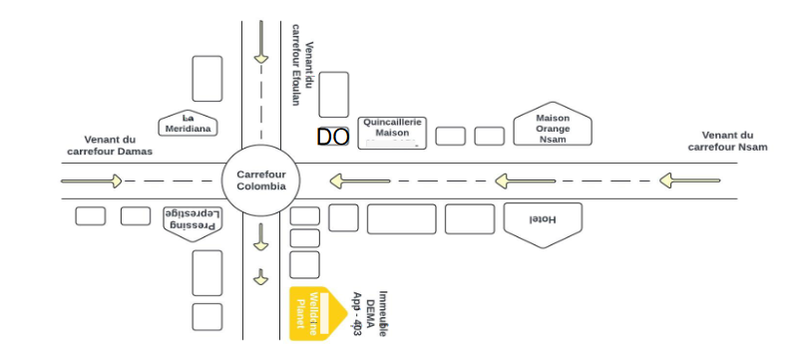

## Material Safety Data Sheet

|  |  |
| --- | --- |
| QUALITY | DESCRIPTION |
| The Head office | Yaoundé (Nsam – Carrefour Colombia) |
| Legal Form type | SARL |
| Type of business | Privée |
| Services | * IOT/AI/BIG DATA * Software Development * IT maintainance Web and mobile * Development * Graphic design * Cyber security * Digital Marketing * IT training |
| Phone number | (237) 677 223 241 |
| website | www.welldoneplanet.com |
| Email | welldoneplanet@gmail.com |
| Language used | English, French |

# HARDWARE AND SOFTWARE RESOURCES OF THE COMPANY

1. **Hardware Resources**

|  |  |
| --- | --- |
| DESIGNATION | IMAGE |
| 3 desktops HP |  |
| 3 Modem Wifi | Modem routeur Wi-Fi : Comparatif et Guide d'achat, Comment le choisir ? -  Test-et-avis.com |
| 3 plasma screens | Un écran plat 39 pouces LCD couleur HD Smart TV Plasma de LED - Chine  Télévision et de la télévision prix |
| 1 fridge | Giantex mini frigo mini réfrigérateur avec congélateur 1 etagère  consommation d'énergie capacité de 48 l - Conforama |
| 1 canon printer | Canon MAXIFY Imprimante jet d'encre MegaTank multifonction (4471C006) |
| 1 hp laptop |  |
| Ultimate kit for Rasberry |  |
| Super starter kit |  |

1. **Software resources**

|  |  |
| --- | --- |
| DESIGNATION | IMAGE |
| Windows 10 operating system |  |
| Windows 11 operating system | Systèmes d'exploitation | bureauengros.com |
| Adobe creative cloud suits 2024 | Adobe Creative Cloud Collection 2024 | Jumia Nigeria |

## Vision, objectives of welldone planet

### Vision

At Welldone, we believe that the true potential of every organization and individual can be unlocked through the harmonious fusion of analysis, development, realization, and data analytics. Our vision propels us forward, guiding us to make a lasting impact on the digital landscape and shape a future where innovation knows no bounds.

### Goals

Welldone Planet sets ambitious goals to have a significant impact on the economic and social development in Africa. Based on a holistic approach and inclusive, the company aims to:

• **Reduce poverty:** By providing innovative technological solutions, Welldone Planet intends to create economic opportunities and improve living conditions of local populations, thus contributing to the reduction of poverty.

**• Facilitate the development of human capacities**: Through programs of quality training in computer science and information technology, the company aspires to strengthen the skills of individuals and professionals, allowing them to remain competitive in the job market.

• **Holistic approach, including young people**: Welldone Planet adopts a global which includes young people, whether they are educated or have dropped out of school, in order to fully integrate them into technological development and economically, providing them with opportunities for learning and growth.

• **Support businesses in their growth*:** By using techniques based on optimization, bottleneck management and cost-effectiveness sustainable, Welldone Planet is committed to supporting businesses in their expansion, by improving their operational efficiency and economic performance

# Activities, Organization Chart and Responsibilities of Welldone Planet

1. **Activities**

Welldone Planet offers a full range of technology services to meet to the diverse needs of its customers. The company's main mission is to solve IT problems that businesses encounter on a daily basis in the areas following:

* + IOT/IA BIG DATA
  + Software Development
  + IT maintenance
  + Web and Mobile Development
  + Infographics
  + Cybersecurity
  + Digital Marketing
  + IT training

1. **Organizational chart**

The organization chart is above all a communication tool intended to Facilitate understanding of existing relationships and links within society. To this end, it allows fora global view of the company in terms of services, divisions and more. Welldone Planet has six departments within it and we have been assigned to technical direction. This is the division coloured in blue in the organization chart below.

1. **Attributes**

below. The Welldone Planet Company includes several executive-led divisions main competent persons:

* **The Human Resources Division (HRD)** headed by a director of human resources which is responsible for personnel management, training and skill development
* **The Sales and Marketing Division (DCM)** headed by a director sales and marketing who is responsible for sales, marketing and development commercial.
* **The Communication Division (DCOM)** headed by a director of communication of the company which is responsible for sales, marketing and Business Development.
* **The Research and Development Division (DR&D)** headed by a director of research and development who is responsible for innovation and development of new products
* **The Financial Division (DRMF)** headed by a director of financial resources who is responsible for financial management, budgets and accounting.
* **The Technical Division (DT)** headed by a technical director who is responsible for the technical management, production and maintenance…
* Secretariat for invoicing, photocopying, customer registration

# BRIEF PRESENTATION OF THE PROJECT THEME

Upon our arrival at WELLDONE, we were encouraged to suggest innovative project ideas for our internship. Following the mission of WELLDONE, which demonstrates the company's commitment to contributing to the sustainable development of the world through innovative solutions, we saw the potential for creativity in our project idea and proposed the theme **"CONCEPTION AND REALIZATION OF A HAIR SALON BOOKING SYSTEM WITH HAIRSTYLE VISUALIZATION: NextLuk."**. This system is made up of an admin’s dashboard, manager’s dashboard that is the manager of the salon, client’s dashboard and hairdresser’s dashboard.

NextLuk’s client’s dashboard provide the clients with a list of hairstyles already made from different hair stylist from which they can choose according to criteria such as prices, location and performance, then they can book an appointment, have a chat discussion with hairdresser, a geo-localisation section where they can locate the different salon selected. Moreover, they can test the selected hairstyle from the hairdresser’s post through the application and get recommended and more suitable hairstyles based on your head features.

# CONCLUSION

The insertion phase was a very educative one, we got to know more about the history of the company, how it started till it reaches the level it is right now, how it is structures. We got to know the staff and other interns, in fact we felt at home. Finally, we decided to work on the theme **"CONCEPTION AND REALIZATION OF A HAIR SALON BOOKING SYSTEM WITH HAIRSTYLE VISUALIZATION: NextLuk"**. Now that we are set with the theme we will work on, we can dive in to the existing system phase in which we will study the existing system to identify its limitations and formulate a problematic.

PART II

# EXISTING SYSTEM

Preamble

This section of our report will cover details of the different research did for the realization of this project. The existing study, criticism of the existing system, problem statement, proposed solutions.

Content overview

INTRODUCTION

1. THEME/PROJECT PRESENTATION
2. EXISTING SYSTEM STUDY
3. CRITICISM OF THE EXISTING SYSTEM
4. PROBLEMATICS
5. PROPOSED SOLUTION

CONCLUSION

INTRODUCTION

In this section of our report, we will delve into the various research conducted for the realization of this project. We will explore the existing study, critique the current system, identify the problem statement, and propose a solution. Through thorough analysis and investigation, we aim to provide a comprehensive understanding of the research undertaken to address the challenges and develop an effective solution. By examining the existing landscape and presenting our proposed approach, we strive to contribute towards the advancement and improvement of the project's objectives.

# THEME PRESENTATION

Our theme is **"CONCEPTION AND REALIZATION OF A HAIR SALON BOOKING SYSTEM WITH HAIRSTYLE VISUALIZATION: NextLuk".** This application will permit us to choose from already made hairstyles. Traditionally, customers would often flip through fashion magazines or browse online galleries to find hairstyle inspiration. This could be a time-consuming process, as they had to sift through numerous images and try to envision how a particular style would look on them. The idea here is not to eliminate magazines but to be able make informed decisions since what is showed to them has already been made. Chat discussion with hairdressers can help customers have more personalized consultation and ensures their preferences are taken into account. Customers can virtually try on their selected hairstyles based on criteria such as pricing, location through the application and at the end book an appointment with the hairdresser of your choice based on hairdresser’s schedule and even chat with the hairdresser. The system sends timely notifications and reminders to customers about their upcoming appointments, any changes or updates, and other relevant information.

Customers can create and manage their personal profiles within the application, storing their contact information, hair details, and service history. This enables the system to provide personalized recommendations and reminders based on the customer's preferences and past experiences.

# STUDY OF EXISTING SYSTEM

## Traditional

We notice more and more an overheating of hair salons because of the increase in the population of women in Africa in general and in Cameroon in particular. As a result, hairdressers are faced with a busy and often poorly organized schedule. Also, clients are constantly encountering satisfaction problems. This is because sometimes they can wait for long for their hairstyle to be done depending on the hairstyle, they may take other clients before finishing with you. Also, the dissatisfaction can come from the result you get and the price you paid.

From a survey carried out from the zone of Mfou to know exactly the number of clients who ended up dissatisfied with the service or even the result at the end of their session,

## Application

|  |  |  |  |  |
| --- | --- | --- | --- | --- |
| NAME | | DESCRIPTION | LOGO | COUNTRY |
| Businesslist | Business list is an application made in Cameroon where you can find hair salon stored in the application found in the different regions of the country | |  | Cameroon |
| Try Hairstyle Lite | Try Hairstyle Lite is an application that permits you to take a picture or load one from photo albums, select a hairstyle and fit a hairstyle to a face. It also permits you to change features like hair colour , rotate hairstyle and share on Facebook, Email etc | |  | Japan |

1. Critique of the existing systems

|  |  |  |
| --- | --- | --- |
| LIMITATION CONSEQUENCE | | PROPOSED SOLUTION |
| Manual hairstyle selection | Customers spend a lot of time and effort searching suitable hairstyles in catalogues. | AI-powered hairstyle recommendation engine that suggests styles based on user preferences and facial features |
| Lack of Personalized Recommendations | Stylists may not accurately recommend hairstyles that fit the customer's preferences or face shape | Personalized recommendations using machine learning algorithms to match hairstyles with user profiles. |
| Inefficient Appointment Booking | Manual scheduling can lead to double bookings, missed appointments, and scheduling conflicts. | Automated appointment system that allows customers to book, reschedule, and cancel appointments online. |
| Inconsistent Customer Support | Delays and inconsistencies in customer support can lead to dissatisfaction and loss of clientele. | AI-powered chatbot that provides instant customer support and answers to frequently asked questions. |
| Limited Feedback Analysis | Manual review of customer feedback can be time-consuming and prone to errors, missing important trends. | Sentiment analysis on customer reviews to gauge overall satisfaction and identify areas for improvement. |
| Static Pricing Models | Fixed pricing doesn't account for demand variations, leading to potential revenue losses. | Dynamic pricing models that adjust based on demand, time slots, and stylist availability, maximizing revenue. | |

1. Criticism of existing application

|  |  |  |  |
| --- | --- | --- | --- |
| Application | Limits | Consequences | Solution |
| Businesslist | It doesn’t provide enough information on the hair salons | Inability to know exactly where it is situated and the services the salons offer | Provide geolocalisation and details of each salon to know exactly |
| Try hairstyle Lite | It is available only on app stores | Inability for everybody to access the application | Provides a web application for everyone to profit |
| Try hairstyle Lite | It is made mostly for white people and doesn’t African hairstyles like braids adapted to our hairs | Inability for us to really enjoy the application | Provides a range of hairstyles adapted to our African hairs |

Table 5: criticism of existing application

1. PROBLEMATICS

In order to increase the satisfaction of client, we consider the following question to:

How can we design and implement an advanced hair salon booking system with hairstyle visualization that optimizes the hairdressing session, enhances outcome, and provides users with a seamless and convenient experience?

1. HAIR SALON BOOKING SYSTEM WITH HAIRSTYLE VISUALISATION

After our study and criticism of the existing situation, we propose the DSEI application that will be able to provide:

By incorporating these advanced features, the proposed Digital Smart Egg Incubator aims to enhance the incubation process, improve efficiency, increase success rates, and provide users with greater control and monitoring capabilities.

# CONCLUSION

In this section, we conducted research to support the conception and realisation of a hair salon booking system with hair visualization project. We analysed the existing system, identified its limitations, and proposed a solution. Our findings contribute to improving the project's objectives. The current system relies on real-time visualization, lacking automation and precise control. It addresses the limitations of the existing system, enhancing efficiency and accuracy. Our research provides a foundation for the development of an advanced hair salon booking system.

PART III

SPECIFICATION BOOK

Preamble

This section of our report will cover details on the product to be delivered with the agreement of the client(s) and the solution provider. In this section, we are going to present the context in which we are to but in place a platform, what the system should do and how the system should do it

Content overview

INTRODUCTION

1. CONTEXT AND JUSTIFICATION
2. OBJECTIVES OF THE PROJECT
3. BENEFICIARIES AND TARGETS
4. EXPRESSION OF NEEDS
5. PLANNING OF THE PROJECT
6. ESTIMATION OF THE PROJECT
7. CONSTRAINTS
8. DELIVERABLES

CONCLUSION

# INTRODUCTION

The specification book of our report helps us provide details about our theme to improve our understanding of it and increase the likelihood of it succeeding. To delimitate the scope of our project, we will specify the context of our theme. From the context, we will list the problems we have decided to address throughout the project. After presenting our solution, we will talk about the objective we have set for the project. Also, we will explore the needs to which our system will respond both at the functional and non-functional level. We will then look at the estimated financial requirements for our project and establish a plan we will follow to complete our project on time. From here, we will discuss what is expected of us by the end of the project under the project deliverables.

# CONTEXT AND JUSTIFICATION OF STUDIES

## Context

Many of us live by the saying “if you look good, you feel good” by Deon Sanders and it’s true our outward appearance can have a positive psychological impact on your confidence and self-esteem levels and our inner confidence radiates out. Hair is one of the main ingredients to our identity in fact over half of U.S women (56%) said that being happy about their hair increases their self-esteem or that good hair makes them feel more positive about their day.

In our society, the way we present ourselves physically holds an immense amount of significance. From the clothes we wear to the hairstyles we choose, our outward appearance is often seen as a reflection of our character, our worth, and our very identity. This intense focus on physical attributes can have a profound impact on our self-confidence and sense of belonging.

For many individuals, particularly those from marginalized communities, the pressure to conform to narrow societal beauty standards can be overwhelming. The concept of "beauty privilege" – the unearned advantages granted to those who align with these ideals – creates a fundamental inequality, where certain people are afforded opportunities and respect simply based on their physical appearance.

This reality is especially evident in the world of hair care, where the celebration of straight, sleek hairstyles as the epitome of beauty has marginalized and devalued the natural textures and styles of those with short curly, or kinky hair. The impact of this bias can be devastating, eroding the self-esteem and confidence of those who feel their natural features are deemed "unprofessional" or "unruly."

## Justification

However, the emergence of innovative hair salon booking systems with hairstyle visualization features has the power to transform this narrative. These tools empower individuals to explore and embrace their unique beauty, experimenting with different styles and seeing how they can enhance their natural features.

By offering a virtual canvas to play with, these systems allow users to break free from the confines of societal expectations and reclaim their sense of self-worth. They encourage users to celebrate their individuality, to see the inherent beauty in their hair, and to feel confident in their own skin.

Moreover, these booking systems can also serve as a powerful educational tool, fostering a greater understanding and appreciation for the diverse range of hair textures and styles that exist. By exposing users to the vibrant, textured looks that challenge the narrow definition of beauty, these systems can help dismantle the harmful beauty privilege that has long plagued our society.

Ultimately, the hair salon booking system with hairstyle visualization represents a significant step towards a more inclusive, equitable world – one where physical appearance is no longer a barrier to self-acceptance and where every individual can feel truly seen, valued, and empowered.

# OBJECTIVES

## General objective

The general objective of the hair salon booking system with hairstyle visualization application is to create a comprehensive and user-friendly platform that seamlessly connects clients and hairdressers, enabling personalized interactions, showcasing of talents, and streamlined salon operations - all with the aim of enhancing the overall salon experience and driving long-term success for both the salon and its team of skilled hairdressers

## Specific objective

1. Enhance Hairstyle Selection Process:

- Utilize AI and machine learning to provide customers with personalized hairstyle recommendations that match their preferences, facial features, and hair type.

- Implement virtual try-on features using augmented reality (AR) to allow customers to visualize different hairstyles before making a decision.

2. Streamline Appointment Booking and Management:

- Develop an automated booking system that enables seamless scheduling, rescheduling, and cancellation of appointments.

- Integrate calendar synchronization and send reminder notifications to reduce no-shows and scheduling conflicts.

3. Provide Instant and Consistent Customer Support:

- Implement an AI-powered chatbot to offer 24/7 customer support, addressing frequently asked questions and assisting with bookings and other inquiries.

- Ensure personalized interactions based on user data and interaction history to enhance customer satisfaction.

4. Leverage Customer Feedback for Continuous Improvement:

- Use sentiment analysis on customer reviews to identify trends, areas for improvement, and overall satisfaction levels.

- Provide stylists and salon managers with actionable insights to enhance services and address common issues.

5. Optimize Revenue Through Dynamic Pricing:

- Implement dynamic pricing models that adjust service costs based on real-time demand, time slots, and stylist availability.

- Offer targeted promotions and discounts to attract customers during off-peak times and maximize revenue.

6. Facilitate Secure and Efficient Payment Processing:

- Integrate secure payment gateways for online transactions, ensuring a smooth and safe payment experience for customers.

- Maintain a transaction history for users, including receipts and payment statuses, and enable easy processing of refunds.

7. Boost Marketing and Customer Engagement:

- Enable salon managers to create and send promotional email and SMS campaigns to engage customers and promote services.

- Implement loyalty programs to reward repeat customers and encourage return visits, enhancing customer retention.

8. Empower Stylists with Management Tools:

- Provide stylists with tools to manage their availability, appointments, and schedules efficiently.

- Allow stylists to build and showcase their portfolios, including photos of their work, experience, specialties, and customer reviews.

# BENEFICIAIRES AND TARGET

1. Beneficiaries:

The beneficiaries of our project will be the hairdressers and

1. Targets:

For this project our targets are the different clients involved in hairstyling

# EXPRESSION OF NEEDS

## Functional needs

In this context, functional requirements describe what the system or application should do. The modules are as follows;

* The administrator (admin) should be able to:
  + **Account Creation:**

The administrator is responsible for creating accounts for each salon that want to register in the application.

* + **Account management:**

Here he can manage their accounts by modifying some information

* The hairdressing manager should be able to:
  + **Manage publication:**

Here salon’s managers are able to post photos, videos and even description of their salon.

* The hairdresser should be able to:
  + **Manage hairstyle publication:**

Here the hairdresser should be able to post pictures and videos on the hairstyles they already did.

* The client should be able to:
  + **User registration and profiles:**

Allow users to create accounts and store their personal information

* + **Hairstyle visualization:**

Provide a user-friendly interface for users to browse and select

* + **Salon and Stylist Management:**

- Allow users to search for and view information about local hair salons, including reviews, services offered, and stylist profiles.

Provide a booking system for users to schedule appointments with specific stylists.

* + **Appointment Management:**

- Allow users to view, modify, and cancel their scheduled appointments.

- Offer features for salons to manage their booking calendars, client information, and service availability.

- Implement automated reminders and notifications for upcoming appointments.

* + **Communication and Feedback:**

- Facilitate two-way communication between users and stylists, enabling users to share their preferences and stylists to provide personalized recommendations.

- Collect user feedback on their salon experiences and hairstyle results, which can be used to improve the system and service quality

## Non-functional needs

1. Usability and User Experience:

- Intuitive and user-friendly interface that is easy to navigate, even for those with limited technical expertise.

- Responsive design that ensures a seamless experience across various devices, including desktops, tablets, and mobile phones.

- Accessibility features to accommodate users with disabilities, such as screen readers and keyboard navigation.

2. Performance and Scalability:

- Rapid response times for browsing hairstyles, booking appointments, and other core functionalities.

- Ability to handle increased user traffic and transactions without compromising system performance.

- Efficient data processing and storage solutions to manage a growing user base and hairstyle database.

3. Security and Privacy:

- Robust security measures to protect user data, including personal information, payment details, and uploaded photos.

- Compliance with relevant data protection regulations, such as GDPR and HIPAA, to ensure the confidentiality and integrity of user data.

- Secure authentication and authorization mechanisms to prevent unauthorized access to user accounts and sensitive information.

4. Reliability and Availability:

- High system uptime and minimal service interruptions to ensure uninterrupted access for users.

- Reliable backup and recovery mechanisms to safeguard data and minimize the impact of potential system failures or outages.

- Proactive monitoring and maintenance to identify and address any performance issues or technical problems.

5. Scalability and Extensibility:

- Scalable architecture that can accommodate a growing user base, expanding hairstyle database, and increasing salon partners.

- Modular design that allows for easy integration of new features and functionalities, such as virtual reality-based hairstyle visualization or integration with salon management systems.

- Flexible and adaptable codebase that can adapt to changing user requirements, industry trends, and technological advancements.

6. Interoperability and Integration:

- Seamless integration with third-party services, such as payment gateways, review platforms, and marketing tools, to enhance the overall user experience.

- Compatibility with industry-standard APIs and data formats to facilitate data exchange and collaboration with salon partners and other ecosystem players.

- Ease of integration with existing salon management systems to streamline operations and data synchronization.

7. Scalability and Maintainability:

- Efficient and well-documented codebase that allows for easy maintenance, updates, and future enhancements by the development team.

- Comprehensive testing and quality assurance measures to ensure the system's stability, reliability, and performance.

- Adaptable deployment and DevOps strategi es to facilitate smooth updates and rollouts without disrupting the user experience.

## PLANNING THE PROJECT

Planning of the Hair salon booking system with hairstyle visualization project

|  |  |  |  |
| --- | --- | --- | --- |
| Phase | Objective | Outing | Duration |
| INSERTION | This stage involves gathering all the relevant information and requirements for the project. | Insertion report | 10 days |
| SPECIFICATION BOOK | The specification book is a document that outlines the detailed specifications and requirements of the automated egg incubator system. It includes the functional and non-functional requirements. | Specification book | 10 days |
| ANALYSIS | The analysis stage involves analyzing the gathered requirements and conducting a feasibility study. This helps determine the technical and economic viability of the project. | Analysis | 20 days |
| CONCEPTION | In the conception stage, the project's conceptual design is developed. This includes defining the system architecture, selecting the appropriate technologies, and creating the initial design project plan | Conception document | 5 days |
| REALIZATION | Build the automated egg incubator system by designing and assembling hardware components, developing software, integrating sensors and controls, and ensuring proper functionality. | Realization Document | 25 days |
| TESTING AND MAINTENANCE | Thoroughly test the system to verify that it meets specified requirements, perform maintenance activities like bug fixes and updates, and ensure ongoing system performance. | User testing | 5 days |
| DEPLOYMENT | Install and configure the automated egg incubator system in the intended environment, making it ready for use and ensuring compatibility with user requirements. | Development | 5 days |
| USER GUIDE | Provide comprehensive documentation and instructions on system operation, user interface navigation, troubleshooting, and maintenance procedures. | User guide | 5 days |
| PRESENTATION | Showcase the completed project to stakeholders through demonstrations, highlighting its functionality, features, and benefits. | PowerPoint | 5 days |

Table 6: Planning of the Project

## ESTIMATE OF THE PROJECT

1. Software Resources

Source: https://www.google.com/search?

|  |  |  |  |
| --- | --- | --- | --- |
| Software | Usage | Quantity | Price(FCFA) |
| Pycharm | It is an IDE used to program in python |  | free |
| Virtualenv | Management of virtual environments | 1 | free |
| WPS Office | Used for the creation of the report and the  PowerPoint. | 1 | 37 247.67 |
| Google chrome | A free and open source web browser use to make  research on the project. | 1 | free |
| Parrot Security System | A system software uses to manage our computer  hardware and software. | 1 | free |
| WSGI Server | A local server use to create and manage our  database. | 1 | free |
| Django | Framework python | 1 | free |
| GANTT Project | Used for the planning of the different task that are  necessary for the realization of our project. | 1 | 209 600 |
| Sybase PowerAMC | Modeling tool which was use for the modeling of  the system to be developed. | 1 | free |
| Visual studio Code | Front-End Development environment | 1 | free |
| Postman | API development and testing tool | 1 | free |
| Pycharm Community | Back-end Development | 1 | free |
| TOTAL 1 | | | **246, 847.67** |

Table 8:Software Resources

1. Hardware Resources

*Source: mercurial 2023*

|  |  |  |  |
| --- | --- | --- | --- |
| Software | Usage | Quantity | Price(FCFA) |
| Computer(Dell Latitude E7450) | Used for the creation of the report and the  PowerPoint. | 1 | 891,394 |
| HP computer | The computer was used for the development of the mobile application and web application | 1 | 767,490 |
| Modem Jio | A system software uses to manage our computer  hardware and software. | 1 | 50,000 |
| Internet Access | For the downloading of resource and achievement of information | 1 | 126,500 |

1. Human Resources

Human resources are vital for developing a hair salon booking system with hairstyle visualization. Engineers and embedded systems design the hardware and software components. experts optimize the incubation process. Project managers coordinate tasks and ensure timely delivery. Collaboration and teamwork among these professionals are crucial. The goal is to create a

*Source: mercurial 2023*

|  |  |  |  |  |
| --- | --- | --- | --- | --- |
| ROLE | NUMBER OF DAYS | QUANTITY | COST PER DAY | TOTAL PRICE (FCFA) |
| Project Manager | 90 | 01 | 30 000 | 2 700 000 |
| Analyst | 21 | 01 | 25 000 | 700000 |
| UI/UX Designer | 07 | 01 | 20 000 | 140 000 |
| Programmer | 30 | 01 | 15 000 | 450 000 |
| Tester | 14 | 02 | 10 000 | 140 000 |
| Margin error | / | / | / | 1,500,000 |
| TOTAL 3 |  |  |  | **10,980,800** |

Table 10:: Human Resources

1. Total of the Project estimation

|  |  |  |
| --- | --- | --- |
| TOTAL | RESOURCE | AMOUNT(FCFA) |
| TOTAL 1 | Software Resources | 246, 847.67 |
| TOTAL 2 | Hardware Resources | 2,645,763.72 |
| TOTAL 3 | Human Resources | 10,980,800 |
| FINAL TOTAL |  | **13,873,411.4FCFA** |

Table 11:Total of the Project estimation

## CONSTRAINTS

1. **Quality**

For the development of our system, we have sufficiently robust tools to guarantee a minimum of security, extensible and excellent Scalability. Moreover, the programming phase will have to follow all the technical standards for a better performance in a reduced execution time, this is why the choice of the development technologies is crucial.

1. **Time Constraint**

The project will be realized in 13 weeks (3 months) starting from the beginning date, July 3rd, 2023.

1. **Cost constraint**

The realization of our project will require expenditures in human resources, material and software a total cost of **13,873,411.4FCFA.**

## DELIVRABLES

At the end of the specified development timeline for our software, the deliverable will consist of a Report that will include:

In project management, any component materializing the result of a realization service is called a deliverable. In the case of our project, the deliverables are:

1. A report composed of the following document
2. The insertion document.
3. The Existing System
4. The specification book.
5. The analysis phase.
6. The conception phase.
7. The realization phase.
8. Test of functionalities.
9. The user guide.
10. A CD-ROM with:
11. The source code of the software
12. Database
13. A soft copy of the internship report
14. A corresponding PowerPoint
15. A prototype of our project

# ANALYSIS PHASE

## CONCLUSION

The specifications book contains detailed information about the project's objectives, requirements (both functional and non-functional), team members, project plan, cost, and constraints. This document serves as a guide to develop a solution that meets the project's needs while avoiding errors and compatibility issues. The specifications book acts as a foundation for the analysis phase of the project, where we carefully examine the provided information to determine the best approach and ensure a successful outcome.

Part IV

Analysis phase

Preamble

After specification book, we have the Analysis phase which permits us to represent a detailed analysis of the limitations identified in our context, and our solution, through a software development process and modelling language.

Content overview

INTRODUCTION

1. PRESENTATION OF THE ANALYSIS METHOD
2. Comparative Study of UML and MERISE
3. Comparative Study of Unified Process
4. MODELLING
5. Use Case Diagram
6. Communication Diagram
7. Sequence Diagram
8. Activity Diagram

CONCLUSION

## INTRODUCTION

The analysis book permits us to examine in an explicit way the existing system, it’s limitations and how we can remedy them. We will also describe in details the modeling language known as UML (Unified Modeling Language) which is coupled with Two Tract Unified Process (2TUP) to form a method and its justification why we decided to use it in preference of another. then we will dive directly into the modeling of the proposed solution consisting of diagrams that meets the requirements of the functional needs.

## PRESENTATION OF ANALYSIS METHOD

1. COMPARATIVE STUDY OF UML AND MERISE

We have studied in details some analysis methods by looking at its objectives, its structuring, its pros and cons, so as to choose an analysis method which is reliable and adaptive to our project, below are some analysis methods we studied and a brief explanation in order for you to understand why we made our choice;

* 1. **MERISE:** it is an information system design and development widely used in France. It was first early introduced in 1980s.
  2. **Agile:** this methodology is growing in popularity, thanks to highly competitive business environment and increased innovation. In general, agile methodologies prioritized shorter, interactive cycle and flexibility.
  3. **Scrum:** this is the most popular agile development framework because it is relatively simple to implement. It also solves so many problems that software developers struggle with in the past, convoluted development cycles, project plan, and shifting production schedules. This methodology allows for rapid development and testing, especially with small teams.
  4. **APF:**  which stands for ADAPTIVE PROJECT FRAMEWORK, it grows from the difficulty in managing most IT projects using traditional project management methods due to uncertain and changing requirement. APF begins with a requirement breakdown structure (RBS) to define strategic goals based on productive requirements, functions, sub-function and features. The project proceeds in iterative stages, and at the end of each step, teams evaluate previous results to improve performance and practices.

**XP:** which stands for Extreme Programming is a software development methodology that advocate frequent releases in short development cycles, which is intended to include checkpoints for the adoption of new customer requirements and improve productivity. This methodology takes its name from the idea that the traditional software engineering practices are taken to extreme levels.

1. MODELING WITH UML (2.5)

The unified modeling language (UML) is a general purpose, developmental modeling language in the field of software engineering that is intended to provide a standard way to visualize the design of a system.

The Unified Modeling Language (UML) was standardized in January 1997 by the Object Management Group (OMG) which is an American association created in 1989 and aims to promote and standardize the object model in all it forms. In 2005, UML was also published by the international organization for standardization (ISO) as an approved ISO standard. Uml since 2015 is in its version 2.5. This version consists of fourteen diagrams classified into structural and behavioral diagrams

1. Structural Diagrams:

Structural diagrams represent the static components of a system; they emphasize on what should be in the system we are modeling. They include:

* Class diagram;
* Object diagram;
* Package diagram;
* Composite structural;
* Deployment diagram;
* Component diagram;
* Profile diagram.

1. Behavioral Diagrams:

The behavioral diagrams capture the dynamic state of a system; they emphasize on what should happen in the system we are modeling. They are:

* + Use case diagram;
  + Activity diagram;
  + State machine diagram;
  + Sequence diagram;
  + Communication diagram;
  + Interaction overview diagram;
  + Timing diagram

1. UML 2.5 diagrams overview :

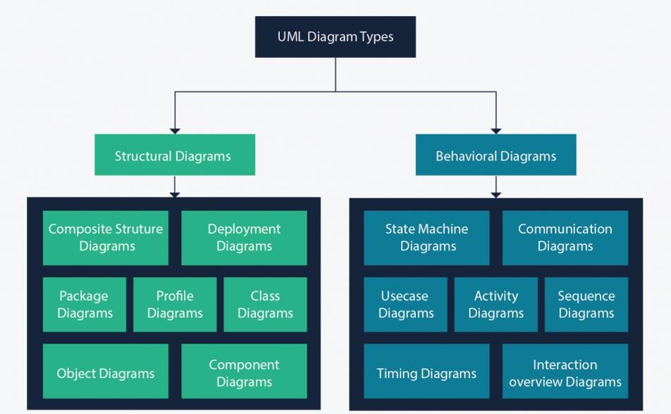

Figure 4: UML 2.5 diagrams overview

Source: <https://creately.com/blog/diagrams/uml-diagram-types-examples/>

It is important to note that UML is a modeling language and not a method or procedure. Hence, to give it an approach, we need to associate UML to a Unified process (UP) in order to give our conception a methodology to follow. A unified process is a generic method for developing software. This implies it is necessary to adapt the UP to the context of the project, team domain and or the organization. We will use the Two Tracks Unified Process (2TUP) throughout our project to implement our solution.

Difference between UML and MERISE

|  |  |
| --- | --- |
| MERISE | UML |
| It stands for Méthode d'Étude et de Réalisation Informatique pour les Systèmes d'Entreprises | Unified Modeling Language |
| MERISE is a systemic method of analysis and design of information systems. That is, it uses a systems approach. | UML is however not a method but rather an object modeling language to which it is necessary to associate an approach to make it a method. This is the case with the 2TUP method; RUP and XP. |
| MERISE proposes to consider the real system from two points of view: - A static view (data) - A dynamic view (treatments). That is, with the MERISE method, we have a separate study of the data and the treatments. | UML offers a different approach from that of MERISE in that it combines data and processing. Because with UML, centralizing the data of a type and the associated processing makes it possible to limit the maintenance points in the code and facilitates access to information in the event of software development. In addition, UML describes the dynamics of the information system as a set of operations attached to the objects of the system. |
| Rational | Object |

Table 12: Difference MERISE and UML

1. COMPARATIVE STUDY OF UNIFIED PROCESS
2. The Process of Development of a Software

A process can be defined as a partially sequence of steps that permits us to obtain software systems or evolution of an existing one. The main objective of software development is the production of quality software that response to the needs of the users during a particular time and at a particular cost.

#### A Unified Process :

A unified Process is a process of development of software constructed on UML; it is iterative, incremental, centered on architecture, driven by use cases and requirements.

**Iteration** is distinct sequence of activities with a basic plan and evaluation criterion that produces an internal or external output. Either the content of an iteration is improved or the evolution of the system is evaluated by users.

**An increment** is the difference between two released products at the end of two iterations. Each iteration that the group is capable of integrating the technical environment in order to develop a final product and give users the possibility of having tangible results.

**Centered on architecture** the different models derived during the establishment of system must be reliable and coherent.

**Driven by use case and requirements** enables the clear definition of a users’ needs and priorities respectively thereby minimizing the risk of project failure.

#### The Two Track Unified Process (2TUP)

2TUP is a unified process which is belt on UML and has as objective to bring solution to constraints of functional and technical changes imposed on information systems by strengthening controls on development capacities. It proposes a Y-sharped development life cycle that separates the functional aspect from the technical aspects, and the merging of these two forms the implementation aspect. 2TUP distinguishes therefore two branches: the functional and technical branches, the combination of the result of these two branches forms the third: the realization branch – where we realize our system. The diagram bellow illustrates the branches of 2TUP.

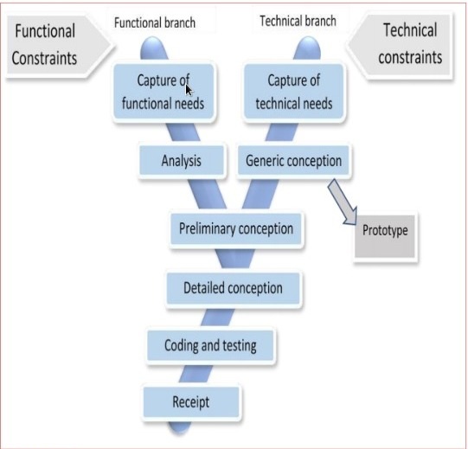

Figure5:RealizationBranch Source:https://image.slidesharecdn.com/2tup-presentation-121226144316-phpapp01/85/mthodologie-2-track-unified-process-7-320.jpg?cb=1666089460

##### The left branch (functional branch)

It captures the functional needs of a system. This ensures the production of software that meets the needs/requirements of the user. The analysis here consists of studying precisely the functional specification in order to obtain an idea of what the system is going to realize and its result does not depend on any technology.

##### The right branch (Technical branch)

The technical branch enumerates the technical needs and proposes a generic design validated by a prototype. The technical needs include constraints and choices related to the conception of the system, the tools and equipment as well as the integration constraint with the existing system condition. The different diagrams are shown in the table below.

##### The middle branch (Realization or implementation branch)

In this branch, we study the preliminary conception, detailed conception, and documentation of the system. The realization branch supports the following:

**Preliminary conception:** This is the most sensitive step of 2TUP as it is the confluence of the functional and technical branch. It is completed when the deployment model, the operating model, the logical model, inter-phases and the software configuration model are defined.

**Detailed conception:** This is the detailed design of each feature of the system.

**Coding and testing:** This are the phase where we program the designed features and test the coded features.

**The recipe:** Also known as the deliverable is the validation phase of the functions of the developed system.

1. JUSTIFICATION OF METHOD OF ANALYSIS

The reason why we chose UML modelling language and the software development process 2TUP instead of many others that exist, include:

UML is the current standard for programming in an object-oriented language. For this reason, it is widely understood and well known making it easy for a new programmer to join the project and be productive from the very first day.

UML diagrams allow teams to visualize how a project is or will be working, and they can be used in any field, not just software engineering. The diagrams will allow teams to visualize together how a system or a process will work or did work. It can provide new ideas for how teams have to collaborate to achieve the goal of the work-flow process.2TUP is centered around the creation and maintenance of a model, rather than the production of mountain documents.

2TUP is user oriented as it permits the development of software that responds to the needs of the users through the study of the user needs.

2TUP is iterative and incremental, hence it enables the project team to produce refined amelioration if necessary and easily integrate it in the already existing system. 2TUP by permitting the project team identify and test the key functionalities of the system limits the risk related to building the system.

## MODELING OF THE SYSTEM

Capture Of Functional Needs:

The first step of the left (functional) branch of Two Track Unified Process (2TUP) is the capture of the functional needs. At this step, we capture the intended behavior of the system that maybe express as services, tasks or functions the system is required to perform.

## Use Case Diagram:

##### Definition:

A use case diagram shows the functionalities of a system, their inter-dependencies and how they relate with actors of the system. A use case is a specification of behavior.

The main objectives of the use case diagram are:

* Provide a high-level view of the system;
* Identify the functions of the system.

Use case diagrams are completed with a textual description of each use case that is intended to define the use case in greater details.

##### Formalism:

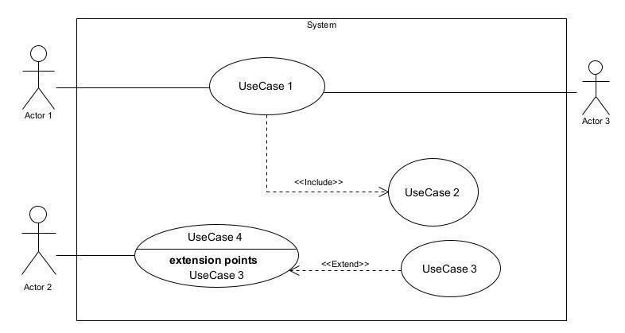

Figure 6: Use Case Diagram Formalism

1. Elements of a usecase diagram

|  |  |  |
| --- | --- | --- |
| Elements Notation Description | | |
| Actors |  | Represents an entity that directly interacts with the system. The actor is what performs the different possible actions of the system. |
| Use case |  | A use case represents a |
|  | Use Case  1 | functionality of the system. It is an action that can be performed by an actor. |
| Association |  | it indicates that an actor takes part in a use Case. |
| Include |  | An inclusion denotes that an included action must be performed before the including action can be performed. |
| Extend |  | An extension denotes that an extending action may be performed while an extended action is being performed. |
| Generalization |  | This shows that an actor or a use case is a kind of another abstract or concrete actors can be defined and later specialized using generalization relationship. |
| Elements | Notation | Description |
| System |  | It is a container of use cases which interact with external actors |

Table 13:Use case diagram component

##### The Actors Of Our System

1. Primary Actors

|  |  |
| --- | --- |
| Actor | Role |
| Client |  |
| Hairdresser |  |
| Hair salon manager |  |
| System Administrator |  |

Table 14:Actors of our system.

1. Secondary Actors

|  |  |
| --- | --- |
| Actors | Role |
| Payment API | Provide |
| Media Device API | Provide access to the phone’s camera |
| Geo-localisation API | Provide |

Table 15:Secondary Actors

|  |  |
| --- | --- |
| TITLE | BOOKING APPOINTMENT |
| Summary | The user needs to book an appointment |
| Actors | Client |
| Precondition(s) | -The actor has an account on the platform  -The application is launched  -The actor has authenticated  -Has internet access |
| Triggers | The user clicks on the book appointment button |
| Nominal Scenario | -The actor after authenticating chooses a hairstyle  -Clicks on plus (book appointment) button to access the interface  -The system displays a form  -The actor fills and submit the form  -The system verifies conformity of the form fields  -The system generates price and displays  -The actor clicks on the validation button  -The system sends the validation request  -The DBMS executes the validation request  -The system displays the available time  -The actor chooses the most suitable time out of the available ones  -The date is sent to the DBMS which stores  -The system finally displays the successful message on an interface |
| Alternative Scenarios | -At step 4 of the nominal scenario, the DBMS undergoes a double booking at a time  -The system displays ‘Try again’ |
| Postcondition of success | The system displays a successful message |
| Postcondition for failure | The user is sent back to the appointment interface |
| Non-functional requirements | There must be a good network connectivity |

Table 16:Nominal Scenario for booking appointment

1. Nominal Scenario For Authentication

|  |  |
| --- | --- |
| TITLE | AUTHENTICATE |
| Summary | The user needs to authenticates |
| Actors | Client, |
| Precondition(s) | The actor has an account on the platform  The app is launched  Has Internet connection |
| Triggers | The user clicks authentication button |
| Nominal Scenario | -The actor launches the mobile application.  -The system displays the login form.  -The actor fills and submits the form.  -The system verifies conformity of the form fields  -The system sends the data to the DBMS.  -The DBMS returns result of the query.  -The system displays a success message to the actor. |
| Alternative Scenarios | -At step 4) of the nominal scenario, the user enters  mismatched or missing information  -The system displays an error message then returns to step 2  of the nominal scenario. |
| Postcondition of success | The actor has access to the dashboard, depending on the type of account |
| Postcondition for failure | The user does not have access to the platform |
| Non-functional requirements | Entering of the password must not be visible on the screen |

Table 17:Nominal Scenario For Authentication

## Activity Diagram

##### Definition:

An activity diagram is a graphical representation of work-flows that show the steps needed in the realization of a process; showing the details from a start point to an end point through all decisions and actions that can possible be performed. Activity diagrams are intended to model both the computational and organizational process. They flow can be sequential, branched or concurrent. Below is an activity diagram formalism.

##### Formalism

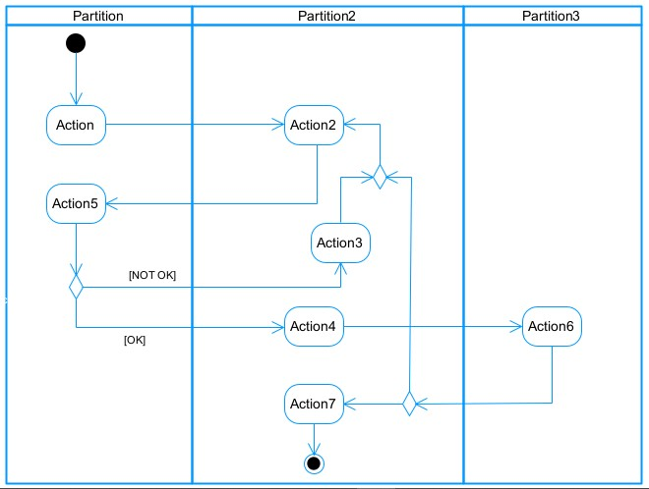

Figure 17 : Activity Diagram formalism

1. Activity Diagram Elements:

|  |  |  |  |  |  |
| --- | --- | --- | --- | --- | --- |
| **Elements Diagrammatic Representation** | | | | **Description** | |
| **Activity** | |  | | Use to represent a set of actions. | |
| **Action** | |  | | Represent a task to be performed. | |
| **Activity edge** | |  | | A directed connection between two activity nodes through which tokens may flow. | |
| **Initial node** | |  | | Shows the beginning of an activity or set of actions. | |
| **Final node** | |  | | Stops all controls and object flows in an activity. | |
| **Object node** | |  | | Represents an object connected to a series of object flows. | |
| **Decision node** | |  | | Represents a test condition that slits an incoming activity edge into opposite outgoing activity edges. | |
| **Merge node** | |  | | Reunite different decision paths created using a decision node. | |
| **Fork node** | |  | | Slits behaviour into parallel or concurrent flows of activities  (or actions) | |
| **Join node** | |  | | Unites a set of parallel or concurrent flows of activities or actions. | |
| **Swimlane and partition** | |  | | A way of grouping activities performed by the same actor in an activity diagram or to group actions in the same thread. | |

Table 20:components of an Activity Diagram

1. NextLuk Activity Diagram to Create Account

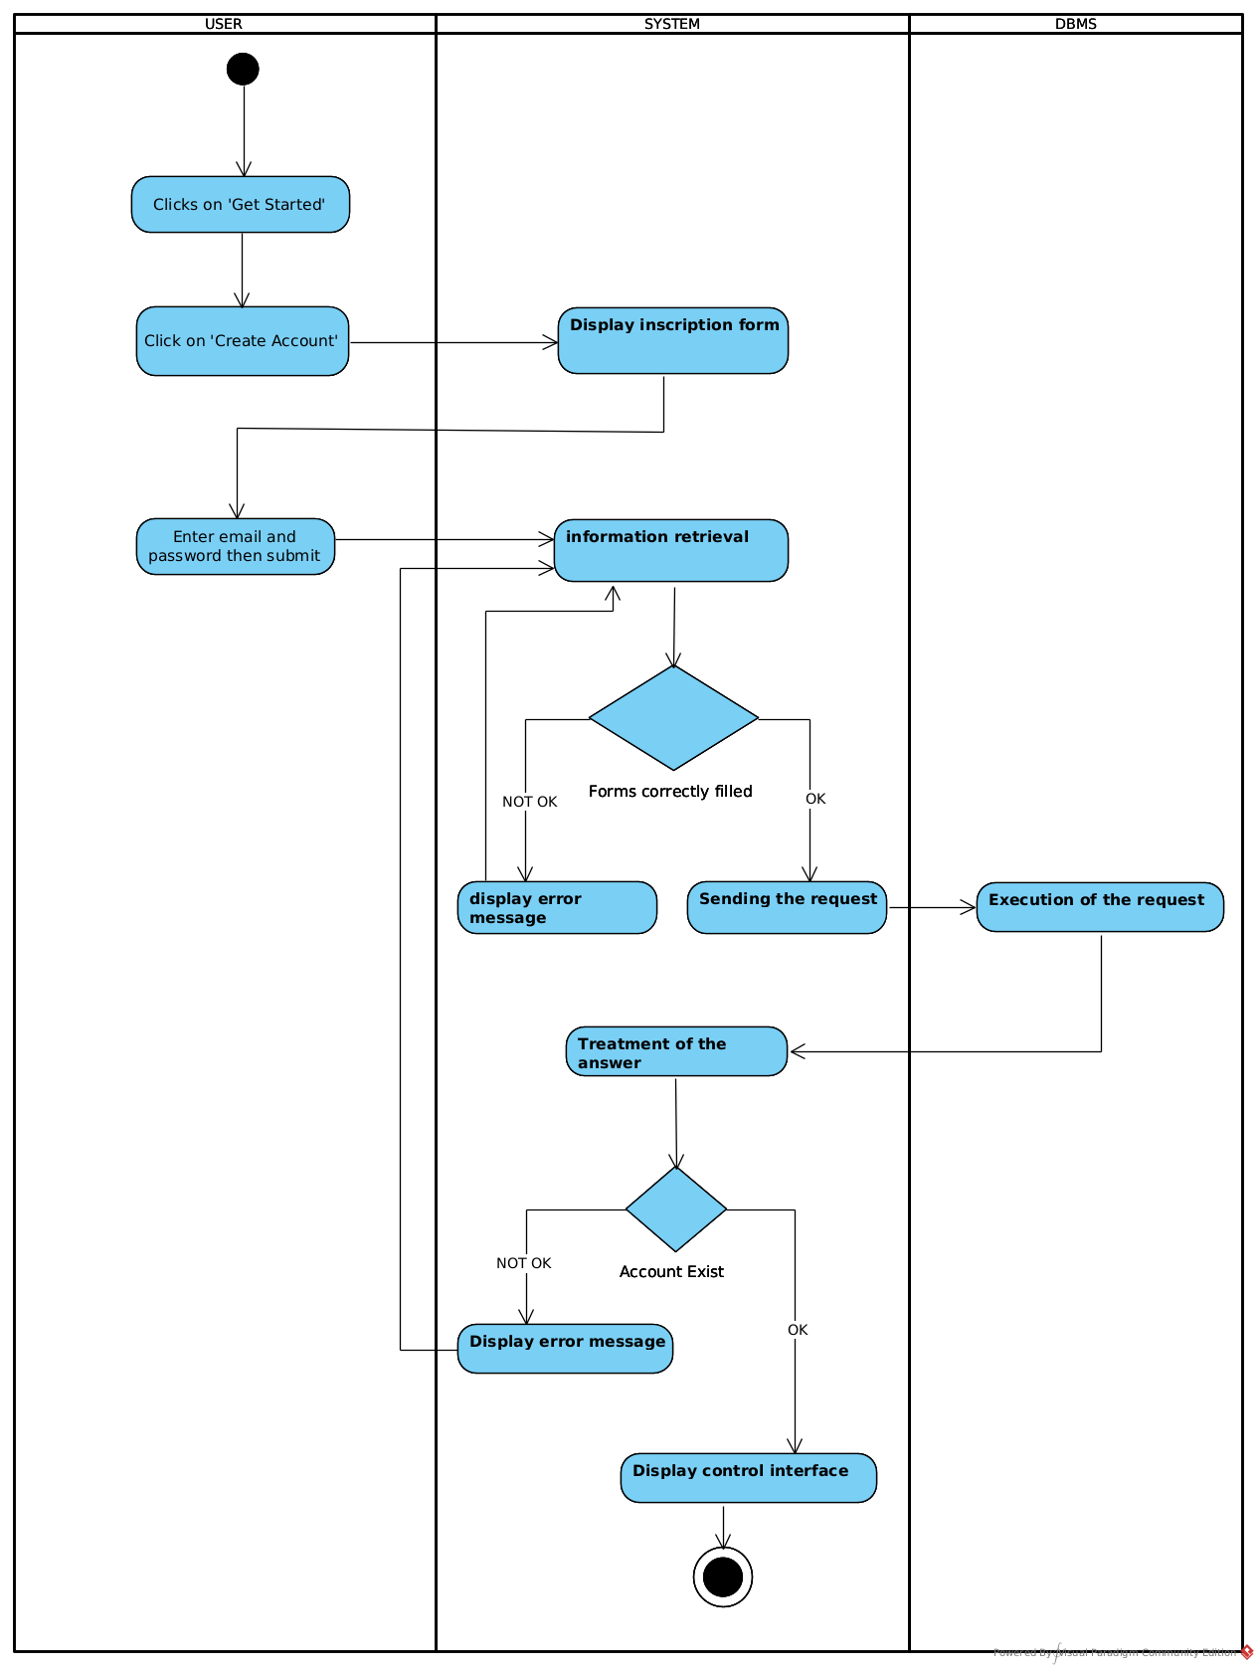

Figure 18: Activity Diagram of create Account

## Sequence Diagram:

1. Definition:

A sequence diagram is an interaction diagram which represents the flow of message between elements in a system, it is termed as an event diagram. It portrays the communication between any two lifelines as a time-ordered sequence of events.

1. Formalism:

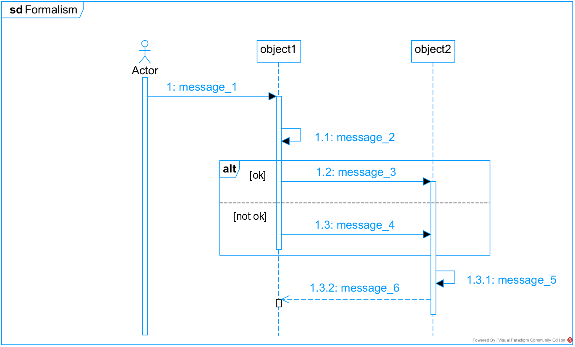

Figure 14: Sequence Diagram formalism

|  |  |  |
| --- | --- | --- |
| **Element** | **Representation** | **Description** |
| **Lifeline** |  | An individual participant in a sequence diagram, it is position at the top of the diagram. |
| **Combined fragment** |  | It represents a choice of behavior in which at most one operand will be chosen. |
| **Messages** |  | These are arrows which shows the direction of message flow. We have the synchronous, the asynchronous and the selfmessages. |
| **Activation** |  | It describes the time period in which an operation is performed by an element. |

Table 19:Sequence Diagram Components

NextLuk Authentication Sequence Diagram

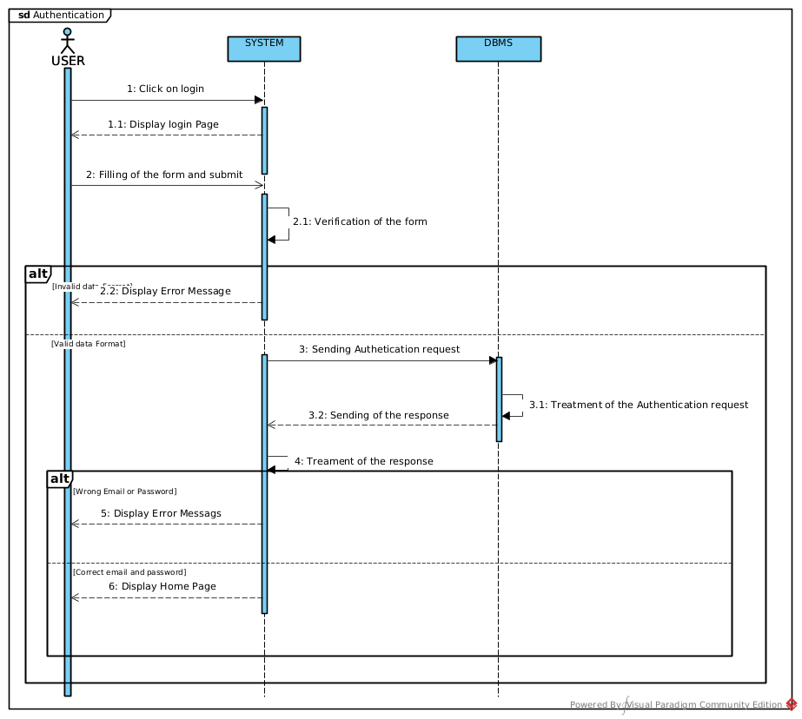

Figure 15: Sequence Diagram of authentication

## Communication Diagram

* 1. Definitions:

It is a diagram which is used to show the relationship between the actors of a system, both the sequence and the communication diagrams represent the same information but differently. Instead of showing the flow of message. It depicts the architecture of the object residing in the system as it is based on object-oriented programming.

* 1. Formalism

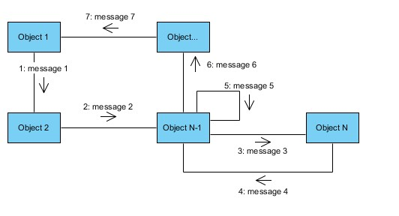

Figure 10:Communication Diagram Formalism

|  |  |  |
| --- | --- | --- |
| **Element** | **Representation** | **Description** |
| **Object** |  | An actor represents an individual participant in the interaction conversation. |
| **link** |  | It initiates an association it connects two objects together for them to communicate. |
| **Actor** |  | A role play by an entity that interacts with the subjects. |
| **message** |  | Defines a particular communication between lifelines in an interaction. |

Table 18:Communication Diagram Components

NextLuk Communication Diagram for Authentication

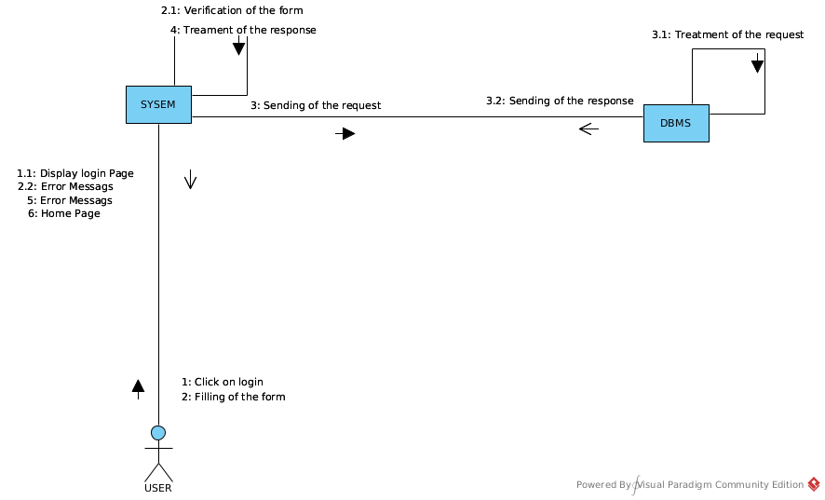

Figure 11 : Communication Diagram of authentication

CONCLUSION

In the analysis phase, we chose a software development process and modelling language, after which we presented the existing system, its limitation and our proposed solutions. We went forth explaining the functional need of our system, we saw the use case diagram which shows the relationship between the actors and use case (the action the actor can perform on the system), we saw the activity diagram which shows the work-flow of our system, and lastly the State machine diagram which shows the behavior of a single object in response to an event. We will now move to the conception phase in which we will present the other two branches of the 2TUP which are the Technical and the realization branch of our system.

PART V

CONCEPTION PHASE

Preamble

The conception phase will permit us to present in an orderly manner the components necessary for the good functioning of our software and also the architecture used for the proposed solution. It bridges the gap between the analysis phase and the realization phase

Content overview

INTRODUCTION

1. TECHNICAL BRANCH
2. GENERIC DESIGN
3. CAPTURES OF TECHNICAL NEEDS
4. RELATED UNL DIAGRAMS
5. Class Diagram
6. State Transition Diagram
7. Package Diagram

CONCLUSION

## INTRODUCTION

The conceptual phase will describe in details the necessary specifications, features and operations that will satisfy the functioning requirements of the proposed system as modeled in the analysis phase. This phase is meant to identify and consider essential components (hardware /or software), structure (network capabilities), processes and procedures for the system to accomplish it objectives. We will look at some diagrams such as the component diagram, package diagram, communication diagram, class diagram and the object diagram.

1. TECHNICAL BRANCH
2. GENERIC DESIGN
3. Hardware diagram of the system:

The hardware diagram simply shows how the system components of our system are deployed; it shows the positioning of each device into it right proportion.

Google Drive API

DBMS

Figure 23:Hardware Architectural Diagram of the system

DBMS

Application Server

Data Layer

Business Layer

Application Layer

Presentation Layer

Weather API

1. High Level Architectural Diagram of the Software

Web Client

The high-level architecture diagram provides an overview of the entire system, identifying the main components that would be developed for the product and their interfaces. The high-level architecture diagram below illustrates this.

iOS Client

Media Device API

## CAPTURE TECHNICAL NEEDS

1. Physical architecture

The design of the DBMS depends on its architecture. An n-tier architecture partitions on the whole system into related but separated n modules, which can be independently modified, altered, changed or replace. A large amount of data on web servers, personal computers and others are link with .

networks with the help of basic client or server architecture.

Within the scope of our project, we made use of the multi-tier architecture This architecture separate it tiers from each other based upon the user and the manipulated data in the database. It is important to note that with the multi-tier architecture, only neighboring layers can communicate. Each layer has a well-defined communication interface and the evolution of the layer is independent of the other. The multi-tier of our system is made up of:

* The hardware tier, which represents
* The client tier, which is also known as our presentation inter-phase.
* Application Tier, which represents our web-server.

❖ The data tier, which represents our DBMS server

### Présentation de l’architecture logique du système IOT

1. Logical architecture:

Model View controller or MVC as it is popularly called, is a software design patten for developing application. A model view controller pattern is made up of the following three parts.

* Model: The lowest level of the patten which is responstupible for maintaining data.
* View: This is responsible for displaying all or a portion of data to the user.
* Controller: It handles software codes that controls the interactions between the model and the view.

MVC is popular as it isolates the application logic from the user interface and supports separation of concerns. Here the controller receives all requests for the application then works with the model to prepare data needed by the view. The view then uses the data prepared by the controller to produce a final response. The MVC can be represented as follows.

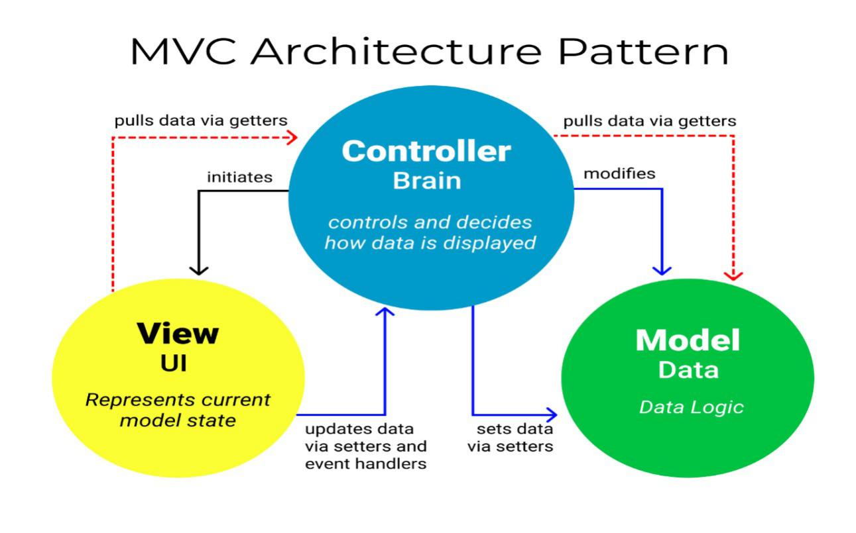

Figure24:The MVC architecture Source:https://www.freecodecamp.org/news/the-model-view-controller-pattern-mvcarchitecture-and-frameworks-explained/

## RELATED UML DIAGRAMS

1. **Class Diagram:**

Application Server

Android client

Google Drive API

1. Definition:

A class diagram is a static diagram. It represents the static view of an application. class diagram is not only used for visualizing, describing and documenting different aspect of the system but also for constructing executable code of the software application. Class diagram describes the attribute and operation of a class and also constraints imposed on the system. It purpose is to model the static view of an application

1. Formalism:

multiplicity

private (accessible

only within the class

scope)

public

(

accessible out

of the class

scope)

0..1

0..*



class name

-

Attribute

:

int



Classe_2

Figure 25 :Class Diagram Formalism

Class Diagram Elements Description

|  |  |  |
| --- | --- | --- |
| **Element** | **Representation** | **Description** |
| **class** |  | A class is an element that defines the attributes and behaviors that an object is able to generate |
| **Composition** |  | If a parent of a composite is deleted, usually, all of its parts are deleted with it. |
| **Aggregation** |  | If the parent of the aggregate is deleted, usually the children are not deleted. |
| **Dependency** |  | It existed between two classes, if one changes it may cause the change in the order, but the other way around. |
| **Generalization** |  | it a relationship between a whole thing (called superclass) and a more specific thing (called subclass) |
| **Association** |  | It is a general type of relationship between elements, it may include cardinality, roles etc. |

Table 23:Class Diagram Components

1. Class Diagram:

**State Machine Diagram**

##### Definition

A state machine diagram describes the behaviour of a single object in response to a series of events in a system. Also known as the state machine diagram, it models the dynamic flow of control from the state of a particular object within a system.

##### Formalism:

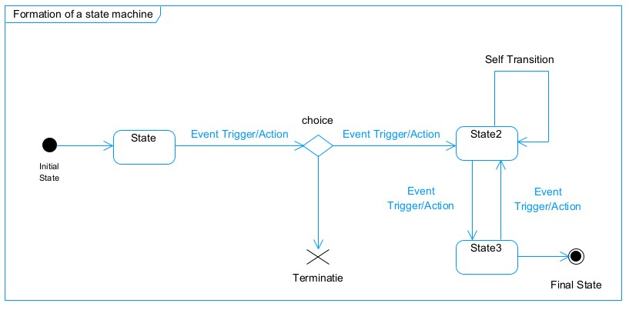

Figure 27:Formalism of a state machine diagram

State Machine Diagram Elements

|  |  |  |
| --- | --- | --- |
|  | **Diagram Relationship** | **Description** |
| **State** | tup | Models a situation during which a certain invariant condition holds. |
| **First (Initial) State** |  | It represents a default vertex, that is, a source for a single transaction to the default or composite state. |
| **Final State** |  | A state specifying that the enclosing region is complete. |
| **Transition** |  | A direction relation between a source and a target vertex. |
| **Choice pseudo State** | tup | A diamond symbol that indicates a dynamic condition with branched potential results |
| **Terminate** |  | Implies that the execution of a state by means of it context is terminated. |
| **Diagram Overview** |  | A placeholder for the linked states in a state machine diagram. |

Table 24:State Machine Diagram Components

1. **Package Diagram:**
   1. Definition:

This is a structural diagram used to show the organization and arrangement of various model elements in the form of packages. A package diagram is the grouping of related uml elements such as classes, diagrams or eve other packages.

* 1. Formalism:

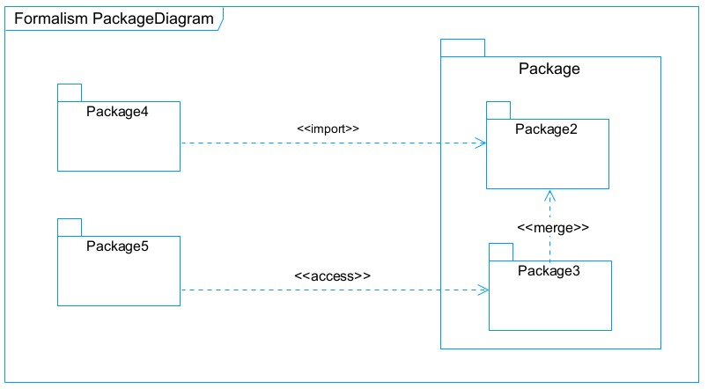

Figure 28:Package Diagram Formalism

|  |  |  |
| --- | --- | --- |
| **NAME** | **Representation** | **Description** |
| **Package** |  | A package is a names-pace use to group related elements; it is a mechanism used to group elements into a better structure in a system. |
| **Package import** | tup | A relationship Indicate that, functionality has been imported from one package to another. |
| **Package access** |  | A relationship Indicates that one package requires assistance from the function of another package. |
| **Package merge** |  | It is a relationship which shows that, the functionality of two packages are combines to a single function. |

Table 25: Package Diagram Component

tup

Figure 29:Package Diagram Components

## CONCLUSION

In the conception phase, we set as objective to plane the different aspect of our system by showing how it will be structure and deployed within existing technical architectures. We began by taking into account the technical constraints for our system, after which we proceeded to identify the components of our system, how they are grouped together and how they should be deployed on appropriate deployment targets. We finished this phase by looking at interactions between the various aspects and actors of our system. The next phase of our report is the realization phase where we will look at aspects concerning the implementation of our system.

PART VI

REALIZATION PHASE

Preamble

In this phase we will to straight forward in the implementation of our solution, we will base ourselves on the analysis and conception phases. Content

Content overview

### 

INTRODUCTION

1. ARCHITECTURE OF THE APPLICATION
2. Logical architecture
3. Physical architecture
4. TECHNOLOGICAL CHOICE
5. Choice of programming language and framework
6. Choice of tools used

CONCLUSION

## INTRODUCTION

Here in the realization phase, we will concentrate on building or implementing our solution, based on the different analysis and conception that we had carried out, which will help to facilitate our work, this phase is as critical as the previous phases. We are going to look at the relationship that exist between the entities of the entity relational diagram. Furthermore, we will see the choices of technologies used for the implementation of our system.

**IMPLEMENTATION BRANCH (TITLE)**

Here we will see the preliminary conception, detailed conception and documentation of the system.

1. PRELEMINARY DESIGN:
2. **Component Diagram:**
3. Definition:

Component diagrams are used to model the physical aspect of a system. Now the question is what are this physical aspect? They are elements such as Executables, libraries, files, document etc. which resides in a node. The component diagram does notupt describe the functionality of the system but it describes the components used to make those functionalities.

1. Formalism:

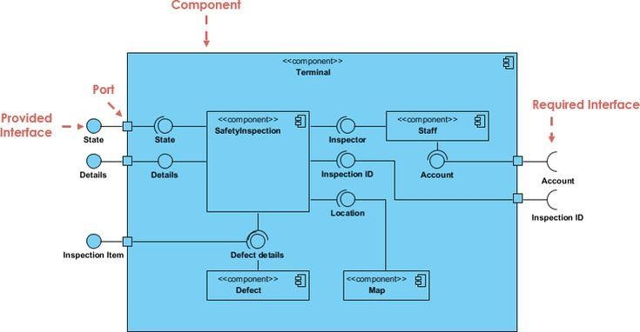

Figure 30 :Component Diagram Formalism

|  |  |  |
| --- | --- | --- |
| **NAME** | **REPRESENTATION** | **DESCRIPTION** |
| **A component** |  | A component is an abstract logical unit block of a system.it is represented as a rectangle with smaller rectangle in the upper right corner which saves as it icon for recognition. |
| **Dependency** |  | Dependency is a directed relationship which is used to show that some components are dependent on others for their correct functioning. |
| **interface** |  | An interface is a circle or a semicircle attached to a stick which looks like a lollipop. It describes groups of operations provided or required by components. |
| **port** | tup | A port (represented by a small square at the end of a required or provided interface) is used when the components delegate the interfaces to an internal class. |

Table 26: Component Diagram Components

Figure 31:System Component Diagram

1. **Deployment diagram:**
   * 1. Definition:

consists of nodes. Nodes are nothing but physical hardware used to deploy the application Deployment diagram is a structural diagram used to visualize the topology of the physical components of a system, where the software is deployed. They consist of nodes and their relationship. It is related to the component diagram because the components are deployedtup using the deployment diagram. A deployment diagram

* + 1. Formalism

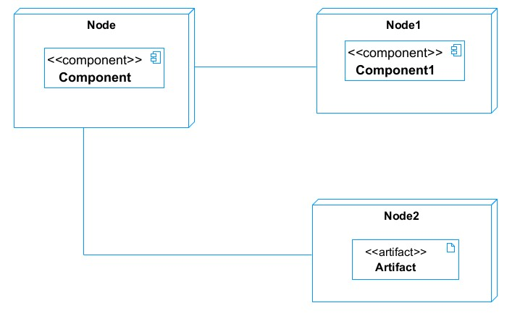

Figure 32:Deployment Diagram Formalism

|  |  |  |
| --- | --- | --- |
| Element | Representation | Description |
| Node |  | It is a hardware used to deploy the tupapplication |
| Artifact |  | An artifact is a major product, which is produced or used during the development of a software. E.g diagrams, data models, setup scripts |
| Component |  | It represents a modular part of a system that encapsulates its content and whose manifestation is replaceable within it environment. |
| Association |  | An association helps to connect two nodes together which permits them to communicate together |

Table 27:Component Diagram Elements

* 1. System Deployment Diagram

Figure 33:System Deployment Diagram

Materials used for the development of the NextLuk

|  |  |  |  |
| --- | --- | --- | --- |
| Material | Quantity | Fonction | Image |
| Dell LATITUDE E7540 | 1 | The computer was used for the programming of the micro controller, the analysis, research, the design of the system architecture. This was the main component in this project. |  |
| HP computer | 1 | The computer was used for the development of the mobile application and web application |  |
| iPhone 11 pro max | 1 | Testing the mobile app functionalities and debugging. |  |

Softwares used for the development of Nextluk

|  |  |  |  |
| --- | --- | --- | --- |
| Software | Version | Role | Image |
| OS  WINDOWS  10 | 18 362 | The operating system required to run the software is the one on which we have worked. |  |
| Sybase  PowerAMC | 16,5 | The software engineering workshop used for solution modeling. We utilized this tool for modeling the various diagrams of our system. |  |
| Visuel studio code | 1.70.0.8 | Éditeur de texte utilisé pour saisir les lignes de code qui seront interprétées par le navigateur. |  |
| Postman | 9.4 | It is a platform that simplifies every step of the API lifecycle and streamlines collaboration, making it easier and faster to create better APIs. |  |
| Github | 3.0.6 | It is a website and cloud service that helps developers store and manage their code. |  |
| Framework  react native | 0.69.0 | React Native is an English framework built on JavaScript for creating Android and iOS applications. |  |
| PostgreSQL |  | Database Management System |  |

Table 21: Softwares used for the development of Nextluk

### 

### Technologies used for the development of the DSEI

|  |  |  |
| --- | --- | --- |
| Image | Name | Usage |
|  | Django – Framework | Used for the development of the application core/kernel. |
|  | JavaScript | The programming language used for front-end processing is JavaScript. |
|  | Framework React JS | Front-end development |
|  | Python3 | Backend development |

Table 22:Technologies used for the development of Nextluk

## CONCLUSION

In our realization phase, we set as objective to plane the different aspect of our system by showing how it will be structure and deployed within existing technical architectures. We began by taking into account the technical constraints for our system, after which we proceeded to identify the components of our system, how they are grouped together and how they should be deployed on appropriate deployment targets. We finished this phase by looking at interactions between the various aspects and actors of our system. The next phase of our report is the realization phase where we will look at aspects concerning the implementation of our system.

BOOK VI

# FUNCTIONAL TESTING

APPLICATION FUNCTIONNALITIES

BOOK VI

# INSTALLATION AND USER GUIDE

Preambletup

The purpose of the user guide is to provide users of our platform with step-by-step instructions on how to install and use the system.

Content overview

INTRODUCTION

1. INSTALLTION
2. USER GUIDE

CONCLUSION

1. INSTALLATION
2. USER GUIDE

Here we have the first interface displayed when the NextLuk application is opened. Here we have to click on “Get Started” to proceed in the application.