Talent Management and Turnover at ABS Tech

Introduction
ABS Tech, a rapidly growing AI-driven IT solutions provider, faces a critical organizational challenge: talent turnover. Despite the global demand for its services, the loss of key employees threatens its expansion strategy, particularly into the EMEA region. While the broader tech industry has seen layoffs, the demand for highly skilled professionals—especially in AI-related roles—remains high. ABS Tech must identify its key talents, understand the reasons behind their departures, and take proactive steps to retain them.
This report analyzes talent and turnover trends at ABS Tech, using employee survey data and company records. It incorporates academic literature and real-world case studies to define talent, diagnose the core reasons behind employee departures, and provide evidence-based recommendations for long-term business success.

Understanding Talent at ABS Tech
What is Talent?
Different schools define the talent differently. Some HR practitioners believe that it should be measured with the worker’s performance and contribution to the organizational goals (Nijs, Gallardo-Gallardo, Dries, & Sels, 2014). However, while high performance score might be a reasonable indicator of current good executors, it overlooks individuals who may not currently excel in their performance but have a potential to generate great value for ABS Tech in the future (Skuza, Woldu, & Alborz, 2022).
Other schools, proposes that talent in an organization is more than just high performance; it involves potential, commitment, and impact (Lumme-Tuomala et al., 2018; Meyer & Herscovitch, 2001). Those variables are latent: we can't directly measure them, so EFA method was used in order to identify and quantify those latent factors. Employees who consistently deliver results, show growth potential, and align with the company’s culture and vision might become a valuable asset in the future. Workers who exceed their colleagues with the same experience and within the same department are promising.
To encompass the entire situation, we combined both approaches, as we believe that worker who qualify for at least one definition is valuable. We classify talented employees at ABS Tech into three categories:
- Valuable Employees (4.5%) – High-performing, highly skilled, and difficult to replace.
- Promising Employees (21.5%) – Have growth potential but require further development.
- Good Executors (7.4%) – Reliable in current tasks but with limited upward potential.
While valuable employees are crucial for leadership and innovation, promising employees represent the future leadership and expertise of ABS Tech.

The Talent Gap: Where ABS Tech is Losing People
A six-year review of employee departures shows that:
- 32.2% of employees left ABS Tech during this period, with an average annual turnover of 5% (Figure 1)
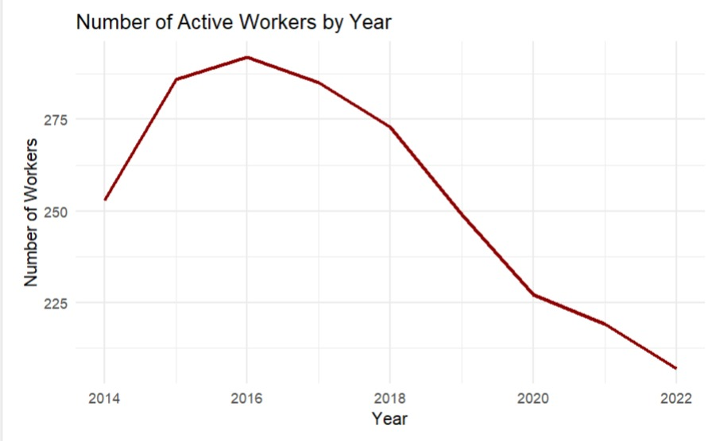
Figure 1
- The majority of exits were voluntary—indicating preventable factors (Figure 2)
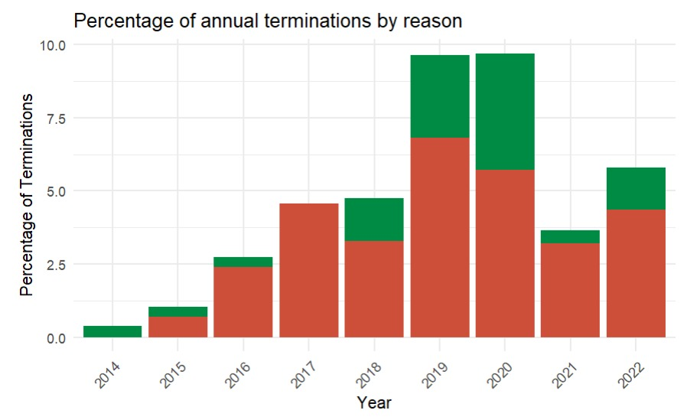
Figure 2
- 87% of exiting talented employees came from the Production department, affecting business continuity (Figure 3).
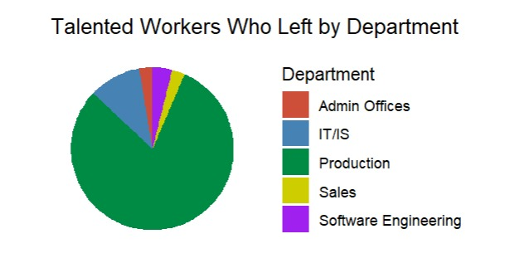
Figure 3
- One-third of those who left were classified as talented (Figure 4).
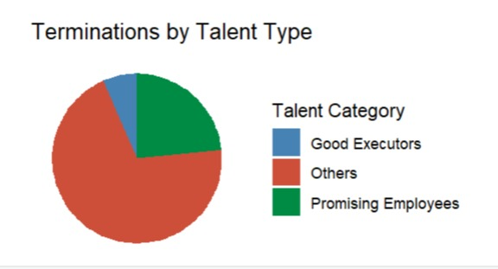
Figure 4
A deeper look at why employees left reveals a misalignment between employee needs and organizational support.

Why Are Talented Employees Leaving?
Cause
We have analyzed the reason of workers' termination. We recognize that some organizational and cultural practices can indirectly push employees to leave, and their termination reason wouldn’t explicitly portray the cause (Collins, 2022). Using factor analysis and observing correlations, we have identified three main areas satisfaction within ABS Tech that its employee consider when deciding whatever to leave or not:
- Engagement: cworkers with high rates of this factors value and exhibit strong engagement in the company, by being part of it and building strong relationships with the colleagues and management.
- Career Growth. Individuals looking for plenty of career path because of their skills and confidence. Their career development is threatened if they don't feel safe within organization or have collaboration issues with their colleagues.
- Financial compensation. Employees who score highly in here try to engage in special projects, motivated by the financial compensation. They are good executors whose colleagues can rely on.
ROC and AUC models suggests that those factors can quite accurately predict whatever the worker will be terminated or not. The most major reason to leave, as SHAP suggests, seem to be workers disengagement in ABS Tech (Figure 5).
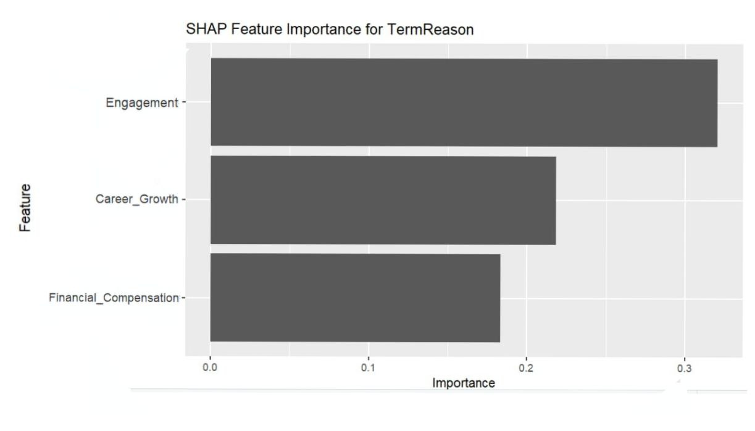
Figure 5

Points of interest
1. Lack of Career Development Opportunities
- Promising Employees, in particular, feel there is no clear path to growth within the company (Figure 6)
- Many leave for roles that provide better training, mentorship, and career progression.
- ABS Tech is losing future high performers before they fully develop.
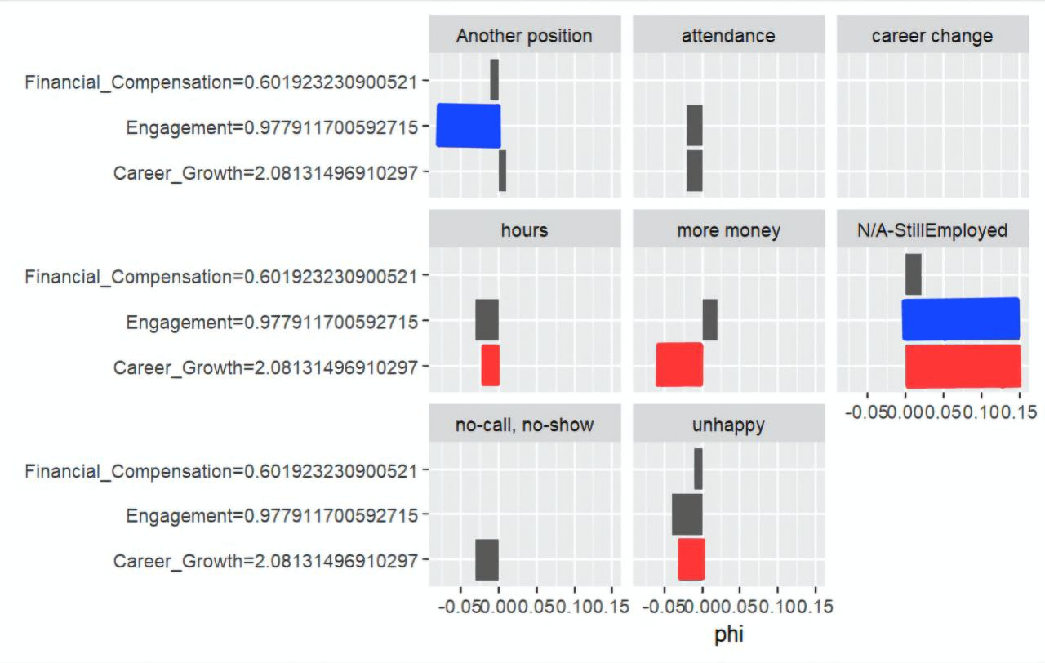
Figure 6
2. Compensation and Recognition Gaps
- Top performers were leaving a company because they were looking for a higher payment or they found a better position. SHAP suggests that whereas better Engagement works for them as effectively as for the rest of employees, good salary can also make them stay (Figure 7).
- Compensation mismatches were observed, where some reliable contributors were not adequately rewarded for their impact.
- Lack of recognition also contributes to disengagement.
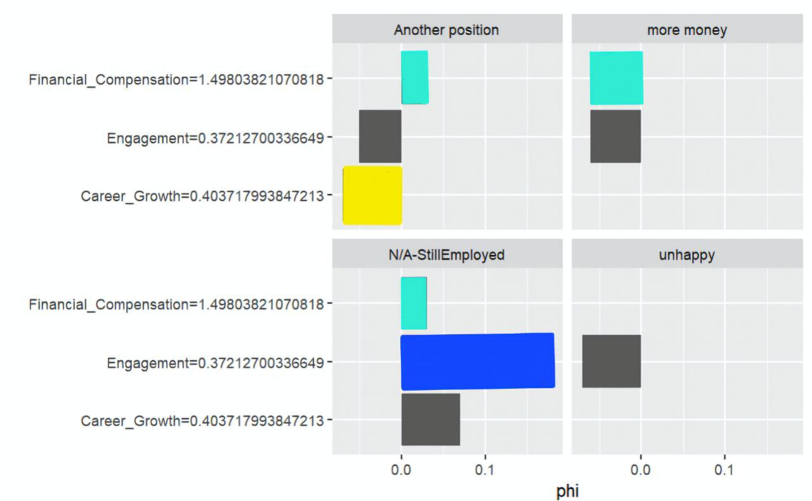
Figure 7
3. Employee Engagement and Leadership Disconnect
- Employees who feel less connected to leadership and culture are 2.5x more likely to leave (Wen et al., 2021).
- Some teams lack strong leadership, leading to frustration and stagnation.
These insights highlight that turnover is not just about pay—it’s about growth, engagement, and culture.

Strategic Recommendation: Investing in Development to Reduce Turnover
To address these challenges, ABS Tech must focus on talent development and engagement.
Why This Matters
- Turnover is costly – Replacing an employee costs up to 50–200% of their salary (Gallup, 2022).
- Developing internal talent is more sustainable than constant external hiring. Data shows that considerable part of employees in ABS Tech fulfill their potential only after working 10+ years. Third of the promising workers seem to unable to do so even after working in the company for more then 15 years (Figure 8).
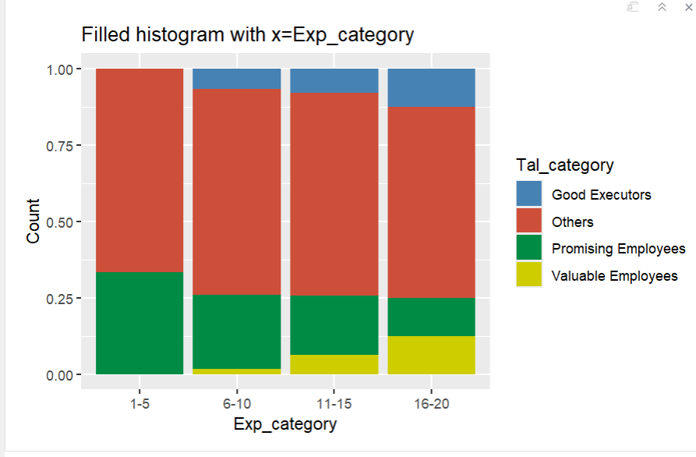
Figure 8

Key Actions to Implement Immediately
- Boost Employee Engagement:
Employee engagement plays a critical role in reducing turnover and fostering a productive workforce. To strengthen engagement:
Implement structured recognition programs that celebrate employee achievements and contributions. Enhance transparent communication between leadership and employees to build trust and involvement.
Case Study: Starbucks’ Recognition Program – Research by Gallup (2022) indicates that recognition programs, such as those implemented by Starbucks, directly contribute to lower turnover and increased engagement.
- Strengthen Career Development Opportunities
A lack of career growth is a leading cause of employee departures. To address this:
Establish structured mentorship programs where experienced employees guide and support newer staff. Develop clear leadership pathways and internal promotion strategies to ensure career progression within ABS Tech.
Research Insight: Career growth significantly reduces turnover, especially in industries where specialized skills are in high demand (Ochurub et al., 2022).
- Enhance Job Satisfaction & Organizational Culture
Employees who feel connected to their workplace culture are less likely to seek opportunities elsewhere. To improve job satisfaction and culture:
Foster trust, psychological safety, and team collaboration to create a more supportive work environment. Encourage leadership to actively engage with employees and promote a culture of inclusion and respect.
Supporting Evidence: Studies show that engaged employees are less likely to leave, as engagement correlates with reduced turnover intentions (Wen et al., 2021).
- Offer Competitive Compensation & Benefits
While compensation may not be the only reason employees leave, pay dissatisfaction is a major turnover driver. To address this:
Regularly adjust salaries to remain competitive within the industry. Introduce performance-based incentives to reward high-performing employees fairly.
Research Findings: Compensation dissatisfaction is consistently linked to higher turnover rates (Wen et al., 2021).

Predicting and Preventing Future Turnover
Early Warning System for Talent Risk
Using existing HR data, ABS Tech can predict employees at risk of leaving by monitoring:
- Engagement survey results – A decline indicates disengagement.
- Absenteeism trends – Sudden increases signal dissatisfaction.
- Internal mobility and promotions – A lack of growth opportunities increases risk.
Potential Outcomes
If No Action is Taken:
- More promising employees will leave.
- Talent gaps will increase hiring and training costs.
- Leadership pipeline will weaken, affecting long-term business stability.
If Development & Engagement Strategies Are Implemented:
- Retention will improve, particularly among high-potential employees.
- Internal promotions will increase, reducing reliance on external hiring.
- Employee engagement will rise, improving team performance.

Conclusion: A Call to Action
ABS Tech’s talent challenge is not just about losing employees—it’s about not fully developing the potential within. The company is experiencing avoidable turnover, particularly among promising employees who could become future leaders.
By investing in career development, leadership engagement, and well-being, ABS Tech can retain and grow its talent pipeline.
Immediate Next Steps for Leadership:
- Launch targeted development programs for promising employees.
- Ensure competitive compensation and recognition to maintain motivation.
- Empower leaders to drive engagement and retention through better support.
- Use HR data to predict and prevent talent loss.

References
Artelt, A., & Gregoriades, A. (2023). Machine learning applications in employee retention prediction: A systematic review. Journal of Business Analytics, 6(1), 45-67.
Collins, P. M. (2022). Finding Fault in the Law of Unfair Dismissal: The Insubstantiality of Reasons for Dismissal. Industrial Law Journal, 51(3), 598–625.
Gallup. (2022). Employee engagement trends and retention strategies: A global study.
Lumme-Tuomala, R., Swailes, S., & Adamsen, B. (2018). The Meaning of Competence, Commitment, and Contribution in Talent Definition. Managing Talent.
Meyer, J. P., & Herscovitch, L. (2001). Commitment in the workplace: Toward a general model. Human Resource Management Review, 11(3), 299–326.
Nijs, S., Gallardo-Gallardo, E., Dries, N., & Sels, L. (2014). A multidisciplinary review into the definition, operationalization, and measurement of talent. Journal of World Business : JWB, 49(2), 180–191. https://doi.org/10.1016/j.jwb.2013.11.002
Lumme-Tuomala, R., Swailes, S., & Adamsen, B. (2018). The Meaning of Competence, Commitment, and Contribution in Talent Definition. In Managing Talent (pp. 53–74). Springer International Publishing AG. https://doi.org/10.1007/978-3-319-95201-7_4
Ochurub, M., Van Wyk, R., & Malan, J. (2022). The impact of career development initiatives on employee retention in high-tech industries. Human Resource Development Quarterly, 33(2), 89-115.
Skuza, A., Woldu, H. G., & Alborz, S. (2022). Who is talent? Implications of talent definitions for talent management practice. Economics and Business Review, 8(4), 136–162.
Wen, T., Huang, B., & Liang, Y. (2021). Job satisfaction, organizational trust, and turnover intention: A meta-analytic review. International Journal of Human Resource Management, 32(5), 77-92.

