7. <li"c;r;.,.)· .(!l.:'1· <l"l'I·)· (\, · t\"'i.W· .l.!10'f":f:9n <lll.U· O</t'l'C 6 h•/'"" Oar f20% cj1r;(i <lrf'm'''lt hfao(lt,s>
n..t. <llh ·>-t.e.1rYt:-t·a1· /n"1<;.,. n.-7· f\att.·1w .e.·rn .\ ::.
7.1. {lrf;J·r<t>· h25 - 50 t\lf'f. n.,.)·11n"f f"g:f •}r...fi .................... 2% !
7.2. 1111;;1'r.m· h51 - 76 t\lf'f. fl,.)• ?lfP' : \'"t<;:f •}r...fi 4%?
7.3. -ort::l'T<D· h77 - 105 t\tr'f. n,:,.·11r9'r ""'"·,:.1•r.1i 6% !
7.4.1lrt;.Nfm-h106 >-.<; Ot\.e t\lf'f.lb.)·11rs»ff"7<;:f¥ni 8%.e l;Jt:\::
8. l'l1t1rt h1'6..lat> O:'J.t\ 075 <i>'lt 1.H. m-l'l-r \><P'l?f.1 9l1.e:·,n":J.t:\1«D· t\atthtt:tr n.t 11fsP:f f<I?. 61 ?D 1l
.pcj'(i ."7(\·::
9. \>>JC:1"1'1 ll,.f-T'i' r'>"l o-.ff \>01/l'llh<l.Y 1.H.:-
9.1. oao-"°iLi7i1"1\>CT<f.m'l RF 0.-fT 03 a,aot ar(l-r (Llf1:
9.2. llht.A iLi7i1"1\>CT<f.mc;' ";rC;J-01/c;' c\.'P SF O..Y.:f 02 a,ao.tar::
10. \>">-.TC;J-01/ (l,-fT at>('i61i], cp.? <it1 m9DC!' nai.:rc Ii&. 011C h '} V1'1<I>- h(j;;J- h '} CT<f.h1't\a>- cf>CO..t\::
\>O...P h(j;;J- 9DC61iJ. \> 10;;: m-::
CJ.;j- tilf'}fil ClAfC lt.t'IA h'i lt.t'IAh<i'
ft\.,.'J:CTD | f1':£CTD | fA'f':fcro | f A.,.:lCID
ilC | ilC | ilC | -OC
155,342.00 | 146,489.00 | 124,223.00 | 120,175.00

OCTDm<i'# /l,j, fir-
-OC

10.1 h3i::-1oi:: b'!cl>

SFCA SFCR RFCA RFCR

189,750.00 185,449.00
199,870.00 198,605.00
125,994.00

164,197.00
196,581.00

SFCA 123,717.00 120,175.00
\110,055.00

SFCR RFCA RFCR
.157,872.00 157,872.00
197,340.00 196,328.00
143,704.00
194,304.00
162,932.00 | 157,619.00
197,087.00 | 196,075.00
108,031.00 | 104,236.00
141,680.00 | 136,620.00
194,810.00 | 192,786.00
91,839.00 | 88,297.00
120,428.00 | 115,621.00

SFCA 115,874.00 106,007.00
94,116.00

SFCR
150,535.00 138,897.00
123,211.00

RFCA RFCR
196,834.00 195,316.00 192,533.00 191,774.00 193,545.00

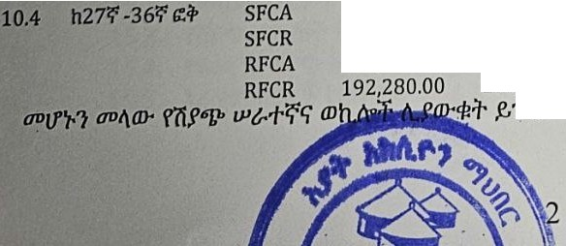
99,935.00
89,815.00
133,331.00
118,151.00
192,027.00

