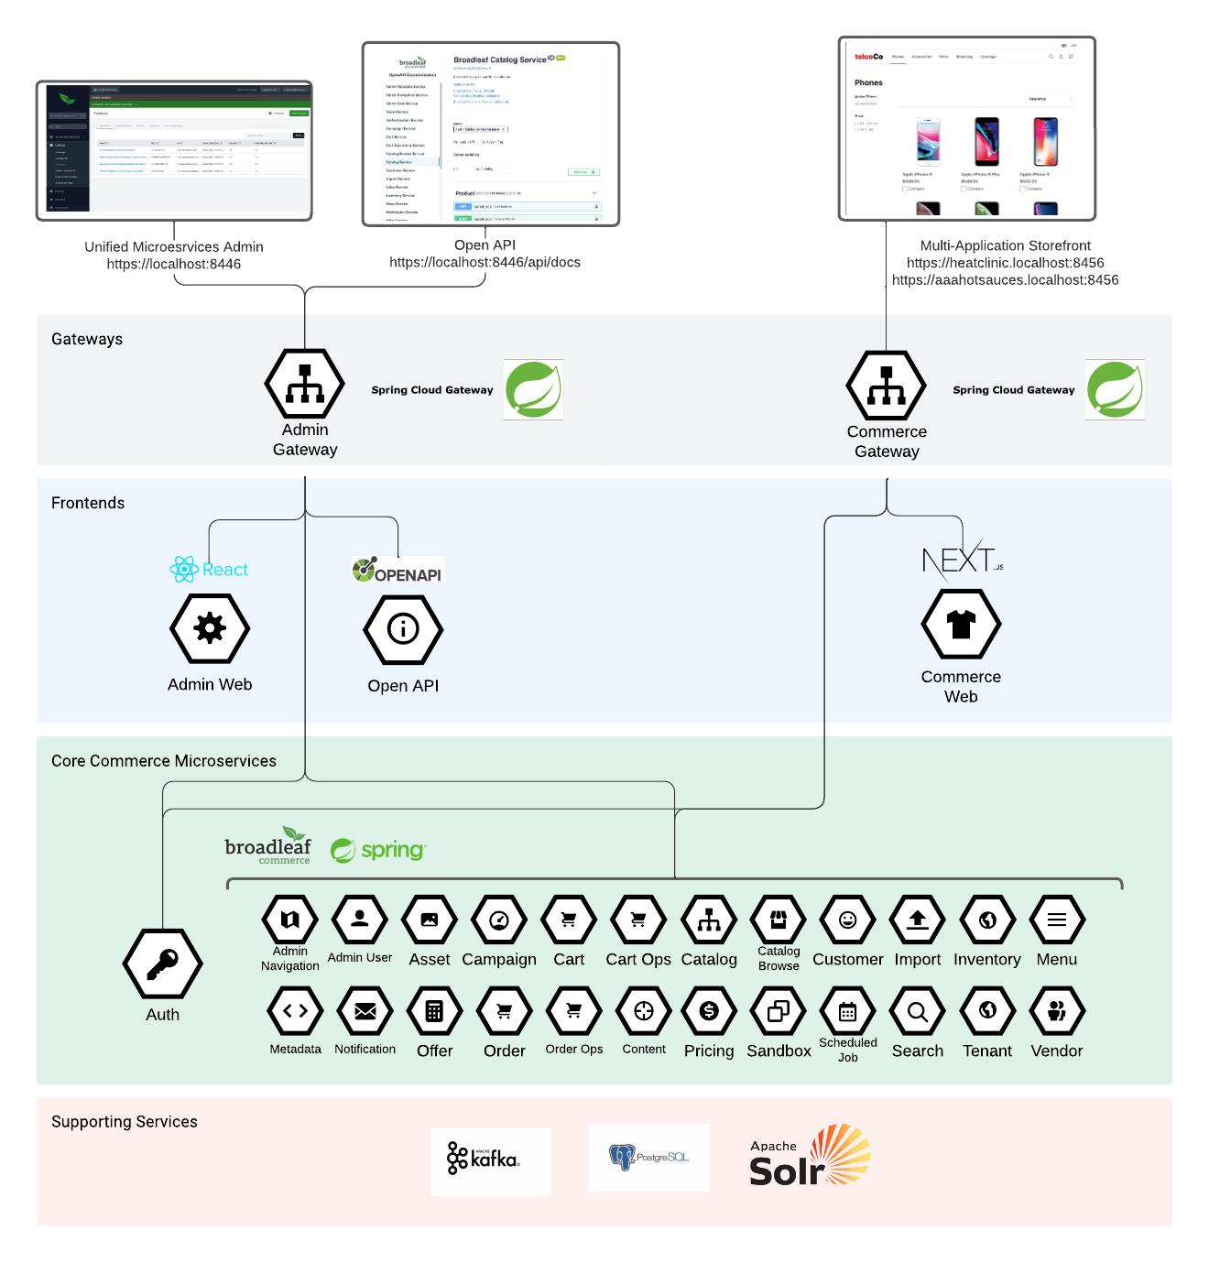
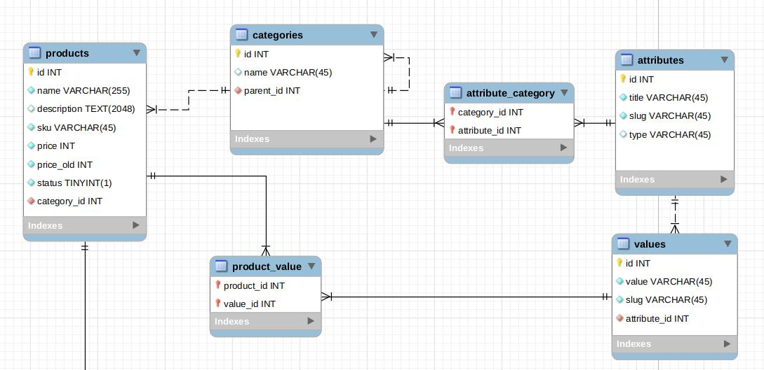
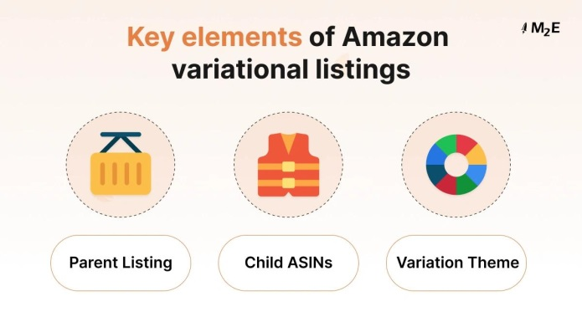
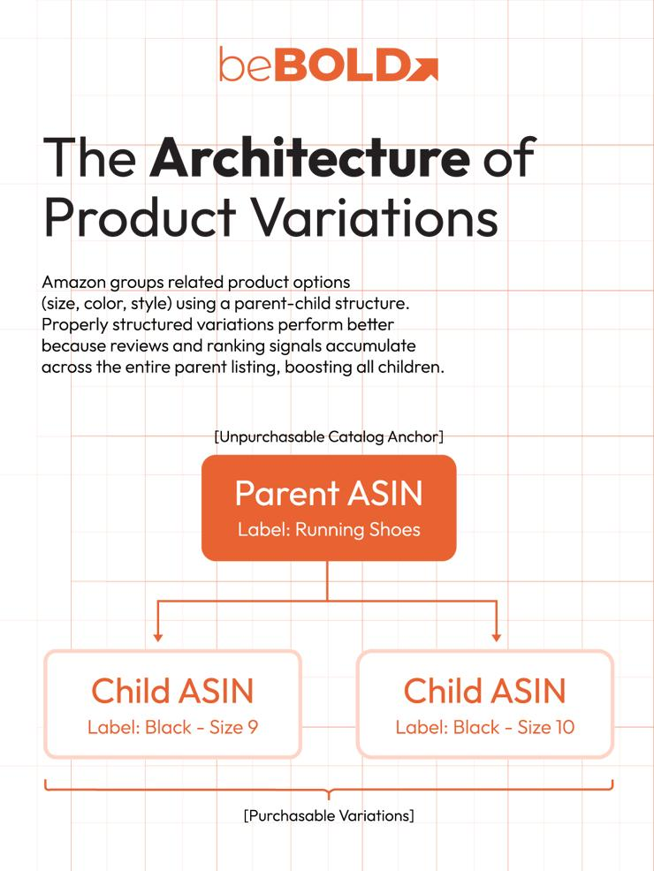
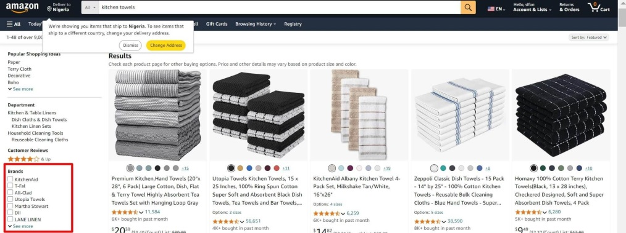
If you want an architecture like Amazon or Broadleaf Commerce, then you should build a:

Dynamic Catalog Engine
Not a simple product table.
Enterprise marketplaces use:
- Dynamic attributes
- Variant engine
- Category templates
- Faceted search
- Search indexing
- Metadata system
- SKU-based inventory
- Configurable product structure

REAL ENTERPRISE STRUCTURE

Layer 1 — Category Tree
Example:
Electronics
├── Mobile
├── Laptop
└── Camera

Fashion
├── Men
├── Women
└── Shoes

Layer 2 — Attribute Definitions
Reusable global attributes.
Example:
Attribute | Type
RAM | dropdown
Color | multi-select
Size | multi-select
Material | text
Battery | text

Layer 3 — Category Attribute Mapping
Defines which category uses which attribute.
Example:
Category | Attribute
Mobile | RAM
Mobile | Battery
Fashion | Size
Fashion | Color
This is the core of Amazon-style systems.

Layer 4 — Products
Basic shared info only.
products
id
title
slug
brand_id
category_id
description

Layer 5 — Product Specifications
Informational attributes.
Example:
Product | Attribute | Value
iPhone | RAM | 8GB
iPhone | Battery | 4500mAh

Layer 6 — Variant Engine
Purchasable combinations.
Example:
Variant | Size | Color
SKU1 | M | Black
SKU2 | L | Black
OR
Variant | Storage | Color
SKU1 | 128GB | Blue
SKU2 | 256GB | Black

Layer 7 — SKU Inventory
Each variant has separate:
- price
- stock
- barcode
- image
- warehouse stock
Example:
product_variants
id
product_id
sku
price
stock

Layer 8 — Faceted Search
Enterprise search uses:
- Elasticsearch
- OpenSearch
- Apache Solr
Filters generated dynamically:
- Brand
- RAM
- Color
- Size
- Price
- Material

Recommended Amazon/Broadleaf Style Database

Category
categories
id
name
parent_id

Attribute
attributes
id
name
code
type
filterable
searchable
comparable
variant_attribute

Category Attribute
category_attributes
category_id
attribute_id
required
display_order

Product
products
id
title
slug
brand_id
category_id

Product Attribute Value
product_attribute_values
product_id
attribute_id
value

Product Variant
product_variants
id
product_id
sku
price
stock
barcode

Variant Attribute Value
variant_attribute_values
variant_id
attribute_id
value

Example

Mobile Phone

Specifications
- Battery = 5000mAh
- Processor = Snapdragon

Variants
- 128GB Black
- 256GB Blue
This separation is VERY important.

Enterprise Best Practice

Separate:
Type | Purpose
Specifications | Information
Variants | Purchasable options
Facets | Search filtering
Attributes | Reusable definitions
Templates | Category schema

What Amazon-like Systems Also Have

Attribute Groups
Example:
- Display
- Performance
- Camera
- Physical

Attribute Validation
Example:
- RAM only numeric
- Color only predefined values

Dynamic Admin UI
When category changes:
- form changes automatically

Search Indexing
Every attribute indexed for:
- filter
- sort
- recommendation
- AI search

What You Should Build in Spring Boot
Since you are building a multi-vendor marketplace:

Phase 1
- Categories
- Attributes
- Variants
- Product specs

Phase 2
- Dynamic filters
- Search indexing
- Attribute templates
- Variant generator

Phase 3
- Elasticsearch/OpenSearch
- AI recommendations
- Semantic search
- Attribute rules engine

Best Recommendation
For long-term scalability:

Follow Broadleaf/Amazon architecture
NOT WooCommerce-style simple tables.
Because later you will need:
- faceted filtering
- AI search
- product comparison
- recommendation engine
- marketplace scaling
- multi-vendor catalogs
- advanced inventory
- analytics
A dynamic attribute architecture is the foundation of enterprise eCommerce.

