WALCHAND COLLEGE OF ENGINEERING, SANGLI
DEPARTMENT OF COMPUTER SCIENCE AND ENGINEERING

LA4/ESE SCHEDULE (POE)
COURSE: PROGRAMMING LABORATORY-3 (4CS354)
CLASS: TY CSE
DATE & TIME: 01/01/2021, FRIDAY, 3.30 PM TO 5.30 PM
------------------------------------------------------------------------------------------------
Exam Seat Number:2018BTECS00092
Name: Bele Shivprasad
Problem Statement:
- Design a website for Health Blog with following objectives:
- Index Home Page that shows list of articles
- At least 3 pages, each for a separate article with images
- User must login to give ratings and comments to an article
- Display ratings and comments for each of the article
- Contact us Page
- Every page should be responsive
- Provide all validations
- Use styles to make it attractive
- Link all pages using navigation bar
- Use appropriate HTML elements and CSS properties

Screen Shots:
- Home
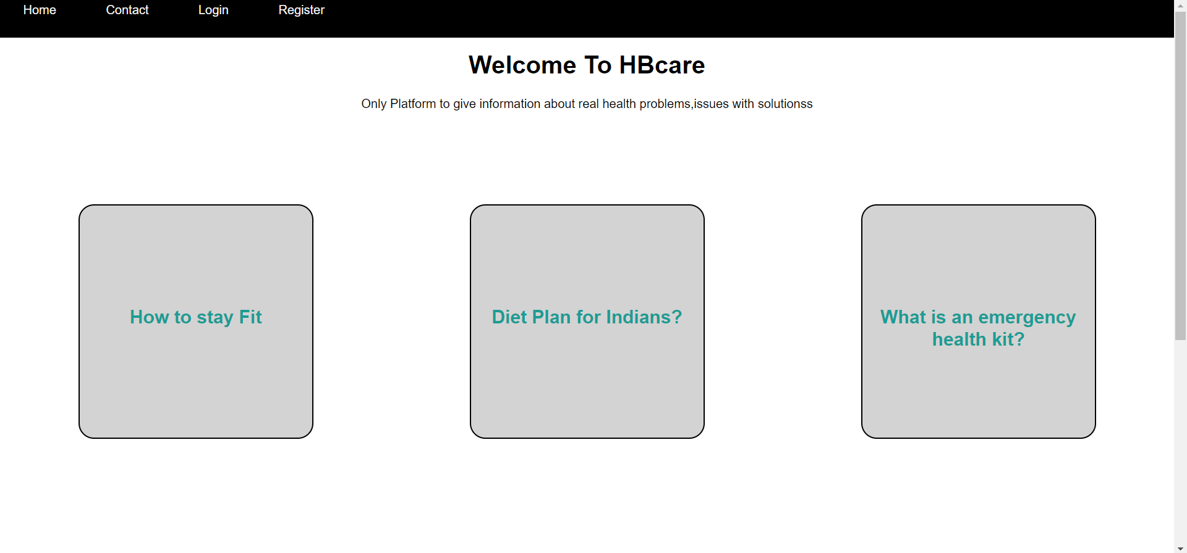
- Contact



- Blog with rate
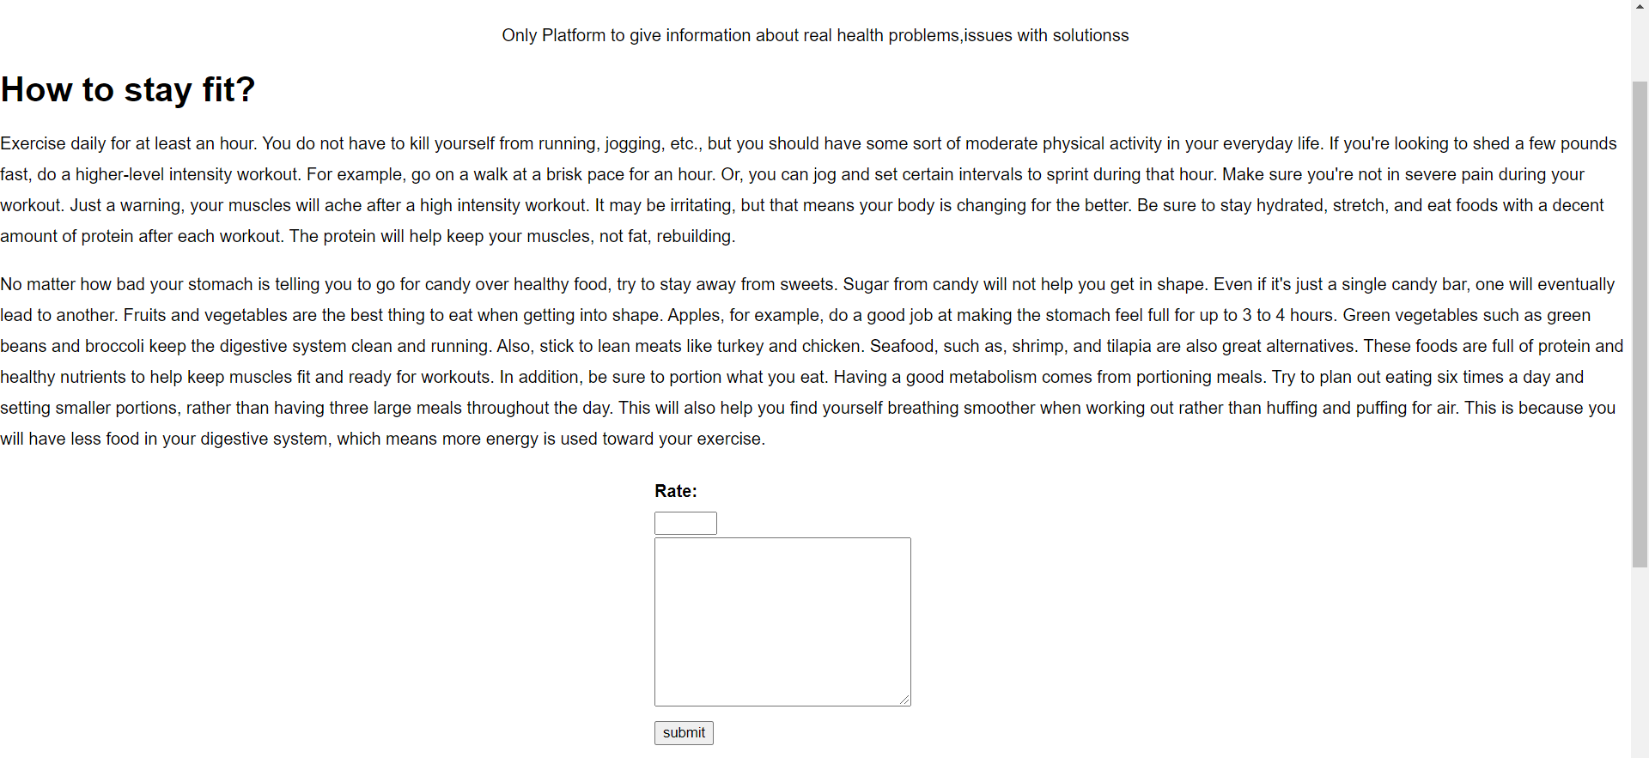

- Login

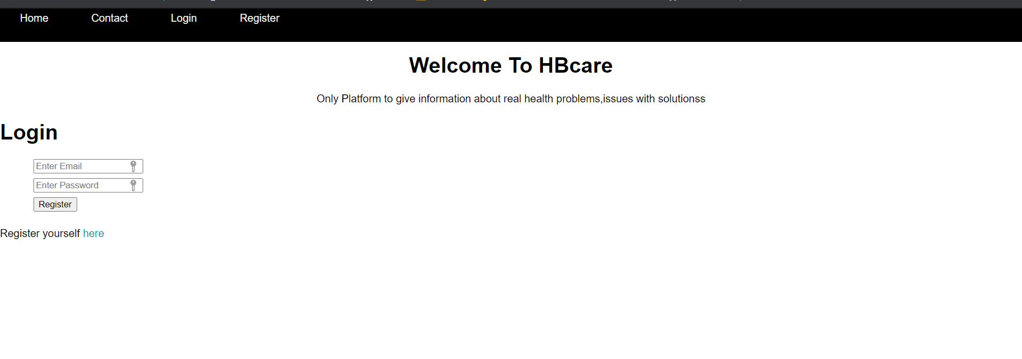

- Register
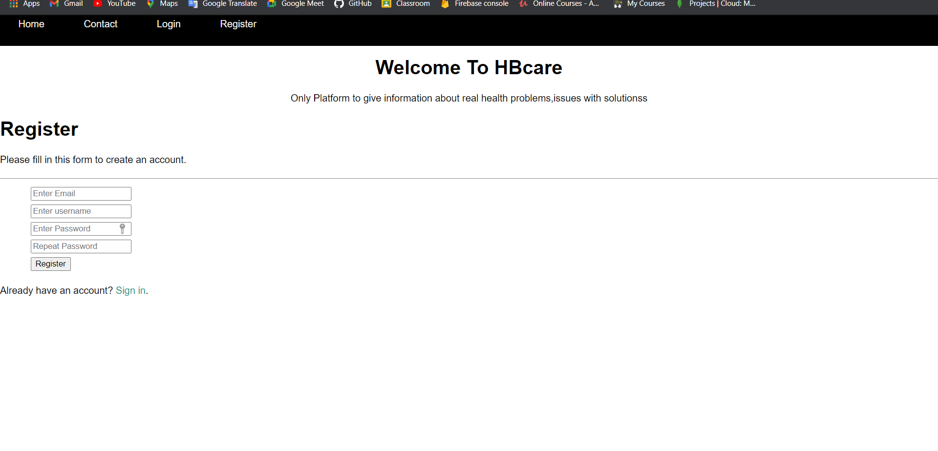

- Storing user data with encrypted password
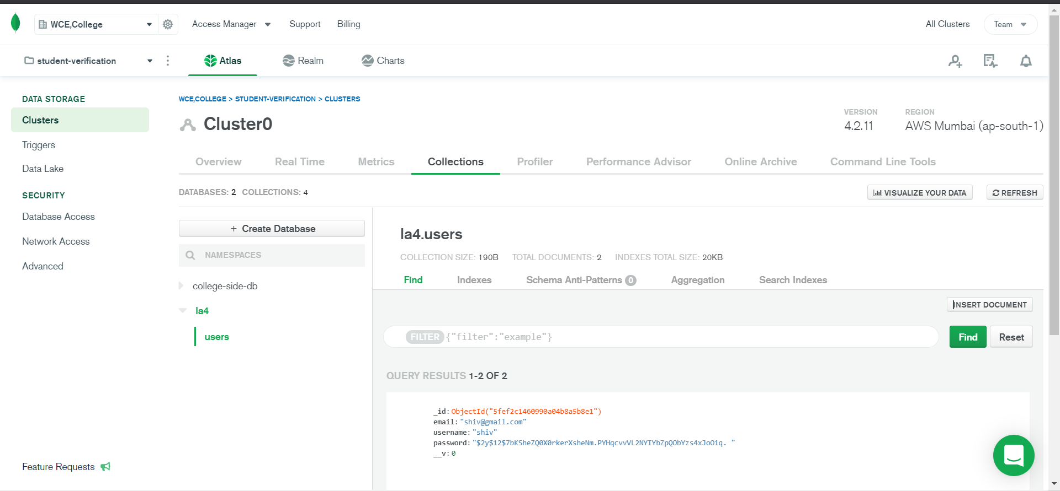
- Rating
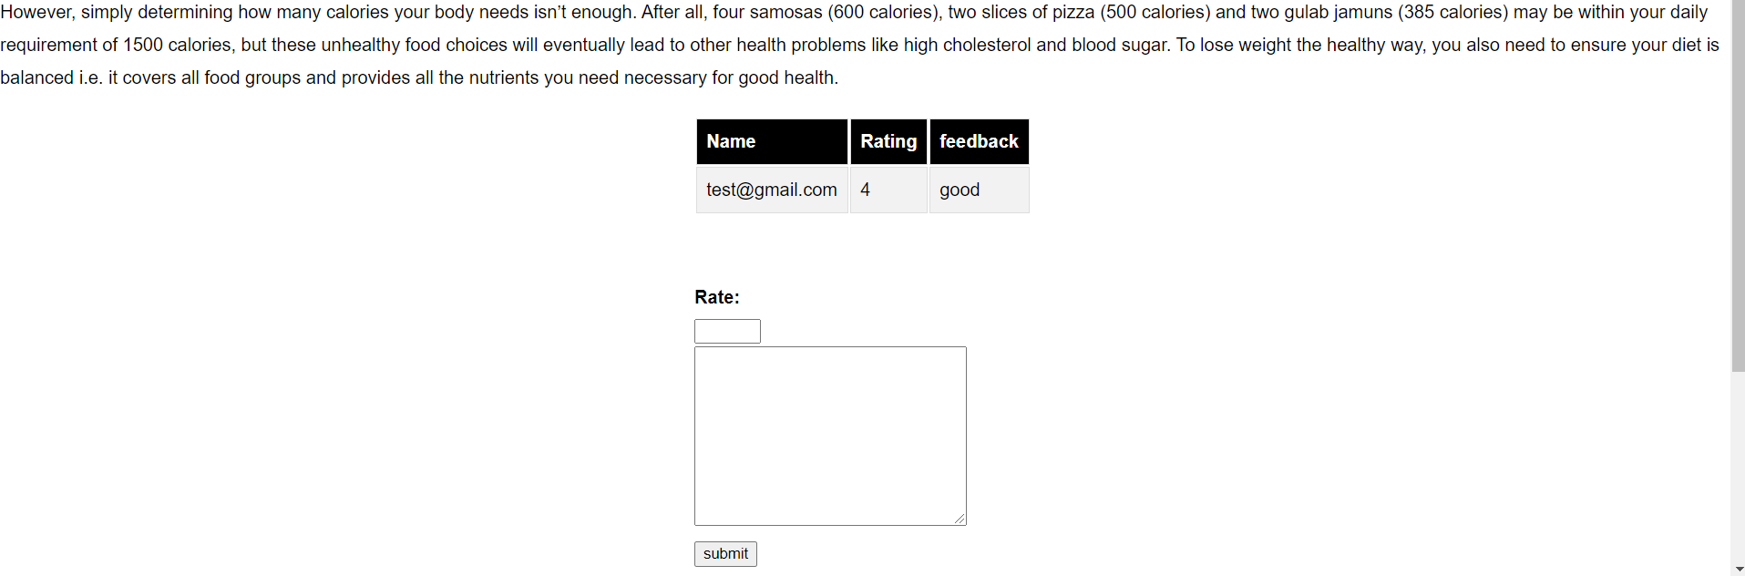

Tech Used:
- Nodejs
- HTML
- CSS
- Express
- Mongoose

GitHub Link:
https://github.com/beleshivprasad/health-blog
Hosting Link:

