**Practical No. 7B**

**To design and develop web pages using HTML Multimedia elements.**

**NAME: SHIVPRASAD MUNJARAO BELE**

**PRN: 2018BTECS00092**

**Problem Statement 1:**

Design a HTML web page that contain audio players. Access it locally and in LAN using a web server.

The page should satisfy following requirements:

1. The page should have four sections: Audio Player Name, Navigation Links, Audio Players, Credits.

2. In the audio player name section, write name of the audio player of your choice.

3. In the navigation links section, add one link to audio streaming website and one link to lyrics website.

4. In the audio player section, add different audio players.

5. In the credits’ sections, write the credits of any audio that you are going to embed.

**Ans:**

**1.Accessing from local machine.**

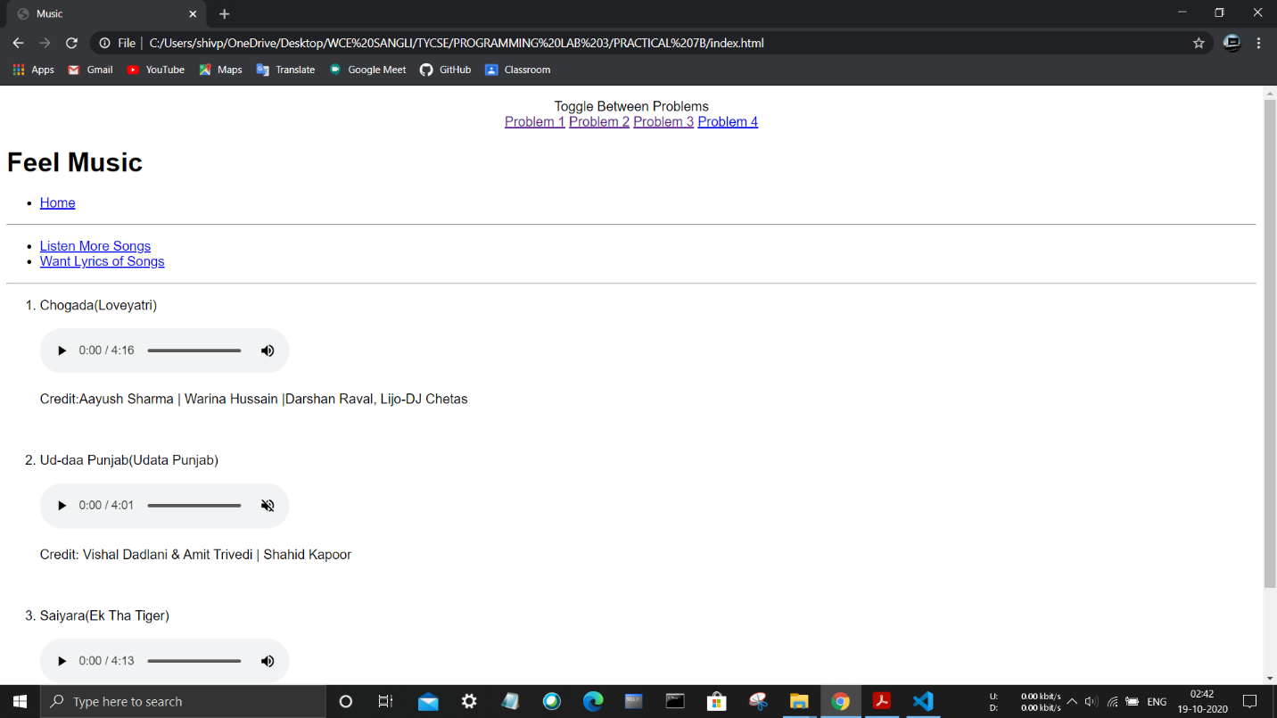

**2.Accessing from mobile phone using LAN network.**

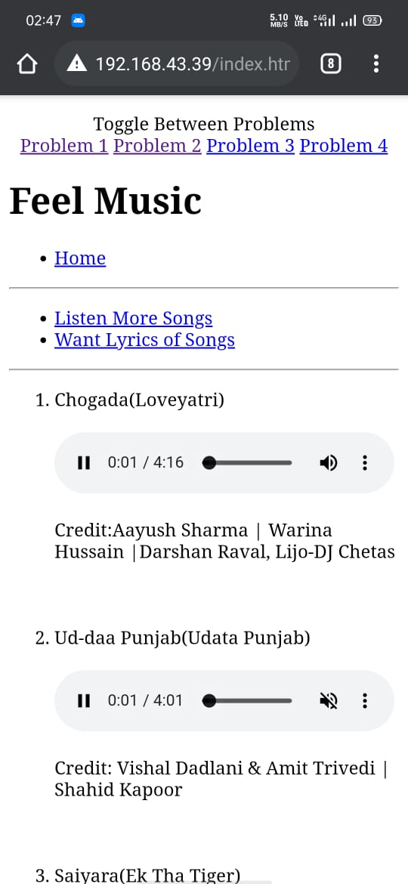

**Problem Statement 2:**

Design a HTML web page that contain video players. Access it locally and in LAN using a web server.

The page should satisfy following requirements:

1. The page should have four sections: Video Player Name, Navigation Links, Video Players, Credits.

2. In the video player name section, write name of the video player of your choice.

3. In the navigation links section, add one link to music video streaming website and one link to lyrics website.

4. In the video player section, add different video players.

5. In the credits’ sections, write the credits of any video that you are going to embed.

**Ans:**

**1.Accessing from local machine.**

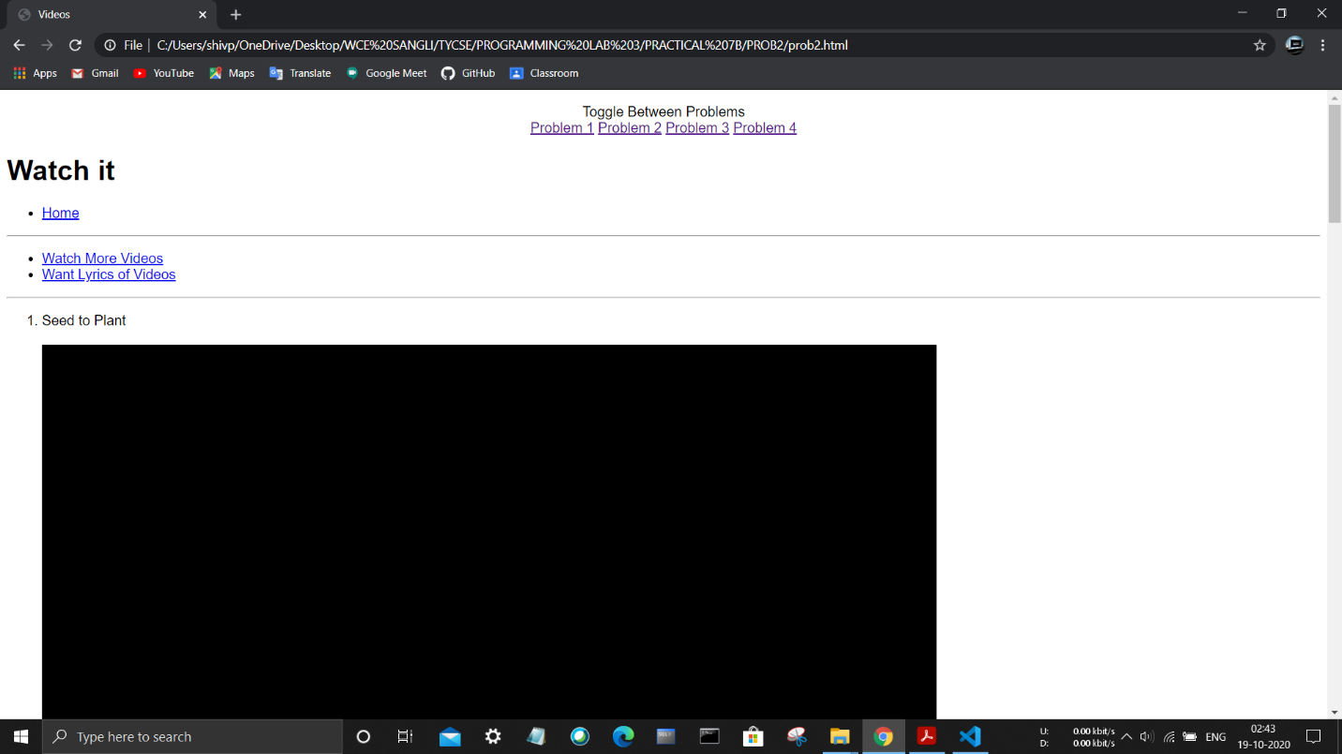

**2.Accessing from mobile phone using LAN network.**

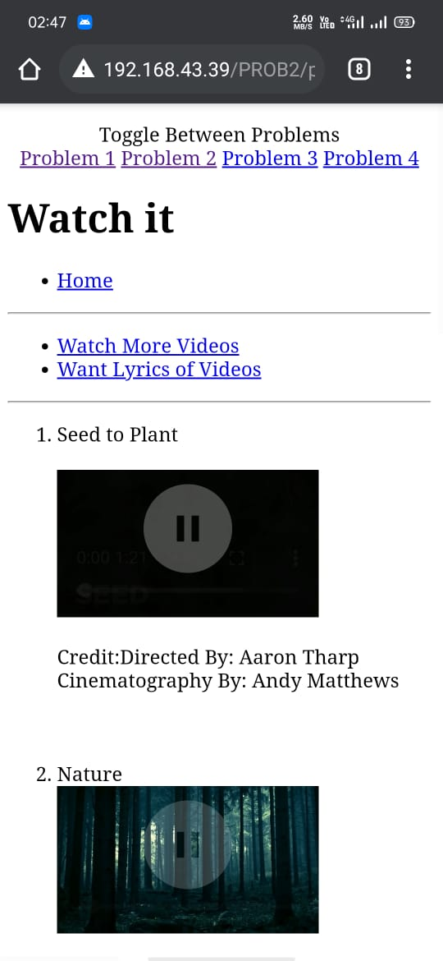

**Problem Statement 3:**

Design a HTML web page that contain YouTube videos. Access it locally and in LAN using a web server.

The page should satisfy following requirements:

1. The page should have four sections: Header, Navigation Links, YouTube Players, and Credits.

2. In the header section, write header name of your choice.

3. In the navigation links section, add one link to music video streaming website and one link to lyrics website.

4. In the YouTube player section, embed different YouTube videos.

5. In the credits’ sections, write the credits of any video that you are going to embed.

**Ans:**

**1.Accessing from local machine.**

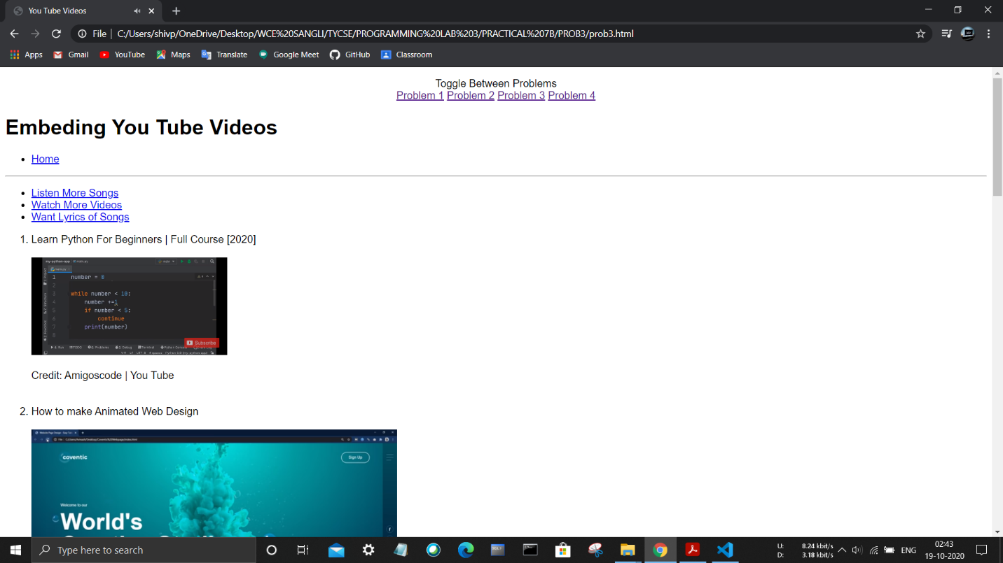

**2.Accessing from mobile phone using LAN network.**

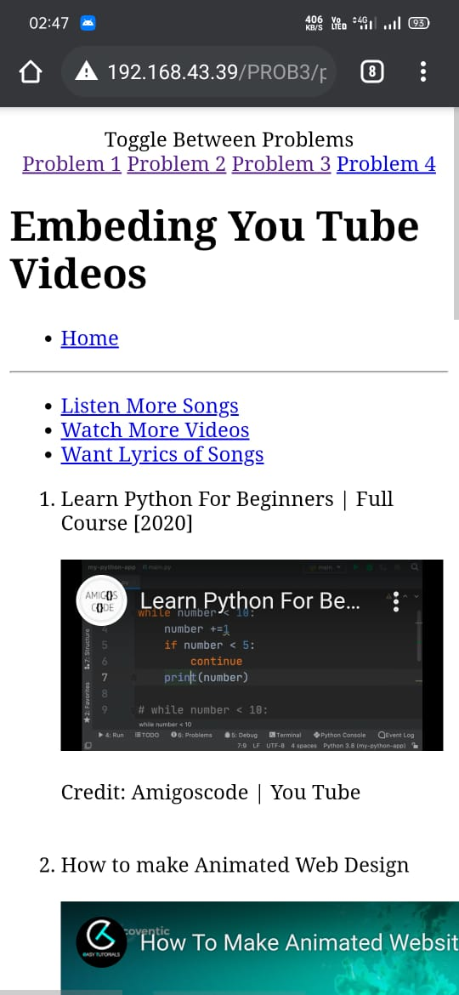

**Problem Statement 4:**

Design a HTML web page that has external resources embedded. Access it locally and in LAN using a web server.

The page should satisfy following requirements:

1. The page should have four sections: Header, Navigation Links, External Resources and developer’s information.

2. In the header section, write header name of your choice.

3. In the external resources section, embed .pdf file and HTML page separately.

4. In the footer, write developers information.

**Ans:**

**1.Accessing from local machine.**

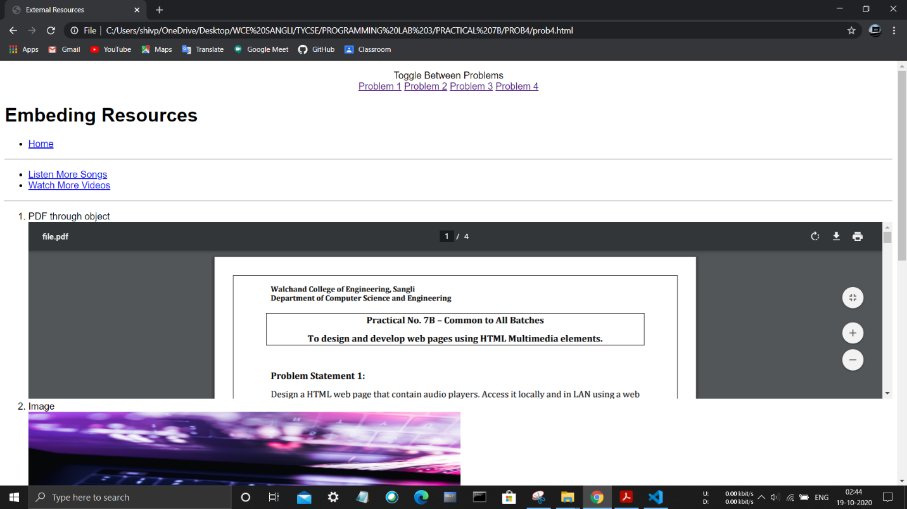

**2.Accessing from mobile phone using LAN network.**

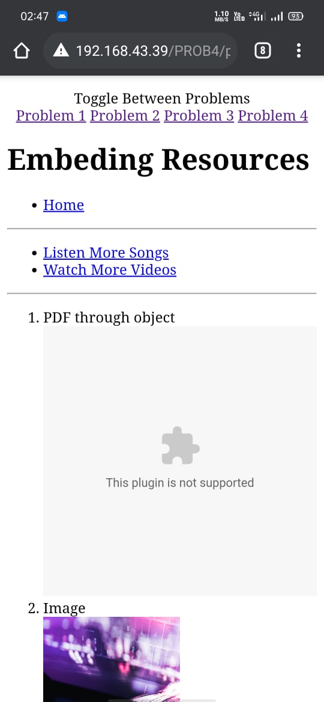

**5. GitHub Directory:**

<https://github.com/beleshivprasad/public/tree/master/PRACTICAL_7B>