

Status page

Objective
The status page aims at providing a full status of our operations. It is spread into 4 categories:
- Availability status in the past 90 days.
- Overview of the upcoming maintenances planned.
- In case of an ongoing incident, a clear communication about its impact and how we are addressing it.
- A list of past incidents.
A notification service is available which provides subscribers with emails related to ongoing incidents and reminders related to upcoming maintenance. Users can subscribe to those notifications by using the “subscribe to update” menu.

How to subscribe or unsubscribe
- Subscribe
Connect to the Status page (https://itsme.statuspage.io/) and select “subscribe to update”.
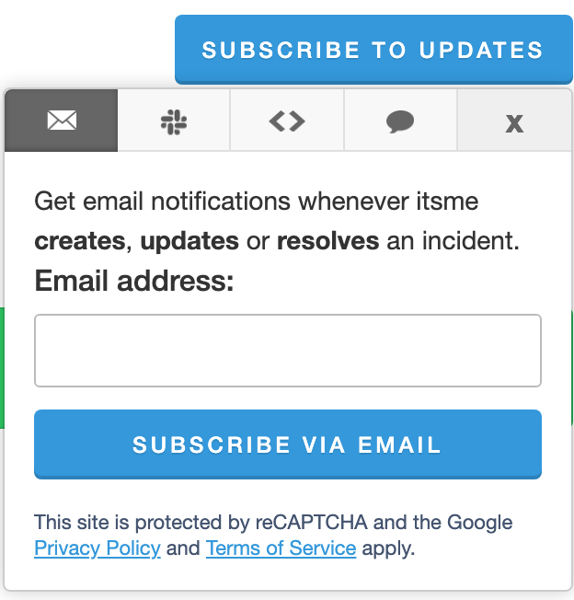
Enter your email address and validate the captcha displayed on screen.
A one-time password (OTP) is sent to the email address to confirm its legitimacy.
Select the “subscribe to update” menu again and enter the email and the OTP in the new screen.
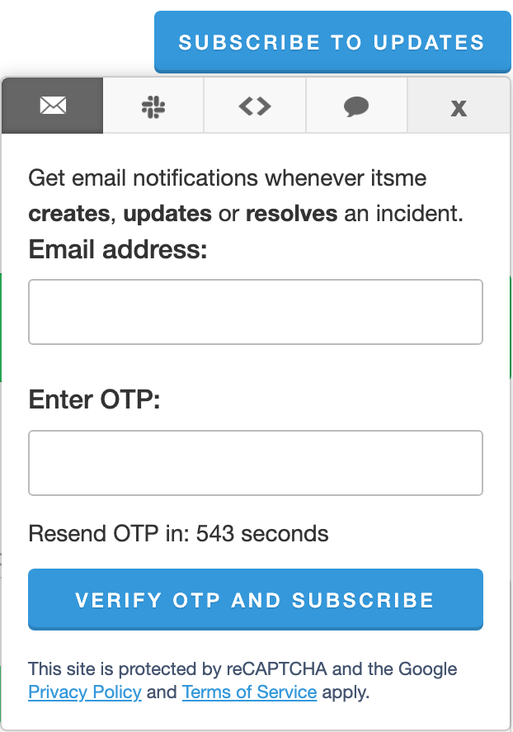
Select the services relevant for you and press “save” at the bottom of the screen.
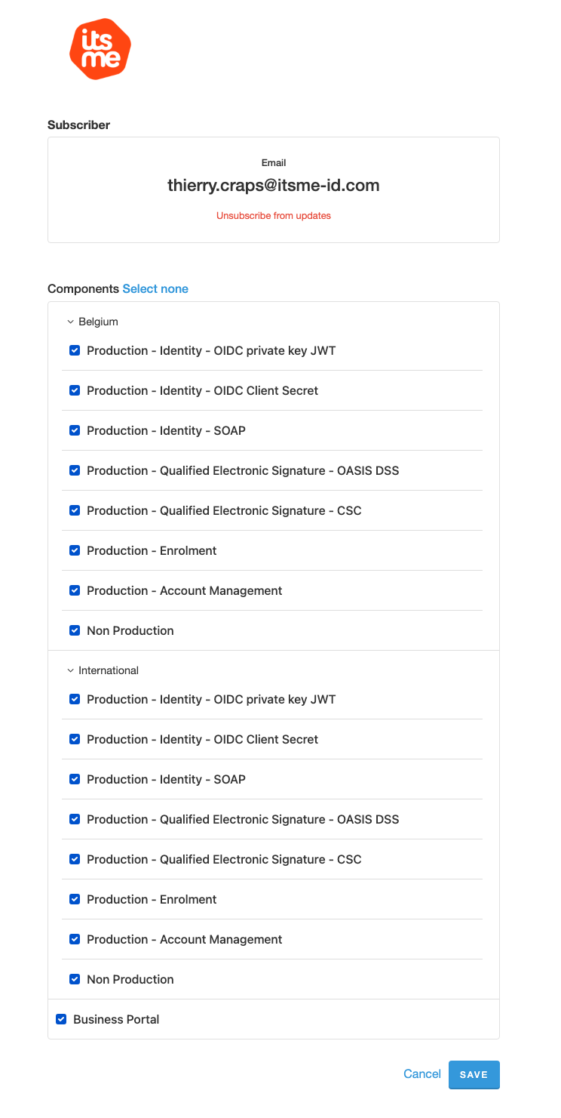

- Unsubscribe
To unsubscribe, connect to the portal and repeat all steps provided in the Subscription section. When accessing the list of services, unselect those for which you do not want to receive notification.
If you choose “select none” and save, you will be fully unregistering and you will no longer receive any notification. You will need to subscribe again should you wish to receive notifications again.

