Setting the TZ variable
Now let’s set TZ in the environment. The command to do this is tzselect. Here’s a typescript of the command output to set TZ
[ehemdal@localhost ~]$ tzselect

Please identify a location so that time zone rules can be set correctly.

Please select a continent or ocean.

1) Africa

2) Americas

3) Antarctica

4) Arctic Ocean

5) Asia

6) Atlantic Ocean

7) Australia

8) Europe

9) Indian Ocean

10) Pacific Ocean

11) none - I want to specify the time zone using the Posix TZ format.

#? 2

Please select a country.

1) Anguilla 19) Dominican Republic 37) Peru

2) Antigua & Barbuda 20) Ecuador 38) Puerto Rico

3) Argentina 21) El Salvador 39) St Barthelemy

4) Aruba 22) French Guiana 40) St Kitts & Nevis

5) Bahamas 23) Greenland 41) St Lucia

6) Barbados 24) Grenada 42) St Maarten (Dutch)

7) Belize 25) Guadeloupe 43) St Martin (French)

8) Bolivia 26) Guatemala 44) St Pierre & Miquelon

9) Brazil 27) Guyana 45) St Vincent

10) Canada 28) Haiti 46) Suriname

11) Caribbean NL 29) Honduras 47) Trinidad & Tobago

12) Cayman Islands 30) Jamaica 48) Turks & Caicos Is

13) Chile 31) Martinique 49) United States

14) Colombia 32) Mexico 50) Uruguay

15) Costa Rica 33) Montserrat 51) Venezuela

16) Cuba 34) Nicaragua 52) Virgin Islands (UK)

17) Curacao 35) Panama 53) Virgin Islands (US)

18) Dominica 36) Paraguay

#? 49

Please select one of the following time zone regions.

1) Eastern (most areas) 16) Central - ND (Morton rural)

2) Eastern - MI (most areas) 17) Central - ND (Mercer)

3) Eastern - KY (Louisville area) 18) Mountain (most areas)

4) Eastern - KY (Wayne) 19) Mountain - ID (south); OR (east)

5) Eastern - IN (most areas) 20) MST - Arizona (except Navajo)

6) Eastern - IN (Da, Du, K, Mn) 21) Pacific

7) Eastern - IN (Pulaski) 22) Alaska (most areas)

8) Eastern - IN (Crawford) 23) Alaska - Juneau area

9) Eastern - IN (Pike) 24) Alaska - Sitka area

10) Eastern - IN (Switzerland) 25) Alaska - Annette Island

11) Central (most areas) 26) Alaska - Yakutat

12) Central - IN (Perry) 27) Alaska (west)

13) Central - IN (Starke) 28) Aleutian Islands

14) Central - MI (Wisconsin border) 29) Hawaii

15) Central - ND (Oliver)

#? 1

The following information has been given:

United States

Eastern (most areas)

Therefore TZ='America/New_York' will be used.

Local time is now: Tue May 31 11:21:04 EDT 2016.

Universal Time is now: Tue May 31 15:21:04 UTC 2016.

Is the above information OK?

1) Yes

2) No

#? 1

You can make this change permanent for yourself by appending the line

TZ='America/New_York'; export TZ

to the file '.profile' in your home directory; then log out and log in again.

Here is that TZ value again, this time on standard output so that you

can use the /usr/bin/tzselect command in shell scripts:

America/New_York

[ehemdal@localhost ~]$
The file ~/.profile (if it exists) gets run when you log in and will set the TZ variable for you. You might use a different initialization file if you use a shell other than /bin/sh or /bin/bash. I set this and logged back in. If you update a file like /etc/profile, you can apply this for all users.
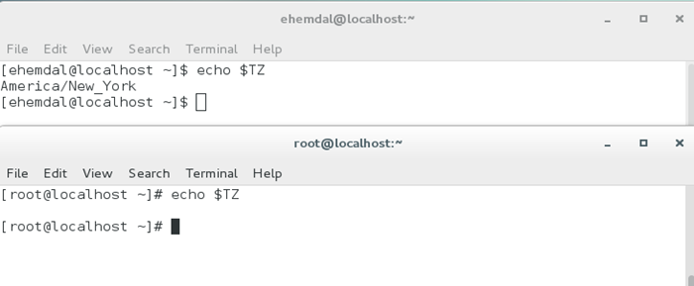
Here you can see that TZ is set for my user (ehemdal), but NOT for the root user.

TZ and the Time and Date Seen by Users –
What happens if a user is connected to your server from a different timezone? The TZ variable helps keep the user’s local time correct while keeping management of timezones and Daylight Saving Time in the hands of the operating system. This affects the time that Cache’ uses as well. For an example, I decided to change my timezone to that for Honolulu.
Here are two screenshots that show the result.
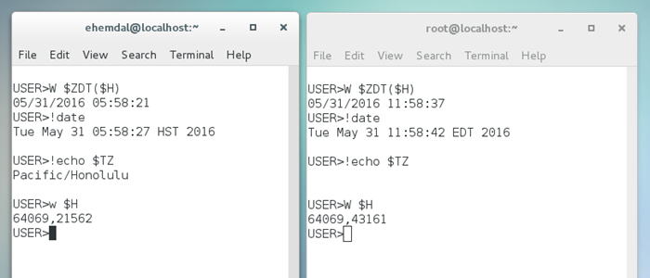
My user’s process has set TZ to Pacific/Honolulu. Root’s process does not have TZ set (so is using the system timezone America/New_York). At operating system level (with the date command), the display reflects local time for both users. The date command reflects the user’s local time (HST for user ehemdal and EDT for root). Since $HOROLOG obtains its value from the OS time available to the user process, the $H values are DIFFERENT for the two users.
I chose Honolulu time as an interesting example because Hawaii does not observe Daylight Saving Time. By setting TZ properly for all users, the local time can “spring ahead and fall back” for users who observe DST, and remain stable for users who don’t.

Reference: https://community.intersystems.com/post/setting-tz-environment-variable-linux

