***Food-Allergy Task Analysis***

This is a psychological task designed to track new causal belief formation. It involves subjects learning to associate causes (foods) with effects (allergies in a fictitious patient).

The scenario is as follows: subjects imagine they are an allergist and they are charged with figuring our which foods cause allergies in a fictitious patient and which ones do not. They see each meal he has eaten (comprised of one or two different foods) , for 3 seconds then they see whether or not an allergy happened (for one second). When a meal is on the screen, they make a prediction with a 2-alternative button push (allergy or no allergy). They also press and hold the key down for longer the more confident they are that they are making the right choice.

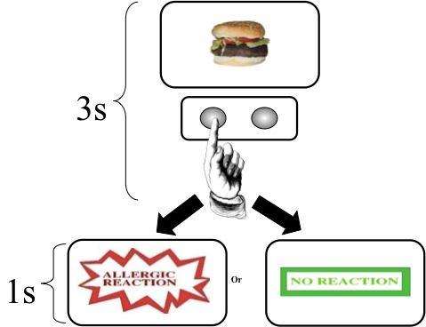

The food allergy task has been used for more than 30 years to explore the psychological mechanisms of causal belief formation. The approach is reviewed by Tony Dickinson (2001 paper - appended). I’ve used it extensively in healthy subjects, patients with psychosis, people with schizotypal odd beliefs, prodromal subjects and people administered ketamine and methamphetamine.

We’ve also used the task extensively during functional neuroimaging. Here we’ve found that a particular learning signal; prediction error, the mismatch between what we expect and what we experience drives new learning. This signal correlates with activation in right dorsolateral prefrontal cortex (DLPFC). The signal here correlates with the strength of learning. We’ve used the signal to adjudicate in favor of an associative model of controversial phenomena (like retrospective revaluation of causal beliefs).

In general, psychotic states engender aberrant learning about redundant, non-predictive stimuli in the task. This is perhaps most simply demonstrated using Kamin blocking – in which one cue that predicts the allergy is presented with a novel cue. This compound of cues also predicts the allergy – nothing new should be learned about the novel cue – the allergy is already fully predicted, there is no prediction error, so there should be no new learning. New learning is blocked by what you already know. We have found that blocking is weaker in people with lots of odd beliefs (e.g. beliefs in alien abduction or telekinesis).

Blocking proceeds across three phases. Below you can see the key trials (target and control). There are also filler cues that balance for the presence and absence of allergy (see table below).

In the first phase of training subjects learn that bananas cause the allergy. They then learn bananas and mushrooms cause the allergy (prior learning about the bananas blocks new learning about the mushrooms). If they see the mushrooms causing the allergy, they will be surprised. Confirmed by their behavioral predictions about the blocked cue in this case mushrooms (on the first trial they see the cue at stage 3).

***Target Conditions***

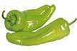

***Control Conditions***



Note the control conditions for blocking and its violation are matched for novelty, familiarity and the presence of the allergy outcome.

**Table 1. Experimental Structure.** Contingencies between foods and allergic reactions.

Letters represent foods, +/- the presence or absence of allergy

|  |  |  |  |
| --- | --- | --- | --- |
| **Stage 1** | **Stage 2** | **Stage 3** | **Role** |
| A1+ | A1B1+ | B1+ | Violation of blocking |
| A2+ | A2B2+ | B2- | Confirmation of blocking |
| C1-` | C1D1+ | D1+ | Confirmation of blocking control |
| C2- | C2D2+ | D2- | Violation of blocking control |
| F- | EF- | EF- | No allergy control |
| I+ | I+ | I+ | Consistent Allergy |
| J- | J- | J- | Consistent No Allergy |

Subjects see 10 repetitions of each stage 1 trial type, 6 repetitions of stages 2 and 3, with the caveat that no trial type is repeated before all of the trials have been seen for that iteration.

We generate average responses to each trial for each trial type. We designate the response as positive if they predict an allergy and negative if they predict no allergy and we use button push length as a measure of their confidence. So a confident allergy prediction yields a large negative number.

Their prediction score for the blocked cue should be near zero – as they should not have learned about the blocked cue. It should be significantly lower than their score for the control cue (Chillis in the figure, D in the table).

A paired t-test can be used to establish blocking – is score to control cue higher than that to blocked cue?

We can compare blocking between groups with repeated-measures ANOVA.

We just submitted a behavior paper showing that people with lots of odd beliefs predict allergy after the blocked cue.

We expect the same thing in first episode psychosis. We recently found that blocking was intact in highly medicated chronic patients, for whom negative symptoms are more profound than delusions and perceptual aberrations.

Given the continuity between obsessions and delusions, we predict that patients with OCD will also show weaker blocking.