3GPP TS 29.219 V12.0.0 (2013-06)
Technical Specification
3rd Generation Partnership Project;
Technical Specification Group Core Network and Terminals;
Policy and Charging Control: Spending Limit Reporting over Sy reference point
(Release 12)



The present document has been developed within the 3rd Generation Partnership Project (3GPP TM) and may be further elaborated for the purposes of 3GPP..
The present document has not been subject to any approval process by the 3GPP Organizational Partners and shall not be implemented.
This Specification is provided for future development work within 3GPP only. The Organizational Partners accept no liability for any use of this Specification.
Specifications and Reports for implementation of the 3GPP TM system should be obtained via the 3GPP Organizational Partners' Publications Offices.

Keywords
UMTS, LTE, QoS, Charging, Policy

3GPP
Postal address

3GPP support office address
650 Route des Lucioles - Sophia Antipolis
Valbonne - FRANCE
Tel.: +33 4 92 94 42 00 Fax: +33 4 93 65 47 16
Internet
http://www.3gpp.org
Copyright Notification
No part may be reproduced except as authorized by written permission.
The copyright and the foregoing restriction extend to reproduction in all media.

© 2013, 3GPP Organizational Partners (ARIB, ATIS, CCSA, ETSI, TTA, TTC).
All rights reserved.

UMTS™ is a Trade Mark of ETSI registered for the benefit of its members
3GPP™ is a Trade Mark of ETSI registered for the benefit of its Members and of the 3GPP Organizational Partners
LTE™ is a Trade Mark of ETSI registered for the benefit of its Members and of the 3GPP Organizational Partners
GSM® and the GSM logo are registered and owned by the GSM Association
Contents
Foreword 5
1 Scope 6
2 References 6
3 Definitions, symbols and abbreviations 7
3.1 Definitions 7
3.2 Symbols 7
3.3 Abbreviations 7
4 Sy reference point 7
4.1 Overview 7
4.2 Sy Reference model 8
4.3 Subscriber Spending Limits 9
4.4 Functional elements 10
4.4.1 PCRF 10
4.4.2 OCS 10
4.5 Spending Limits procedures over Sy reference point 10
4.5.1 Initial/Intermediate Spending Limit Report Request 10
4.5.1.1 General 10
4.5.1.2 Detailed behaviour of the PCRF 11
4.5.1.3 The behaviour of the OCS 11
4.5.2 Spending Limit Report 12
4.5.2.1 General 12
4.5.2.2 The behaviour of the OCS 12
4.5.2.3 Detailed behaviour of the PCRF 13
4.5.3 Final Spending Limit Report Request 13
4.5.3.1 General 13
4.5.3.2 Detailed behaviour of the PCRF 13
4.5.3.3 The behaviour of the OCS 13
5 Sy protocol 14
5.1 Protocol support 14
5.1.1 Use of Diameter base protocol 14
5.1.2 Void 14
5.1.3 Accounting functionality 14
5.1.4 Transport protocol 14
5.1.5 Advertising Application Support 14
5.1.6 Use of the Supported-Features AVP 14
5.2 Initialization and maintenance of connection and session 15
5.3 Sy specific AVPs 15
5.3.1 Policy-Counter-Identifier AVP 16
5.3.2 Policy-Counter-Status AVP 16
5.3.3 Policy-Counter-Status-Report AVP 16
5.3.4 SL-Request-Type AVP 16
5.3.5 Pending-Policy-Counter-Information AVP 16
5.3.6 Pending-Policy-Counter-Change-Time AVP 17
5.4 Sy re-used AVPs 17
5.5 Sy specific Experimental-Result-Code AVP values 17
5.5.1 General 17
5.5.2 Permanent Failures 17
5.5.3 Transient Failures 18
5.6 Sy Messages 18
5.6.1 Command-Code Values 18
5.6.2 Spending-Limit-Request (SLR) command 18
5.6.3 Spending-Limit-Answer (SLA) command 19
5.6.4 Spending-Status-Notification-Request (SNR) command 19
5.6.5 Spending-Status-Notification-Answer (SNA) command 19
5.6.6 Session-Termination-Request (STR) command 20
5.6.7 Session-Termination-Answer (STA) command 20
Annex A (informative): Change history 21

Foreword
This Technical Specification has been produced by the 3rd Generation Partnership Project (3GPP).
The contents of the present document are subject to continuing work within the TSG and may change following formal TSG approval. Should the TSG modify the contents of the present document, it will be re-released by the TSG with an identifying change of release date and an increase in version number as follows:
Version x.y.z
where:
x the first digit:
1 presented to TSG for information;
2 presented to TSG for approval;
3 or greater indicates TSG approved document under change control.
y the second digit is incremented for all changes of substance, i.e. technical enhancements, corrections, updates, etc.
z the third digit is incremented when editorial only changes have been incorporated in the document.

1 Scope
The present document provides the stage 3 specification of the Sy reference point for the present release. The functional requirements and the stage 2 specifications of the Sy reference point are contained in 3GPP TS 23.203 [2]. The Sy reference point lies between the Policy and Charging Rule Function (PCRF) and the Online Charging System (OCS). The internal OCS functionality for policy counter provision management pertaining to Sy is specified in 3GPP TS 32.296 [16].

2 References
The following documents contain provisions which, through reference in this text, constitute provisions of the present document.
- References are either specific (identified by date of publication, edition number, version number, etc.) or non-specific.
- For a specific reference, subsequent revisions do not apply.
- For a non-specific reference, the latest version applies. In the case of a reference to a 3GPP document (including a GSM document), a non-specific reference implicitly refers to the latest version of that document in the same Release as the present document.
[1] 3GPP TR 21.905: "Vocabulary for 3GPP Specifications".
[2] 3GPP TS 23.203: "Policy Control and Charging architecture".
[3] IETF RFC 3588: "Diameter Base Protocol".
[4] IETF RFC 4005: "Diameter Network Access Server Application"
[5] IETF RFC 4006: "Diameter Credit Control Application".
[6] IETF RFC 5719: "Updated IANA Considerations for Diameter Command Code Allocations”
[7] IETF RFC 2234: "Augmented BNF for syntax specifications".
[8] 3GPP TS 29.213: "Policy and charging control signalling flows and Quality of Service (QoS) parameter mapping".
[9] 3GPP TS 23.335: "User Data Convergence (UDC); Technical realization and information flows; Stage 2".
[10] 3GPP TS 29.335: "User Data Convergence (UDC); User Data Repository Access Protocol over the Ud interface; Stage 3".
[11] Void.
[12] Void.
[13] IETF RFC 791: "Transmission Control Protocol".
[14] IETF RFC 4960: "Stream Control Transmission Protocol".
[15] 3GPP TS 29.229: "Cx and Dx interfaces based on the Diameter protocol".
[16] 3GPP TS 32.296: "Telecommunication management; charging management; Online Charging System (OCS) applications and interfaces".

3 Definitions, symbols and abbreviations

3.1 Definitions
For the purposes of the present document, the terms and definitions given in TR 21.905 [1] and the following apply. A term defined in the present document takes precedence over the definition of the same term, if any, in TR 21.905 [1].
policy counter: A mechanism within the OCS to track spending applicable for a subscriber.
policy counter identifier: A reference to a policy counter in the OCS for a subscriber.
policy counter status: A label whose values are not standardized and that is associated with a policy counter's value relative to the spending limit(s) (the number of possible policy counter status values for a policy counter is one greater than the number of thresholds associated with that policy counter, i.e policy counter status values describe the status around the thresholds). This is used to convey information relating to subscriber spending from OCS to PCRF. Specific labels are configured jointly in OCS and PCRF.
spending limit: A spending limit is the usage limit of a policy counter (e.g. monetary, volume, duration) that a subscriber is allowed to consume.
spending limit report: a notification, containing the current policy counter status generated from the OCS to the PCRF via the Sy reference point.

3.2 Symbols
For the purposes of the present document, the following symbols apply:

3.3 Abbreviations
For the purposes of the present document, the abbreviations given in TR 21.905 [1] and the following apply. An abbreviation defined in the present document takes precedence over the definition of the same abbreviation, if any, in TR 21.905 [1].
OCS Online charging system
OFCS Offline charging system
PCEF Policy and Charging Enforcement Function
PCRF Policy and Charging Rule Function
SLA Spending-Limit-Answer (SL-Answer)
SLR Spending-Limit-Request (SL- Request)
SNA Spending-Status-Notification-Answer (SN-Answer)
SNR Spending-Status-Notification-Request (SN- Request)
STA Session-Termination-Answer (ST-Answer)
STR Session-Termination-Request (ST- Request)

4 Sy reference point

4.1 Overview
The Sy reference point is located between the Policy and Charging Rules Function (PCRF) and the Online Charging System (OCS). The Sy reference point enables transfer of policy counter status information relating to subscriber spending from OCS to PCRF and supports the following functions:
- Request of policy counter status reporting from PCRF to OCS and subscribe to or unsubscribe from spending limit reports (i.e. notifications of policy counter status changes).
- Notification of spending limit reports from OCS to PCRF.
- Cancellation of spending limit reporting from PCRF to OCS.
Since the Sy reference point resides between the PCRF and OCS in the HPLMN, roaming with home routed or visited access as well as non-roaming scenarios are supported in the same manner.
The stage 2 level requirements for the Sy reference point are defined in 3GPP TS 23.203 [2].
Signalling flows related to the Sy interface are specified in 3GPP TS 29.213 [8].

4.2 Sy Reference model
The Sy reference point is defined between the PCRF and the OCS. The relationships between the different functional entities involved are depicted in figure 4.2.1 and 4.2.2.
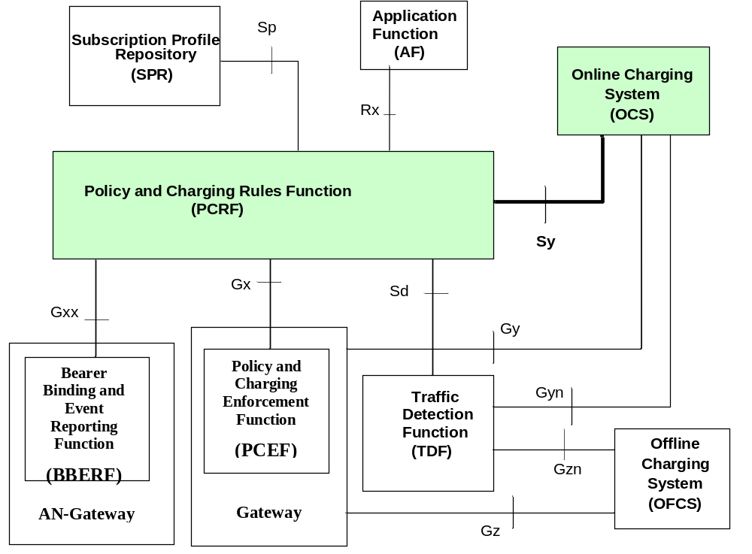

Figure 4.2.1: Sy reference point at the Policy and Charging Control (PCC) architecture with SPR
With the UDC-based architecture, as defined in 3GPP TS 23.335 [9] and applied in 3GPP TS 23.203 [2], the UDR replaces SPR and the Ud reference point provides access to the subscription data in the UDR. The Ud interface as defined in 3GPP TS 29.335 [10] is the interface between the PCRF and the UDR The relationships between the different functional elements are depicted in figure 4.2.2. When UDC architecture is used, SPR and Sp, whenever mentioned in this document, is replaced by UDR and Ud.
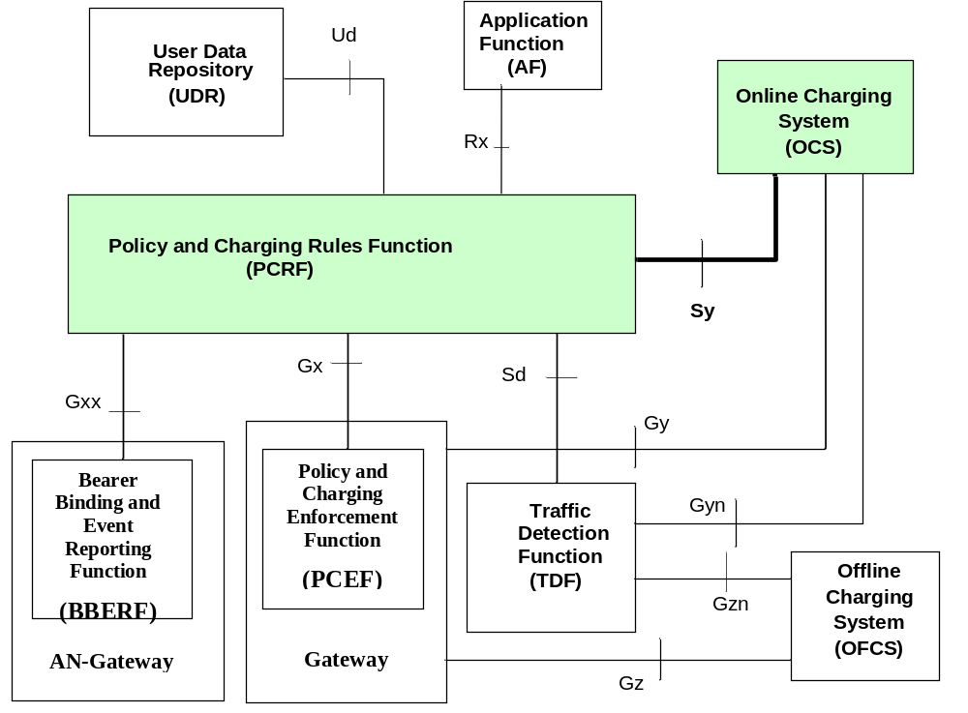

Figure 4.2.2: Sy reference point at the Policy and Charging Control (PCC) architecture with UDR
NOTE 1: The details associated with the Sp reference point are not specified in this Release. The SPR’s relation to existing subscriber databases is not specified in this Release.
NOTE 2: The UDC Application Informational Model related to the PCRF is not specified in this Release.
NOTE 3: PCEF is located in the Gateway node implementing the IP access to the PDN. Refer to annexes of 3GPP TS 23.203[2] for application to specific IP-CAN types.
NOTE 4: Refer to annexes A.5 and H.2 of 3GPP TS 23.203[2] for application of AN-Gateways.

4.3 Subscriber Spending Limits
Policy decisions based on spending limits is a function that allows the PCRF to make policy decisions based on the status of policy counters that are maintained in the OCS. The PCRF uses the policy counter statuses received from the OCS as input to its policy decisions, e.g. downgrade the QoS (e.g. APN-AMBR) or modify the PCC/QoS/ADC Rules.
When the status of policy counters is first required to make a policy decision for a subscriber, the PCRF uses the Initial Spending Limit Report Request procedure. The PCRF may request specific or all policy counter statuses to be reported by the OCS for the user. The OCS provides the status to the PCRF of the requested policy counters, and will notify the PCRF of any changes in the status of those policy counters. Optionally, the OCS can provide one or more pending statuses for a requested policy counter with the times that have to be applied. The pending status of a policy counter shall autonomously become the current status of a policy counter at the PCRF when the indicated corresponding time is reached. Subsequently, the provided information for pending statuses of a policy counter shall overwrite the previously received information.
NOTE 1: The mechanism for provisioning the policy counters in the OCS is out of scope of this document.
NOTE 2: A policy counter in the OCS can represent the spending for one or more services, one or more devices, one or more subscribers, etc. The representation is operator dependent. There is no explicit relationship between Charging-Key and policy counter.
The PCRF may request reporting for specific policy counter(s) that it is not currently subscribed and/or cancel reporting for specific policy counter status(es) using the Intermediate Spending Limit Report Request. The PCRF may cancel spending limit reporting for all policy counter(s) using the Final Spending Limit Report Request.
The updated subscriber profile may also trigger the PCRF sending the Initial/Intermediate/Final Spending Limit Report Request to the OCS to subscribed and/or cancel reporting for policy counter status(es). If spending limit reporting for a policy counter is enabled, the OCS shall notify the PCRF of changes in the status of this policy counter (e.g. daily spending limit of $2 reached) and optionally pending statuses of this policy counter with the activation time (e.g. due to a billing period that will expire at midnight).

4.4 Functional elements

4.4.1 PCRF
The Policy Control and Charging Rules Function (PCRF) is a functional element that encompasses policy control decision and flow based charging control functionalities.
The PCRF may take information on the subscriber's spending status into account in its policy decisions. The PCRF may request spending limit reporting for policy counters from the OCS using the Initial or Intermediate Spending Limit Report Request procedure as specified in clause 4.5.1. The PCRF may cancel spending limit reporting for specific policy counter(s) using the Intermediate Spending Limit Report Request procedure, or for all policy counter(s) using the Final Spending Limit Report Request procedure as specified in clause 4.5.3.
The PCRF shall have at least one active IP-CAN session to be able to initiate an Sy session to be used when required for spending limit reporting for that subscriber. The PCRF shall terminate the Sy session when the last IP-CAN session for that subscriber is terminated or no IP-CAN session for the same user depends on the spending status information provided over Sy reference point.
The PCRF may use the status of each relevant policy counter as input to its policy decision as required by the decision logic.

4.4.2 OCS
The Online Charging System (OCS), for the purpose of policy decisions based on the subscriber's spending, shall
- maintain the policy counter statuses applicable for a subscriber
- report the policy counter status values for the subscriber when requested to the PCRF
- when a policy counter status changes, report the change to the PCRF

4.5 Spending Limits procedures over Sy reference point

4.5.1 Initial/Intermediate Spending Limit Report Request

4.5.1.1 General
This procedure shall be used by the PCRF to request the status of policy counters available at the OCS, and to subscribe or unsubscribe to updates of policy counters by the OCS.
This procedure is mapped to the Spending-Limit-Request/Answer commands specified in section 5.6.
Table 4.5.1.1/1: Initial/Intermediate Spending Limit Report Request
Information element name | Mapping to Diameter AVP | Cat. | Description
User Identity | Subscription-Id | C | This IE shall contain the identity of the user. It shall be present in the initial request when the SL-Request-Type=INITIAL_REQUEST.
Request Type | SL-Request-Type | M | This IE shall indicate whether this is the initial or a subsequent request for the user.
Subscribed Policy Counter Identifier List | Policy-Counter-Identifier | O | This IE shall indicate the list of policy counter identifiers to be subscribed to. In the intermediate spending limit report request procedure, this list overrides a previously provisioned list. If omitted in either the Initial or Intermediate Spending Limit Report Request procedures the PCRF requests subscription to all available policy counters.

Table 4.5.1.1/2: Initial/Intermediate Spending Limit Report Response
Information element name | Mapping to Diameter AVP | Cat. | Description
Policy Counter Status Report | Policy-Counter-Status-Report | O | If present, this information element shall contain a policy counter identifier, the current status value and/or pending policy counter statuses with the activation times.
Result | Result-Code | M | This IE shall contain the result of the operation.

4.5.1.2 Detailed behaviour of the PCRF
The PCRF shall make use of this procedure when it determines for a subscriber that
- The status of policy counter(s) to which the PCRF does not have an existing subscription for status change notifications is/are required.
- The status of one or more, but not all, policy counter(s) to which the PCRF has an existing subscription for status change notifications are no longer required.
NOTE: The Final Spending Limit Request procedure in clause 4.5.3 is used to remove all subscriptions.
In the initial request, i.e. when the request is sent for the first time for the Subscriber, the PCRF shall set the SL-Request-Type AVP to the value INITIAL_REQUEST (0). For subsequent requests for the same Subscriber, the PCRF shall set the SL-Request-Type AVP to INTERMEDIATE_REQUEST (1).
For each policy counter that the PCRF requires the current status and notifications of future status changes, the PCRF shall indicate the concerned policy counter identifiers in the request. Alternatively, the policy counter identifiers may be omitted if the PCRF requires the current status and notifications of future status changes of all available policy counters.

4.5.1.3 The behaviour of the OCS
Upon reception of the request from the PCRF, the OCS shall check if there is an ongoing Sy session associated with the received Session-Id AVP. If there is no Sy session and the SL-Request-Type AVP is set to INITIAL_REQUEST, an Sy session is created on the OCS. If there is an Sy session and the SL-Request-Type AVP is not set to INTERMEDIATE_REQUEST (1), the OCS shall return a response with the Result-Code set to DIAMETER_INVALID_AVP_VALUE and with the Failed-AVP AVP containing the SL-Request-Type AVP. If there is no Sy session and the SL-Request-Type AVP is not set to INITIAL_REQUEST (0), the OCS shall return a response with the Result-Code AVP set to DIAMETER_UNKNOWN_SESSION_ID.
Upon reception of the request from the PCRF provided with explicit Policy Counter Identifier(s):
If all the policy counter identifiers are known to the OCS, the OCS shall be able to subsequently notify the PCRF of any policy counter state changes and optionally the pending policy counter statuses with the activation times.
If a policy counter identifier is known by the OCS, but is not applicable to the subscriber (e.g. not provisioned), the OCS may use an operator configured policy counter status to indicate this to the PCRF.
If the OCS is configured to accept the request provided with unknown policy counter identifier(s) , and if the OCS determines that one or more policy counter identifiers are unknown, an operator configured policy counter status may be used to indicate the policy counter identifier(s) determined as unknown by OCS. The status of known policy counter identifier(s) shall be returned to the PCRF in the same procedure in this case.
Alternatively, if the OCS is configured to reject the request provided with unknown policy counter identifier(s), and if the OCS determines that one or more policy counter identifiers are unknown, the OCS shall return a response with the Experimental-Result-Code AVP set to DIAMETER_ERROR_UNKNOWN POLICY_COUNTERS and with the Failed-AVP AVP indicating the unknown policy counter identifiers. If the SL-Request-Type AVP is set to INITIAL_REQUEST when this failure occurs, the Sy session is not created. If the SL-Request-Type AVP is set to INTERMEDIATE_REQUEST (1) when this failure occurs, then none of the changes in the request take effect but the Sy session is maintained.
When the PCRF provides a new subscribed policy counter identifier list, the OCS shall remove any policy counter identifiers no longer in the list from association with the Sy session such that the OCS will no longer notify the PCRF of those policy counter state changes.
If an initial or intermediate request contains no policy counter identifiers, the OCS shall subsequently notify the PCRF of all available policy counter state changes and optionally the pending policy counter statuses with the activation times. If the OCS has no available policy counters for that subscriber during the Initial Spending Limit Report Request procedure, it sets the Experimental-Result-Code to DIAMETER_ERROR_NO_AVAILABLE_POLICY_COUNTERS, and the Sy session is not created.
If the user identified in an initial request is not known to the OCS, the OCS shall reject the Spending Limit Report Request by including the result code of DIAMETER_USER_UNKNOWN in the Spending Limit Report Answer. In this case, the Sy session is not created.
Upon successful creation of an Sy session, the OCS shall include the current status of all subscribed policy counters (if any) in the response and set the Result-Code to DIAMETER_SUCCESS.

4.5.2 Spending Limit Report

4.5.2.1 General
This procedure shall be used by the OCS to notify the PCRF of changes in the status of subscribed policy counter(s).
This procedure is mapped to the Spending-Status-Notification-Request /Answer commands specified commands specified in section 5.6.
Table 4.5.2.1/1: Spending Limit Report Request
Information element name | Mapping to Diameter AVP | Cat. | Description
Policy Counter Status Report | Policy-Counter-Status-Report | M | If present, this information element shall contain a policy counter identifier, the current status value and/or pending policy counter statuses with the activation times.

Table 4.5.2.1/2: Spending Limit Report Response
Information element name | Mapping to Diameter AVP | Cat. | Description
Result | Result-Code | M | This IE shall contain the result of the operation.

4.5.2.2 The behaviour of the OCS
When the status of a specific policy counter changes, the OCS shall determine the Sy sessions impacted by the change (i.e. those Sy sessions that have subscribed to status change notifications for the changed policy counter) and send a Spending Limit Report request including the current policy counter status, and optionally pending policy counter statuses with the activation times to the PCRF associated with each affected Sy session.
If several policy counters change status at the same time, the OCS may group the status change notifications into a single Spending Limit Report request to the PCRF by sending multiple Policy-Counter-Status-Report AVPs in the request.

4.5.2.3 Detailed behaviour of the PCRF
The PCRF shall acknowledge the request by sending a response with a Result-Code AVP set to DIAMETER_SUCCESS and use the status of the received policy counter(s) as input to its policy decision to apply operator defined actions, e.g. downgrade the QoS.
The PCRF shall ignore an unknown policy counter status report for all unknown policy counter identifiers in an SLA or in an SNR from the OCS.
If the PCRF receives a Policy-Counter-Status-Report with one or more Pending-Policy-Counter-Information AVPs, then at the time defined by the Pending-Policy-Counter-Change-Time AVP, the pending Policy-Counter-Status shall autonomously become the current status of a policy counter. Subsequently provided information for pending statuses of a policy counter shall overwrite the previously received information.

4.5.3 Final Spending Limit Report Request

4.5.3.1 General
This procedure shall be used by the PCRF to unsubscribe to any future updates of policy counters for a given subscriber by the OCS.
This procedure is mapped to the Session-Termination-Request/Answer commands specified in RFC3588 [3].
Table 4.5.3.1/1: Final Spending Limit Report Request
Information element name | Mapping to Diameter AVP | Cat. | Description
Termination Cause | Termination-Cause | M | This IE shall contain the reason why the session was terminated. It shall be set to "DIAMETER_LOGOUT".

Table 4.5.3.1/2: Final Spending Limit Report Response
Information element name | Mapping to Diameter AVP | Cat. | Description
Result | Result-Code | M | This IE shall contain the result of the operation.

4.5.3.2 Detailed behaviour of the PCRF
When the PCRF decides that policy decisions for a given user no longer depend on policy counter(s) to which the PCRF has existing subscriptions for status change notifications, the PCRF shall send the Final Spending Limit Report Request to the OCS.

4.5.3.3 The behaviour of the OCS
Upon reception of the request from the PCRF, the OCS shall check that there is an ongoing Sy session associated with the received Session-Id AVP. If there is no Sy session, the OCS shall return a response with the Result-Code AVP set to DIAMETER_UNKNOWN_SESSION_ID.
The OCS shall remove all policy counter subscriptions associated with the Sy session such that the OCS will no longer notify the PCRF of policy counter state changes and close the session by returning a response with the Result-Code AVP set to DIAMETER_SUCCESS.

5 Sy protocol

5.1 Protocol support

5.1.1 Use of Diameter base protocol
The Diameter Base Protocol as specified in IETF RFC 3588 [3] shall apply except as modified by the defined support of the methods and the defined support of the commands and AVPs, result and error codes as specified in this specification. Unless otherwise specified, the procedures (including error handling and unrecognised information handling) shall be used unmodified.
With regard to the Diameter protocol defined over the Sy interface, the OCS acts as a Diameter server, in the sense that it is the network element that handles policy counter status requests for a particular realm. The PCRF acts as the Diameter client, in the sense that is the network element requesting policy counter status to the OCS.
A Diameter routing table entry can have a different destination based on the application identifier of the command. The application identifier stored in the command header must match the value of any application identifier AVPs in the command body. Diameter agents (relay, proxy, redirection, translation agents) should use the application identifier in the command header to route to a suitable destination.

5.1.2 Void

5.1.3 Accounting functionality
Accounting functionality (Accounting Session State Machine, related command codes and AVPs) shall not be used on the Sy interface.

5.1.4 Transport protocol
Diameter messages over the Sy interface shall make use of TCP IETF RFC 791 [13] or SCTP IETF RFC 4960 [14].

5.1.5 Advertising Application Support
The Diameter application identifier assigned to the Sy interface application is 16777302.
The PCRF and OCS shall advertise support of the Diameter Sy Application by including the value of the Sy application identifier in the Auth-Application-Id AVP within the Vendor-Specific-Application-Id grouped AVP of the Capabilities-Exchange-Request and Capabilities-Exchange-Answer commands.
The vendor identifier value of 3GPP (10415) shall be included in the Supported-Vendor-Id AVP of the Capabilities-Exchange-Request and Capabilities-Exchange-Answer commands, and in the Vendor-Id AVP within the Vendor-Specific-Application-Id grouped AVP of the Capabilities-Exchange-Request and Capabilities-Exchange-Answer commands.
The Vendor-Id AVP included in Capabilities-Exchange-Request and Capabilities-Exchange-Answer commands that is not included in the Vendor-Specific-Application-Id AVPs as described above shall indicate the manufacturer of the Diameter node as per RFC 3588 [3].

5.1.6 Use of the Supported-Features AVP
The Supported-Features AVP is used during session establishment to inform the destination host about the required and optional features that the origin host supports. The client shall, in the first request in a Diameter session indicate the set of supported features. The server shall, in the first answer within the Diameter session indicate the set of features that it has in common with the client and that the server shall support within the same Diameter session. Any further command messages shall always be compliant with the list of supported features indicated in the Supported-Features AVPs during session establishment. Features that are not advertised as supported shall not be used to construct the command messages for that Diameter session. Unless otherwise stated, the use of the Supported-Features AVP on the Sy reference point shall be compliant with the requirements for dynamic discovery of supported features and associated error handling on the Cx reference point as defined in clause 7.2.1 of 3GPP TS 29.229 [15].
The base functionality for the Sy reference point is the 3GPP Rel-11 standard and a feature is an extension to that functionality. If the origin host does not support any features beyond the base functionality, the Supported-Features AVP may be absent from the Sy commands. As defined in clause 7.1.1 of 3GPP TS 29.229 [15], when extending the application by adding new AVPs for a feature, the new AVPs shall have the M bit cleared and the AVP shall not be defined mandatory in the command ABNF.
As defined in 3GPP TS 29.229 [15], the Supported-Features AVP is of type grouped and contains the Vendor-Id, Feature-List-ID and Feature-List AVPs. On the Sy reference point, the Supported-Features AVP is used to identify features that have been defined by 3GPP and hence, for features defined in this document, the Vendor-Id AVP shall contain the vendor ID of 3GPP (10415). If there are multiple feature lists defined for the Sy reference point, the Feature-List-ID AVP shall differentiate those lists from one another.
On receiving an initial request application message, the destination host shall act as defined in clause 7.2.1 of 3GPP TS 29.229 [15]. The following exceptions apply to the initial SLR/SLA command pair:
- If the PCRF supports post-Rel-11 Sy, the SLR shall include the features supported by the PCRF within Supported-Features AVP(s) with the 'M' bit cleared.
NOTE: One instance of Supported-Features AVP is needed per Feature-List-ID.
- If the SLR command does not contain any Supported-Features AVP(s) and the OCS supports Rel-11 Sy functionality, the OCS shall not include the Supported-Features AVP in the SLA command. In this case, both PCRF and OCS shall behave as specified in the Rel-11 version of this document.
Once the PCRF and OCS have negotiated the set of supported features during session establishment, the set of common features shall be used during the lifetime of the Diameter session.

5.2 Initialization and maintenance of connection and session
The Diameter protocol between the PCRF and the OCS, shall always keep the session state, and use the same Session-Id parameter for the lifetime of each Diameter session.
Each Diameter session shall identify a Sy session for a given user. In order to indicate that the session state is to be maintained, the Diameter client and server shall not include the Auth-Session-State AVP, either in the request or in the response messages (see IETF RFC 3588 [3]).
The PCRF shall link the Gx session(s) or S9 session with the Sy session at Sy session initialization and maintain that until the IP-CAN session(s) for that subscriber are terminated or no IP-CAN session for the same user depends on the spending status information provided over Sy reference point.

5.3 Sy specific AVPs
Table 5.3.1 describes the Diameter AVPs defined for the Sy reference point, their AVP Code values, types and possible flag values. The Vendor-Id header of all AVPs defined in the present document shall be set to 3GPP (10415).
Table 5.3.1: Sy specific Diameter AVPs
 |  |  |  | AVP Flag rules (note 1)
Attribute Name | AVP Code | Clause defined | Value Type | Must | May | Should not | Must not
Policy-Counter-Identifier | 2901 | 5.3.1 | UTF8String | M,V | P
Policy-Counter-Status | 2902 | 5.3.2 | UTF8String | M,V | P
Policy-Counter-Status-Report | 2903 | 5.3.3 | Grouped | M,V | P
SL-Request-Type | 2904 | 5.3.4 | Enumerated | M,V | P
Pending-Policy-Counter-Information | 2905 | 5.3.5 | Grouped | M,V | P
Pending-Policy-Counter-Change-Time | 2906 | 5.3.6 | Time | M,V | P
NOTE 1: The AVP header bit denoted as 'M', indicates whether support of the AVP is required. The AVP header bit denoted as 'V', indicates whether the optional Vendor-ID field is present in the AVP header. For further details, see RFC 3588 [3].

5.3.1 Policy-Counter-Identifier AVP
The Policy-Counter-Identifier AVP (AVP code 2901) is of type UTF8String, and it uniquely identifies a policy counter that is maintained per subscriber within the OCS.

5.3.2 Policy-Counter-Status AVP
The Policy-Counter-Status AVP (AVP code 2902) is of type UTF8String, and identifies the policy counter status applicable for a specific policy counter and subscriber.
NOTE: The valid values for the Policy-Counter-Status AVP are specific for each Policy-Counter-Identifier value.

5.3.3 Policy-Counter-Status-Report AVP
The Policy-Counter-Status-Report AVP (AVP code 2903) is of type Grouped. It is used by the OCS to report the status of a specific policy counter.
AVP Format:
Policy-Counter-Status-Report ::= < AVP Header: 2903 >
{ Policy-Counter-Identifier }
{ Policy-Counter-Status }
*[ Pending-Policy-Counter-Information ]
*[ AVP ]

5.3.4 SL-Request-Type AVP
The SL-Request-Type AVP (AVP code 2904) is of type Enumerated, and informs the OCS whether the SLR command is being sent as part of the initial or intermediate spending limit report request procedure.
The following values are defined:
INITIAL_REQUEST (0)
This value indicates that this is the first request in the Diameter session.
INTERMEDIATE_REQUEST (1)
This value indicates that this is the second or subsequent request in the Diameter session.

5.3.5 Pending-Policy-Counter-Information AVP
The Pending-Policy-Counter-Information AVP (AVP code 2905) is of type Grouped, which contains the pending policy counter status and the active time. If multiple pending policy counter AVPs are included, they shall be sorted in order of change time.
AVP Format:
Pending-Policy-Counter-Information ::= < AVP Header: 2905 >
{ Policy-Counter-Status }
{ Pending-Policy-Counter-Change-Time }
*[ AVP ]

NOTE: The valid values for the Pending-Policy-Counter-Status AVP are specific for each Policy-Counter-Identifier value.

5.3.6 Pending-Policy-Counter-Change-Time AVP
The Pending-Policy-Counter-Change-Time AVP (AVP code 2906) is of type Time. This value indicates the NTP time at which the pending policy counter becomes the current status of a policy counter.

5.4 Sy re-used AVPs
Table 5.4 lists the Diameter AVPs re-used by the Sy reference point from existing Diameter Applications, reference to their respective specifications and a short description of their usage within the Sy reference point. Other AVPs from existing Diameter Applications, except for the AVPs from Diameter base protocol, do not need to be supported. The AVPs from Diameter base protocol are not included in table 5.4, but they are re-used for the Sy reference point. Unless otherwise stated, re-used AVPs shall maintain their 'M', 'P' and 'V' flag settings. Where 3GPP Radius VSAs are re-used, unless otherwise stated, they shall be translated to Diameter AVPs as described in RFC 4005 [4] with the exception that the 'M' flag shall be set and the 'P' flag may be set.
Table 5.4: Sy re-used Diameter AVPs
Attribute Name | Reference |  | Description
Subscription-Id |  | IETF RFC 4006 [5] | The identification of the subscription (IMSI, MSISDN, etc)

5.5 Sy specific Experimental-Result-Code AVP values

5.5.1 General
RFC 3588 [3] specifies the Experimental-Result AVP containing Vendor-ID AVP and Experimental-Result-Code AVP. The Experimental-Result-Code AVP (AVP Code 298) is of type Unsigned32 and contains a vendor-assigned value representing the result of processing a request. The Vendor-ID AVP shall be set to 3GPP (10415).

5.5.2 Permanent Failures
Errors that fall within the Permanent Failures category shall be used to inform the peer that the request failed, and the request should not be attempted again.
The Result-Code AVP values defined in Diameter base protocol IETF RFC 3588 [3] are applicable. Also, the following Result-Code AVP value defined in IETF RFC 4006 [5] is applicable:
DIAMETER_USER_UNKNOWN (5030)
This error shall be used by the OCS to indicate to the PCRF that the end user specified in the request is unknown to the OCS and that the Sy session cannot be created.
The following specific Sy Experimental-Result-Code value is defined for permanent failures:
DIAMETER_ERROR_UNKNOWN_POLICY_COUNTERS (5570)
This error shall be used by the OCS to indicate to the PCRF that the OCS does not recognize one or more Policy Counters specified in the request, when the OCS is configured to reject the request provided with unknown policy counter identifier(s).

5.5.3 Transient Failures
Errors that fall within the transient failures category are used to inform a peer that the request could not be satisfied at the time it was received, but may be able to satisfy the request in the future.
The Result-Code AVP values defined in Diameter base protocol IETF RFC 3588 [3] are applicable. Also the following specific Sy Experimental-Result-Code value is defined for transient failures:
DIAMETER_ERROR_NO_AVAILABLE_POLICY_COUNTERS (4241)
This error shall be used by the OCS to indicate to the PCRF that the OCS has no available policy counters for the subscriber.
The PCRF may retry the request based on local configuration or operator policy on receipt of a transient failure.

5.6 Sy Messages

5.6.1 Command-Code Values
This section defines the Command-Code values for the Sy interface application as allocated by IANA from the vendor-specific namespace defined in IETF RFC 5719 [6]. Every command is defined by means of the ABNF syntax IETF RFC 2234 [7], according to the rules in IETF RFC 3588 [3].
The following Command Codes are defined in this specification:
Table 5.6.1: Command-Code values for Sy
Command-Name | Abbreviation | Code | Section
Spending-Limit-Request | SLR | 8388635 | 5.6.2
Spending-Limit-Answer | SLA | 8388635 | 5.6.3
Spending-Status-Notification-Request | SNR | 8388636 | 5.6.4
Spending-Status-Notification-Answer | SNA | 8388636 | 5.6.5

In addition, the Session-Termination-Request and Session-Termination-Answer commands are reused from IETF RFC 3588 [3].
For the commands defined in this specification and reused commands, the Application-ID field shall be set to 16777302.

5.6.2 Spending-Limit-Request (SLR) command
The SLR command, indicated by the Command-Code field set to 8388635 and the 'R' bit set in the Command Flags field, is sent by the PCRF to the OCS as part of the Initial or Intermediate Spending Limit Report Request procedure.
Message Format:
<SL-Request> ::= <Diameter Header: 8388635, REQ, PXY >
< Session-Id >
{ Auth-Application-Id }
{ Origin-Host }
{ Origin-Realm }
{ Destination-Realm }
[ Destination-Host ]
[ Origin-State-Id ]
{ SL-Request-Type }
*[ Subscription-Id ]
*[ Policy-Counter-Identifier ]
*[ Proxy-Info ]
*[ Route-Record ]
*[ AVP ]

NOTE: Multiple instances of the Subscription-Id AVP in the SLR command correspond to multiple types of identifier for the same subscriber, for example IMSI and MSISDN.

5.6.3 Spending-Limit-Answer (SLA) command
The SLA command, indicated by the Command-Code field set to 8388635 and the 'R' bit cleared in the Command Flags field, is sent by the OCS to the PCRF as part of the Initial or Intermediate Spending Limit Report Request procedure.
Message Format:
<SL-Answer> ::= < Diameter Header: 8388635, PXY >
< Session-Id >
{ Auth-Application-Id }
{ Origin-Host }
{ Origin-Realm }
[ Result-Code ]
[ Experimental-Result ]
*[ Policy-Counter-Status-Report ]
[ Error-Message ]
[ Error-Reporting-Host ]
*[ Failed-AVP ]
[ Origin-State-Id ]
*[ Redirect-Host ]
[ Redirect-Host-Usage ]
[ Redirect-Max-Cache-Time ]
*[ Proxy-Info ]
*[ AVP ]

5.6.4 Spending-Status-Notification-Request (SNR) command
The SNR command, indicated by the Command-Code field set to 8388636 and the 'R' bit set in the Command Flags field, is sent by the OCS to the PCRF as part of the Spending Limit Report procedure.
Message Format:
<SN-Request> ::= < Diameter Header: 8388636, REQ, PXY >
< Session-Id >
{ Origin-Host }
{ Origin-Realm }
{ Destination-Realm }
{ Destination-Host }
{ Auth-Application-Id }
[ Origin-State-Id ]
*[ Policy-Counter-Status-Report ]
*[ Proxy-Info ]
*[ Route-Record ]
*[ AVP ]

5.6.5 Spending-Status-Notification-Answer (SNA) command
The SNA command, indicated by the Command-Code field set to 8388636 and the 'R' bit cleared in the Command Flags field, is sent by the PCRF to the OCS as part of the Spending Limit Report procedure.
Message Format:
<SN-Answer> ::= < Diameter Header: 8388636, PXY >
< Session-Id >
{ Origin-Host }
{ Origin-Realm }
[ Result-Code ]
[ Experimental-Result ]
[ Origin-State-Id ]
[ Error-Message ]
[ Error-Reporting-Host ]
*[ Redirect-Host ]
[ Redirect-Host-Usage ]
[ Redirect-Max-Cache-Time ]
*[ Failed-AVP ]
*[ Proxy-Info ]
*[ AVP ]

5.6.6 Session-Termination-Request (STR) command
The STR command, indicated by the Command-Code field set to 275 and the 'R' bit set in the Command Flags field, is sent by the PCRF to the OCS as part of the Final Spending Limit Report Request procedure.
Message Format:
<ST-Request> ::= < Diameter Header: 275, REQ, PXY >
< Session-Id >
{ Origin-Host }
{ Origin-Realm }
{ Destination-Realm }
{ Auth-Application-Id }
{ Termination-Cause }
[ Destination-Host ]
[ Origin-State-Id ]
*[ Proxy-Info ]
*[ Route-Record ]
*[ AVP ]

5.6.7 Session-Termination-Answer (STA) command
The STA command, indicated by the Command-Code field set to 275 and the 'R' bit cleared in the Command Flags field, is sent by the OCS to the PCRF as part of the Final Spending Limit Report Request procedure.
Message Format:
<ST-Answer> ::= < Diameter Header: 275, PXY >
< Session-Id >
{ Origin-Host }
{ Origin-Realm }
[ Result-Code ]
[ Error-Message ]
[ Error-Reporting-Host ]
*[ Failed-AVP ]
[ Origin-State-Id ]
*[ Redirect-Host ]
[ Redirect-Host-Usage ]
[ Redirect-Max-Cache-Time ]
*[ Proxy-Info ]
*[ AVP ]

Annex A (informative):
Change history
Change history
Date | TSG # | TSG Doc. | CR | Rev | Subject/Comment | Old | New
2011-08 | CT3#65 | C3-111638 |  |  | Initial version includes agreed documents C3-101608, C3-101540, C3-111486, C3-111609, C3-111610, C3-111622 and C3-111612. | 0.0.0 | 0.1.0
2011-11 | CT3#67 | C3-112143 |  |  | Includes agreed documents C3-111680, C3-112033, C3-111682, C3-111705, C3-112138, C3-112011, C3-112026, C3-112015, C3-112016, C3-111843, C3-112035, C3-111846, C3-111886. | 0.1.2 | 1.0.0
2011-11 | CP#54 | CP-110848 |  |  | Editorial update by MCC for presentation to TSG CT for information | 0.1.2 | 1.0.0
2012-02 | CT3#68 | C3-120495 |  |  | Includes agreed documents C3-120411, C3-120385, C3-120025, C3-120386. | 1.0.0 | 1.1.0
2012-02 | CP#55 | CP-120083 |  |  | Editorial update by MCC for presentation to TSG CT for approval | 1.1.0 | 2.0.0
2012-03 | CP#55 | CP-120083 |  |  | v 11.0.0 was produced by MCC | 2.0.0 | 11.0.0
2012-06 | CP#56 | CP-120347 | 2 | 1 | Sy Error Case | 11.0.0 | 11.1.0
2012-06 | CP#56 | CP-120347 | 3 | 1 | Sy Corrections | 11.0.0 | 11.1.0
2012-06 | CP#56 | CP-120347 | 4 |  | Parameters for Spending Limit Report Request | 11.0.0 | 11.1.0
2012-06 | CP#56 | CP-120347 | 5 |  | Command Code for SLR & SLA (R11 29.219) | 11.0.0 | 11.1.0
2012-09 | CP#57 | CP-120536 | 7 |  | Clean-up for spending limit description | 11.1.0 | 11.2.0
2012-12 | CP#58 | CP-120832 | 8 | 1 | Clarification of Supported-Features AVP | 11.2.0 | 11.3.0
2012-12 | CP#58 | CP-120832 | 10 | 4 | Addition of values to the Experimental-Result-Code AVP | 11.2.0 | 11.3.0
2013-03 | CP#59 | CP-130073 | 13 | 3 | Addition of values to the Experimental-Result-Code AVP | 11.3.0 | 11.4.0
2013-06 | CP#60 | CP-130323 | 16 | 1 | Time Based Sy Controls | 11.4.0 | 11.5.0
2013-06 | CP#60 | CP-130341 | 15 | 1 | Reference model update to include Gyn and Gzn | 11.5.0 | 12.0.0

