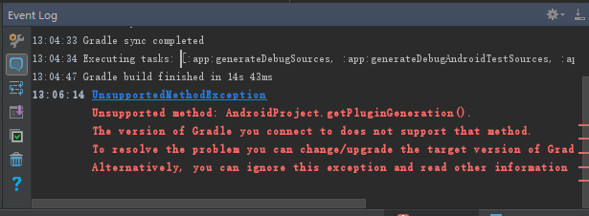

Instant Run的问题。

解决方法：

禁止Instant Run的功能就可以了

Windows & Linux:

File -> Settings -> Build, Execution, Deployment -> Instant Run.

Mac:

Android Studio -> Preferences -> Build, Execution, Deployment -> Instant Run.

Enable Instant Run to hot swap code...