**CIA1**

**Question1:**

package com.test.Testing;

import org.openqa.selenium.By;

import org.openqa.selenium.JavascriptExecutor;

import org.openqa.selenium.WebDriver;

import org.openqa.selenium.WebElement;

import org.openqa.selenium.chrome.ChromeDriver;

import org.openqa.selenium.chrome.ChromeOptions;

import io.github.bonigarcia.wdm.WebDriverManager;

public class CIA1_2 {

public static void main( String[] args )throws InterruptedException

{

ChromeOptions co=new ChromeOptions();

co.addArguments("--remote-allow-origins=*");

WebDriverManager.chromedriver().setup();

WebDriver d=new ChromeDriver(co);

d.get("https://www.amazon.in/");

d.manage().window().maximize();

String Etit=d.getTitle();

String Atit="Online Shopping site in India: Shop Online for Mobiles, Books, Watches, Shoes and More - Amazon.in";

if(Etit.equals(Atit))

{

System.out.println(Etit);

System.out.println("Title is Verified");

}

else

{

System.out.println("Not Verified");

}

WebElement search=d.findElement(By.xpath("//*[@id=\"twotabsearchtextbox\"]"));

search.sendKeys("Carromboard");

d.findElement(By.xpath("//*[@id=\"nav-search-submit-button\"]")).click();

String SEtit=d.getTitle();

String SAtit="Amazon.in:Carromboard";

if(SEtit.equals(SAtit))

{

System.out.println(SEtit);

System.out.println("Title is Matched");

}

else

{

System.out.println("Not Matched");

}

WebElement price=d.findElement(By.xpath("//*[@id=\"twotabsearchtextbox\"]"));

search.sendKeys("9999");

d.findElement(By.xpath("//*[@id=\"nav-search-submit-button\"]")).click();

String PEtit=d.getTitle();

String PAtit="Amazon.in:9999";

if(PEtit.equals(PAtit))

{

System.out.println(PEtit);

System.out.println("Title is Matched");

}

else

{

System.out.println("Not Matched");

}

}

}

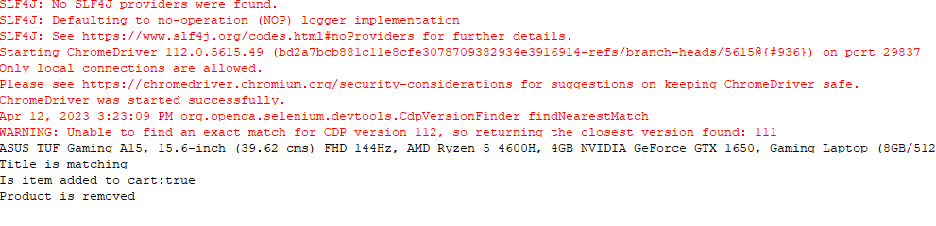

**Question 2:**

ChromeOptions co=new ChromeOptions();  
co.addArguments ("--remote-allow-origins=*");  
WebDriverManager.chromedriver().setup ();  
WebDriver driver=new ChromeDriver(co);  
driver.get ("<https://www.amazon.in/>");  
driver.manage().window().maximize() ;  
String currentTitle=driver.getTitle();  
System.out.println(currentTitle);  
String expectedTitle="Online Shopping site in India: Shop Online for Mobiles, Books, Watches, Shoes and More - Amazon.in";  
if(currentTitle.equals(expectedTitle)) {  
System.out.println("Title Matched");  
}  
else {  
System.out.println("Title not Matched");  
}  
WebElement txtBoxl=driver.findElement(By.xpath("//*[@id=\"twotabsearchtextbox\"]"));  
txtBoxl.sendKeys("macbook");  
driver.findElement(By.xpath("//*[@id=\"nav-search-submit-button\"]")).click();  
  
//displaying 5 products  
String txt1=driver.findElement(By.xpath("//*[@id=\"search\"]/div[1]/div[1]/div/span[1]/div[1]/div[3]/div/div/div/div/div/div/div/div[2]/div/div/div[1]/h2/a/span")).getText();  
System.out.println(txt1);  
String txt2=driver.findElement(By.xpath("//*[@id=\"search\"]/div[1]/div[1]/div/span[1]/div[1]/div[4]/div/div/div/div/div/div/div/div[2]/div/div/div[1]/h2/a/span")).getText();  
System.out.println(txt2);  
String txt3=driver.findElement(By.xpath("//*[@id=\"search\"]/div[1]/div[1]/div/span[1]/div[1]/div[5]/div/div/div/div/div/div[2]/div/div/div[1]/h2/a/span")).getText();  
System.out.println(txt3);  
String txt4=driver.findElement(By.xpath("//*[@id=\"search\"]/div[1]/div[1]/div/span[1]/div[1]/div[6]/div/div/div/div/div/div[2]/div/div/div[1]/h2/a/span")).getText();  
System.out.println(txt4);  
String txt5=driver.findElement(By.xpath("//*[@id=\"search\"]/div[1]/div[1]/div/span[1]/div[1]/div[7]/div/div/div/div/div/div[2]/div/div/div[1]/h2/a/span")).getText();  
System.out.println(txt5);  
//filter  
driver.findElement(By.xpath("//*[@id=\"p_36/7252032031\"]/span/a/span")).click();  
driver.findElement(By.xpath("//*[@id=\"p_n_pattern_browse-bin/1464446031\"]/span/a/span")).click();  
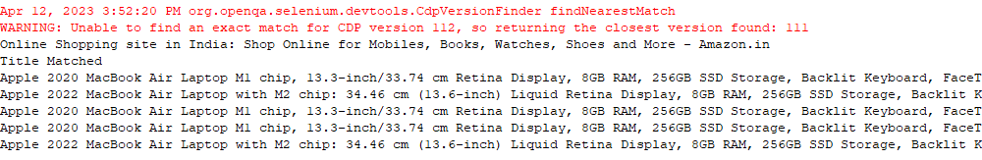

**Question 3**

**package** com.test.Testing;

**import** org.openqa.selenium.By;

**import** org.openqa.selenium.WebDriver;

**import** org.openqa.selenium.WebElement;

**import** org.openqa.selenium.chrome.ChromeDriver;

**import** org.openqa.selenium.chrome.ChromeOptions;

**import** io.github.bonigarcia.wdm.WebDriverManager;

**public** **class** CIA_3 {

**public** **static** **void** main (String args[])**throws** InterruptedException

{

ChromeOptions co=**new** ChromeOptions();

co.addArguments ("--remote-allow-origins=*");

WebDriverManager.*chromedriver*().setup ();

WebDriver driver=**new** ChromeDriver(co);

driver.get ("https://www.amazon.in/");

driver.manage().window().maximize() ;

String currentTitle=driver.getTitle();

System.***out***.println(currentTitle);

String expectedTitle="Online Shopping site in India: Shop Online for Mobiles, Books, Watches, Shoes and More - Amazon.in";

**if**(currentTitle.equals(expectedTitle)) {

System.***out***.println("Title Matched");

}

**else** {

System.***out***.println("Title not Matched");

}

driver.findElement(By.*xpath*("//*[@id=\"nav-link-accountList\"]")).click();

WebElement txtBoxl=driver.findElement(By.*xpath*("//*[@id=\"ap_email\"]"));

txtBoxl.sendKeys("9345573224");

driver.findElement(By.*xpath*("//*[@id=\"continue\"]")).click();

WebElement txtBox2=driver.findElement(By.*xpath*("//*[@id=\"ap_password\"]"));

txtBox2.sendKeys("V@IGNESH123");

driver.findElement(By.*xpath*("//*[@id=\"signInSubmit\"]")).click();

driver.findElement(By.*xpath*("//*[@id=\"nav-link-accountList\"]")).click();

driver.findElement(By.*xpath*("//*[@id=\"a-page\"]/div[2]/div/div[2]/div[1]/a/div/div")).click();

String ctit=driver.getTitle();

System.***out***.println(currentTitle);

String etit="Your Orders";

**if**(currentTitle.equals(expectedTitle)) {

System.***out***.println("Verified");

}

**else** {

System.***out***.println("Title not Matched");

}

driver.navigate().back();

}

}

