**DAY4**

***Task1:***

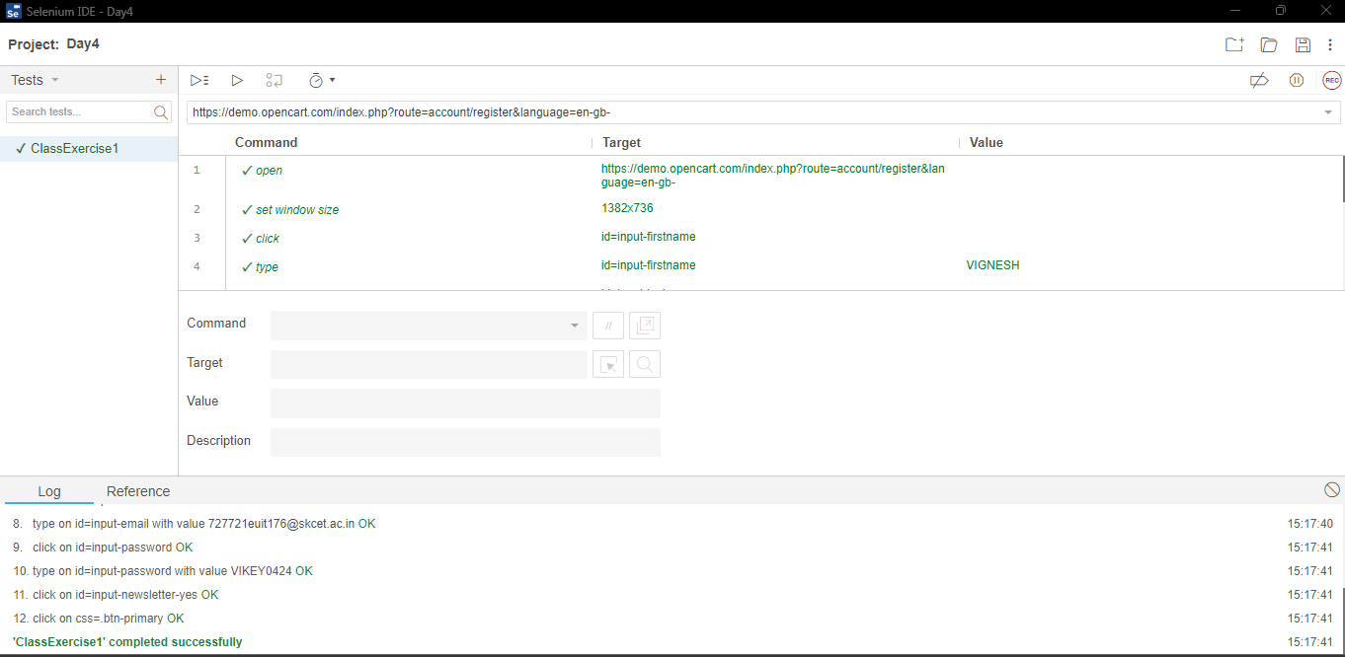

***Task2:***

**package** com.test.Testing;

**import** org.openqa.selenium.By;

**import** org.openqa.selenium.WebDriver;

**import** org.openqa.selenium.WebElement;

**import** org.openqa.selenium.chrome.ChromeDriver;

**import** org.openqa.selenium.chrome.ChromeOptions;

**import** io.github.bonigarcia.wdm.WebDriverManager;

**public** **class** App

{

**public** **static** **void** main( String[] args )**throws** InterruptedException

{

ChromeOptions co=**new** ChromeOptions();

co.addArguments("--remote-allow-origins=*");

WebDriverManager.*chromedriver*().setup();

WebDriver d=**new** ChromeDriver(co);

d.get("https://demo.opencart.com/index.php?route=account/register&language=en-gb");

d.manage().window().maximize();

WebElement fname=d.findElement(By.*id*("input-firstname"));

fname.sendKeys("VIGNESH");

WebElement lname=d.findElement(By.*id*("input-lastname"));

lname.sendKeys("KUMAR");

WebElement email=d.findElement(By.*cssSelector*("input#input-email"));

email.sendKeys("727721euit176@skcet.ac.in");

d.findElement(By.*id*("input-password")).sendKeys("VIKEY0424");

Thread.*sleep*(5000);

d.findElement(By.*id*("input-newsletter-yes")).click();

Thread.*sleep*(5000);

d.findElement(By.*name*("agree")).click();

Thread.*sleep*(5000);

d.findElement(By.*xpath*("//*[@id=\"form-register\"]/div/div/button")).click();

}

}

***Task3:***

**package** com.test.Testing;

**import** org.openqa.selenium.By;

**import** org.openqa.selenium.JavascriptExecutor;

**import** org.openqa.selenium.WebDriver;

**import** org.openqa.selenium.WebElement;

**import** org.openqa.selenium.chrome.ChromeDriver;

**import** org.openqa.selenium.chrome.ChromeOptions;

**import** io.github.bonigarcia.wdm.WebDriverManager;

**public** **class** ClassExcercise3 {

**public** **static** **void** main( String[] args )**throws** InterruptedException

{

ChromeOptions co=**new** ChromeOptions();

co.addArguments("--remote-allow-origins=*");

WebDriverManager.*chromedriver*().setup();

WebDriver d=**new** ChromeDriver(co);

d.get("https://demo.opencart.com/index.php?route=checkout/voucher&language=en-gb");

d.manage().window().maximize();

d.findElement(By.*xpath*("//input[@id=\"input-to-name\"]")).sendKeys("Vignesh");

d.findElement(By.*xpath*("//input[@id=\"input-to-email\"]")).sendKeys("727721euit176@skcet.ac.in");

d.findElement(By.*xpath*("//input[@id=\"input-from-name\"]")).sendKeys("Kumar");

d.findElement(By.*xpath*("//input[@id=\"input-from-email\"]")).sendKeys("727721euit045@skcet.ac.in");

JavascriptExecutor js=(JavascriptExecutor) d;

Thread.*sleep*(5000);

d.findElement(By.*xpath*("//input[@id=\"input-theme-7\"]")).click();

d.findElement(By.*xpath*("//*[@id=\"input-message\"]")).sendKeys("Happy Birthday Vignesh have a nice day.");

d.findElement(By.*xpath*("//*[@id=\"input-amount\"]")).sendKeys("10");

//*[@id="form-voucher"]/div[8]/div/div/input

Thread.*sleep*(3000);

d.findElement(By.*xpath*("//*[@id=\"form-voucher\"]/div[8]/div/div/input")).click();

Thread.*sleep*(3000);

d.findElement(By.*xpath*("//*[@id=\"form-voucher\"]/div[8]/div/button")).click();

}

}

***Task4:***

**package** com.test.Testing;

**import** org.openqa.selenium.By;

**import** org.openqa.selenium.JavascriptExecutor;

**import** org.openqa.selenium.WebDriver;

**import** org.openqa.selenium.chrome.ChromeDriver;

**import** org.openqa.selenium.chrome.ChromeOptions;

**import** io.github.bonigarcia.wdm.WebDriverManager;

**public** **class** ClassExcercise4 {

**public** **static** **void** main(String[] args)**throws** InterruptedException {

ChromeOptions co=**new** ChromeOptions();

co.addArguments("--remote-allow-origins=*");

WebDriverManager.*chromedriver*().setup();

WebDriver d=**new** ChromeDriver(co);

d.get("https://j2store.net/free/");

d.manage().window().maximize();

JavascriptExecutor js=(JavascriptExecutor) d;

js.executeScript("window.scroll(0,1000)","");

Thread.*sleep*(5000);

d.findElement(By.*xpath*("//*[@id=\"Mod112\"]/div/div/ul/li[1]/a")).click();

d. navigate(). back();

d. navigate(). forward();

d. navigate(). refresh();

d.close();

}

}

***Task5.1***

**package** com.test.Testing;

**import** org.openqa.selenium.By;

**import** org.openqa.selenium.JavascriptExecutor;

**import** org.openqa.selenium.WebDriver;

**import** org.openqa.selenium.chrome.ChromeDriver;

**import** org.openqa.selenium.chrome.ChromeOptions;

**import** io.github.bonigarcia.wdm.WebDriverManager;

**public** **class** ClassExcercise5_1 {

**public** **static** **void** main(String[] args)**throws** InterruptedException {

ChromeOptions co=**new** ChromeOptions();

co.addArguments("--remote-allow-origins=*");

WebDriverManager.*chromedriver*().setup();

WebDriver d=**new** ChromeDriver(co);

d.get("https://j2store.net/free/");

d.manage().window().maximize();

String CurrentUrl=d.getCurrentUrl();

String ExpectedUrl="https://j2store.net/free/";

**if**(CurrentUrl.equals(ExpectedUrl))

{

System.***out***.println("URL MATCHED.");

}

**else**

{

System.***out***.println("URL NOT MATCHED.");

}

d.findElement(By.*xpath*("//*[@id=\"Mod112\"]/div/div/ul/li[1]/a")).click();

String CUrl=d.getCurrentUrl();

String EUrl="https://j2store.net/free/index.php/shop?filter_catid=11";

**if**(CUrl.equals(EUrl))

{

System.***out***.println("URL MATCHED.");

}

**else**

{

System.***out***.println("URL NOT MATCHED.");

}

d.close();

}

}

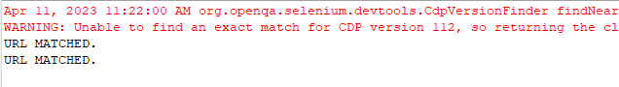

***Task5.2***

**package** com.test.Testing;

**import** java.util.List;

**import** org.openqa.selenium.By;

**import** org.openqa.selenium.WebDriver;

**import** org.openqa.selenium.WebElement;

**import** org.openqa.selenium.chrome.ChromeDriver;

**import** org.openqa.selenium.chrome.ChromeOptions;

**import** io.github.bonigarcia.wdm.WebDriverManager;

**public** **class** ClassExcercise5_2 {

**public** **static** **void** main(String[] args)**throws** InterruptedException {

ChromeOptions co=**new** ChromeOptions();

co.addArguments("--remote-allow-origins=*");

WebDriverManager.*chromedriver*().setup();

WebDriver d=**new** ChromeDriver(co);

d.get("https://j2store.net/free/");

d.manage().window().maximize();

WebElement el6= d.findElement(By.*linkText*("Clothing (5)"));

el6.click();

List<WebElement> li=d.findElements(By.*xpath*("//h2[@itemprop=\"name\"]"));

**for**(WebElement link:li)

{

System.***out***.println(link.getText());

}

}

}

