**Day7:**

***TASK1***:

**package** com.test.Day7;

**import** org.openqa.selenium.WebDriver;

**import** org.openqa.selenium.chrome.ChromeDriver;

**import** org.openqa.selenium.chrome.ChromeOptions;

**import** org.testng.annotations.Test;

**import** io.github.bonigarcia.wdm.WebDriverManager;

**import** junit.framework.Assert;

**public** **class** ClassExcercise1 {

@Test

**public** **void** TitleCheck() {

ChromeOptions co=**new** ChromeOptions();

co.addArguments ("--remote-allow-origins=*");

WebDriverManager.*chromedriver*().setup ();

WebDriver driver=**new** ChromeDriver(co);

driver.get ("https://demo.wpeverest.com/user-registration/guest-registration-form/");

driver.manage().window().maximize() ;

String etit=driver.getTitle();

String atit="Guest Registration Form – User Registration";

Assert.*assertEquals*(etit,atit);

System.***out***.println("Verified");

}

}

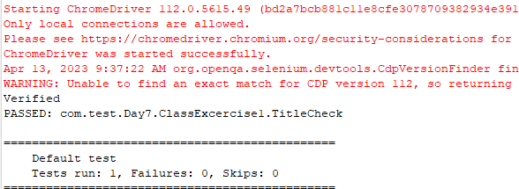

***Task2:***

**package** com.test.Day7;

**import** org.testng.annotations.Test;

**public** **class** Calculator {

Integer num1=16;

Integer num2=4;

@Test

**public** **void** addtion() {

Integer add=num1+num2;

System.***out***.println(add);

}

@Test

**public** **void** subraction() {

Integer sub=num1-num2;

System.***out***.println(sub);

}

@Test

**public** **void** multiplication() {

Integer mul=num1*num2;

System.***out***.println(mul);

}

@Test

**public** **void** division() {

Integer div=num1/num2;

System.***out***.println(div);

}

}

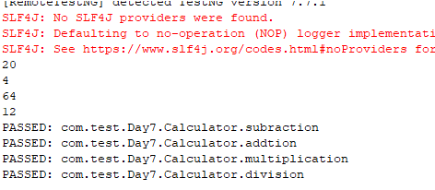

***Task3:***

**package** com.test.Day7;

**import** org.testng.annotations.Test;

**import** io.github.bonigarcia.wdm.WebDriverManager;

**import** junit.framework.Assert;

**import** org.testng.annotations.BeforeMethod;

**import** org.openqa.selenium.By;

**import** org.openqa.selenium.WebDriver;

**import** org.openqa.selenium.WebElement;

**import** org.openqa.selenium.chrome.ChromeDriver;

**import** org.openqa.selenium.chrome.ChromeOptions;

**import** org.testng.annotations.AfterMethod;

**public** **class** ClassExcercise3 {

WebDriver driver;

@Test

**public** **void** Login() **throws** InterruptedException{

Thread.*sleep*(5000);

driver.findElement(By.*xpath*("//*[@id=\"app\"]/div[1]/div/div[1]/div/div[2]/div[2]/form/div[1]/div/div[2]/input")).click();

driver.findElement(By.*xpath*("//*[@id=\"app\"]/div[1]/div/div[1]/div/div[2]/div[2]/form/div[1]/div/div[2]/input")).sendKeys("Admin");

Thread.*sleep*(5000);

driver.findElement(By.*xpath*("//*[@id=\"app\"]/div[1]/div/div[1]/div/div[2]/div[2]/form/div[2]/div/div[2]/input")).click();

Thread.*sleep*(5000);

driver.findElement(By.*xpath*("//*[@id=\"app\"]/div[1]/div/div[1]/div/div[2]/div[2]/form/div[2]/div/div[2]/input")).sendKeys("admin123");

Thread.*sleep*(5000);

driver.findElement(By.*xpath*("//*[@id=\"app\"]/div[1]/div/div[1]/div/div[2]/div[2]/form/div[3]/button")).click();

String etit=driver.getTitle();

String atit="OrangeHRM";

Assert.*assertEquals*(etit,atit);

System.***out***.println("Verified");

}

@BeforeMethod

**public** **void** beforeMethod() {

ChromeOptions co=**new** ChromeOptions();

co.addArguments ("--remote-allow-origins=*");

WebDriverManager.*chromedriver*().setup ();

driver=**new** ChromeDriver(co);

driver.get ("https://opensource-demo.orangehrmlive.com/web/index.php/auth/login");

driver.manage().window().maximize() ;

}

@AfterMethod

**public** **void** afterMethod() {

driver.close();

}

}

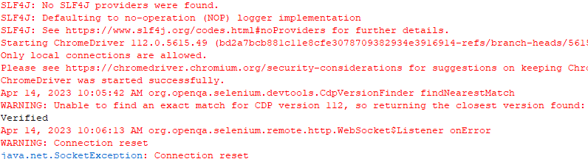

***Task4:***

**package** com.test.Day7;

**import** org.testng.annotations.Test;

**import** io.github.bonigarcia.wdm.WebDriverManager;

**import** junit.framework.Assert;

**import** org.testng.annotations.BeforeMethod;

**import** org.openqa.selenium.By;

**import** org.openqa.selenium.WebDriver;

**import** org.openqa.selenium.chrome.ChromeDriver;

**import** org.openqa.selenium.chrome.ChromeOptions;

**public** **class** ClassExcercise4 {

WebDriver driver;

@Test

**public** **void** Login() **throws** InterruptedException{

Thread.*sleep*(5000);

driver.findElement(By.*xpath*("//*[@id=\"app\"]/div[1]/div/div[1]/div/div[2]/div[2]/form/div[1]/div/div[2]/input")).click();

driver.findElement(By.*xpath*("//*[@id=\"app\"]/div[1]/div/div[1]/div/div[2]/div[2]/form/div[1]/div/div[2]/input")).sendKeys("Admin");

Thread.*sleep*(5000);

driver.findElement(By.*xpath*("//*[@id=\"app\"]/div[1]/div/div[1]/div/div[2]/div[2]/form/div[2]/div/div[2]/input")).click();

Thread.*sleep*(5000);

driver.findElement(By.*xpath*("//*[@id=\"app\"]/div[1]/div/div[1]/div/div[2]/div[2]/form/div[2]/div/div[2]/input")).sendKeys("admin123");

Thread.*sleep*(5000);

driver.findElement(By.*xpath*("//*[@id=\"app\"]/div[1]/div/div[1]/div/div[2]/div[2]/form/div[3]/button")).click();

String etit=driver.getTitle();

String atit="OrangeHRM";

Assert.*assertEquals*(etit,atit);

System.***out***.println("Verified");

driver.close();

}

@Test(dependsOnMethods={"Login"})

**public** **void** Logout() **throws** InterruptedException{

Thread.*sleep*(5000);

driver.manage().window().maximize() ;

Thread.*sleep*(5000);

String curru1=driver.getCurrentUrl();

String Eurl1="https://opensource-demo.orangehrmlive.com/web/index.php/auth/login";

Assert.*assertEquals*(Eurl1,curru1);

System.***out***.println("Verified LogedOut");

driver.close();

}

@BeforeMethod

**public** **void** beforeMethod()**throws** InterruptedException {

ChromeOptions co=**new** ChromeOptions();

co.addArguments ("--remote-allow-origins=*");

WebDriverManager.*chromedriver*().setup ();

driver=**new** ChromeDriver(co);

driver.get ("https://opensource-demo.orangehrmlive.com/web/index.php/auth/login");

driver.manage().window().maximize() ;

Thread.*sleep*(5000);

}

}

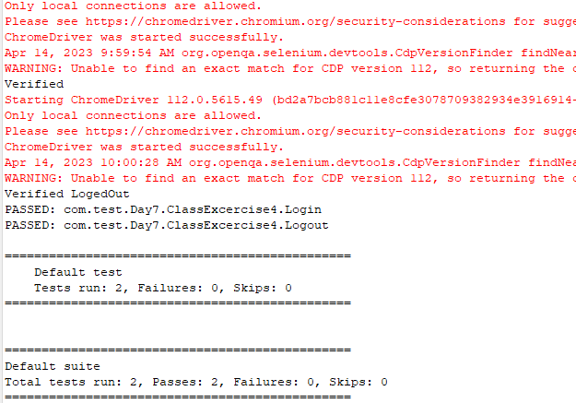

**Task5:**

import java.util.concurrent.TimeUnit;

import org.openqa.selenium.By;

import org.openqa.selenium.WebDriver;

import org.openqa.selenium.chrome.ChromeDriver;

import org.openqa.selenium.chrome.ChromeOptions;

import org.testng.Assert;

import org.testng.annotations.BeforeMethod;

import org.testng.annotations.Test;

import io.github.bonigarcia.wdm.WebDriverManager;

public class CE_7_5 {

WebDriver driver;

@Test

public void tc1() throws InterruptedException {

ChromeOptions co=new ChromeOptions();

co.addArguments("--remote-allow-origins=*");

WebDriverManager.chromedriver().setup();

driver=new ChromeDriver(co);

driver.get("https://www.godaddy.com/");

driver.manage().window().maximize();

Thread.sleep(3000);

String expectedTitle="Domain Names, Websites, Hosting & Online Marketing Tools - GoDaddy IN";

String actualTitle=driver.getTitle();

System.out.println(actualTitle);

Assert.assertEquals(expectedTitle,actualTitle);

String CurrentUrl=driver.getCurrentUrl();

String ExpectedUrl="https://www.godaddy.com/en-in";

Assert.assertEquals(CurrentUrl, ExpectedUrl);

}

@Test

public void tc2() throws InterruptedException{

ChromeOptions co=new ChromeOptions();

co.addArguments("--remote-allow-origins=*");

WebDriverManager.chromedriver().setup();

driver=new ChromeDriver(co);

driver.get("https://www.godaddy.com/");

driver.manage().window().maximize();

driver.manage().timeouts().implicitlyWait(10,TimeUnit.SECONDS);

driver.findElement(By.xpath("//*[@id=\"id-631b049a-e9c0-4d24-8710-c504745206dd\"]/div[2]/div[1]/ul/li[1]/button")).click();

driver.findElement(By.xpath("//*[@id=\"id-631b049a-e9c0-4d24-8710-c504745206dd\"]/div[2]/div[1]/ul/li[1]/div/div[2]/div[1]/ul/li[2]/a")).click();

}

@Test

public void testCase1() {

String expectedTitle="Domain Names, Websites, Hosting & Online Marketing Tools - GoDaddy IN";

String actualTitle=driver.getTitle();

System.out.println(actualTitle);

Assert.assertEquals(expectedTitle,actualTitle);

String CurrentUrl=driver.getCurrentUrl();

String ExpectedUrl="https://www.godaddy.com/en-in";

Assert.assertEquals(CurrentUrl, ExpectedUrl);

}

@Test

public void testCase2() {

driver.manage().timeouts().implicitlyWait(10,TimeUnit.SECONDS);

driver.findElement(By.xpath("/html/body/header/div/section/div/div[1]/nav/div[2]/div[1]/ul/li[1]/button")).click();

driver.findElement(By.xpath("/html/body/header/div/section/div/div[1]/nav/div[2]/div[1]/ul/li[1]/div/div[2]/div[1]/ul/li[2]/a")).click();

}

@BeforeMethod

public void beforeMethod() throws InterruptedException {

WebDriverManager.chromedriver().setup();

ChromeOptions co=new ChromeOptions();

co.addArguments("--remote-allow-origins=*");

driver=new ChromeDriver(co);

driver.get("https://www.godaddy.com/");

driver.manage().window().maximize();

Thread.sleep(3000);

}

}

