**Day9**

**Task1:**

**package** com.test.Day9;

**import** org.testng.annotations.DataProvider;

**import** org.testng.annotations.Test;

**import** junit.framework.Assert;

**public** **class** ClassExcercise1 {

@Test(dataProvider = "dp")

**public** **void** add(Integer a, Integer b) {

**int** act=a+b;

**int** exp=9;

Assert.*assertEquals*(act, exp);

System.***out***.println("Added");

}

@Test(dataProvider = "dp")

**public** **void** sub(Integer a, Integer b) {

**int** act1=a-b;

**int** exp1=5;

Assert.*assertEquals*(act1, exp1);

System.***out***.println("Subtracted");

}

@Test(dataProvider = "dp")

**public** **void** mult(Integer a, Integer b) {

**int** act2=a*b;

**int** exp2=14;

Assert.*assertEquals*(act2, exp2);

System.***out***.println("Multiplied");

}

@Test(dataProvider = "dp")

**public** **void** div(Integer a, Integer b) {

**int** act3=a/b;

**int** exp3=3;

Assert.*assertEquals*(act3, exp3);

System.***out***.println("Divided");

}

@DataProvider

**public** Object[][] dp() {

**return** **new** Object[][] {

**new** Object[] { 7,2 },

};

}

}

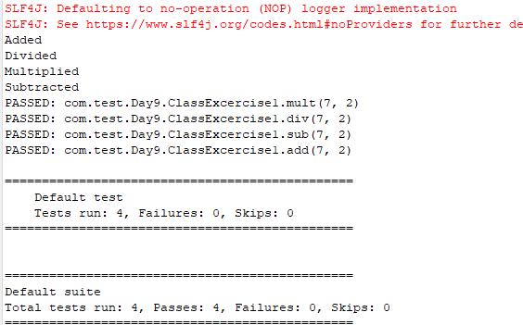

**Task2:**

**package** com.test.Day9;

**import** org.testng.annotations.Test;

**import** io.github.bonigarcia.wdm.WebDriverManager;

**import** org.testng.annotations.BeforeMethod;

**import** java.util.concurrent.TimeUnit;

**import** org.openqa.selenium.By;

**import** org.openqa.selenium.WebDriver;

**import** org.openqa.selenium.chrome.ChromeDriver;

**import** org.openqa.selenium.chrome.ChromeOptions;

**import** org.testng.Assert;

**import** org.testng.annotations.AfterMethod;

**public** **class** ClassExcercise2 {

WebDriver driver;

@Test

**public** **void** check() **throws** InterruptedException {

Thread.*sleep*(5000);

String url = driver.getCurrentUrl();

String title = driver.getTitle();

String expectedUrl = "https://www.godaddy.com/en-in";

String expectedTitle = "Domain Names, Websites, Hosting & Online Marketing Tools - GoDaddy IN";

Assert.*assertEquals*(url,expectedUrl);

Assert.*assertEquals*(title,expectedTitle);

}

@BeforeMethod

**public** **void** BeforeMethod() {

ChromeOptions co = **new** ChromeOptions();

co.addArguments("--remote-allow-origins=*");

WebDriverManager.*chromedriver*().setup();

driver = **new** ChromeDriver(co);

driver.get("https://godaddy.com/en-in");

driver.manage().window().maximize();

}

@AfterMethod

**public** **void** AfterMethod() {

driver.close();

}

@Test

**public** **void** f2() **throws** InterruptedException{

ChromeOptions co=**new** ChromeOptions();

co.addArguments("--remote-allow-origins=*");

WebDriverManager.*chromedriver*().setup();

driver=**new** ChromeDriver(co);

driver.get("https://www.godaddy.com/");

driver.manage().window().maximize();

driver.manage().timeouts().~~implicitlyWait~~(10,TimeUnit.***SECONDS***);

driver.findElement(By.*xpath*("//*[@id=\"id-631b049a-e9c0-4d24-8710-c504745206dd\"]/div[2]/div[1]/ul/li[1]/button")).click();

driver.findElement(By.*xpath*("//*[@id=\"id-631b049a-e9c0-4d24-8710-c504745206dd\"]/div[2]/div[1]/ul/li[1]/div/div[2]/div[1]/ul/li[2]/a")).click();

}

@Test

**public** **void** f3() **throws** InterruptedException{

ChromeOptions co=**new** ChromeOptions();

co.addArguments("--remote-allow-origins=*");

WebDriverManager.*chromedriver*().setup();

driver=**new** ChromeDriver(co);

driver.get("https://www.godaddy.com/");

driver.manage().window().maximize();

Thread.*sleep*(5000);

String url = driver.getCurrentUrl();

String expectedUrl = "https://www.godaddy.com/en-in";

Assert.*assertEquals*(url,expectedUrl);

}

}

