FirstKnitR
Charlie
2/1/2022
Newlines in RStudio are done by adding two spaces to the end of a line.
Things you can do in RMD:
Bold
Italics
Bold/Italics
Headers must have a blank line before in order to work.

Header 1

Header 2

Header 3
You can go up to Header 6… I think you see the pattern!
A hyperlink https://unsplash.com/s/photos/llama
More RMD features using the
RMD Cheat Sheat

Embedded R code
You can embed R code and output in this document using 26, 32, 29, 17, 18, 28, 35, 34, 40, 27 everything between the apostrophes is treated as script. So, you can also output the average temp 50.6584699. You can use anything from your script!

Including Plots
You can also embed plots, for example:
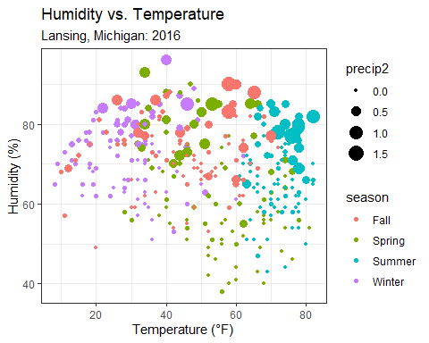
Note that the echo = FALSE parameter was added to the code chunk to prevent printing of the R code that generated the plot.

