**Question1  
What are the key security concerns when it comes to DevOps?**

* **Code Security:** Ensuring secure coding practices, code review, and static code analysis.
* **Configuration Management:** Managing configurations securely to prevent unauthorized changes.
* **Access Control:** Implementing strict access controls and role-based access control (RBAC).
* **Infrastructure as Code (IaC):** Ensuring IaC templates are secure and free from vulnerabilities.
* **CI/CD Pipeline Security:** Securing the build and deployment pipelines to prevent unauthorized access and tampering.
* **Monitoring and Logging:** Continuous monitoring and logging to detect and respond to security incidents.
* **Cultural Resistance and Too much focus on tools:** With the ever increasing tools and technologies that DevOps engineers employ to make their works easier, security in devops is a shared responsibility. Convincing teams to join in and makes implementing security in DevOps practices easier.
* **Legacy environments:** Inasmuch as DevOps is a relatively new concept, most tools are not compatible with legacy environments which hosts most services. This presents the dilemma of incompatibility with these systems and might take some time to find a compatible solution to these systems.  
  **Cloud security:** As Cloud computing becomes the defacto the the day, the security risk with deploying to cloud environments increases with the ever changing cybersecurity landscape and the proliferation of AI. This poses the challenge to ensure proper security measures are put in place to mitigate the risks of accidentally exposing sensitive data in cloud environments.  
  **New and Complex security implementations for Containers and k8s environment:** Change is the only constant in this ever changing technology industry. With the introduction of new tools and technologies on the daily, the need arises for proper security implementation in utilizing these tools for critical production environments. Most of these tools come with their custom security configurations and setup which requires expertise and learning before efficient automation can be implemented using DevOps.

**Question2**

**How do you design a self-healing distributed service?**

* **Health Checks and Heartbeats:** Implement regular health checks to monitor the status of services.
* **Redundancy and Replication:** Use redundant components to ensure availability and avoid single points of failure. This can be implemented using loadbalancer,backup databases or microservices.
* **Implement Monitoring and Logging:** Utilize tools like prometheus,grafana or Elastic search to collect and visualize data about a systems health and performance. You can also use CloudWatch, CloudTrail or Logstash to capture and analyze logs and events from your systems.
* **Apply feedback and control loops:** You can use feedback and control loops to scale your system based on demand(autoscaling), to balance load across your services(loadbalancing), to switch to alternative resources(failover). This can be implemented by using technologies like kubernetes, AWS Auto Scaling,etc.
* **Loose coupling(Event Driven Architectures):** Design various components of your distributed service to be loosely coupled, eliminating dependencies and bottlenecks that comes with scaling. This can be implemented using message brokers, queues, consumer-producer pattern, publisher-subscriber etc.
* **Failure Detection:** Use automated failure detection mechanisms to identify and isolate faulty components with little no human intervention.
* **Leader election:** Utilize consensus algorithms(eg: raft and paxos) in your distributed architecture to ensure consistency and uniformity in executing tasks.
* **Throttling and Rate Limiting requests:** Implement throttling algorithms(Leaky bucket, Sliding window, fixed window, token bucket,etc) to streamline requests to the service and efficiently handle peak loads without breaking down your service
* **Chaos engineering:** Improve and learn from how your service recovers from failure by stress testing your service using tools like chaos monkey, gremlin, etc
* **Checkpoint long-running transactions**: Use checkpoints to provide resiliency if a long-running operation fails.
* **Follow best practices and standards:** Design modular, decoupled and loosely coupled components. Also enforce consistent naming conventions, documentation and code quality standards. Adhere to DevOps principles such as continuous integration,delivery,improvement and testing.

**Question 3**

**Describe a centralized logging solution and how can you implement logging for a microservice architecture?**

**Solution:** Using a centralized logging solution like the EFK Stack (Elasticsearch, FluentD, Kibana) or Fluentd with Grafana

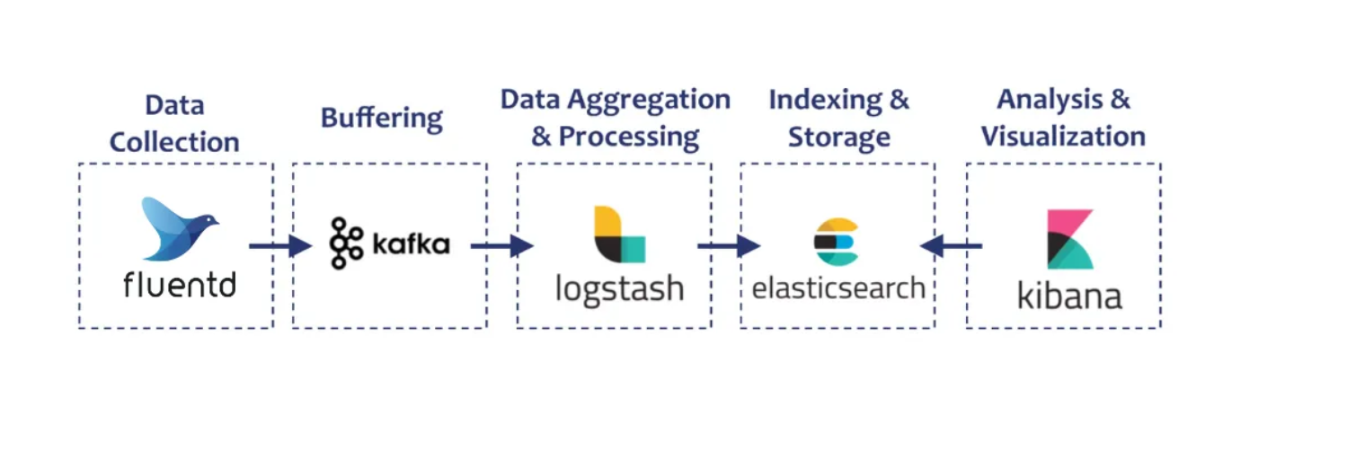

**Implementation:**

Intall log agents on associated systems and services(FluentD)

Standardize Log Formats(JSON, necessary logs)

Use correlation IDs and Distributed Tracing tools like OpenTelemetry to map the flow of requests through the system.

Centralize Log Collection by using a log aggregator(Logstash)

Implement Real-Time processing(Apache Kafka)  
Ensure scalability(Horizontal scaling and Load balancing)