# Genome 575 Problem Set 3

Here are two spectra each shown with 3 images to provide the best display of the entire mass range. For each spectrum provide the best peptide sequence and the protein sequence it was derived (the later can be done by Blastp). Show all of your work like we did in class today so that if you don’t get the full sequence, you can get at least partial credit. You should work on this assignment alone. You can use the slide, tables and the information sheet I provide in class or the ones up on the class website. You should not use any software or computers other than a calculator.

## Spectrum 1 was derived from a tryptic digest of *C. elegans*

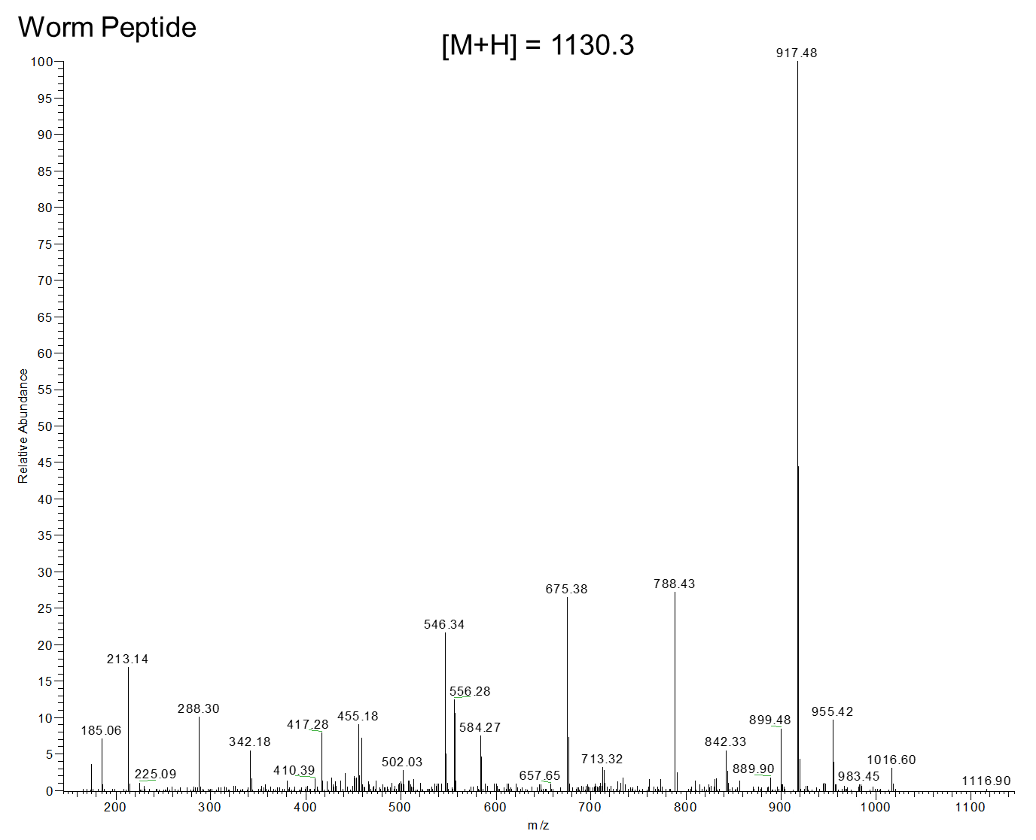

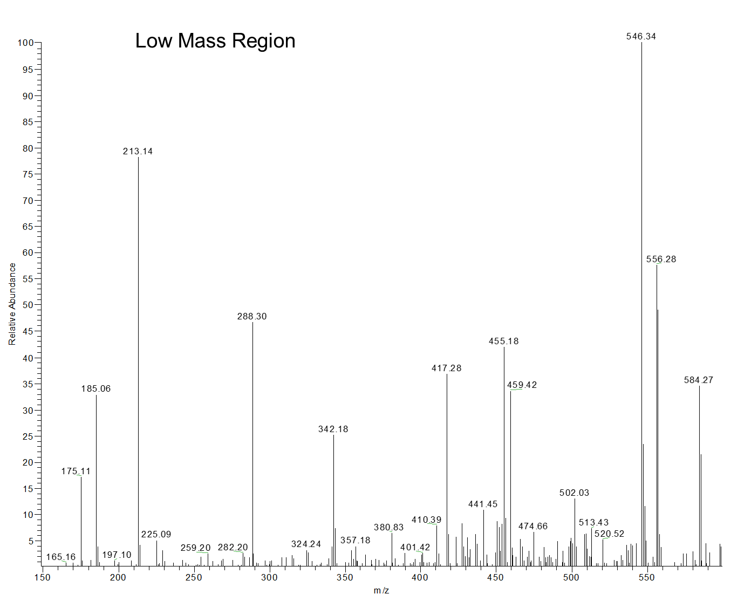

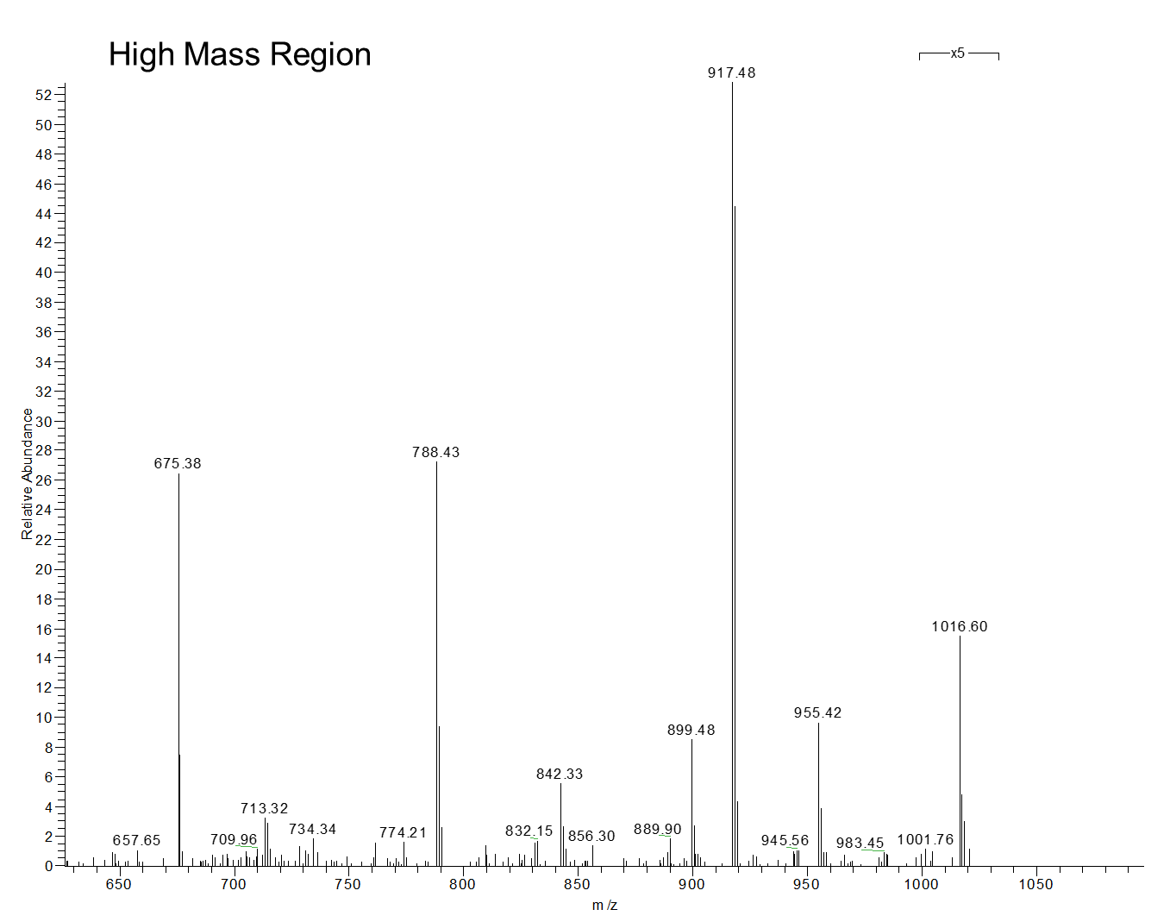

## Spectrum 2 was derived from a tryptic digest of *S. cerevisiae*

