**Gen 575 Spring 2024**

**Problem Set 4**

*Due by 11:59 pm June-6-2025 to beliveau [at] uw.edu*

**Name:**

**Problem 1 (10 points)**

* 1. **(5 points)** After Lecture 17, you found that you couldn’t stop thinking about point spread functions. You share this with your friend and mention that you learned about using fluorescent beads to QC an imaging system. Your friend, who works in astrophysics, is surprised that ***Shack-Hartmann*** ***sensors*** were not mentioned in class. Naturally, you race to the internet to look this sensor up. In your own words, describe below in a few sentences what the Shack-Hartmann sensor is designed to do and how it achieves this. A high-level description is sufficient:
  2. **(5 points)** Your research into Shack-Hartmann sensors leads to the concept of ***Adaptive Optics***, on which, predictably, you dive deep. In your own words, describe below in a few sentences what an adaptive optics system is designed to do and how it achieves this. A high-level description is sufficient:

**Problem 2 (15 points)** Your burgeoning interests in optics and instrumentation after taking 575 leads you to look up how FACS machines work in more detail. During your research, you find a nice schematic to add to your notes (shown below).

(*Source: https://upload.wikimedia.org/wikipedia/commons/thumb/3/3f/Cytometer.svg/2560px-Cytometer.svg.png*)

**2.1 (5 points)** Your first point of curiosity is the “Obscuration bar” and its relation to the “Forward Scatter Detector / FSC”. In your own words, describe below in a few sentences what the Obscuration bar and Forward Scatter Detector are and their function in a FACS machine. A high-level description is sufficient:

**2.2 (5 points)** Your next point of curiosity is the “Side Scatter Detector / SSC”. In your own words, describe below in a few sentences what the Side Scatter Detector is and how it relates to the Forward Scatter Detector in the function of a FACS machine. A high-level description is sufficient:

**2.3 (5 points)** You remember a senior graduate student telling you that “green” (ie, 488 nm excitation / 520 nm emission) detection was more sensitive than “far red” (ie, 647 nm excitation / 670 nm emission) detection. Using your knowledge of optics/instruments and the diagram above, describe two factors that could help explain this observation:

**Problem 3 (25 points)** Your PI is sick of paying the “Illumina Illuminati” thousands upon thousands of dollars for sequencing and requests that you use your knowledge of optics and instrumentation to build a DIY next generation sequencer. Some googling leads you to a famous DIY sequencing platform from the early days of NGS, the “Polonator” (see image below). You get excited and decide to construct a “Polonator 2.0” using modern optics and old hacked MiSeq kits (dye info also shown below). You know that next generation sequencers are essentially automated, high-content microscopes that image flow cells. For your first proof-of-concept work, you decide to buy the biggest glass “slide” that your existing microscope can fit—a 96/384 well plate. With some trickery, you are able to take a glass-bottom 96-well plate and remove the plastic well inserts, leaving you with a bare 127.71 mm x 85.43 mm glass plate to perform sequencing reactions on top of. Your initial goal is to to estimate how many “reads” (ie, optically resolvable clusters to sequence) your proposed system can support.

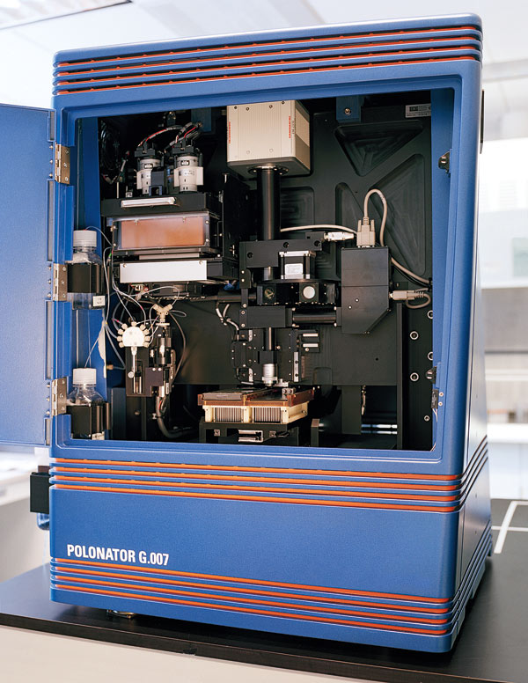

|  |  |  |
| --- | --- | --- |
| **Label** | **Absorbance Max (nm)** | **Emission Max (nm)** |
| Dye A | 530 | 550 |
| Dye B | 580 | 600 |
| Dye C | 650 | 670 |
| Dye D | 700 | 720 |

(*Sources*: *https://wp.technologyreview.com/wp-content/uploads/2008/06/0708-pol_x600-8.jpg, https://dspace.mit.edu/bitstream/handle/1721.1/113770/1022284037-MIT.pdf?sequence=1, https://www.science.org/doi/epdf/10.1126/science.1117389*)

**3.1 (10 points)** Assume you will be acquiring images of the dyes in the table above using a 40x N.A. 0.95 air objective, that the entire surface of the plate will available for imaging, and that spots must be at minimum separated by the Rayleigh Criterion distance to be resolvable. As a reminder, the diameter of an airy disc *D*, as defined by the Rayleigh Criterion is *D* = 1.22 * 𝝀 / N.A. Given these constraints, what is the maximum number of reads/clusters your system can support? Show your work:

**3.2 (10 points)** Assume you have a “Orca-Flash 4.0” camera with 2048 x 2048 6.5 µm pixels and that it will take 5 seconds in total to image your four channels in one field of view. Using the 40x objective and a 1x relay lens, how long would the imaging take to generate 150 bp “reads” (ie, to image the whole slide 150 times). <http://www.iscopecalc.com/> may be helpful. Show your work:

**3.3 (5 points** How would the answers to 3.1 and 3.2 change if you switched to a 10x N.A. 0.45 air objective? Show your work: