LAB PRACTICUM: OpenMP Multi-Core Scaling in Python
Hands-Off Benchmark Practicum • 60 Minutes • Autonomous Execution

Student Name: | Praliyeva Nuray | Student ID: | 230103057
Hardware / CPU: |  | Date & Section: | 01.10.26  06-P

📌 LAB PROTOCOL & AUTONOMOUS RULES OF ENGAGEMENT
- Autonomous Session: You are expected to read, run, optimize, and document all findings independently.
- Zero Support for Dependency Issues: If you encounter an error, verify that you installed packages inside a clean virtual environment. Compilers are NOT needed for this lab.
- Equal Hardware Standard: Keep your laptop plugged into wall power and close background browsers, video streams, or games to prevent CPU thermal throttling and frequency capping.
- Whiteboard Leaderboard: When you finish Task 1 and Task 3, record your CPU model and best speedup factor on the lab whiteboard.

Background & Environment Setup (10 Minutes)
Standard CPython executes bytecode under the Global Interpreter Lock (GIL), preventing multiple CPU threads from executing simultaneously in Python space. In this lab, we bypass the GIL using Numba's JIT compiler with its native multithreaded OpenMP/TBB work-stealing engine. Because Numba compiles numeric Python loops directly to machine code and releases the GIL inside parallel loops (prange), we achieve bare-metal native CPU scaling across both macOS (Apple Silicon M-series) and Windows/Linux x86_64 machines with zero local C++ compiler dependencies.

Execute the following in your terminal / command prompt:
pip install numpy numba matplotlib

Challenge 1: The Core Speedometer & Amdahl's Law
Objective: Benchmark an embarrassingly parallel Monte Carlo simulation to approximate π across varying thread counts. You will measure execution latency, quantify parallel speedup, and observe where Amdahl's Law caps performance.
import time
import numpy as np import numba
from numba import njit, prange
print(f"Hardware Threads Detected: {numba.config.NUMBA_NUM_THREADS}") @njit(parallel=True)
def monte_carlo_pi(n_samples): inside_circle = 0
for i in prange(n_samples):
x = np.random.uniform(0.0, 1.0) y = np.random.uniform(0.0, 1.0) if x * x + y * y <= 1.0:
inside_circle += 1
return (4.0 * inside_circle) / n_samples

# JIT Warmup (excludes JIT compilation overhead from benchmarks)
_ = monte_carlo_pi(10_000)

SAMPLES = 120_000_000
thread_counts = [1, 2, 4, 8, numba.config.NUMBA_NUM_THREADS] # Filter out duplicates and invalid counts
thread_counts = sorted(list(set([t for t in thread_counts if t <= numba.config.NUMBA_NUM_THREADS])))

print(f"{'Threads':<10} | {'Time (s)':<12} | {'Speedup':<10} | {'Efficiency (%)':<15}")
print("-" * 55)

t1_baseline = None
for t in thread_counts: numba.set_num_threads(t) start = time.perf_counter()
pi_est = monte_carlo_pi(SAMPLES) elapsed = time.perf_counter() - start

if t == 1:
t1_baseline = elapsed speedup = 1.0
efficiency = 100.0 else:

speedup = t1_baseline / elapsed efficiency = (speedup / t) * 100.0

print(f"{t:<10} | {elapsed:<12.4f} | {speedup:<10.2f}x |
{efficiency:<15.1f}")

Deliverables & Technical Questions for Challenge 1:
  - A. Record your baseline T_1 (1 thread) and your maximum multi-thread runtime T_max in Table 1 below.
  - B. Why is the warm-up call _ = monte_carlo_pi(10_000) strictly required before recording benchmark timings?
The warm-up call compiles the Numba function using JIT (Just-In-Time) compilation before the benchmark starts. Without the warm-up, the first measured execution would include compilation time, making the runtime artificially high and the speedup inaccurate.

  - C. Did your parallel efficiency stay at 100% when scaling from 1 to max threads? What architectural factors (e.g. memory bus contention, hyperthreading/SMT core vs physical core limits) explain the degradation?
No. Efficiency decreased from 100.0% with 1 thread to 54.2% with 8 threads. This happens because CPU resources are shared as more threads are added. Factors such as memory bandwidth contention, cache contention, thread-management overhead, and the difference between physical CPU cores and logical SMT/hyperthreads can limit scaling.

  - D. Why does inside_circle += 1 inside prange not corrupt the count? What implicit OpenMP reduction construct does Numba generate here?
Numba recognizes the variable as a reduction variable inside prange. It creates a separate private counter for each thread and combines the partial counters at the end. This is equivalent to an OpenMP reduction(+:inside_circle) operation.

threads | Time (S) | speedup | Efficiency | Pi
1 | 5.5524 | 1.00 x | 100 | 3.1416271000
2 | 2.8994 | 1.92x | 95.8 | 3.1414420333
4 | 1.8902 | 2.94x | 73.4 | 3.1418433000
8 | 1.2809 | 4.33x | 54.2 | 3.1416197000

Challenge 2: Load Imbalance & Dynamic Scheduling
Objective: Compute a high-resolution 2500×2500 Mandelbrot fractal. Unlike Monte Carlo, points in the complex plane require radically different amounts of compute: points inside the set iterate all the way to max_iter , while outer points escape in 2-3 iterations. You will investigate how non-uniform workloads impact thread utilization.
import time
import numpy as np
import matplotlib.pyplot as plt from numba import njit, prange

@njit(parallel=True)
def render_mandelbrot_rows(h, w, max_iter): img = np.zeros((h, w), dtype=np.int32) # Row-parallel loop
for r in prange(h):
cy = -1.2 + (r / h) * 2.4 for c in range(w):
cx = -2.0 + (c / w) * 2.5 z_real, z_imag = 0.0, 0.0
it = 0
while (z_real * z_real + z_imag * z_imag <= 4.0) and (it <
max_iter):
next_real = z_real * z_real - z_imag * z_imag + cx z_imag = 2.0 * z_real * z_imag + cy
z_real = next_real it += 1
img[r, c] = it return img

@njit(parallel=True)
def render_mandelbrot_cols(h, w, max_iter): img = np.zeros((h, w), dtype=np.int32)
# Column-parallel loop (swapped iteration axis) for c in prange(w):
cx = -2.0 + (c / w) * 2.5 for r in range(h):
cy = -1.2 + (r / h) * 2.4 z_real, z_imag = 0.0, 0.0
it = 0
while (z_real * z_real + z_imag * z_imag <= 4.0) and (it <
max_iter):
next_real = z_real * z_real - z_imag * z_imag + cx z_imag = 2.0 * z_real * z_imag + cy
z_real = next_real it += 1

img[r, c] = it return img

# Warmup JIT
_ = render_mandelbrot_rows(100, 100, 50)
_ = render_mandelbrot_cols(100, 100, 50)

H, W, MAX_IT = 2500, 2500, 1000

t0 = time.perf_counter()
grid_rows = render_mandelbrot_rows(H, W, MAX_IT) t_rows = time.perf_counter() - t0

t1 = time.perf_counter()
grid_cols = render_mandelbrot_cols(H, W, MAX_IT) t_cols = time.perf_counter() - t1
print(f"Row-Parallel Render Time:
{t_rows:.3f} s")
print(f"Column-Parallel Render Time: {t_cols:.3f} s")

# Save visual artifact plt.figure(figsize=(8, 8))
plt.imshow(grid_rows, cmap='magma', extent=[-2.0, 0.5, -1.2, 1.2]) plt.title(f"Mandelbrot {H}x{W} (Render: {t_rows:.2f}s)") plt.axis('off')
plt.savefig('mandelbrot_output.png', dpi=300, bbox_inches='tight')
print("Saved image: mandelbrot_output.png")

Deliverables & Technical Questions for Challenge 2:
  - A. Compare t_rows vs t_cols . Which axis decomposition completed faster on your machine and why?
The row-parallel version completed faster. The row-parallel runtime was 4.882 s, while the column-parallel runtime was 5.040 s. The row version benefits from sequential memory access and better CPU cache utilization.

  - B. Explain how NumPy's C-contiguous (row-major) memory layout interacts with CPU cache lines when threads write to img[r, c] vs img[c, r] .
NumPy uses C-contiguous row-major memory layout. In the row-parallel version, img[r,c] accesses neighboring elements as c changes, allowing efficient cache-line utilization. In the column-parallel version, changing r accesses memory locations separated by an entire row, resulting in less efficient cache usage.

  - C. Load imbalance analysis: If thread 0 receives the top 20% of rows and thread 2 receives the center 20% of rows, why does one thread idle while the other struggles? How does OpenMP dynamic scheduling resolve this?
Mandelbrot calculations have load imbalance because different pixels require different numbers of iterations. A thread processing easy rows may finish early while another thread processing computationally expensive rows continues working. Dynamic scheduling distributes new chunks of rows to threads as they become available, reducing idle time and improving utilization.

  - D. Attach your exported mandelbrot_output.png file alongside your completed task sheet.

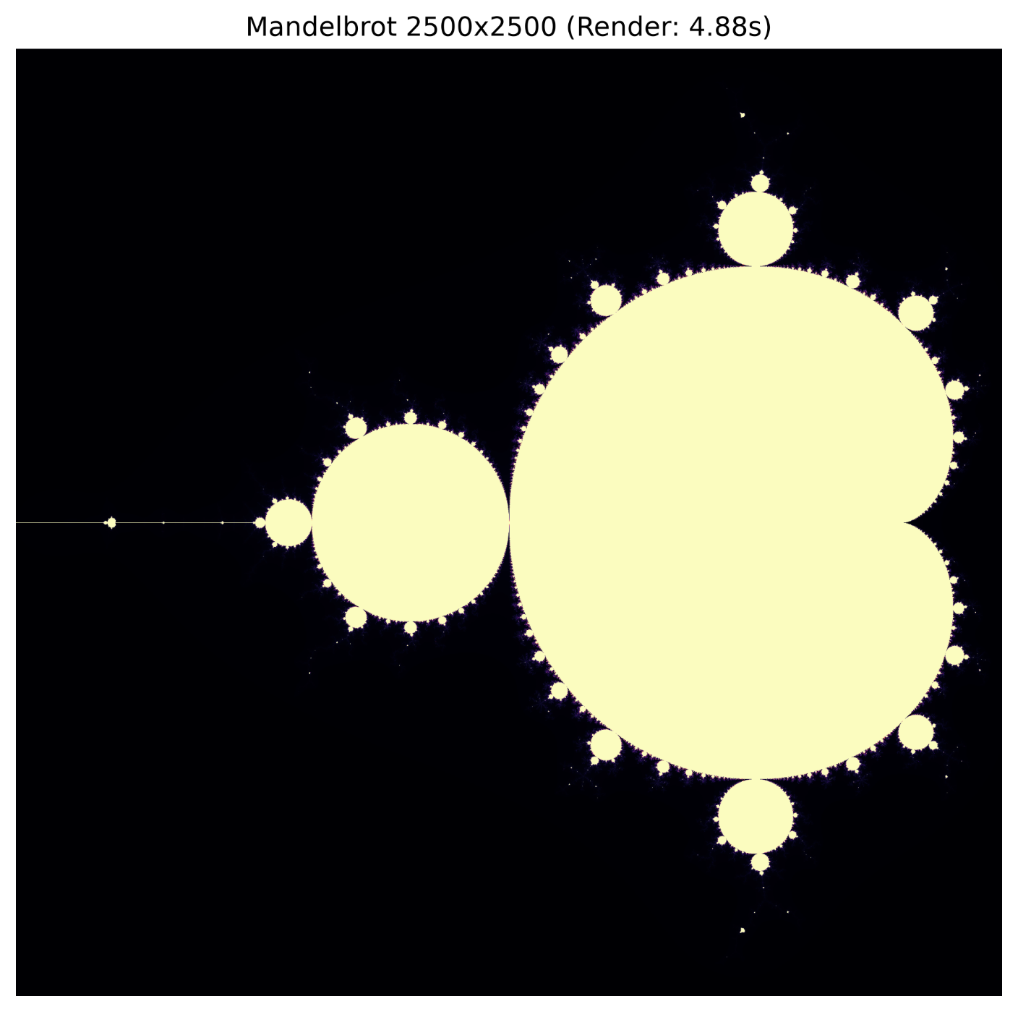

Challenge 3: Stencil Computation & Memory Bandwidth
Objective: Simulate 2D heat diffusion using a 5-point discrete Laplacian stencil over 300 timesteps on a 1500×1500 grid. Unlike the compute-bound fractal, stencil computations are strictly memory-bandwidth bound. You will determine whether adding CPU cores continues to speed up performance or hits the RAM memory bus wall.
import time
import numpy as np
from numba import njit, prange

@njit(parallel=True)
def heat_step(u, u_next, alpha=0.20): rows, cols = u.shape
for i in prange(1, rows - 1): for j in range(1, cols - 1):
u_next[i, j] = u[i, j] + alpha * (
u[i+1, j] + u[i-1, j] + u[i, j+1] + u[i, j-1] - 4.0 * u[i, j]
)

GRID_SIZE = 1500
STEPS = 300

u = np.zeros((GRID_SIZE, GRID_SIZE), dtype=np.float64) u_next = np.zeros_like(u)

# Dirichlet Boundary conditions: Top & Left walls maintained at 100°C u[0, :] = 100.0
u[:, 0] = 100.0
u_next[0, :] = 100.0 u_next[:, 0] = 100.0

# Warmup heat_step(u, u_next)

# Benchmark Execution
start = time.perf_counter() for step in range(STEPS):
heat_step(u, u_next)
# Pointer swap (avoids array allocation copies) u, u_next = u_next, u
elapsed = time.perf_counter() - start

cells_per_sec = (GRID_SIZE * GRID_SIZE * STEPS) / elapsed / 1e6 print(f"Heat Diffusion Complete: {elapsed:.3f} s") print(f"Throughput: {cells_per_sec:.2f} Megacells/sec")

Deliverables & Technical Questions for Challenge 3:
  - A. Record your benchmark runtime and Megacells/sec throughput in Table 1.
  - B. Change the array precision from np.float64 to np.float32 . Re-run the test. By what factor did runtime decrease? Why does halving memory footprint improve stencil throughput far more than compute capability?
  - C. Memory Roofline Model: Explain why adding twice as many CPU cores does not produce a 2x speedup on stencil codes once memory bandwidth is saturated.

Student Result Scorecard & Data Collection
Fill in your benchmark results into Table 1 below before submitting this document:

Benchmark Challenge | Active Threads | Array Size / Samples | Time (seconds) | Speedup Factor | Efficiency (%)
Challenge 1: Monte Carlo | 1 Thread (Base) | 120,000,000 |  | 1.00x | 100.0%
Challenge 1: Monte Carlo | 2 Threads | 120,000,000
Challenge 1: Monte Carlo | 4 Threads | 120,000,000
Challenge 1: Monte Carlo | Max Threads | 120,000,000
Challenge 2: Mandelbrot (Rows) | Max Threads | 2500 x 2500 |  | 4.882 | N/A
Challenge 2: Mandelbrot (Cols) | Max Threads | 2500 x 2500 |  | 5.040 | N/A
Challenge 3: Heat Stencil | Max Threads | 1500 x 1500 x  300 |  | N/A | N/A

