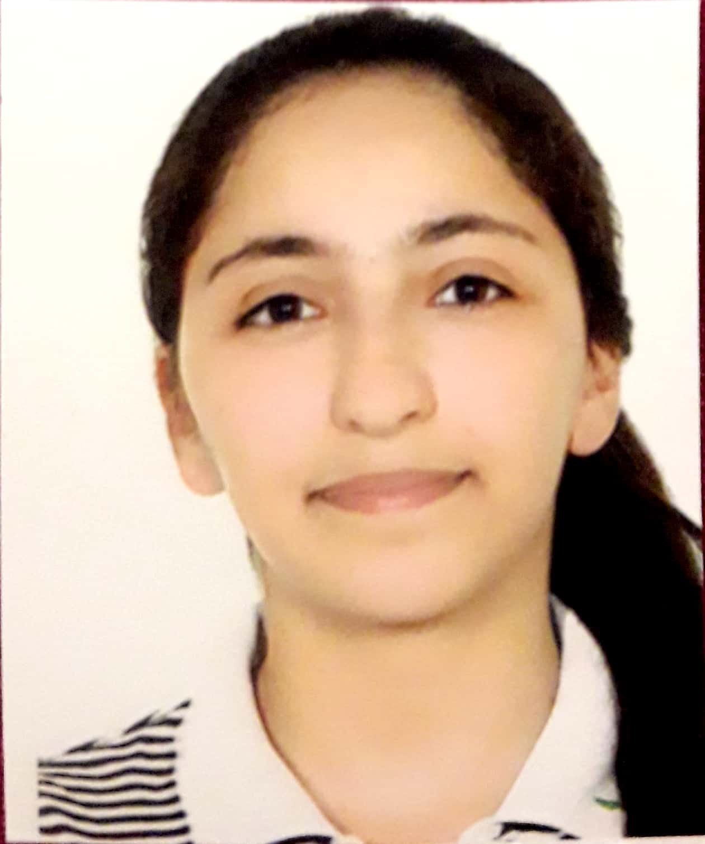

Belkis%98765/sananebe@stuff.com

# About me

I'm an engineering student at école centrale lyon

# Work Experience

**tex** *2020-2021*software engineer

# Skills

* python