# Installation of Ubuntu server into VM using Hyper-V

## Enabling Hyper-V on Windows

Follow instructions on this site to enable Hyper-V on Windows. Installation of Ubuntu server is also described on the site. For detailed manual follow this tutorial.

<https://wiki.ubuntu.com/Hyper-V>

## Ubuntu server image

Download Ubuntu server image from this link. You can choose also the newer version of Ubuntu server, if you want.

<https://releases.ubuntu.com/18.04.5/ubuntu-18.04.5-live-server-amd64.iso>

## Create Virtual Machine (VM) in Hyper-V Manager

### Crate virtual machine

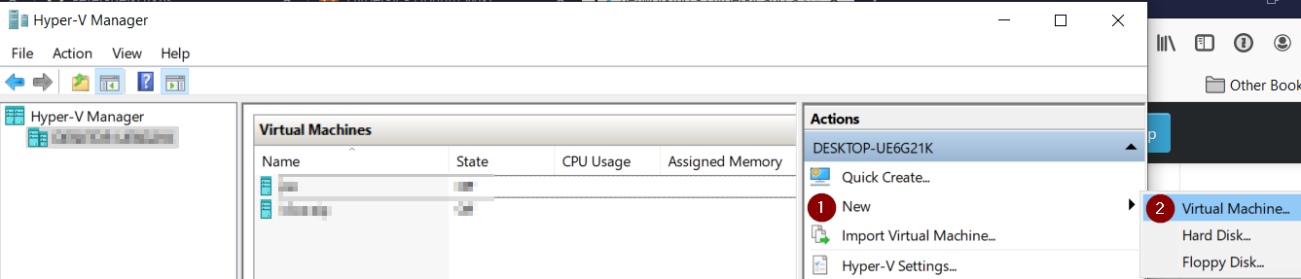

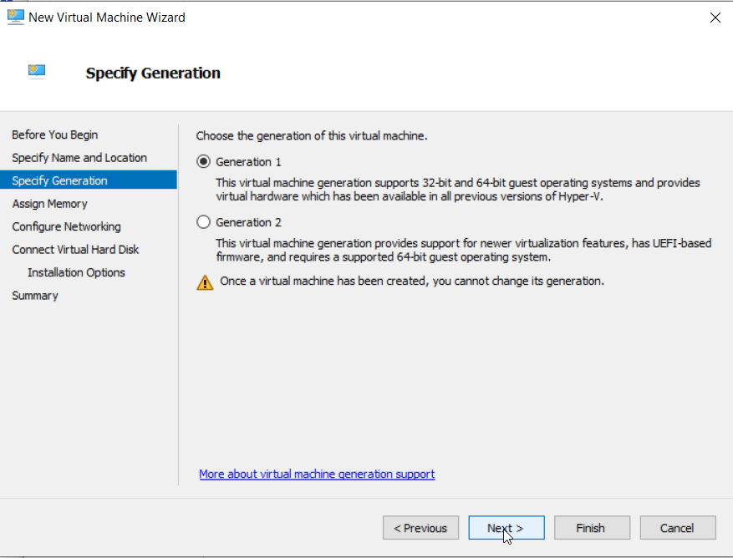

### Assign memory

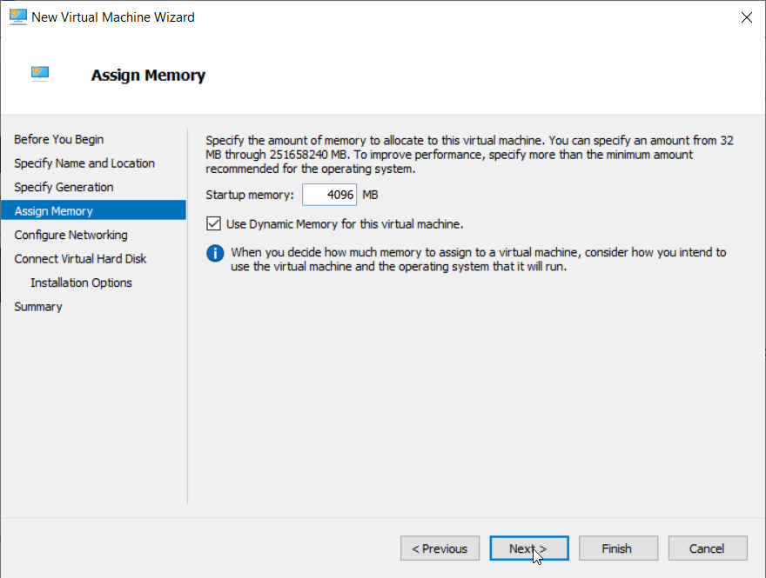

### Attach default network adapter

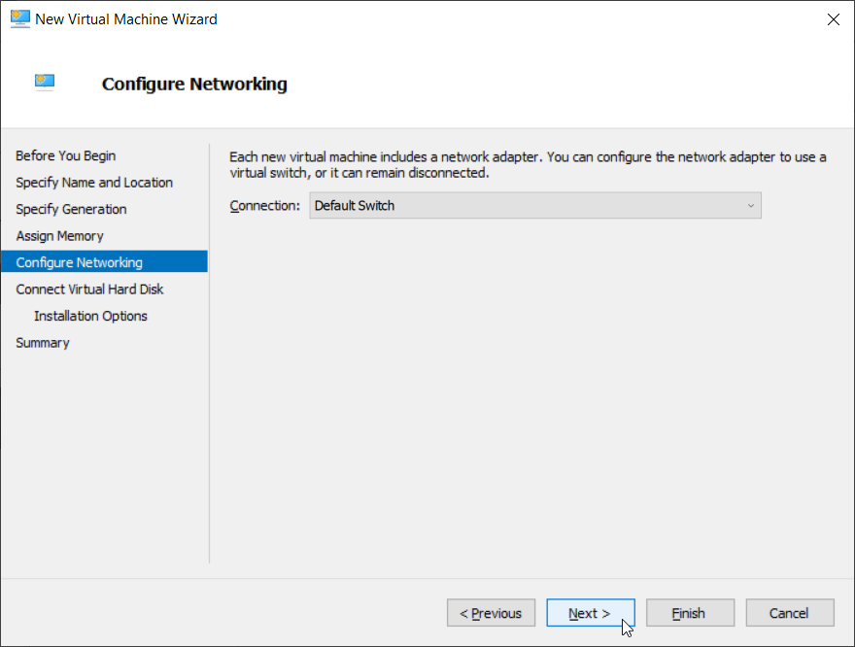

### Connect virtual hard disk

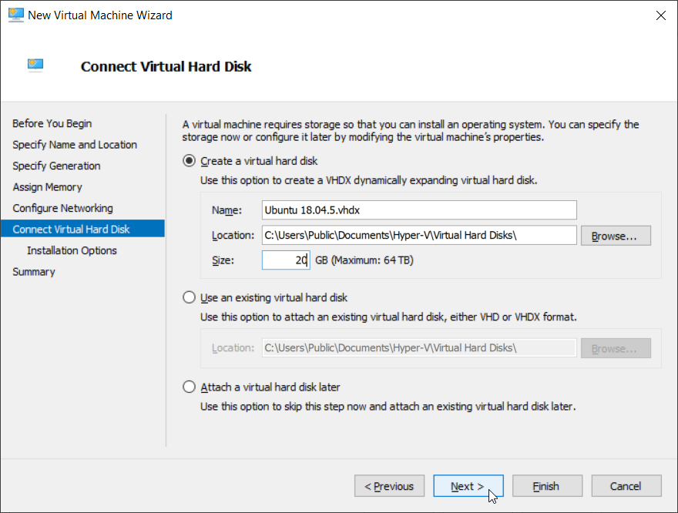

### Installation media

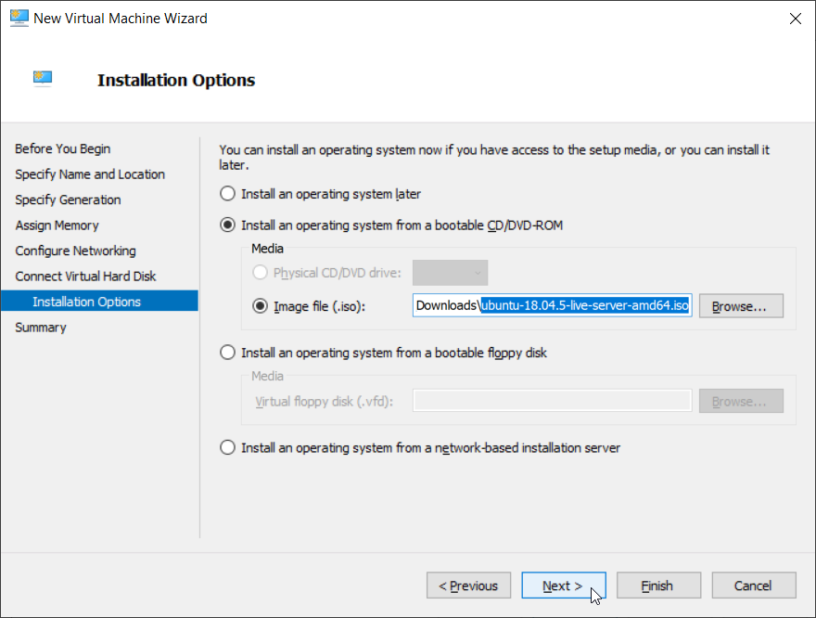

Use downloaded ISO image to install the server.

### Final overview

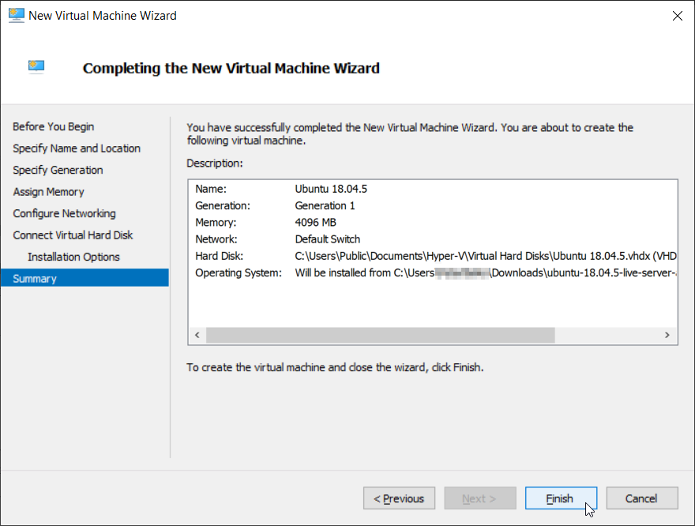

## Connect to the newly created VM

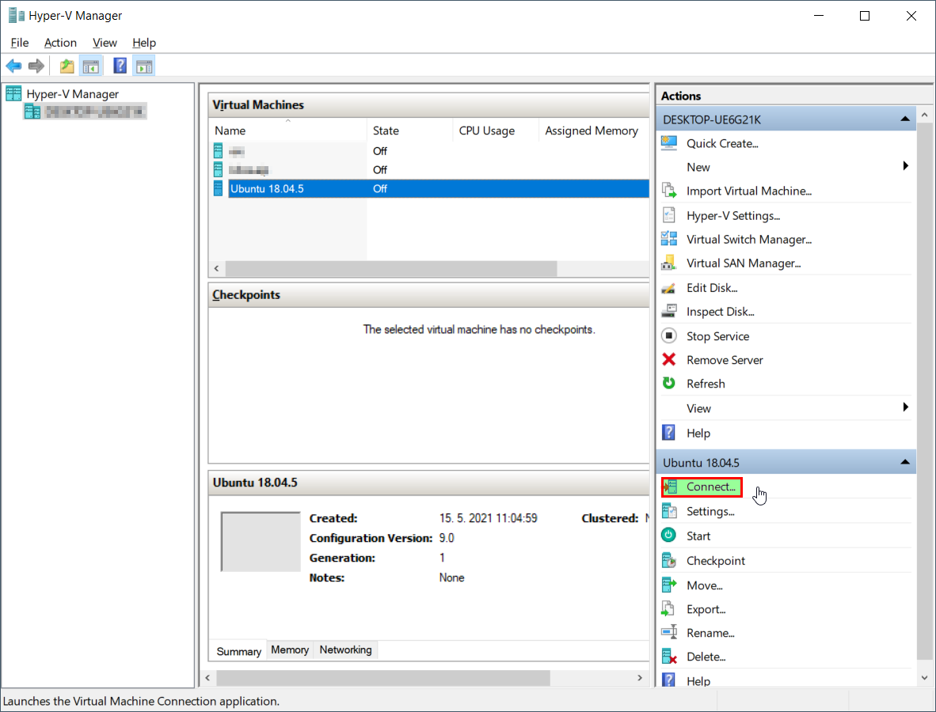

## Start the VM

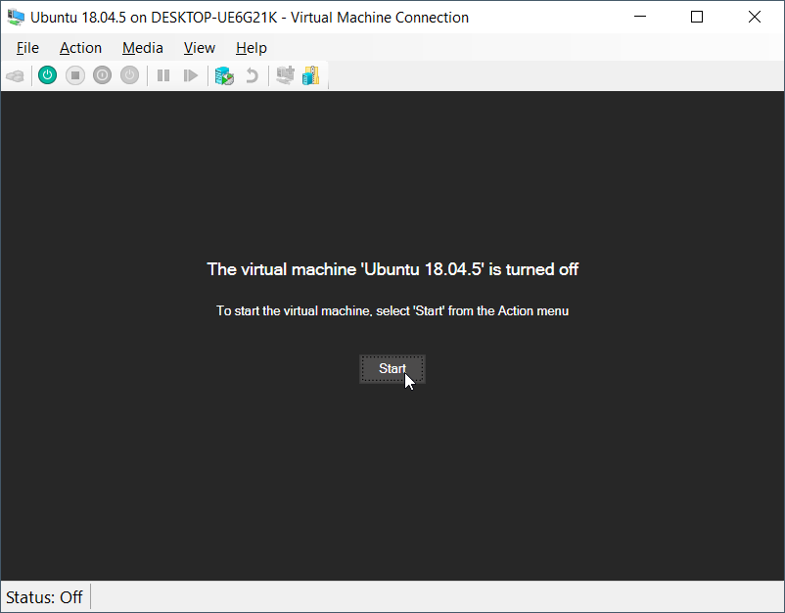

## Install the Ubuntu server

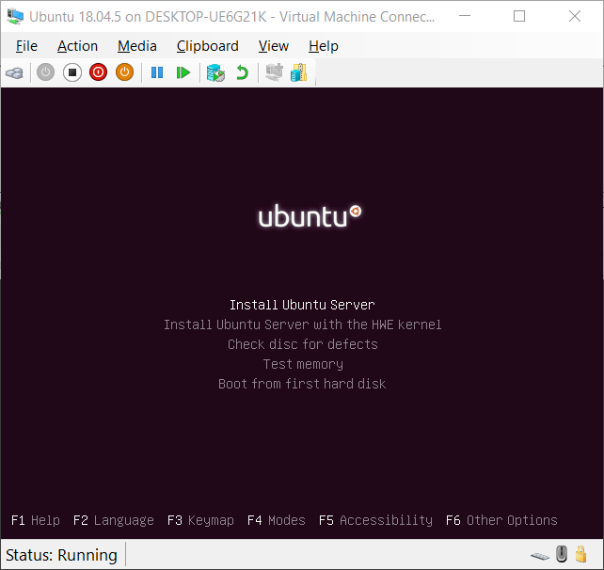

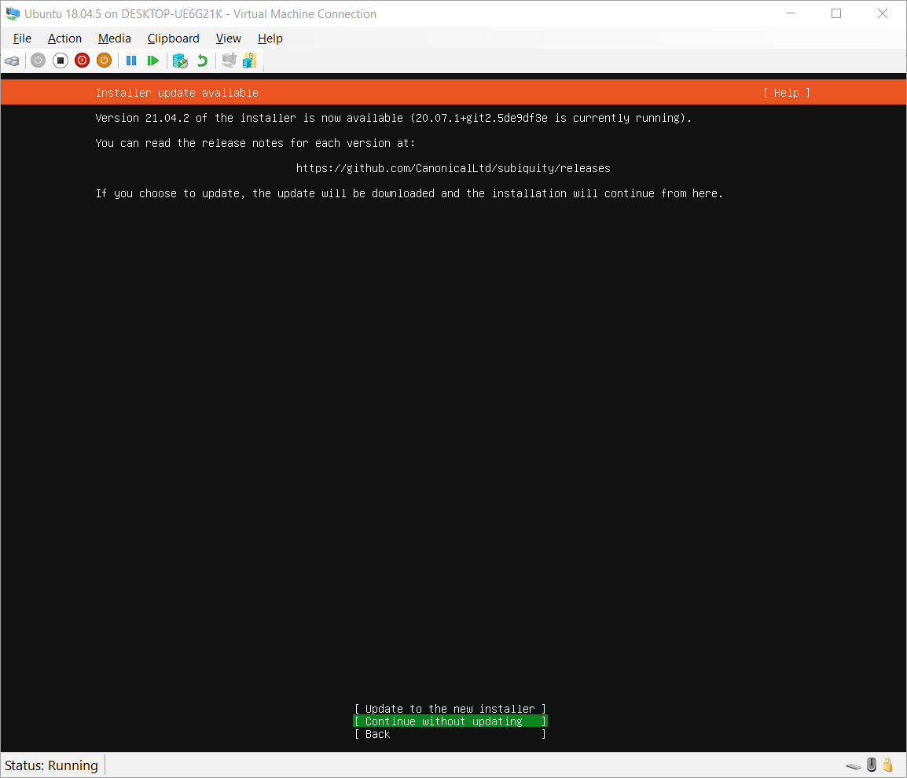

## Allow SSH connection to the VM

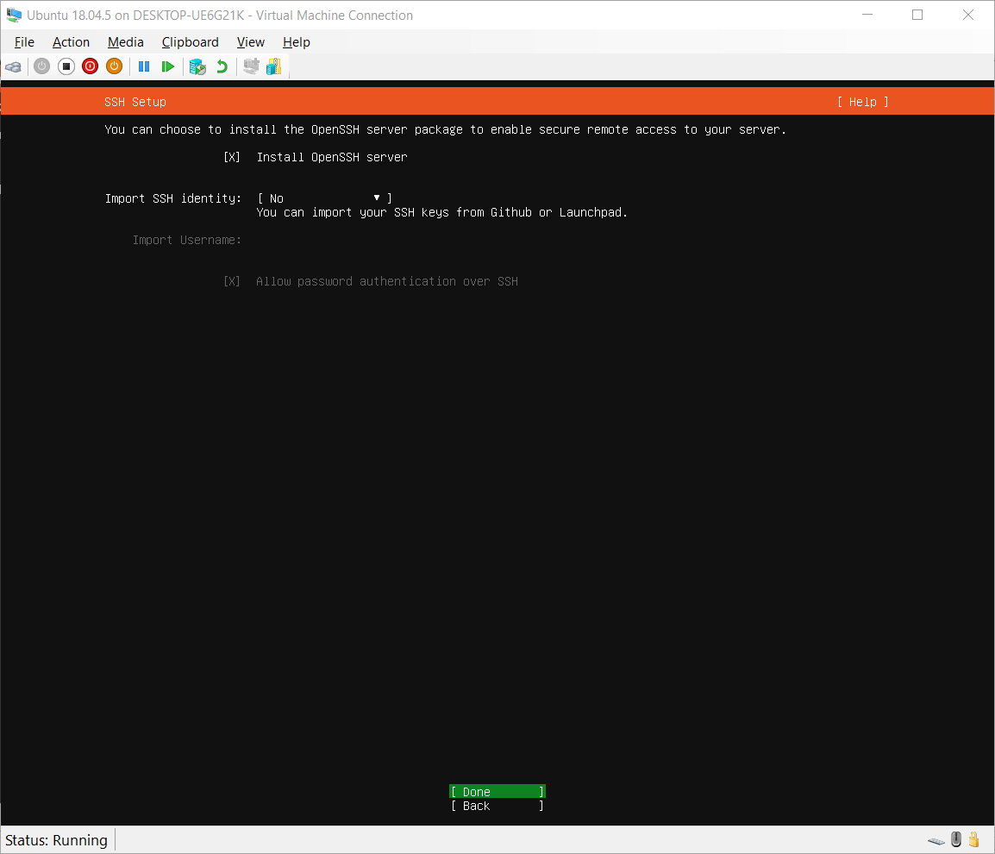

## Install microk8s

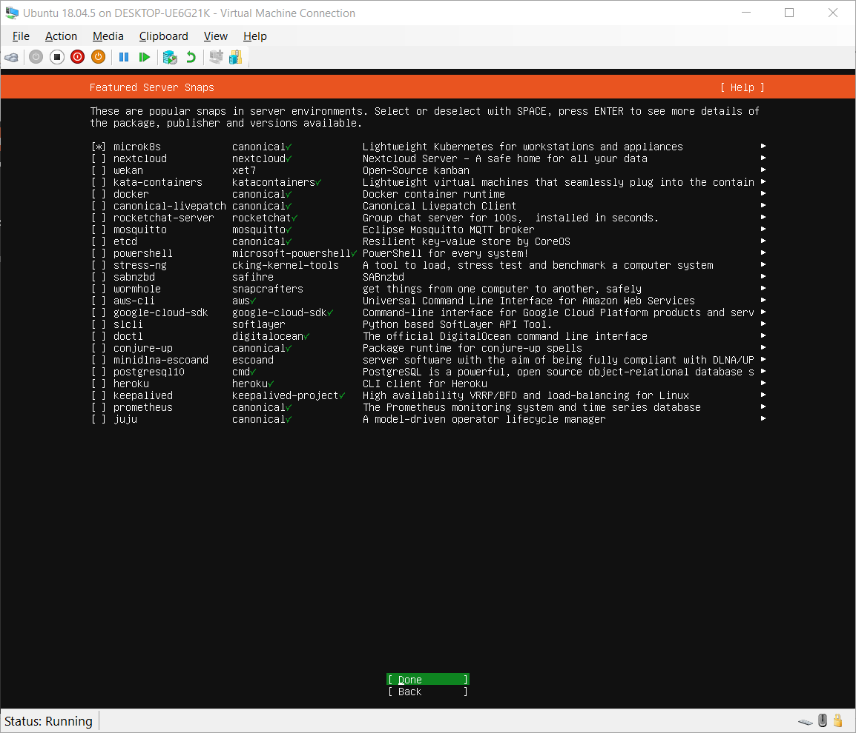

## Login using credentials entered during installation

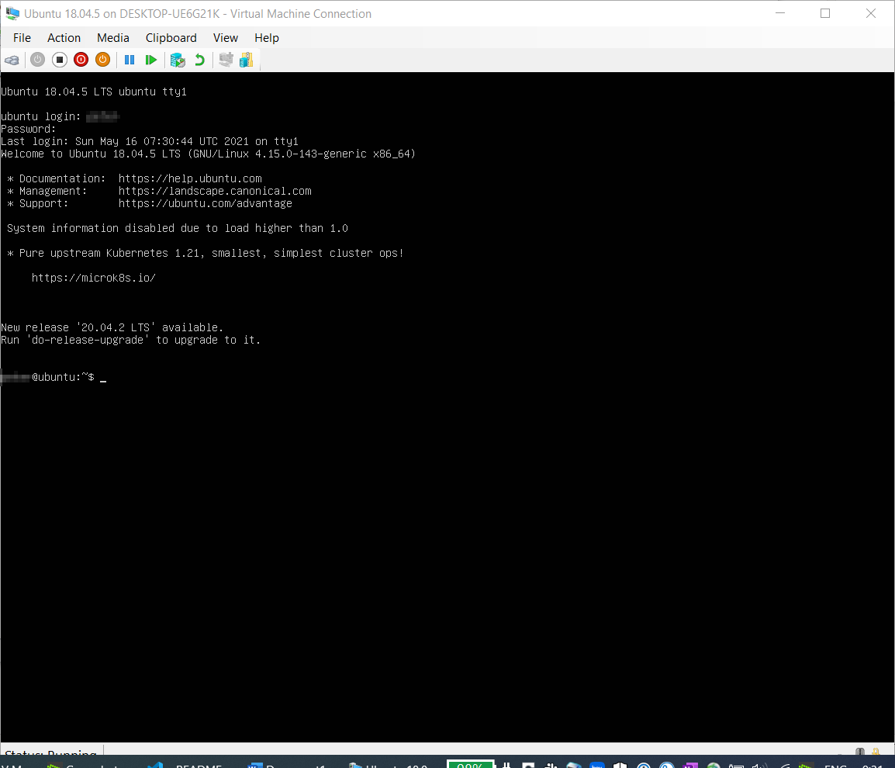

## Find out VMs IP address

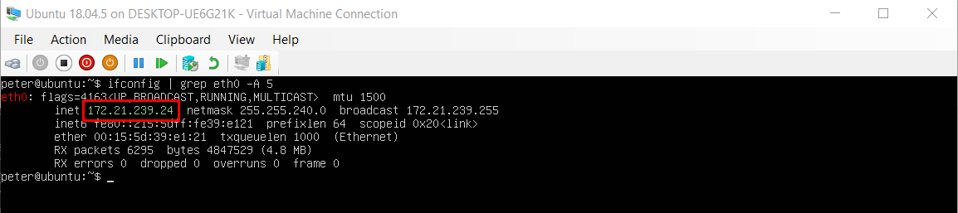

## Use any console to connect to the VM

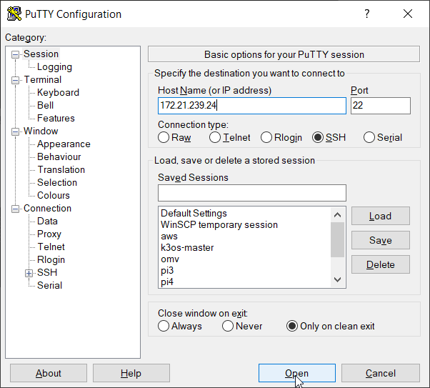

Figure : Putty as an example

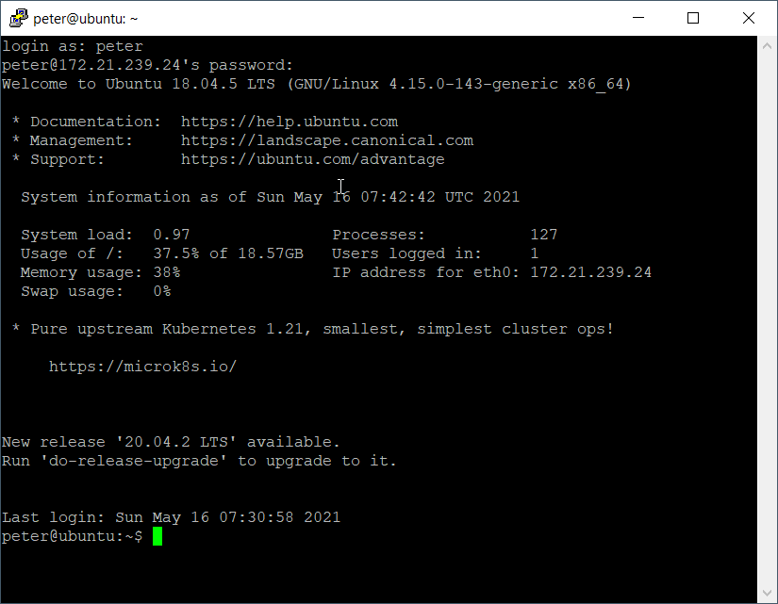

## Creating of alias and command autocomplete

Use following link to learn more about the topic:

<https://www.b2-4ac.com/kubernetes-in-seconds-microk8s/>

Default command for microk8s is *microk8s.kubectl.*

### Alias

To save time and our effort during typing of commands we will create an alias (kubectl instead of microk8s.kubectl)

sudo snap alias microk8s.kubectl kubectl

### Autocomplete

echo "source <(kubectl completion bash)" >> ~/.bashrc

source ~/.bashrc

You will probably see insufficient permissions error. Add your user to the microk8s group and change owner of the ~/.kube folder (see commands in the screenshot)

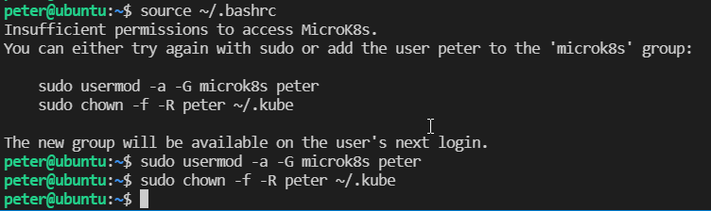

After next login all changes will be applied.

## Final status

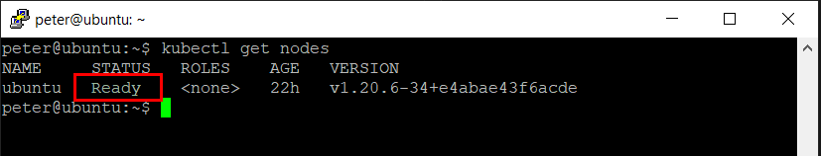

If your node’s status is ***Ready***, congratulation.