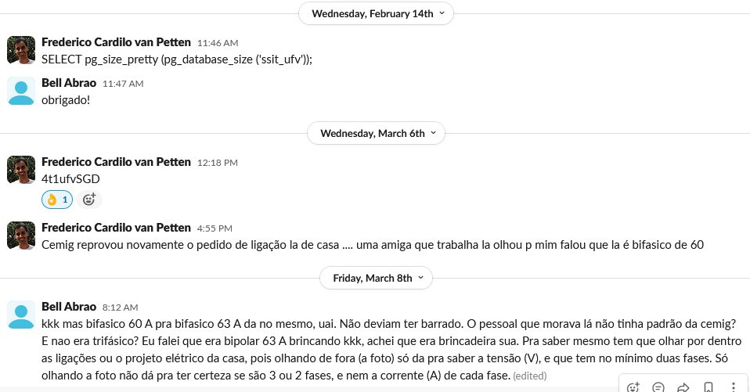

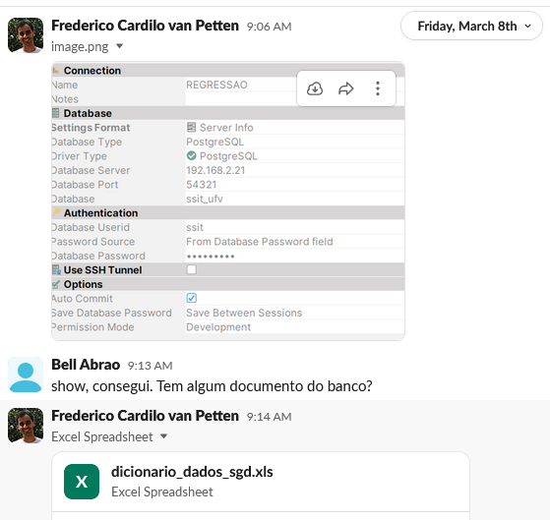

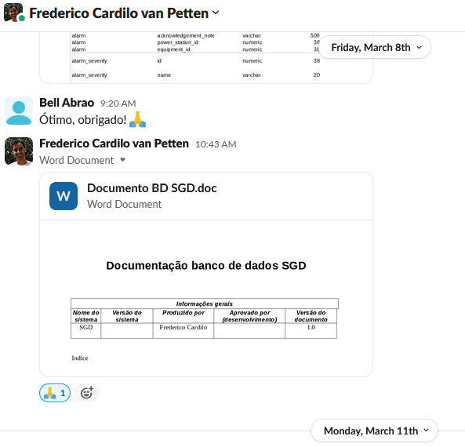

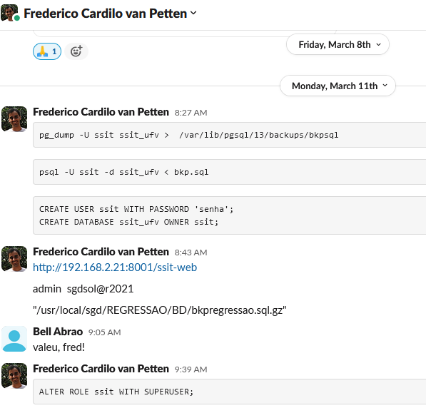

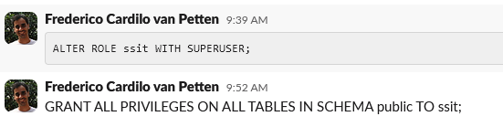

3.227.101.136 [auth.sgdapp.com](http://auth.sgdapp.com)  
3.227.101.136 [gateway.sgdapp.com](http://gateway.sgdapp.com)  
3.227.101.136 [main.sgdapp.com](http://main.sgdapp.com)  
3.227.101.136 [mail.sgdapp.com](http://mail.sgdapp.com)  
3.227.101.136 [notification.sgdapp.com](http://notification.sgdapp.com)  
3.227.101.136 [customer.sgdapp.com](http://customer.sgdapp.com)  
3.227.101.136 [maindb.sgdapp.com](http://maindb.sgdapp.com)  
3.227.101.136 [influxdb.sgdapp.com](http://influxdb.sgdapp.com)  
3.227.101.136 [app.sgdapp.com](http://app.sgdapp.com)  
3.227.101.136 [ui.sgdapp.com](http://ui.sgdapp.com)  
3.227.101.136 [pgadmin.sgdapp.com](http://pgadmin.sgdapp.com)  
3.227.101.136 [discovery.sgdapp.com](http://discovery.sgdapp.com)  
3.227.101.136 [zookeeper.sgdapp.com](http://zookeeper.sgdapp.com)  
3.227.101.136 [redis.sgdapp.com](http://redis.sgdapp.com)  
3.227.101.136 [zipkin.sgdapp.com](http://zipkin.sgdapp.com)  
3.227.101.136 [kafka.sgdapp.com](http://kafka.sgdapp.com)  
3.227.101.136 [kafka-control.sgdapp.com](http://kafka-control.sgdapp.com)  
3.227.101.136 [rabbitmq.sgdapp.com](http://rabbitmq.sgdapp.com)  
3.227.101.136 [prometheus.sgdapp.com](http://prometheus.sgdapp.com)  
3.227.101.136 [grafana.sgdapp.com](http://grafana.sgdapp.com)44.217.121.16 [auth.rel.sgdapp.com](http://auth.rel.sgdapp.com)  
44.217.121.16 [gateway.rel.sgdapp.com](http://gateway.rel.sgdapp.com)  
44.217.121.16 [main.rel.sgdapp.com](http://main.rel.sgdapp.com)  
44.217.121.16 [mail.rel.sgdapp.com](http://mail.rel.sgdapp.com)  
44.217.121.16 [notification.rel.sgdapp.com](http://notification.rel.sgdapp.com)  
44.217.121.16 [customer.rel.sgdapp.com](http://customer.rel.sgdapp.com)  
44.217.121.16 [maindb.rel.sgdapp.com](http://maindb.rel.sgdapp.com)  
44.217.121.16 [influxdb.rel.sgdapp.com](http://influxdb.rel.sgdapp.com)  
44.217.121.16 [app.rel.sgdapp.com](http://app.rel.sgdapp.com)  
44.217.121.16 [ui.rel.sgdapp.com](http://ui.rel.sgdapp.com)  
44.217.121.16 [pgadmin.rel.sgdapp.com](http://pgadmin.rel.sgdapp.com)  
44.217.121.16 [discovery.rel.sgdapp.com](http://discovery.rel.sgdapp.com)  
44.217.121.16 [zookeeper.rel.sgdapp.com](http://zookeeper.rel.sgdapp.com)  
44.217.121.16 [redis.rel.sgdapp.com](http://redis.rel.sgdapp.com)  
44.217.121.16 [zipkin.rel.sgdapp.com](http://zipkin.rel.sgdapp.com)  
44.217.121.16 [kafka.rel.sgdapp.com](http://kafka.rel.sgdapp.com)  
44.217.121.16 [kafka-control.rel.sgdapp.com](http://kafka-control.rel.sgdapp.com)  
44.217.121.16 [rabbitmq.rel.sgdapp.com](http://rabbitmq.rel.sgdapp.com)  
44.217.121.16 [prometheus.rel.sgdapp.com](http://prometheus.rel.sgdapp.com)  
44.217.121.16 [grafana.rel.sgdapp.com](http://grafana.rel.sgdapp.com)3.219.162.138 [auth.dev.sgdapp.com](http://auth.dev.sgdapp.com)  
3.219.162.138 [gateway.dev.sgdapp.com](http://gateway.dev.sgdapp.com)  
3.219.162.138 [main.dev.sgdapp.com](http://main.dev.sgdapp.com)  
3.219.162.138 [mail.dev.sgdapp.com](http://mail.dev.sgdapp.com)  
3.219.162.138 [notification.dev.sgdapp.com](http://notification.dev.sgdapp.com)  
3.219.162.138 [customer.dev.sgdapp.com](http://customer.dev.sgdapp.com)  
3.219.162.138 [maindb.dev.sgdapp.com](http://maindb.dev.sgdapp.com)  
3.219.162.138 [influxdb.dev.sgdapp.com](http://influxdb.dev.sgdapp.com)  
3.219.162.138 [app.dev.sgdapp.com](http://app.dev.sgdapp.com)  
3.219.162.138 [ui.dev.sgdapp.com](http://ui.dev.sgdapp.com)  
3.219.162.138 [pgadmin.dev.sgdapp.com](http://pgadmin.dev.sgdapp.com)  
3.219.162.138 [discovery.dev.sgdapp.com](http://discovery.dev.sgdapp.com)  
3.219.162.138 [zookeeper.dev.sgdapp.com](http://zookeeper.dev.sgdapp.com)  
3.219.162.138 [redis.dev.sgdapp.com](http://redis.dev.sgdapp.com)  
3.219.162.138 [zipkin.dev.sgdapp.com](http://zipkin.dev.sgdapp.com)  
3.219.162.138 [kafka.dev.sgdapp.com](http://kafka.dev.sgdapp.com)  
3.219.162.138 [kafka-control.dev.sgdapp.com](http://kafka-control.dev.sgdapp.com)  
3.219.162.138 [rabbitmq.dev.sgdapp.com](http://rabbitmq.dev.sgdapp.com)  
3.219.162.138 [prometheus.dev.sgdapp.com](http://prometheus.dev.sgdapp.com)  
3.219.162.138 [grafana.dev.sgdapp.com](http://grafana.dev.sgdapp.com)

