1. **语法**

SELECT <select_list> 、

FROM <table_source>

[ WHERE <search_condition> ]

[ GROUP BY <group_by_expression> ]

[ HAVING <search_condition> ]

[ ORDER BY <order_expression> [ ASC | DESC ]]

1. **限制查询结果**

SELECT TOP 5 prod_name FROM Products; （SQL Server和Access）

SELECT prod_name FROM Products WHERE ROWNUM <=5; （Oracle）

SELECT prod_name FROM Products LIMIT 5; （MySQL、MariaDB、PostgreSQL或者SQLite）

SELECT prod_name FROM Products LIMIT 5 OFFSET 5; (第一个数字是指从哪儿开始[0开始]，第二个数字是检索的行数)

1. **注释**

# 注释（少见，整行都注释了）

SELECT prod_name FROM Products LIMIT 5 OFFSET 5; -- 单行注释（比较常见）

多行注释：/* */

1. **设定查询条件Where子句**

* 操作符：=、>、<、>=、<=、！=、BETWEEN、IS NULL

SELECT prod_name, prod_price FROM Products WHERE prod_price < 10;

* AND/OR（多列，AND优先级高于OR）

SELECT prod_name, prod_price,prod_id FROM Products WHERE vend_id = 'DLL01' AND prod_price<=4;

OR：在第一个条件满足时，不管第二个条件是否满足；以下二个说明优先级，不管什么时候都最好使用圆括号来说明优先级

SELECT prod_name, prod_price FROM Products WHERE vend_id = 'DLL01' OR vend_id='BRS01' AND prod_price>=10;

SELECT prod_name, prod_price FROM Products WHERE (vend_id = 'DLL01' OR vend_id='BRS01') AND prod_price>=10;

* IN操作符（和OR相同功能）/NOT（和其他操作符配合使用，否定）

SELECT prod_name, prod_price FROM Products WHERE vend_id IN ('DLL01','BRS01') ORDER BY prod_price DESC;

IN操作符逻辑比OR清楚；可以包含SELECT子句；性能比较好

* 通配符LIKE：

%任意次数，区分大小写

SELECT prod_id,prod_name FROM products WHERE prod_name LIKE 'Fish%';

* 下划线_：单个字符，注意空格，下面二个结果不一样

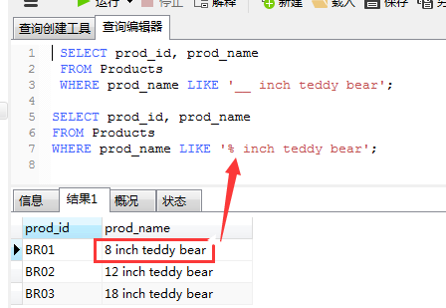

* 方括号（[ ]）通配符
* 是

1. **排序**

SELECT prod_name,prod_id,prod_price FROM products ORDER BY prod_price,prod_name;

按位置排序：SELECT prod_id,prod_price,prod_name FROM products ORDER BY 2,1;（默认升序，DESC降序）

SELECT prod_id,prod_price,prod_name FROM products ORDER BY 2 DESC;

1. 计算字段
2. 是