Template for apps on the APP_SERVER

Create the application folder: e.g career_service_app

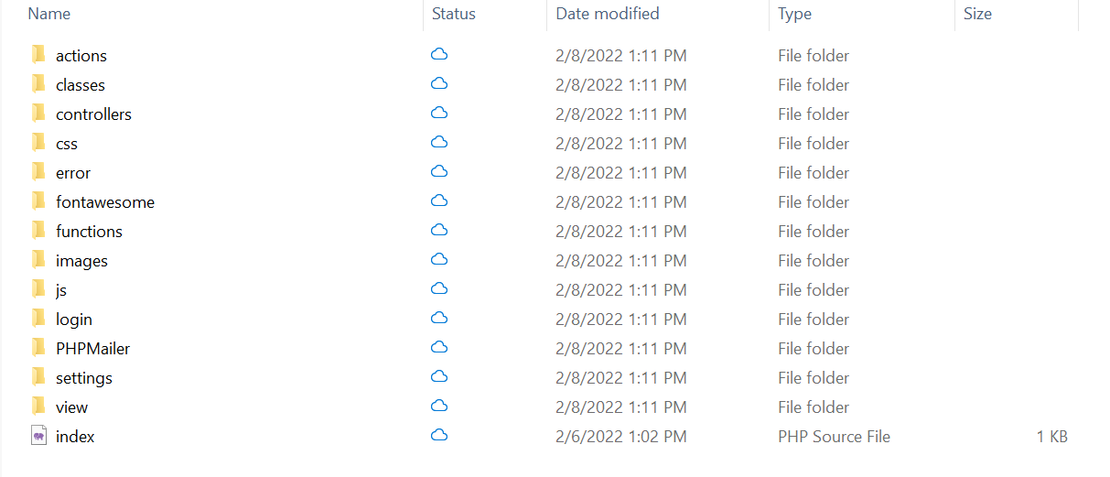

Index page – just a redirect function to dashboard in the view folder. No change required here

Classes folder

* General_class – this is the main file for db connect. Do not connect to db elsewhere.
* User_account_class
  + get_user_permission_cls(…)

Controllers folder

* general_controller – call this if you need to make connection to the db
* User_account_controller
  + Get_user_permission_ctr(…)

Settings folder

* Core
  + Take notice of the check login header redirection link
  + Core_get_user_permission – keep this if you need to check permission for app access. Else remove all redirects and keep only the permission id
* DB class – no change required
* DB credentials – may change the credentials