**CP3047** & **CP5047** ASSESSMENT TASK 1: **Cycle Reports**

This assessment task has been prepared by Dr. Dmitry Konovalov for James Cook University. Updated 26 November 2014.

**© Copyright 2014**

This publication is copyright. Apart from any fair dealing for the purpose of private study, research, criticism, or review as permitted under the Copyright Act, no part may be reproduced by any process or placed in computer memory without written permission.

|  |  |
| --- | --- |
| Aligned BIT course & CP3047 subject learning outcomes | * SLO - Subject Learning Outcome: SLO-1, SLO-2; * BLO - BIT Course Learning Outcome: BLO-K1, BLO-K3, BLO-S3, BLO-S5. |
| **Group or individual** | *Group* |
| **Weighting / Length** | *20%* |
| **Due date** | *during week-7 workshop* |

|  |  |
| --- | --- |
| Aligned MIT course & CP5047 subject learning outcomes | * SLO - Subject Learning Outcome: SLO-1, SLO-2; * MLO - MIT Course Learning Outcome : MLO-K1, MLO-S5. |
| **Group or individual** | *Group* |
| **Weighting / Length** | *20%* |
| **Due date** | *during week-7 workshop* |

## ASSESSMENT TASK DESCRIPTION

This task is the ***iteration-3*** in terms of the Agile Software development. It delivers the ***beta-release*** to the client, and makes planning for the ***iteration-4*** (***final release***), which is due at the end of CP3047/5047.

Your instructor may ask you to provide a paper copy of this assignment. Depending on the class size, campus or timetable circumstances, it could be more appropriate/convenient/efficient to mark the hard copy rather than electronic version of this assignment.

## [Total awarded _____ out of 100 marks] ASSESSMENT TASK CRITERIA SHEET

The following is the list of items which are required to be completed in this assignment. Maximum possible marks are given in brackets at the beginning of each item. Where relevant, the SLOs and BLO/MLOs from the preceding table are specified.

**[_____/5 marks, BLO-S5] Assignment is done in a group with 2-4 students.**

Write group members here:

Student Name-1, Project role(s), specific ***individual*** contributions to this assessment item:

Student Name-2:

|  |  |  |
| --- | --- | --- |
| Items | Hong Yu | Jananie Illango |
| Game idea | ✔ | ✔ |
| - Story definition  - Character definition  - Logic definition | ✔ | ✔ |
| ✔ | ✔ |
| ✔ | ✔ |
| Design | **✔** |  |
| Main stage | ✔ |  |
| Background | ✔ |  |
| Grass wall | ✔ |  |
| Slingshot framework | ✔ |  |
| Eagle | ✔ |  |
| Rabbit | ✔ |  |
| Carrot | ✔ |  |
| Cloud | ✔ |  |
| Explosion effect | ✔ |  |
| Stage Option Cards | ✔ |  |
| Title and banners | ✔ |  |
| Game Logical definition | **✔** |  |
| System Logic | **✔** |  |
| LEVEL parameters | **✔** |  |
| How to start | **✔** |  |
| How to restart | **✔** |  |
| How to begin next level | **✔** |  |
| How to choose level | **✔** |  |
| High score | **✔** |  |
| All enemies down | **✔** |  |
| All carrots exhausted | **✔** |  |
| All rabbits caught | **✔** |  |
| Character Logic | **✔** |  |
| Eagle logic | **✔** |  |
| Fly action | **✔** |  |
| Random creating action | **✔** |  |
| Catch rabbits | **✔** |  |
| Carry rabbits | **✔** |  |
| Successfully catch rabbits | **✔** |  |
| Successfully hit by carrots | **✔** |  |
| Rabbit Logic | **✔** |  |
| Jump on the main screen | **✔** |  |
| Be caught by eagle | **✔** |  |
| Saved by carrots | **✔** |  |
| Reset position | **✔** |  |
| Carrot Logic | **✔** |  |
| Drag action | **✔** |  |
| Shot action | **✔** |  |
| Successfully hit eagles | **✔** |  |
| Not successfully hit eagles | **✔** |  |
| Technique implementation | **✔** |  |
| Build title screen | **✔** |  |
| Flying cloud | **✔** |  |
| Jumping rabbits | **✔** |  |
| Moving grass | **✔** |  |
| Play button | **✔** |  |
| Levels Option screen | **✔** |  |
| Back to title | **✔** |  |
| Round 1 selection | **✔** |  |
| Round 2 selection | **✔** |  |
| High score of round 1 | **✔** |  |
| High score of round 2 | **✔** |  |
| If locked, in round 2 | **✔** |  |
| Main screen | **✔** |  |
| Load parameter for different level | **✔** |  |
| Create eagle | **✔** |  |
| Eagles fly to rabbits randomly | **✔** |  |
| Eagles catching rabbit | **✔** |  |
| Eagles carting rabbit vertically to out of layer | **✔** |  |
| Carrots could be dragged, ready for shot | **✔** |  |
| Carrots shotting | **✔** |  |
| Carrots hit eagle (with explosion effect) | **✔** |  |
| Carrots does not hit eagle | **✔** |  |
| Rabbit lay out to grass | **✔** |  |
| Rabbit caught by eagle on flying | **✔** |  |
| Rabbit caught by eagle successfully out of layout | **✔** |  |
| Rabbit be saved (reset the rabbit) | **✔** |  |
| When eagle number reduce to 0 (winner action: again or go next level) | **✔** |  |
| When carrot number reduce to 0 (loser action: again) | **✔** |  |
| When rabbit number reduce to 0(loser action: again) | **✔** |  |
| Next level (set eagle more speedy and increase the number of eagle) | **✔** |  |
| High score (The playing time lower than high score, then replace to save) | **✔** |  |
| Testing Task | **✔** | **✔** |
| - Title screen  - Level option screen  - Main screen  - Level logic  - Character logic  - High score logic  - UAT arrangement | **✔** | **✔** |
| **✔** | **✔** |
| **✔** | **✔** |
| **✔** | **✔** |
| **✔** | **✔** |
| **✔** | **✔** |
| **✔** | **✔** |
| Documentation | **✔** | **✔** |
| - Cycle report  - Presentation Slider  - Audit report  - Delivery meeting  - Client communication | **✔** |  |
| **✔** | **✔** |
| **✔** | **✔** |
| **✔** | **✔** |
| **✔** | **✔** |

**[_____/5 marks] Assignment is completed using electronic copy of *this* document (available from LearnJCU).**

**[_____/5 marks] Assignment (*this* filled out document) is submitted to LearnJCU electronically.** One submission per team.

**[_____/60 marks, SLO-1, SLO-2, BLO-S3, MLO-S5] Report *ACTUALLY* delivered beta-release (see your user stories in iteration-2). Any deviations from the plan for beta-release must be documented and briefly explained.** Write here: Minimum **ONE** page, maximum **THREE** pages.

<Define stories for this cycle leading to beta release. Include also stories from past cycle (leading to alpha)>

* [____/10 marks] Demonstrate delivered beta **and** alpha releases. ***Highlight the difference*** between alpha and beta releases;

|  |  |
| --- | --- |
| Alpha | Beta |
| Build title screen |  |
| Flying cloud |  |
| Jumping rabbits |  |
| Moving grass |  |
| Play button |  |
| Levels Option screen |  |
|  | Back to title |
| Round 1 selection |  |
|  | Round 2 selection |
| High score of round 1 |  |
|  | High score of round 2 |
|  | If locked, in round 2 |
| Main screen |  |
| Load parameter for different level  Number of eagles:5  Speed of eagles:450 | Particular in level2  **Number of eagles:7**  **Speed of eagles:600** |
| Create eagle | Can tweet simultaneously |
| Eagles fly to rabbits frequently | Eagles fly to rabbits randomly |
| Eagles catching rabbit |  |
| Eagles carting rabbit vertically to out of layer |  |
| Carrots could be dragged, ready for shot |  |
| Carrots shotting |  |
| Carrots hit eagle (with explosion effect) | Optimization of explosion effect |
| Carrots does not hit eagle |  |
| Rabbit lay out to grass |  |
| Rabbit caught by eagle on flying |  |
| Rabbit caught by eagle successfully out of layout |  |
| Rabbit be saved (reset the rabbit) |  |
| When eagle number reduce to 0 (winner action: again or go next level) |  |
| When carrot number reduce to 0 (loser action: again) |  |
| When rabbit number reduce to 0(loser action: again) |  |
|  | Next level (set eagle more speedy and increase the number of eagle) |
|  | High score (The playing time lower than high score, then replace to save) |

* [____/10 marks] Quality, acceptance testing, how well the ***alpha and beta user stories*** are implemented;

|  |  |  |  |
| --- | --- | --- | --- |
| Alpha | Quality | Beta | Quality |
| Build title screen |  |  |  |
| Flying cloud | Correctly |  |  |
| Jumping rabbits | Correctly |  |  |
| Moving grass | Correctly |  |  |
| Play button | Correctly |  |  |
| Levels Option screen |  |  |  |
|  |  | Back to title | Correctly |
| Round 1 selection | Correctly |  |  |
|  |  | Round 2 selection | Correctly |
| High score of round 1 | Programmed |  |  |
|  |  | High score of round 2 | Correctly |
|  |  | If locked, in round 2 | Correctly |
| Main screen |  |  |  |
| Load parameter for different level  Number of eagles:5  Speed of eagles:450 | Correctly | Particular in level2  **Number of eagles:7**  **Speed of eagles:600** | Correctly |
| Create eagle |  | Can tweet simultaneously | Correctly |
| Eagles fly to rabbits frequently | Correctly | Eagles fly to rabbits randomly  Case number of rabbits on the stage:  4🡪choose(1,2,3,4)  3🡪 if 1 gone then choose(2,3,4)  if 2 gone then choose(1,3,4)  if 3 gone then choose(1,2,4)  if 4 gone then choose(1,2,3)  2🡪 if 1 2 gone then choose(3,4)  if 1 3 gone then choose(2,4)  if 1 4 gone then choose(2,3)  if 2 3 gone then choose(1,4)  if 2 4 gone then choose(1,3)  if 3 4 gone then choose(1,2)  1🡪choose the last one | Correctly |
| Eagles catching rabbit | Correctly |  | Correctly |
| Eagles carting rabbit vertically to out of layer | Correctly |  | Correctly |
| Carrots could be dragged, ready for shot | Correctly |  | Correctly |
| Carrots shotting | Correctly |  | Correctly |
| Carrots hit eagle (with explosion effect) | Programmed | Optimization of explosion effect:  Add **Fade** behaviour to explosion effect | Correctly |
| Carrots does not hit eagle | Correctly |  | Correctly |
| Rabbit lay out to grass | Correctly |  | Correctly |
| Rabbit caught by eagle on flying | Correctly |  | Correctly |
| Rabbit caught by eagle successfully out of layout | Correctly |  | Correctly |
| Rabbit be saved (reset the rabbit) | Correctly |  | Correctly |
| When eagle number reduce to 0 (winner action: again or go next level) | Programmed |  | Correctly |
| When carrot number reduce to 0 (loser action: again) | Programmed |  | Correctly |
| When rabbit number reduce to 0(loser action: again) | Programmed |  | Correctly |
|  |  | Next level (set eagle more speedy and increase the number of eagle) | Correctly |
|  |  | High score (The playing time lower than high score, then replace to save) | Correctly |

* [____/10 marks] Complexity, technical competence, appropriate ICT solution/languages/tools;

|  |  |
| --- | --- |
| Item | Tools |
| Documentation | Microsoft word, power point |
| Arts and graphic design | Adobe Photoshop, Fireworks, Procreate |
| Game implementation | Scirra Construct 2 |

Due to the limitation of capital and investment, the game is implemented by Free Version of Construct 2, as a result, it is hardly to achieve more excellent function through it.

Moreover, the music and sound track are copied from Internet should have copyright with the original authors, because it is lack of the ability to audio editing jobs.

* [____/**20** marks] Client satisfaction and feedback. Demonstrate how and where the client’s feedback was used to improve the existing alpha-release features, and implement new features of the beta-release.

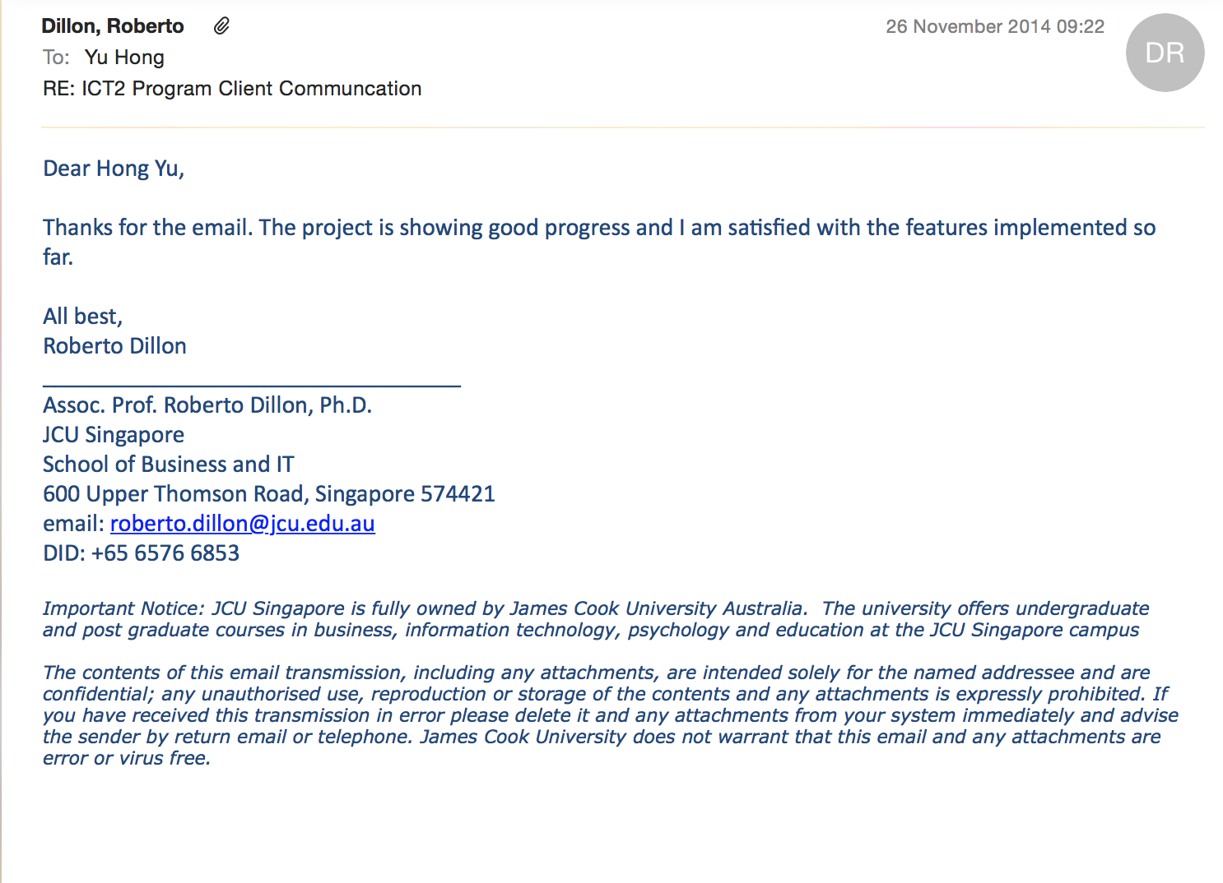

* [____/10 marks] ***Burn-down chart*** for iterations #2 and #3, which is used to plan iteration-4.

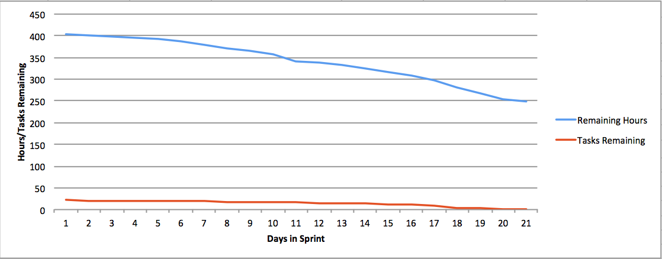

**[_____/5 marks, BLO-K1, BLO-K3, BLO-S5] Project sponsor/client/customer signed and accepted the delivery of the beta-release.** Cut/Paste clients’ email here, or show signed the preceding “**delivered beta-release**” to your marker/lecturer.

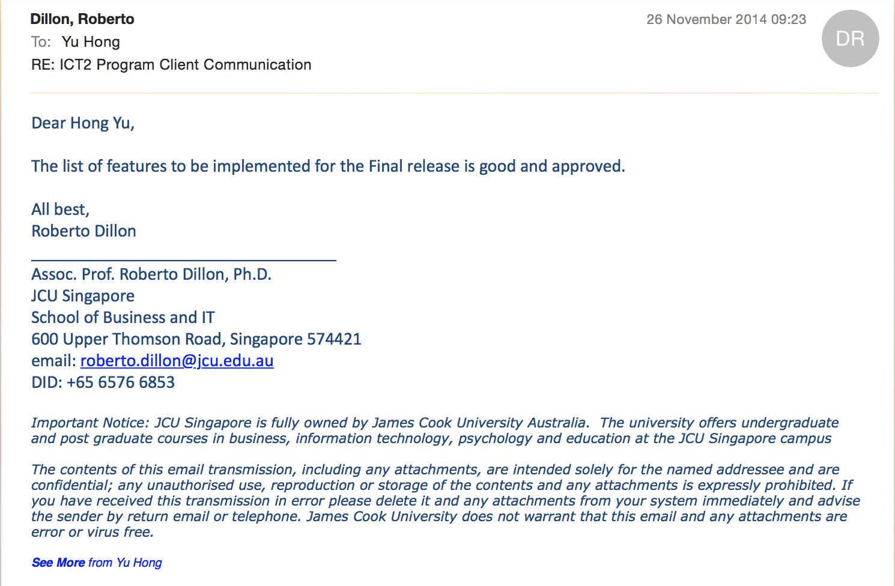

**[_____/10 marks, SLO-1, SLO-2, BLO-S3, MLO-S5] Planning and scope of the final-release (Project audit at the end of CP3047/5047 subject).** Write here: Minimum **ONE** page, maximum **THREE** pages.

**Available days:** PASS-level (minimum) effort is 1-day and maximum is 3-days per teaching week (assume 12 weeks per study period), per team member. For example: 12 x 2 = 24 days is the minimum for a team with 2 students, 12x2x3=72 days is the maximum. The available days must match the SUM of your user story estimates below.

User story 1: title, short description, effort estimate (in days, maximum of 5 days), assumptions (if any).

User story 2: ...

|  |  |
| --- | --- |
| Process One (Plan Design and Arts) | Time consumption （Week 1 - 2） |
| Game story definition | 2 days |
| Game logic definition | 1 days |
| Character definition | 1 day |
| Draft and prototype | 2 days |
| Art work of stage | 2 days |
| Art work of character | 2 days |
| Art work of elements | 2 days |
| Art work of background and accessories | 1 day |
| Client communication and Milestone meeting | 1 day |

|  |  |
| --- | --- |
| Process Two (Alpha Version) | Time consumption （Week 3 - 7） |
| Build title screen | 4 days |
| Flying cloud | 1 day |
| Jumping rabbits | 1day |
| Moving grass | 1 day |
| Play button | 2 days |
| Levels Option screen | 1 day |
| Round 1 selection | 1 day |
| High score of round 1 | 2 days |
| Main screen | 2 days |
| Load parameter for different level  Number of eagles: 5  Speed of eagles: 450 | 1 day |
| Create eagle | 1 day |
| Eagles fly to rabbits frequently | 1 day |
| Eagles catching rabbit | 2 day |
| Eagles carting rabbit vertically to out of layer | 1 day |
| Carrots could be dragged, ready for shot | 1 day |
| Carrots shotting | 1 day |
| Carrots hit eagle (with explosion effect) | 2 days |
| Carrots does not hit eagle | 2 days |
| Rabbit lay out to grass | 1 day |
| Rabbit caught by eagle on flying | 1 day |
| Rabbit caught by eagle successfully out of layout | 1 day |
| Rabbit be saved (reset the rabbit) | 1 day |
| When eagle number reduce to 0 (winner action: again or go next level) | 1 day |
| When carrot number reduce to 0 (loser action: again) | 1 day |
| When rabbit number reduce to 0(loser action: again) | 1 day |
| Milestone 2 Client meeting | 5 days |

|  |  |
| --- | --- |
| Process Three (Beta Version) | Time consumption（Week 8 - 10） |
| Test Alpha related functions | 1 day |
| Test Alpha related functions | 1 day |
| Test Alpha related functions | 1 day |
| Test Alpha related functions | 1 day |
| Test Alpha related functions | 1 day |
| Test Alpha related functions | 1 day |
| Back to title | 1 day |
| Test Alpha related functions | 1 day |
| Round 2 selection | 1 day |
| Test Alpha related functions | 1 day |
| High score of round 2 | 1 day |
| If locked, in round 2 | 1 day |
| Test Alpha related functions | 1 day |
| Particular in level2  Number of eagles: 7  Speed of eagles: 600 | 3 days |
| Can tweet simultaneously | 2 days |
| Eagles fly to rabbits randomly  Case number of rabbits on the stage:  4🡪choose(1,2,3,4)  3🡪 if 1 gone then choose(2,3,4)  if 2 gone then choose(1,3,4)  if 3 gone then choose(1,2,4)  if 4 gone then choose(1,2,3)  2🡪 if 1 2 gone then choose(3,4)  if 1 3 gone then choose(2,4)  if 1 4 gone then choose(2,3)  if 2 3 gone then choose(1,4)  if 2 4 gone then choose(1,3)  if 3 4 gone then choose(1,2)  1🡪choose the last one | 3 days |
| Test Alpha related functions | 1 day |
| Test Alpha related functions | 1 day |
| Test Alpha related functions | 1 day |
| Test Alpha related functions | 1 day |
| Optimization of explosion effect:  Add Fade behaviour to explosion effect | 3 days |
| Test Alpha related functions | 1 day |
| Test Alpha related functions | 1 day |
| Test Alpha related functions | 1 day |
| Test Alpha related functions | 1 day |
| Test Alpha related functions | 1 day |
| Test Alpha related functions | 1 day |
| Test Alpha related functions | 1 day |
| Test Alpha related functions | 2 days |
| Next level (set eagle more speedy and increase the number of eagle) | 2 days |
| High score (The playing time lower than high score, then replace to save) | 3 days |
| Final documentation (Presentation and Final Audit) |  |

**[_____/10 marks, BLO-K1, BLO-K3, BLO-S5, MLO-K1, MLO-S5] Project sponsor/client/customer signed/agreed to the scope of the final-release.** Cut/Paste clients’ email here, or show signed the preceding “**scope of final-release**” to your marker/lecturer.

* [___/2] Intellectual property (IP) in client agreement;
* [___/3] Evidence of clients priority and ranking of user stories;
* [___/5] Signed and agreed scope.

贴Email证据的 最后一封。

## Reference BIT & MIT course and learning outcomes

|  |  |
| --- | --- |
| BIT course & CP3047 subject learning outcomes | * SLO-1 Communicate technical information clearly through presentations, demonstrations and documentation; * SLO-2 Apply appropriate tools and technologies to meet project requirements; * SLO-3 Develop knowledge of a specific industry standard for project management; * BLO-K1 - Demonstrate essential knowledge for a career in technology related professions and practice; * BLO-K2 - Synthesise industry standard and underlying principles and concepts for decision making; * BLO-K3 - Critically analyse the core professional obligations, values and operations of organisations including sustainability; * BLO-S2 - Apply critical thinking to address IT related issues; * BLO-S3 - Convey information clearly and fluently, in high quality written form appropriate for their audience; * BLO-S4 - Demonstrate effective oral presentation skills for academic and professional audiences; * BLO-S5 - Demonstrate the ability to work collaboratively; * BLO-A1 - Apply technical skills, including numeracy, necessary for professional practice; * BLO-A3 - Identify and act upon, learning opportunities and self-improvements. |

|  |  |
| --- | --- |
| MIT course & CP5047 subject learning outcomes | * SLO-1 Communicate technical information clearly through presentations, demonstrations and documentation; * SLO-2 Apply appropriate tools and technologies to meet project requirements; * SLO-3 Develop knowledge of a specific industry standard for project management; * MLO-K1 - Critically analyse to select appropriate tools and technologies to meet project requirements; * MLO-K2 - Evaluate industry standard contexts for project management approaches; * MLO-S4 - Apply lateral and original thinking to conceptualise and evaluate a range of solutions to relevant problems; * MLO-S5 - Communicate technical information clearly through presentations, demonstrations and documentation; * MLO-A1 - Apply appropriate tools and technologies to meet project managements; * MLO-A3 - Critically reflect on progress to tailor self-learning goals to advance professional development. |

**Marking Rubric for Cycle Reports:** This assessment rubric provides you with the characteristics of exemplary, competent, marginal and unacceptable work in relation to task criteria.

|  |  |  |  |  |
| --- | --- | --- | --- | --- |
| **Criteria** | **Exemplary (DISTINCTION-level)** | **Competent (CREDIT-level)** | **Marginal (PASS-level)** | **Unacceptable** |
| **Assignment is done in a group with 2-4 students.** | **5**  Group demonstrated **exemplary ability** to work collaboratively, e.g. all team members always attended the same workshop | **4** Group demonstrated **competent ability** to work collaboratively, e.g. all team members nearly always attended the same workshop. | **3**  Group demonstrated **marginal ability** to work collaboratively, e.g. all team members sometimes attended the same workshop. | **0**  Group did not demonstrated ability to work collaboratively. |
| **Assignment is completed using electronic copy of this document** | **5**  One submission per team. | **4** More than one submission per team. |  | **0**  Not done. |
| **Assignment (this filled out document) is submitted to LearnJCU electronically** | **5**  No presentation and style errors | **4** Minor presentation and/or style errors. | **2**  Major presentation and/or style errors. | **0**  Not done. |
| **Report ACTUALLY delivered BETA-release** | **60**  All delivered user stories are correct, correctly implemented, and tested. Technical information in the report is exemplarily. | **45** Minor errors in: All delivered user stories are correct, correctly implemented, and tested. Technical information in the report is competent. | **30** More than half of delivered user stories are correct, correctly implemented, and tested. Technical information in the report is PASS-level. | **0**  Not done, or done unacceptably. |
| **Client accepted the delivery of the BETA-release** | **5**  Clear evidence of client’s acceptance and client is running alpha-release. | **4** Some evidence of client’s acceptance, and client is running alpha-release. | **3**  Minimal evidence of client’s acceptance and client is running alpha-release. | **0**  Not done, or done unacceptably. |
| **Planning and scope of FINAL-release** | **10**  All user stories are correct, and correctly estimated. Client’s feedback is clearly present. | **7** Most user stories are correct, and correctly estimated. Client’s feedback is somewhat present. | **3**  More than half of user stories are correct, and correctly estimated. Client’s feedback is minimal. | **0**  Less than half of user stories are correct, and correctly estimated. |
| **Project client signed the scope of the FINAL-release** | **10**  Intellectual property (IP) in client agreement; Evidence of clients priority and ranking of user stories; Signed and agreed scope. | **7** Minor errors. | **3**  Errors. | **0**  Not done, or done unacceptably. |