HW 05 - Static Code Analysis
Repo: https://github.com/bella458/HK5
Bella Manoim

Summary: With this assignment I learned how to use a static code analyzer tool and coverage tool to improve my Triangle program. I noticed a lot of the results from the static analyzer revolved around whitespace. The static analyzer wanted me to use spaces, and the python editor wanted me to use tabs and actually wouldn’t run unless I changed the spaces to tabs. This was something I couldn’t resolve, and had to ignore the whitespace comments. I found a way to run the static analyzer and ignore the whitespace error as it did not pertain. I did clear any other errors such as too many booleans by splitting up the code, however I didn't think this was necessary. I also ignored name convention errors. There are different kinds of information that the tool picks up (convention, refactor, warning, error), and they vary in importance. I did improve my formatting by adding a space after commas, for example. I found playing with the coverage tool interesting as well, and added some code to improve my original program (basic rules of triangle geometry I didn't realize I was missing in the first assignment) and as I edited my code, I watched the coverage results get better and better until I covered enough tests. Going through the tutorial helped me figure out how to read and improve my results.

- GitHub URL containing the code that was analyzed: https://github.com/bella458/HK5
- Static code analyzer tool : Pylint
Output screen shots below, static code analyzer picked up three screenshots worth of information, and once I cleaned up all of the important items (errors, warnings, refactor), I was just left with convention items. I had to also ignore tab errors because of the way my python editor works (whitespace/tabs).
- Code coverage tool : Coverage
Output screen shots below, coverage went from 80% to 100%.
- Original test cases:
classify_triangle(2,2,3) #isosceles
classify_triangle(-5,2,5) #not valid triangle
classify_triangle(3,4,5) #scalene and right
classify_triangle(1,2,3) #scalene
classify_triangle(2,2,2) #equilateral
classify_triangle(5,12,13) #scalene and right
classify_triangle(5,5,5) #equilateral
classify_triangle(5,2,5) #isosceles
5. New test cases created to achieve at least 80% code coverage:
classify_triangle(2, 3, 3) #isosceles
classify_triangle(5, 2, 5) #isosceles
classify_triangle(5, 4, 3) #scalene and right
classify_triangle(4, 5, 3) #scalene and right
classify_triangle(4, 2, 3) #scalene
classify_triangle(-5, -5, -5) #not valid triangle
classify_triangle(0, 0, 0) #not valid triangle
classify_triangle(2.1, 2, 3) #not valid triangle
classify_triangle(300, 300, 300) #not valid triangle
classify_triangle(squirrel, 2, 3) #not valid triangle

6. Screen shots of the output of the static code analyzer as well as code coverage. You should show a screen shot of the analysis results both before and after any changes that you make to your programs:
  - Static code analysis report on original program
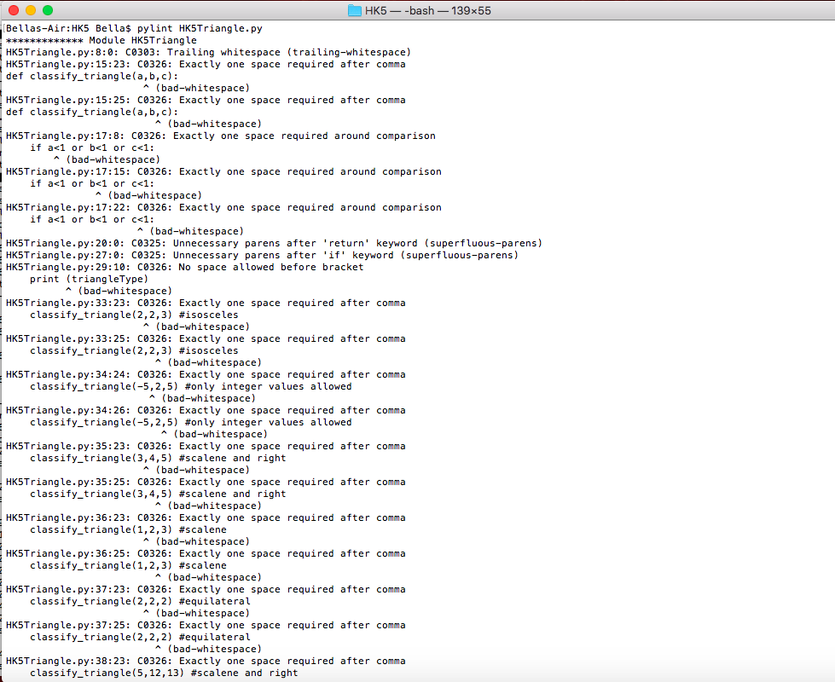
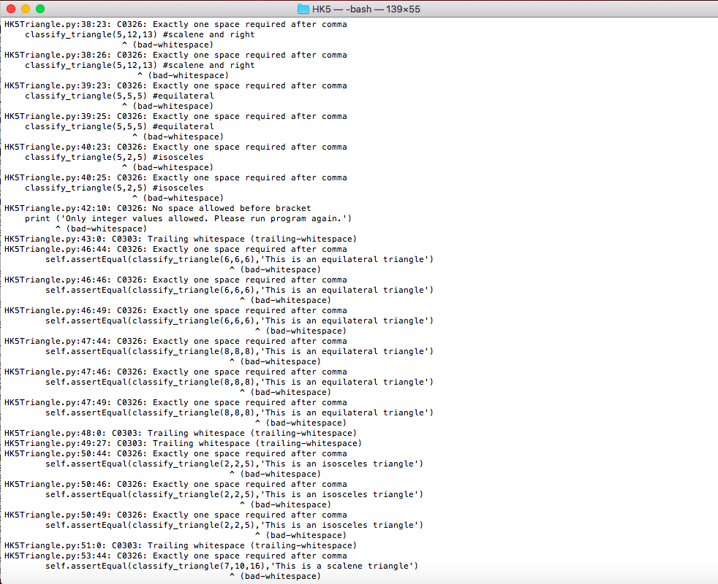
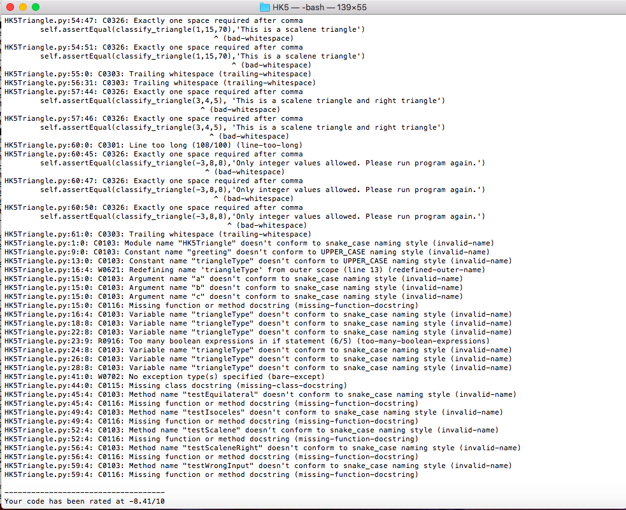
  - Code coverage report before any changes to the program
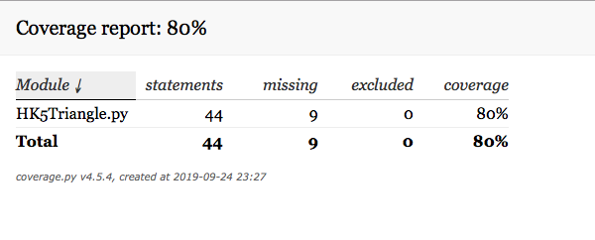
  - Static code analysis report after you have made changes to eliminate issues
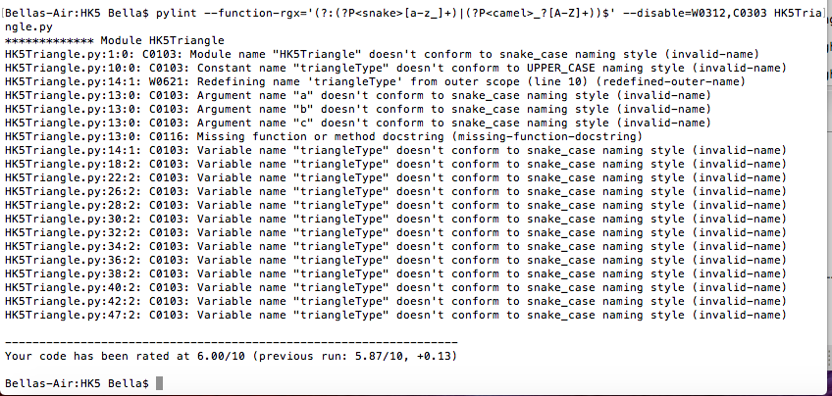
  - Code coverage after any changes to the programs (coverage should be > 80%)
