Part two –
This week we start programming, specifically we will set up our matrices.
There are ten matrices:
- xstart
  - This is a fillable matrix and is left empty so that it may be utilized later.
- whichconstraints
  - This is a 4x20 matrix in which the columns correspond to 20 constraints and the rows correspond to ‘which’, ‘isslack’, ‘penalty’, and ‘amount of slack’.
    - The ‘which’ row should be filled with all 1 where 1 implies the constraint is active.
    - It is up to you to decide which constraints will have slack in the ‘is slack’ row, for those that do have slack put a 1 as 1 implies slack is active.
    - The amount of ‘penalty’ for each constraint is up to you. The minimum is 0 and the maximum for now will be 10^6. Keep in mind not all constraints need a ‘penalty’.
    - The amount of slack for those constraints that have it is also up to you. The minimum is 0 and for now the maximum will be 4. Keep in mind that not all constraints that have active slack need a slack value other than 0.
  - The twenty constraints are as follows:
    - C1: Every team plays in every slot
    - C2: Every game is home vs visitor
    - C3: every team has 70 home games
    - C4: Every team has home 22 Fridays+Saturdays, and Th between 10 and 12
    - C5: Distribution of games between teams
    - C6: Travel distance controls
    - C7: Every team home for one of the first two slots, last two slots
    - C8: Each team is home for atl least one of July 3 and July 4
    - C9: Control 10 game homestands
    - C10: No team is home for three consecutive series or away; no three-window violations
    - C11: Of every five-consecutive series, we want 2 or 3 home;
    - C12: No pair of teams should play each other more than twice in 5 series
    - C13: Controlling 10 game roundtrips
    - C14: Of every five consecutive weekends, each team, number of weekends is two or three.
    - C15: July 3 and July 4 and weekend distance control
    - C16: No back to back series between two teams
    - C17: no revisiting a stadium until intervening series pass
    - C18: No traveling over a rest day
    - C19: Hard constrained days
    - C20: Absolutely hard constrained days
- template
  - This is a 23x7 matric in which the columns correspond to a Monday-Sunday and the rows correspond to the number of weeks during the season.
  - You will fill this matrix with the values from your template, below is an example from 2019.
  - 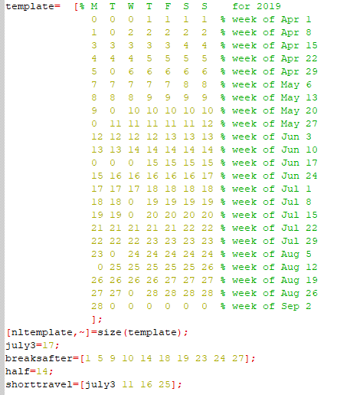
  - Notice the code below template, these other matrices keep track of important events and too must be included using the information from your template.
- North and South
  - Both matrices are 1x5 and correspond to the teams in their respective division.
  - NORTH = [1 2 3 4 5]; as it contains teams 1-5 and SOUTH=[6 7 8 9 10]; as it contains teams 6-10
- Dist
  - This is a 10x10 matrix and to be filled with the mileage distribution that I included in the first email.
  - 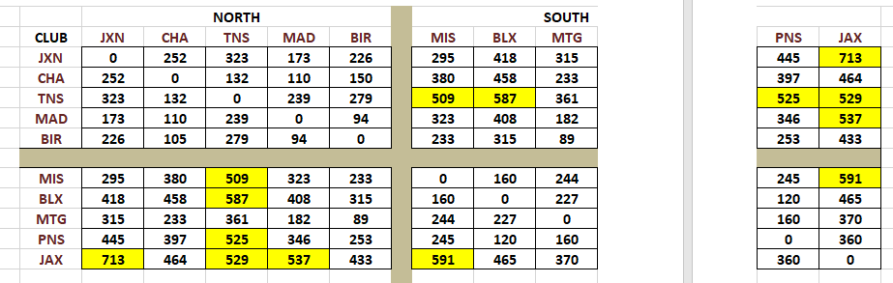
- HARDWIRE
  - This is a nx10 matrix in which the columns correspond to the teams (keep in mind 1-5 are North and 6-10 are South) and the rows correspond to the number of series. Hence n will be whatever the number of series your template contains.
  - This matrix deals with the second set of team requests included in the first email.
    - 0 -> no request, -100 -> request away from home, -101 -> within division, -102 -> away from home but within division
  - Example from 2019
    - 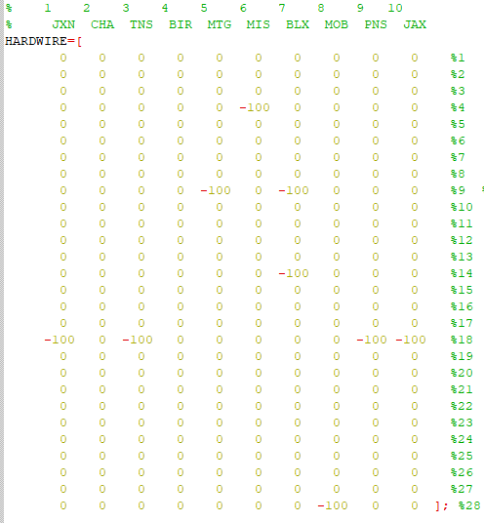
- HARDWIREstronger
  - This is a nx10 matrix in which the columns correspond to the teams (keep in mind 1-5 are North and 6-10 are South) and the rows correspond to the number of series. Hence n will be whatever the number of series your template contains.
  - This matrix deals with the first set of team requests included in the first email.
    - 0 -> no request, -100 -> request away from home, -101 -> within division, -102 -> away from home but within division
  - Example from 2019
    - 