Part three – Due 11/05/2019
Part three of the project will be to set up the code that will be utilized by our constraints, and the first three constraints.
You will notice that the equality and inequality constrains utilize this formula: nslots*nteams*nteams + cushioncolumns
Put some thought into why.
Functions: max, sum, length, zeros, sparse
- max - https://www.mathworks.com/help/matlab/ref/max.html
- sum - https://www.mathworks.com/help/matlab/ref/sum.html
- length - https://www.mathworks.com/help/matlab/ref/length.html
- zeros - https://www.mathworks.com/help/matlab/ref/zeros.html
- sparse - https://www.mathworks.com/help/matlab/ref/sparse.html

First set up three variables: nteams, nslots, and gamesperslot
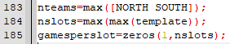

- nteams – utilize the max function along with your NORTH SOUTH matrices to store a team count in nteams.
  - nteams = max([NORTH SOUTH])
- nslots – utilize the max functions along with your template matrix to store a slot count in nslots.
  - nslots = max(max(template))
- gamesperslot – use the zero function to create a zeroth matrix with 1 by the number of slots.
  - gamesperslot = zeros(1, nslots)

Nest we fill the zeroth matrix gamesperslot
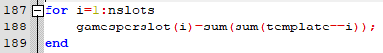
- use a for loop that counts up to nslots to fill that gamesperslot with template values via sum functions.
  - for i:nslots
gamesperslot(i)=sum(sum(template==i))
end
Next set up six variables: numcontrainttypes, howmanyeq, howmanyineq, howmanycolumns, cushionrows, cushioncolumns

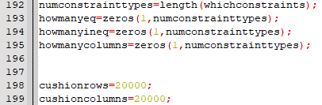

- numconstrainttypes – utilizes the length function to obtain and store number of constraints according to whichconstrains matrix
  - numsontrainttypes = length(whichconstraints)
- howmanyeq – use the zeros function create a matrix with the 1 by the number of constraints dimensions.
  - howmanyeq = zeros(1, numconstrainttypes)
- howmanyineq – use the zeros function to create a matrix 1 by the number of constraints dimensions.
  - howmanyineq = zeros(1, numconstrainttypes)
- howmanycolumns – use zeros function to create a matrix 1 by the number of constraints dimensions.
  - howmanycolumns = zeros(1, numconstrainttypes)
- cushionrows – variable for quick row creation
  - cushionrows = 20000
- cushioncolumns – variable for quick column creation
  - cushioncolumns = 20000

We then set up and store inequalities and equalities: Ain, Aeg, bin, beq, f
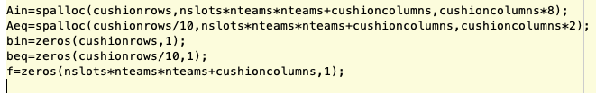
- Ain – allocate space for a sparse matrix which is cushionrows by nslots+nteams*nteams+cushioncolumns. Estimated that there are on average 8 variables filled in each row
  - Ain=spalloc(cushionrows,totalslots*nteams*nteams+cushioncolumns,cushioncolumns*8);
- Aeq – allocate space for a sparse matrix which is cushionrows/10 by nslots+nteams*nteams+cushioncolumns. Estimated that there are on average 2 variables in each row
  - Aeq=spalloc(cushionrows/10,totalslots*nteams*nteams+cushioncolumns,cushioncolumns*2);

- bin – use fzeros function to create a cushionrows by 1 matrix
  - bin = zeros(cushionrows, 1)
- beq – use zeros function to create a cushionrows/10 by 1 matrix
  - beq = zeros(cushionrows/10, 1)
- f – use zeros function to create a nslots*nteams*nteams+cushioncolums by 1 matrix.
  - f = zeros(nslots*nteams*nteams+cushioncolumns, 1)
Next we declare variables meant to keep track of constraints, slots, teams, stadiums, and a matrix for slack: TRin, TReq, xslack
- TRin – use zeros function to create cushionrows by 4 matrix.
  - TRin = zeros(cushionrows, 4)
- TReq – use zeros function to create a cushionrows by 4 matrix
  - TReq = zeros(cushionrows/10, 4)
- xslack – use zeros function to create a nslots*nteams*nteams+cushioncolumns by 1 matrix.
  - xslack = zeros(nslots*nteams*nteams+cushioncolumns, 1)

Last, we set up indexes to keep track of rows and columns in our Equality and Inequality matrices: rin, req, cols
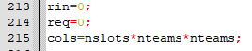
- rin – indexes row for Ain
  - rin = 0
- req – indexes row for Aeq
  - req = 0
- cols – indexes columns for Ain and Aeq
  - cols = nslots*nteams*nteams

