Part 4 – Due asap
For part 4 you will code all twenty constraints.
The outline goes over the specifics of the code but only does so for Constraints 1-10 and 13. The second half of constraints are not all that different from 1-10 as in logically they are structured the same, only differing in the iterations of the for loops, conditions of the if statements, and leading coefficients of the inequalities/equalities.
If any constraint or snippet of code
The constraints are the following:
% C1; every team plays in every slot
% C2; every game is home vs visitor
% C3; every team has 70 home games
% C4; every team has home 22 fridays+saturdays, and Th between 10 and 12
% C5; distribution of games between teams
% C6; travel distance controls
% C7 every team home for one of first two slots, last two slots
% C8; each team is home for at least one of july3 and july4
% C9; control 10 game homestands
% C10; no team is home three consecutive series or away; no three-window violations.
% C11; of every five consecutive series, we want 2 or 3 home;
% C12; no pair of teams should play each other more than twice in 5 series
% C13; controlling 10 game roadtrips
% C14; of every five consecutive weekends, each team, number of weekends is two or three
% C15; July3 to July4 and weekend distance control
% C16; no back to back series between two teams
% C17; no revisiting a stadium until w intervening series pass
% C18; no traveling over a rest day
% C19 Hard constrained days
% C20 Absolutely Hard constrained days

Constraint 1 : Every team plays in every slot
if whichconstraints(1,1)==1 -> utilize the whichconstraint() function and have the second value set to ‘1’ to imply constraint one. Set the if statement equal to 1 to make it ‘True’
for i=1:nslots -> sets i=1, hence 1 is the starting index, and Iterates from 1 to nslots. Recall that nslots=max(max(template)). What value is nslots?
for j=1:nteams –> sets j=1, hence 1 is the starting index, and iterates from 1 to nteams. Recall that nteams=max([NORTH SOUTH]). What value is nteams?
req=req+1 –> Adds 1 to the index of rows. Recall req indexes rows for Aeq
for k=1:nteams –> Sets k=1, hence 1 is the starting index, and iterates from 1 to nteams. Notice we iterate from 1 to nteams again but for the purpose of calculating Aeq instead of indexing the rows for Aeq.
Aeq(req,(i-1)*nteams*nteams+(j-1)*nteams+(k-1)+1)=1 – > For the index row req(computed in the previous loop) calculate (i-1)*nteams*nteams+(j-1)*nteams+(k-1)+1 and test if it equals 1.
- Notice that (i-1), (j-1), and(k-1). Aeq is always 1 less than the index used by the for loop.
- (i-1)*nteams*nteams+(j-1)*nteams+(k-1)+1 = 1 can be thought of as $ax^{2}+βx+γ=1$
End –> ends for loops
Constraint 2: Every game is home vs visitor
If j==k then Aeq(req,(i-1)*nteams*nteams+(j-1)*nteams+(k-1)+1)=1 –> when the indexes are the same the equality is computed.
- Once again $ax^{2}+βx+γ=1$
Else Aeq(req,(i-1)*nteams*nteams+(j-1)*nteams+(k-1)+1)=-1 –> when the indexes are not equal the equality is computer.
- Aeq(req,(i-1)*nteams*nteams+(j-1)*nteams+(k-1)+1)=-1 can be thought of $ax^{2}+βx+1=-1$

C3: Every team has 70 home games, 35 per half
for i=1:half Ain(rin,(i-1)*nteams*nteams+(j-1)*nteams+(j-1)+1)=-gamesperslot(i) –> index starts at i=1 and iterates to half while calculating the inequality.
- The inequality can be thought of as $ax^{2}+βx+1=-gamesperslot(i)$
- Recall gamesperslot=zeros(1,nslots); and for i=1:nslots gamesperslot(i)=sum(sum(template==i));
End
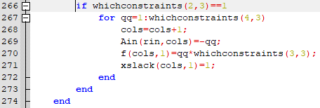
If whichconstraints(2,3) == 1 –> checks to see if the slack is activated.
For index 1 to the slack value
Cols=cols+1 –> Recall that cols=nslots*nteams*nteams; and indexes columns for Ain and Aeq
Ain(rin,col)=-qq –> Compute inequality for row indexed by rin and column indexed by cols and check if equal to current index version.
F(cols, 1)=qq*whichconstraints(3,3) –> sets f at (cols, 1) equal to the product of the index and penalty
- Recall f=zeros(nslots*nteams*nteams+cushioncolumns,1)
Xslack(cols,1)=1 –> xslack at (cols,1) equal to 1
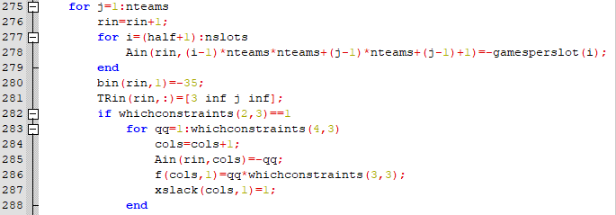
Fundamentally the same as the last half of code but for the second half of the season.

Constraint 4: Every team has home 22 Friday+Saturdays
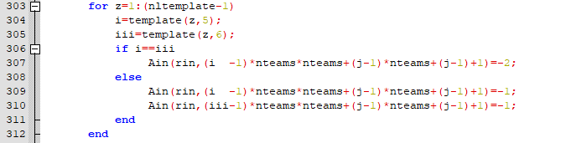
For z=1 : (nltemplate-1) –> index between 1 to netemplate-1
- Recall [nltemplate,~]=size(template)
i = template(z, 5) –> i is equal to (z,5) in the template
iii = template(z, 6) –> iii is equal to (z, 6) in the template
if i=iii Ain(rin, (i-1)*nteams*nteams +(j-1)*nteams+(j-1)+1=-2–> if position (z,5) is equal to (z, 6) then compute the inequality
if the position (z, 5) does not equal (z, 6) then compute the inequalities
Ain(rin, (i-1)*nteams*nteams+(j-1)*nteams+(j-1)+1)=-1 &
Ain(rin, (iii-1)*nteams*nteams+(j-1)*nteams+(j-1)+1)=-1
- Notice the inequalities only differ in the leading coefficient, one corresponding to position (z,5) and the other to (z, 6).
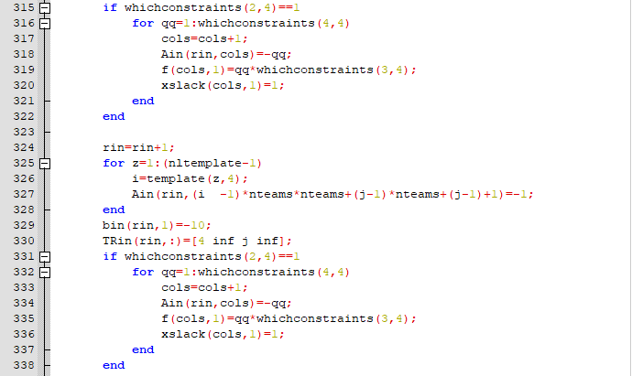
This portion of code is fundamentally the same as that from constraint 3, it deals with deals with penalty and slack.

Constraint 5: Distribution of games between teams
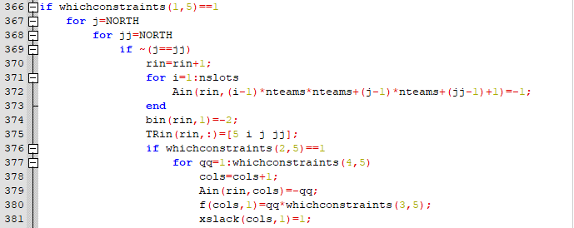
If ~(j==jj) –> when j does not equal jj where j=NORTH and jj=NORTH
For i=1: nslots Ain(rin, (i-1)*nteams*nteams+(j-1)*nteams+(jj-1)+1)=-1 –> iterates through slots and computes inequality.
Then, once again, is slack and penalty are utilized if active.
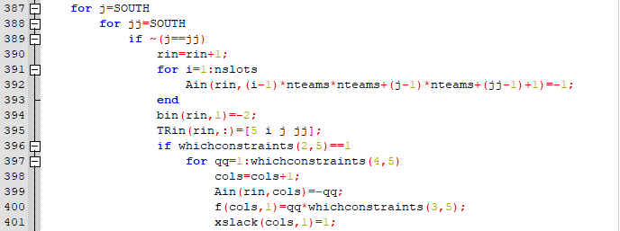
The code is repeated for the southern division

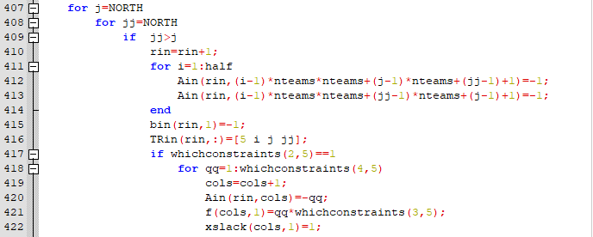
If jj>j –> when jj is greater than j when jj=NORTh and j=NORTH
For i=1 : half
Ain(rin, (i-1)*nteams*nteams+(j-1)*nteams+(jj-1)+1)=-1 &
Ain(rin, (i-1)*nteams*nteams+(jj-1)*nteams+(j-1)+1)=-1
–> iterates through first half of season and computes inequalities
- Notice the differing coefficients in the inequalities
Then deal with slack if active.
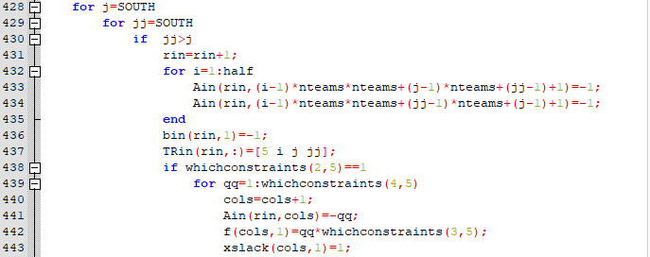
The code is repeated for the southern division
The rest of constraint 5 is the same, only differing in the conditions of the if statements and iterations of the for loops.

Constraint 6: Travel distance controls
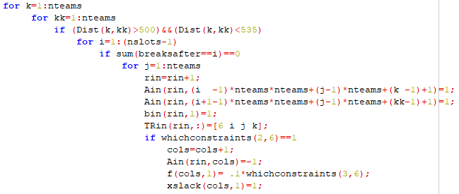
For k=1:nteams and for kk=1:nteams –> iterates through teams
If (Dist(k, kk)>500 && (Dist(k,kk)<535) -> if distance is between 500 and 535 miles
If sum(breaksafter==i)==0 for j=1 : nteams –> if there are is no breaks after then iterate through times
Then compute inequalities, one for k and one for kk
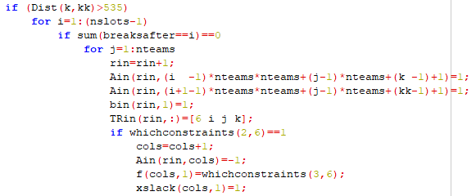
Same cod as above but for when distance between teams is greater than 535.

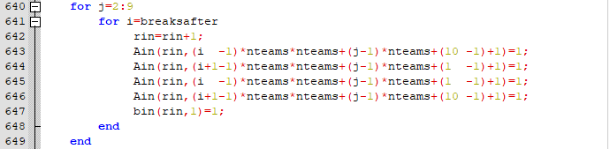
For all breaksafter values compute the inequalities.
Constraint 7: Every team is home first or second slot, every team is home last or second to last slot
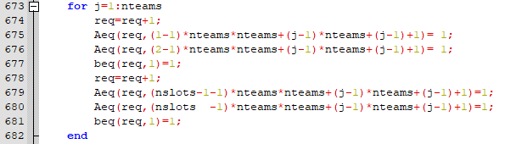
Iterates through all teams and computes the Equalities.
Lines 675 & 676 deal with the first and second slots while 679 & 680 deal with the last and second to last slots.
Constraint 8: Each teams is home either July3 or July4 and before/after ASB
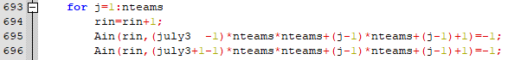
First inequality deals with July 3 and the second deals with July 4
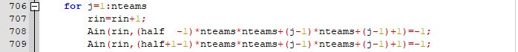
First inequality deals with before the All-star break while the second inequality deals with after the All-star break.

Constraint 9: Control 10 game homestands
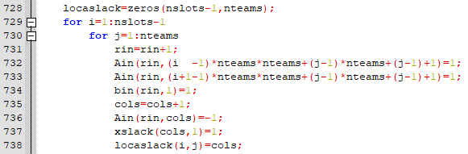
In constraint 9 localslack is established, the rest of constraint 9 should be familiar.
Localslack=zeros(nslots-1, nteams) –> localslack is zeroth matrix with(nslot-1) by nteams dimensions
Localslack(I,j) = cols – insert cols at (I, j) of the localslack matrix
Constraint 10: No team is home three consecutive series or away
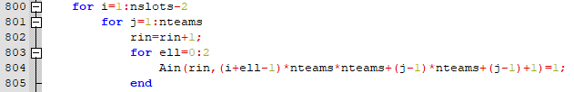
Iterates through slots and iterates through teams.
For ell=0:2 Ain(rin, (i+ell-1)*nteams*nteams+(j-1)*nteams+(j-1)+1) = 1 –> ell iterates through two series and then computes inequality where the leading coefficient is 1 less than the sum of the sum index and series number.
Same inequality as before but check against -1.

Constraint 13: Controlling 10 game roadtrips
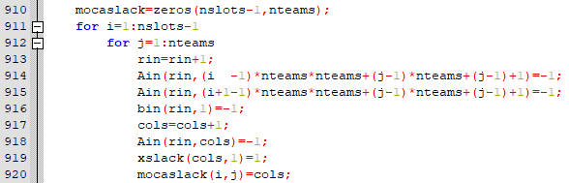
The only new thing in constraint 13 is another local slack variable
Mocaslack=zeros(nlost-1, nteams) –> zeroth matrix nlot-1 by nteams dimension
Mocslack(I,j) = cols –> At (I,j) in matrix insert cols

