Part 5 – Due asap
The last part of the project is to write the code that organizes, models, and then optimizes the data that will then be put into excel format. Furthermore, relevant statistics pertaining to the schedule are calculated, stored, and outputted.
If your interested in gurobi:
- https://www.gurobi.com/documentation/8.1/refman/matlab_api_overview.html#matlab:MATLAB
Relevant functions:
- Repmat(): http://www.ece.northwestern.edu/local-apps/matlabhelp/techdoc/ref/repmat.html#:~:targetText=repmat%20(MATLAB%20Functions)&targetText=B%20%3D%20repmat(A%2Cm%2Cn)%20creates%20a,A%2Cm%2Cn)%20.
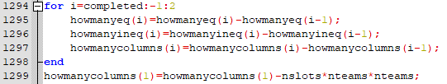
- Recall completed has been computed for every constraint.
  - It is set to i and acts as the starting index.
- Howmanyeq(i) is the number of equalities utilized by the program over the computation of all constraints.
- Howmanyineq(i) is the number of inequalities utilized by the program over the computation of all constraints.
- Howmanycolumns(i) number of columns utilized over the computation of all constraints.
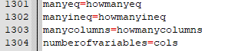
- Howmanyeq, howmanyineq, howmanycolumns, and cols are all stored in variables so that they may be printed.
- Notice that cols is the number of variables utilized by the program
  - This value should be in the 10000’s
- Output example:
  - 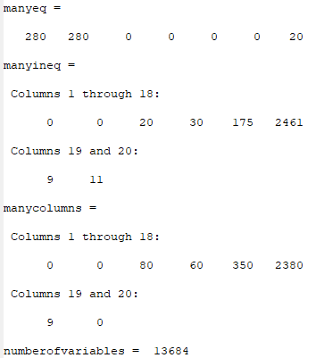

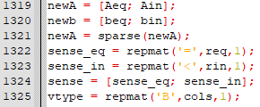
- The equalities and inequalities are stored as a matrix and then that matrix is sparsed.
- Beq and bin are stored as a matrix
- Sense_eq uses the repmat() to create a rep by 1 matrix filled with ‘=’
- Sense_in uses repmat() to create a rin by 1 matrix filled with ‘<’
- Sense_eq and sense_in are then stored as a matrix
- Vtype uses repmat() to create a cols by 1 matrix filled with ‘B’
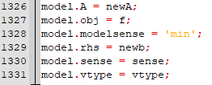
- Models sparsed Equality/Inequality matrix
- Models objective function
- Models beq/bin matrix
- Models sense matrix
- Models vtype matrix
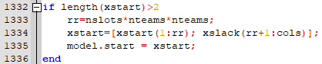
- If the length of xstart is greater than 2 compute rr
- Turns xstart into multidimensional matrix
- Models xstart matrix
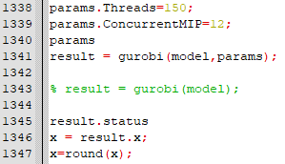
- Sets threads and concurrency
- Prints param type
  - This should be scalar
- Gurobi optimizes model given param and then the status is given
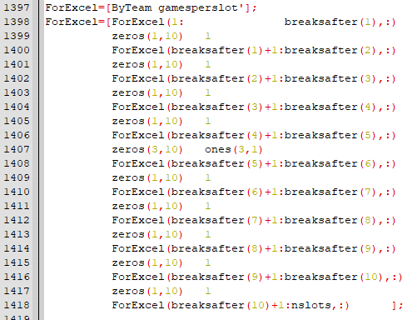
- Data for excel created – this will then be used to create the visual schuduel
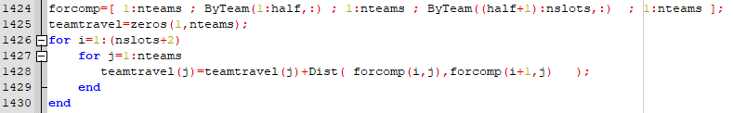
- Travel states computed

