Name: Bella

Date: 2021/09/10

Instructor: R.Spencer Steenblik

Course title/number: Arch 3105 studio

* Definition for home

For most people, home is a place to escape from the world. It is not just social cautious words and deeds that are avoided, but also anxiety and anxiety caused by other spaces. At the same time, in my memory, the memories of home have a lot to do with the care of my parents. Home is a place to cure diseases, not only physical cure, but also peace of mind. In my memory related to my parents, the memory of being sick and being taken care of as a child accounted for a large part. Not only that, when I was alone during my internship abroad, I also had the experience of being sick. A residential space that is not warm and uncomfortable will make me feel anxious and make my body more uncomfortable.

The air quality problem in Salt Lake City can be considered as the most serious social problem at present, which causes a large part of the people in the area to suffer from respiratory diseases, so I hope to design a small living space for families with respiratory diseases.

* Title: Air translator

—A tiny house designed for families suffering from respiratory diseases

* Site

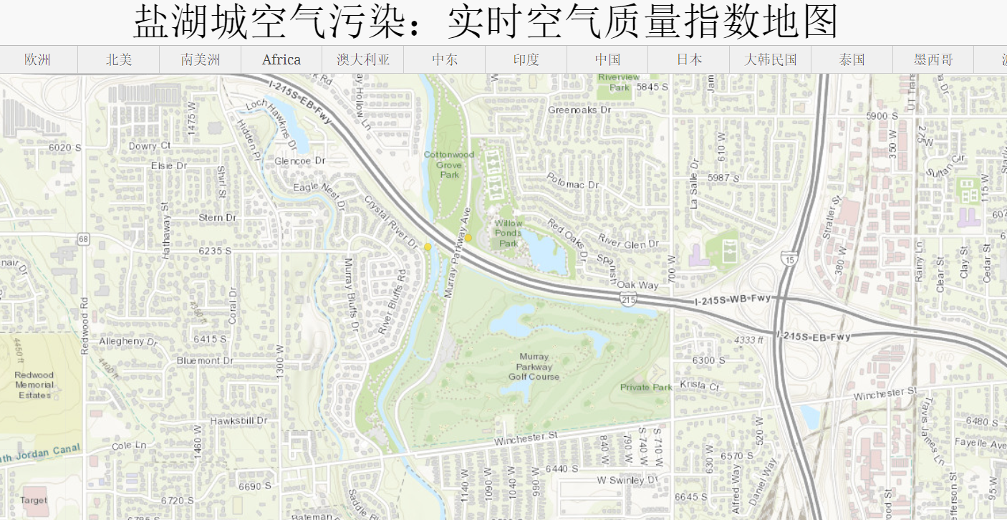

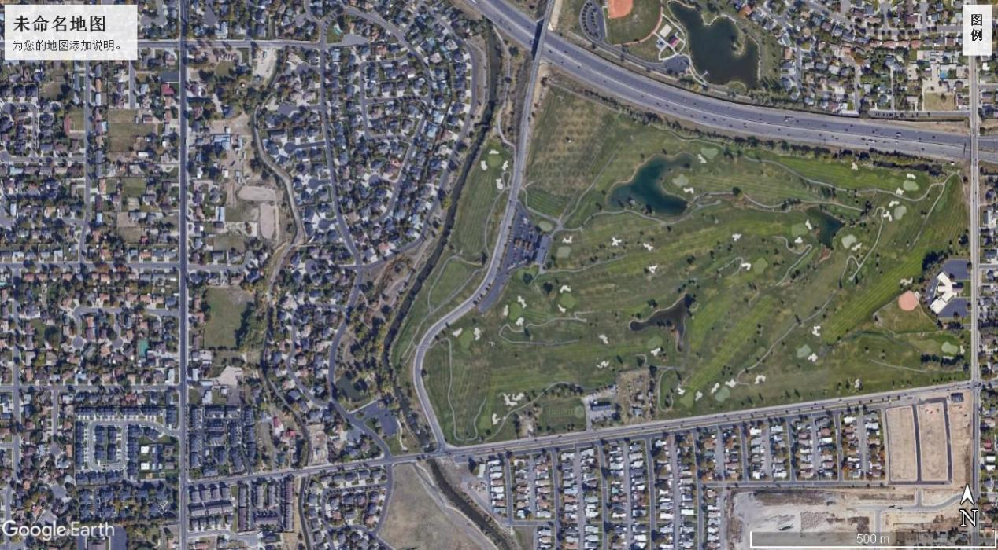

* Definition of client

-Retired elderly

-Walks, plant research

-6 people: grandfather/mother, father/mother, 2 kids

-1 small dog

-2-3 cohabitants