**02**

**TP**

**INTRODUCTION**

This rapport of practical work was made to complete the first one and remind us about other functionality of sql

The process starts by creating an non-organized data base and effect the necessary modification to run it and also getting more control over the data base

**Creation**

**Tables**

1. This figure presents the creation of table < PIECE >

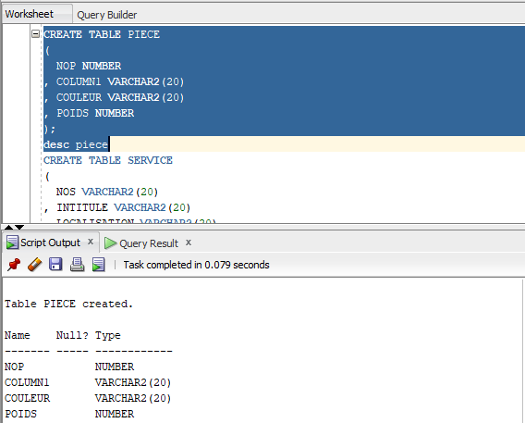

1. This figure presents the creation of table <>

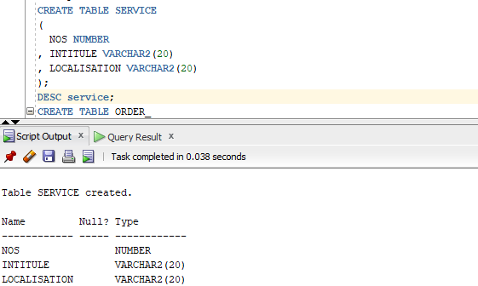

1. This figure presents the creation of table <Order_>

**Creation**

**Tables**

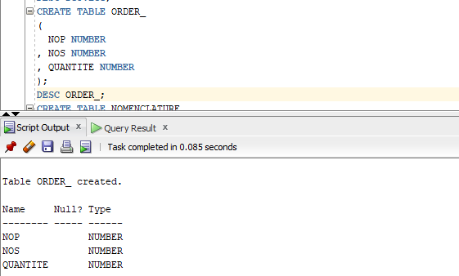

1. This figure presents the creation of table < nomenclature >

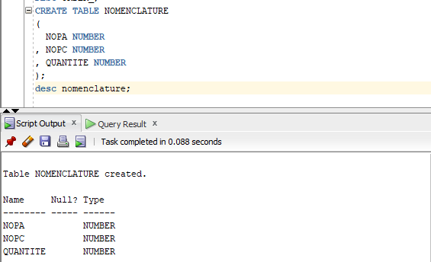

**DATA**

**INSERT**

* TABLE PIECE

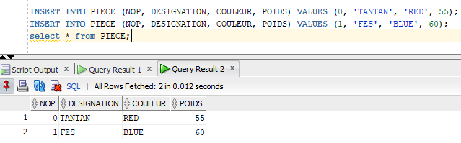

* TABLE SERVICE

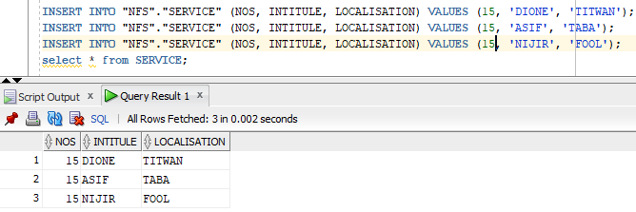

* TABLE ORDER_

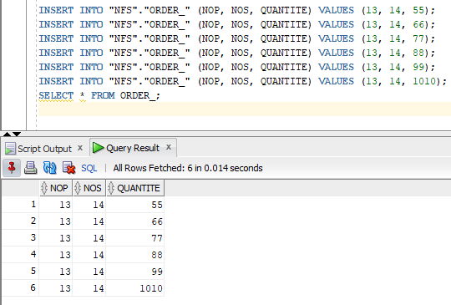

**DATA**

**INSERT**

* TABLE NOMENCLATUR

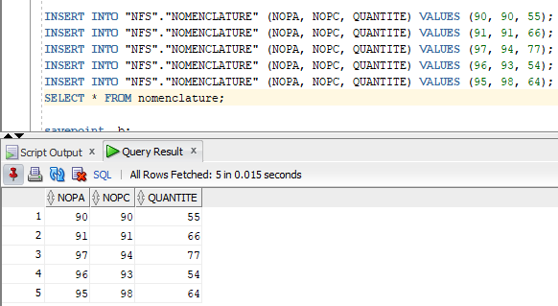

**ADD**

**CONSTRAINT**

* PRIMARY KEY

To add a primary key we need to make sure that there is no data that repeats.

Or we get this error:

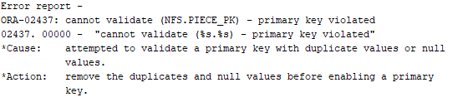

This applies to all the other tables .

To correct it we could make the following changes:

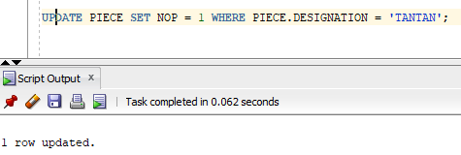

Now we can set the primary key:

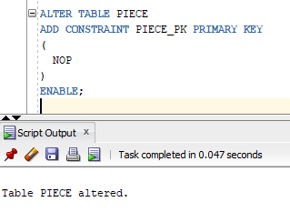

So let do the same process:

* Table service:

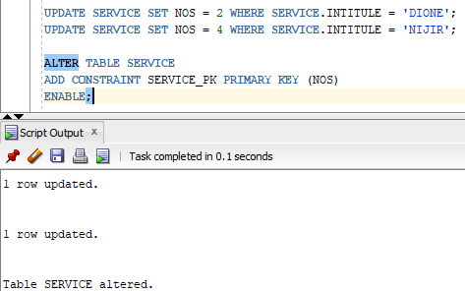

* Table ORDER_:

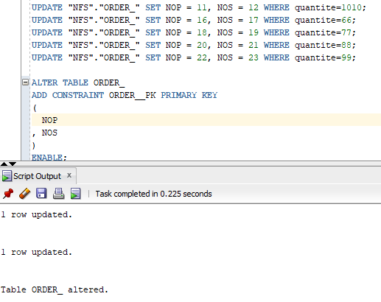

* Table NOMENCLATURE

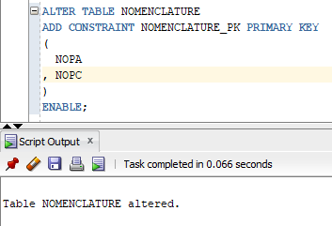

* FOREIGN KEY
* Table NOMENCLATURE

In order to add foreign key to NOMENCLATURE we need to make sure that the key exist in the parent table:

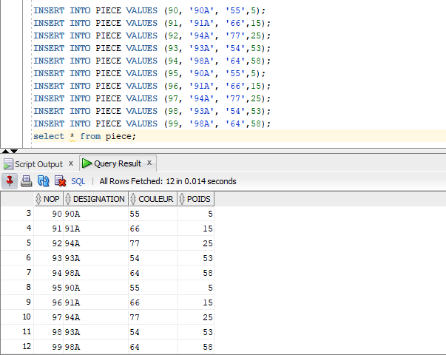

Now that all the parent keys inserted we can add constraint:

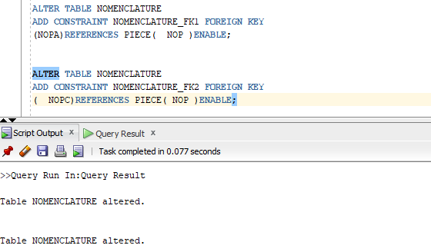

1. Table order_

Same steps goes for this table

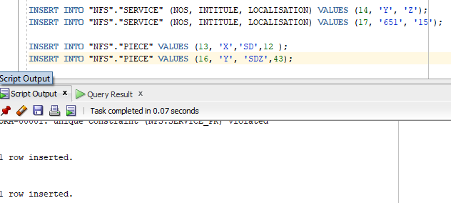

Now we add constraint

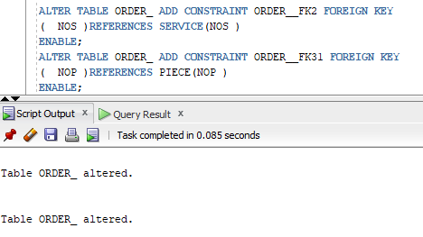

1. Table price <check-condition>

To add a check condition we must first make sure that all old data are compatible with the constraint :

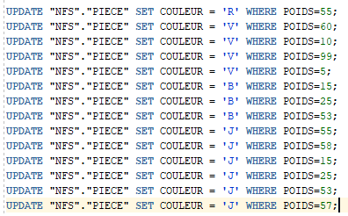

After that we add the check constraint

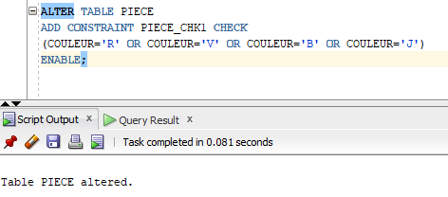

**operation**

1. Changing the column type :

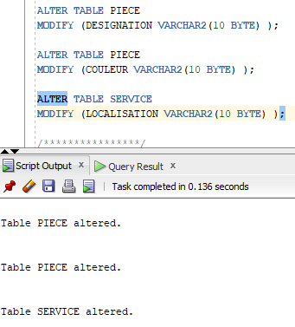

1. Add Column DIRECTEUR to SERVICE:

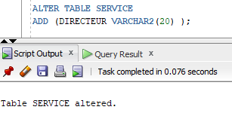

1. Drop Column from SERVICE:

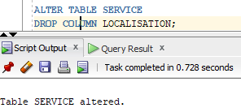

**On Tables**

1. Drop a primary key:

At first glance this may look a bit easy but no, because the primary key is connected with two other tables NOMENCLATURE and ORDER_, here is a graphic model to explain:

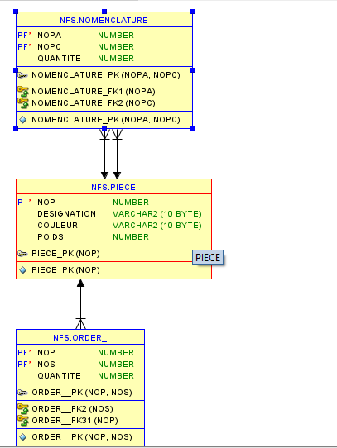

Now we need to delete these constraint

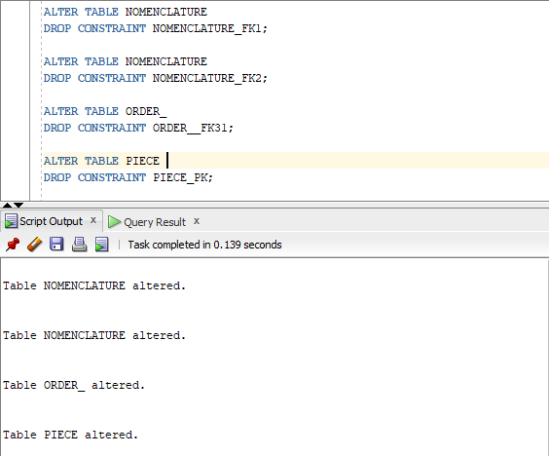

Now we can delete the primary key safely :

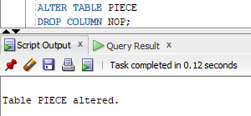

1. Deleting the check constraint:

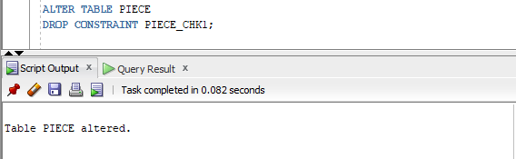

1. Deleting table NOMENCLATURE

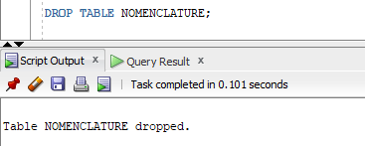

1. Deleting table ORDER_ using command CASCADE:

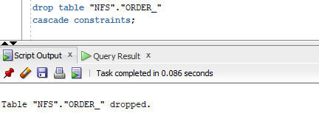

We notice that after we used the CASCADE option all the related constraint were removed.

during this practical work we have learned how to deal with an non-orgenazed data base and also how useful is CASCADE option to remove all the constraint .

**CONCLUSION**