Report of Practical Work

**INTRODUCTION**

In order to develop our level in data base management, we were given this practical work wish aim to make us more familiar with this domain by giving us an outside glance on how data base works,

The purpose of this rapport is to review what has been examined, and explain the methodology for filling the database using the oracle language.

Without further delay let us start.

in general, to stock data in a table form we need first to create the table in the database and with this process we can have the access to a lot of functionality.

Tables Creation

To create a table, we use the command CREATE TABLE and then specify the table name and give the name type and propriety to each column.

Now we will start our creation of each table.

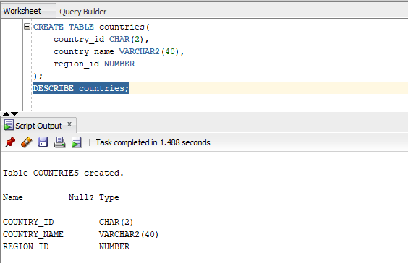

As shown in the previous picture we created a table named countries whish has three column (country_id,country_name,region_id) and we also specify each column type , notice the there are some proprieties are being initialed by default like null and primary key, the command discrib used as its name sugguest

1. This figure presents the creation of table <departement>

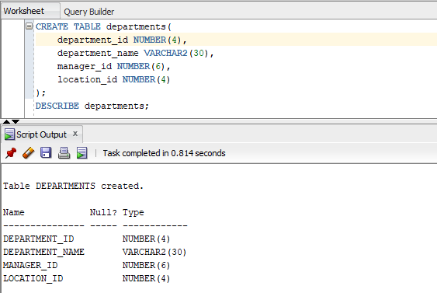

Tables Creation

notice that we use the same command to create a different table (department).

Tables Creation

1. This figure presents the creation of table <employees>

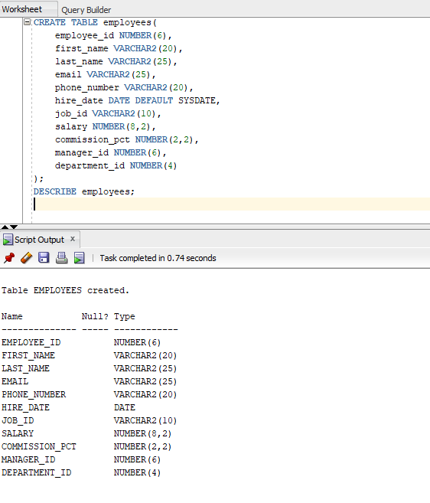

Tables Creation

1. This figure presents the creation of table <jobs>

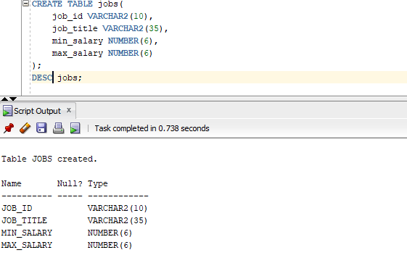

1. This figure presents the creation of table <job_grade>

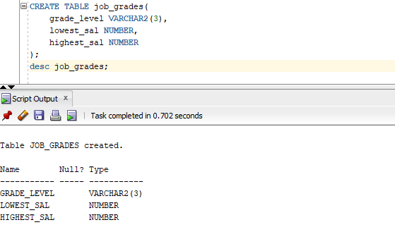

1. This figure presents the creation of table <job_history>

Tables Creation

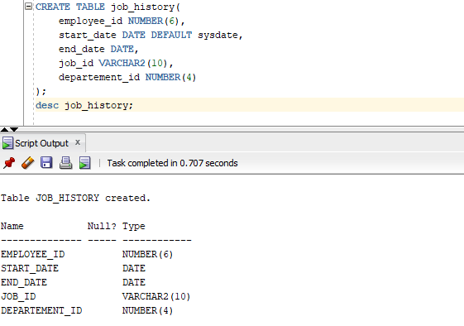

1. This figure presents the creation of table <locations>

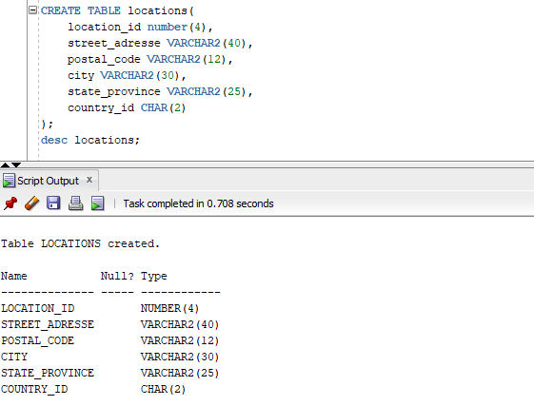

1. This figure presents the creation o f table <regions>

Tables Creation

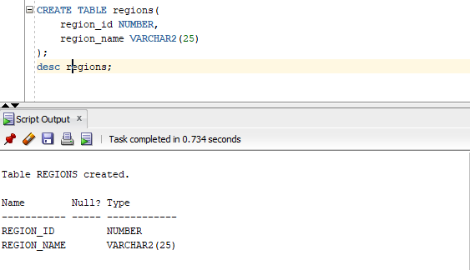

Primary Keys

In a relational database, a primary key is the data which uniquely identifies a record in a table. A key primary can be composed of one or more columns of the table.

In this part, in going to add the reference of key primary in all arrays with the ALTER TABLE command as shown below.

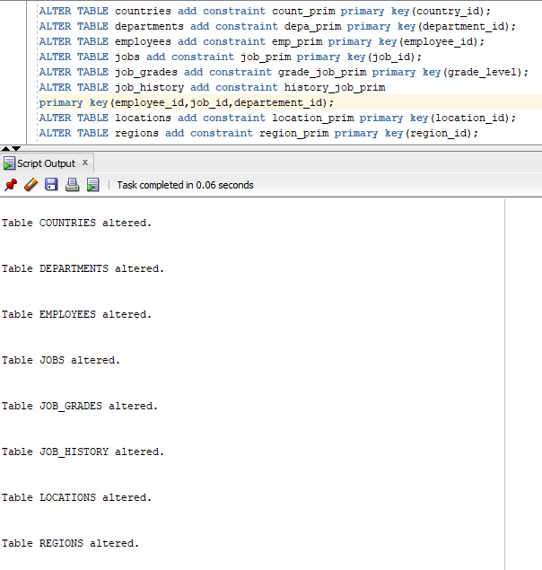

A foreign key, in a relational database, is a constraint that guarantees referential integrity between two tables. A foreign key identifies a column or set of columns in a table as referencing a column or a set of columns from another table (the referenced table).

Foreign Keys

In this part, we will then use the SAVE POINT method and COMMIT to save our step with foreign keys as shown below.

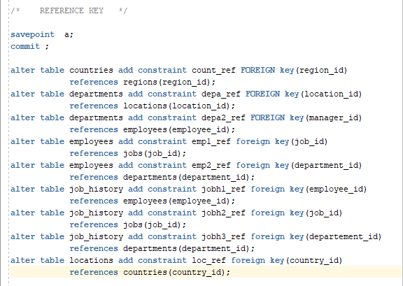

In our database there may be a foreign key which is manager_id in the employee table, but there are no tables with manager_id as a key primer, so we will say that a manager is a

employee, in other words that the reference of the manager_id key is the employee.

Is in this figure, go to the modification part of the tables

with foreign keys with the addition of SAVE POINT successful ...

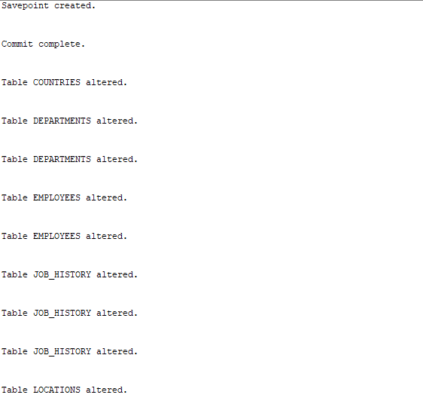

Foreign Keys

Other Constraint

The ADD CONSTRAINT method in SQL language contains several methods inside PRIMARY KEY and FOREGIN KEY, and in this part, we will add more method in our tables as needed.

For example, it is forbidden for a key primer to contain a value null, so in this figure we will prescribe the addition of the NOT NULL method to all table ...

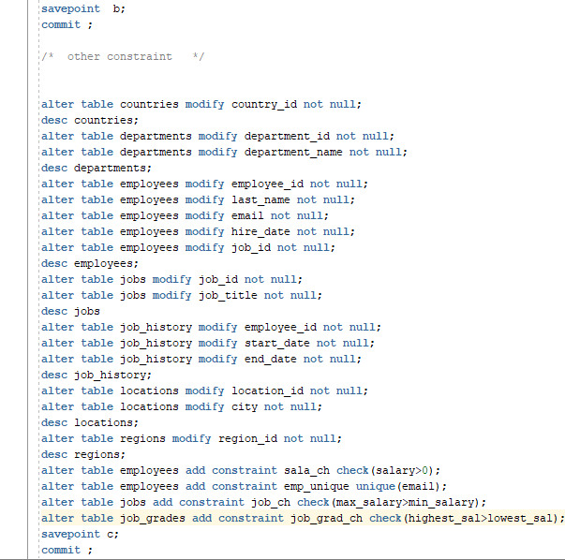

Foreign Keys

Now, we will present all the modification that has been affected to the table,

* Describe tables countries and departement

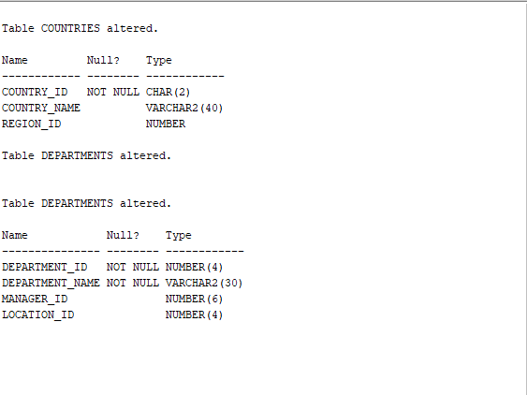

* Table employees

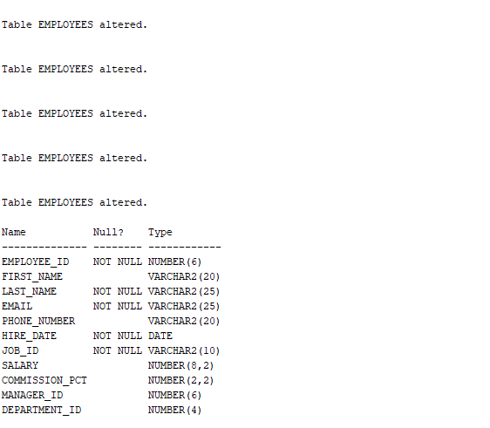

Foreign Keys



* Describe jobs

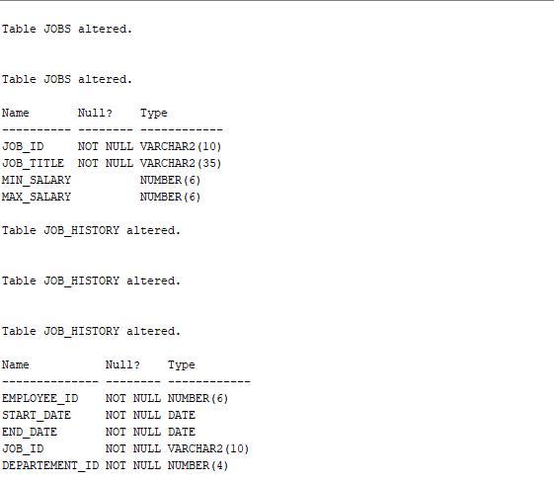

* Describe job history



Foreign Keys

* Describe locations

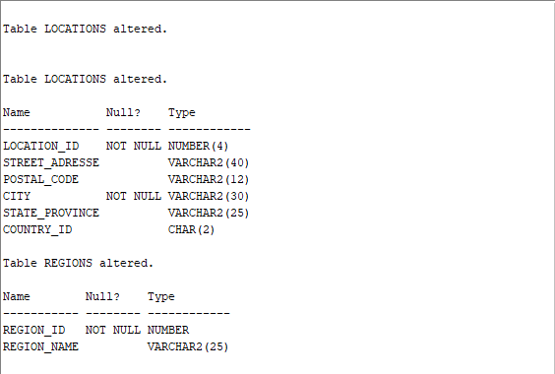

* Describe Regions



* Other changes like <<unique>><<check>>

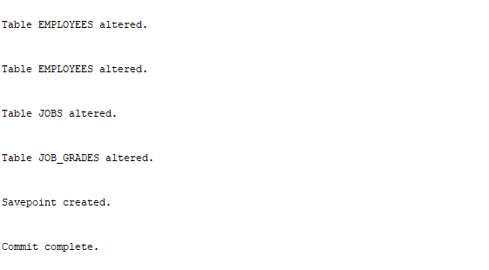

Fill In The Data

After we have set all the tables an the rolations netween them now we can move to fill the data into the table. We will start with the sample tables that does not have complex rolationship with other table .

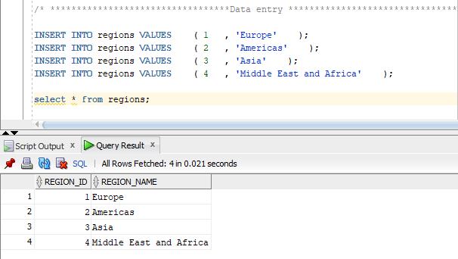

As shown after we enter the command select * from regions all the data pops up in the query result.

* Countries Data

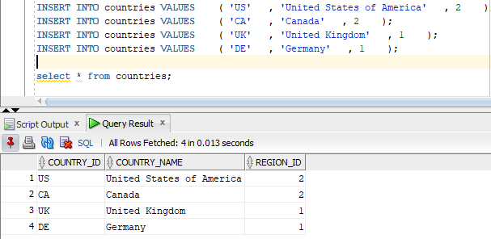

* Locations Data

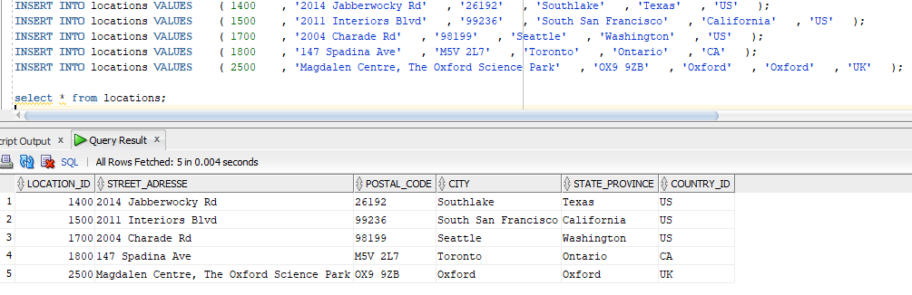

* Department

For this next table when we try to enter the data we get this error :

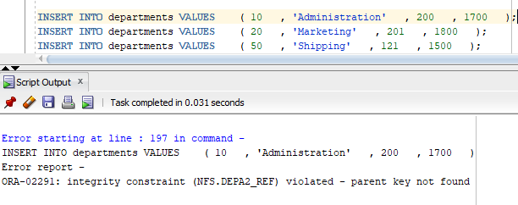

And what is this means is the system did not found the parent key for the foreign key manager_id because we have not set it yet in the employees table.

So in order to force the system to enter the data we have to disable this column for now

(in same cases we do not have the choice because all the tables connected to each other )



After we have disabled the foreign key now the data will be accepted :

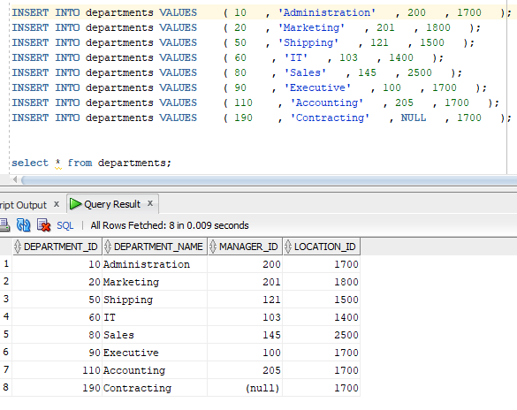

* Jobs Data :

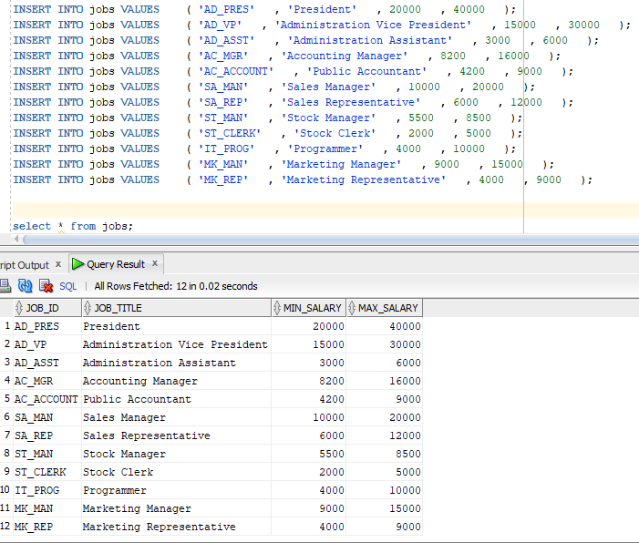

* Employees Data :

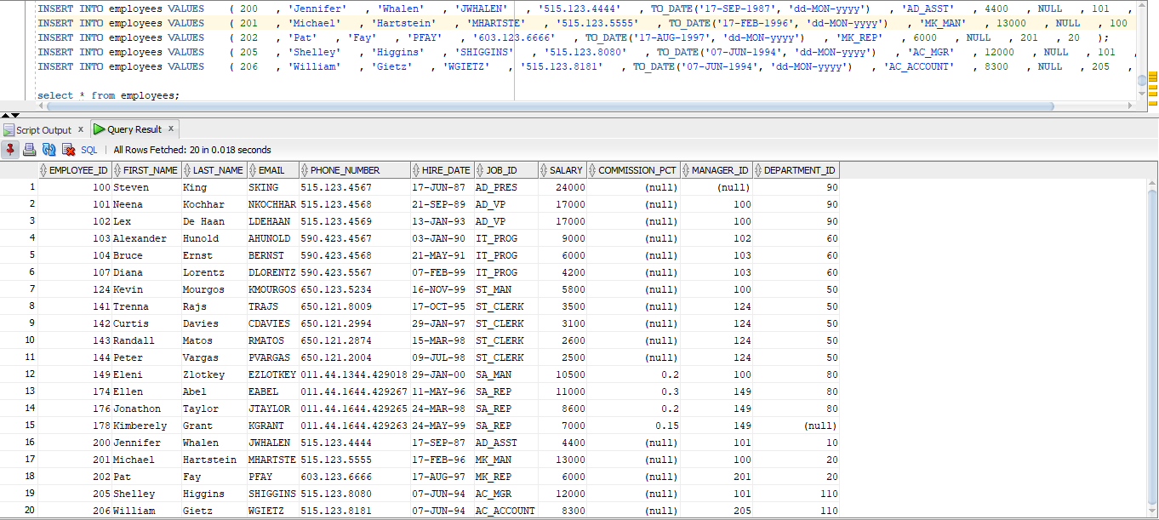

* Job History Data:

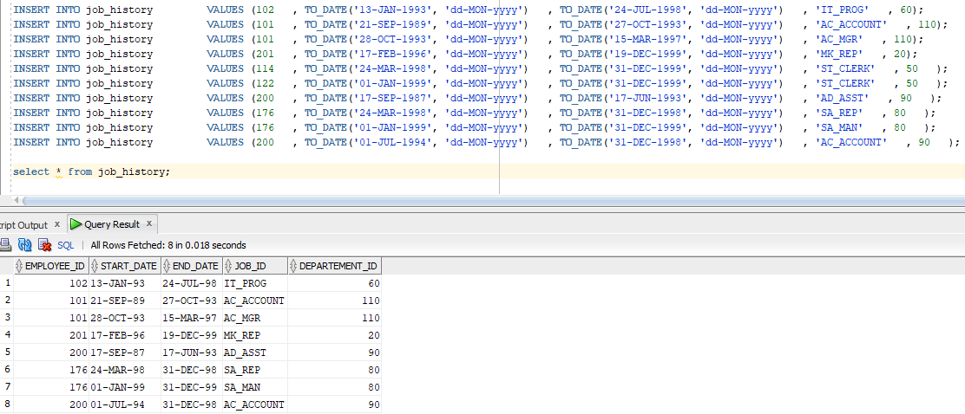

Finally, we make sure that all the disabled column are enabled again in order to access all the relationship.

during this practical work we have learned lots of thing in data base management, like how relations between the tables work, all the new form to write the conditions. finally, we look forward to learn newer thing about database management, as we are data scientists.

**CONCLUSION**